Institute of Computer Technology

B. Tech Computer Science and Engineering

Subject: BOSS (2CSE204)

**PRACTICAL-11**

**AIM: - To learn about Archiving and Transferring Files in linux.**

**Commands:**

* **tar –** used to compress files or dirs. in .tar format.
* **scp –** used to copy files or dir from one system to another in secure manner.
* **rsync –** used to copy files or dir from one to another in secure manner and speed in compared to scp.

**Exercise:**

1. Synchronize the **/etc** directory tree from localhost to the **/configsync** directory.

***SOLUTION***

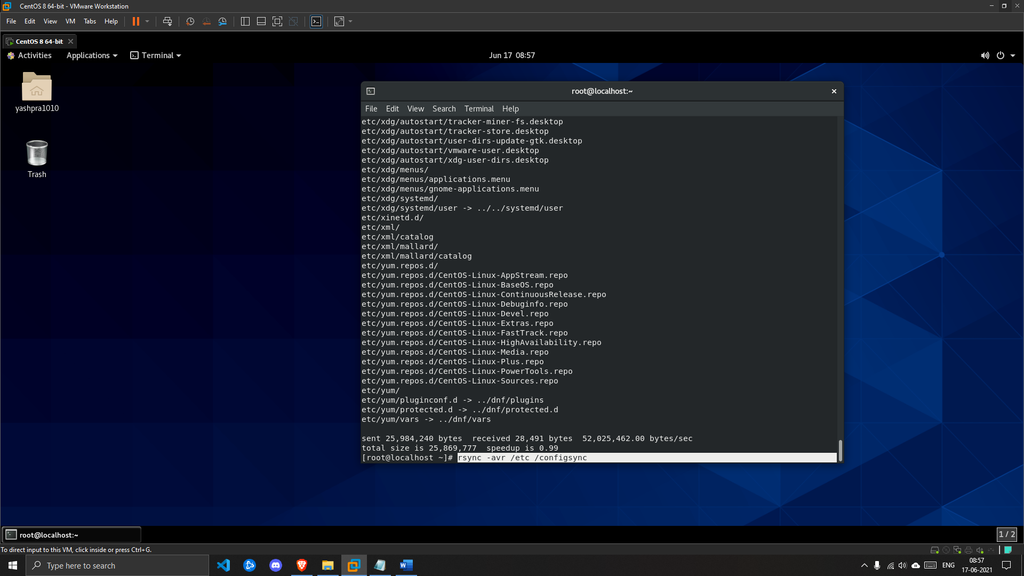

2. Use gzip compression to create an archive named **configfilebackup.tar.gz** with the contents of the **/etc** directory.

***SOLUTION***

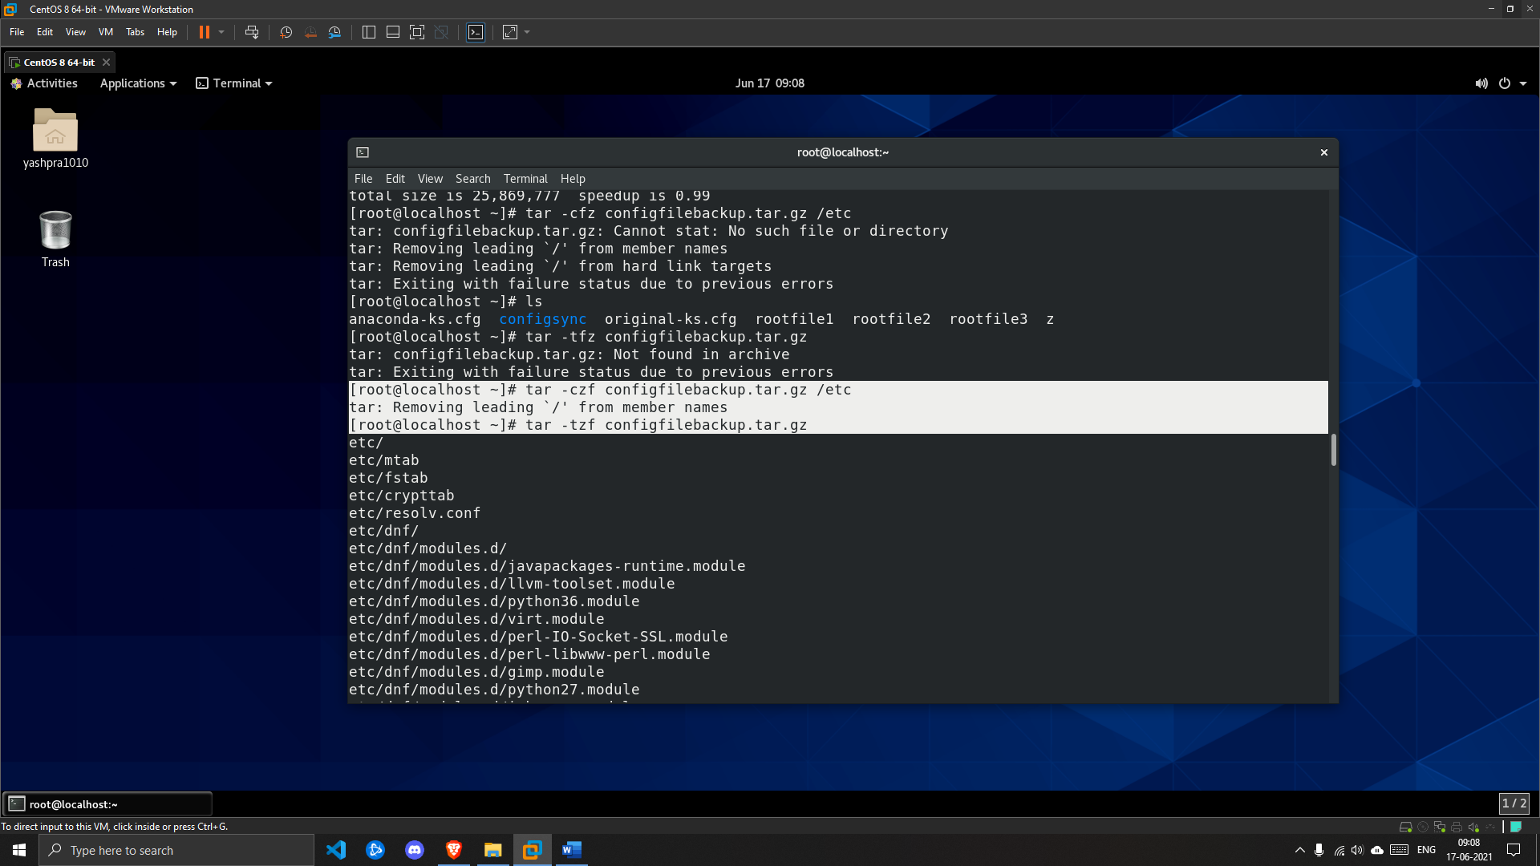

3. Securely copy the **/root/configfilebackup.tar.gz** archive file from localhost to the **/home/student** directory on localhost as the student user using student as the password.

***SOLUTION***

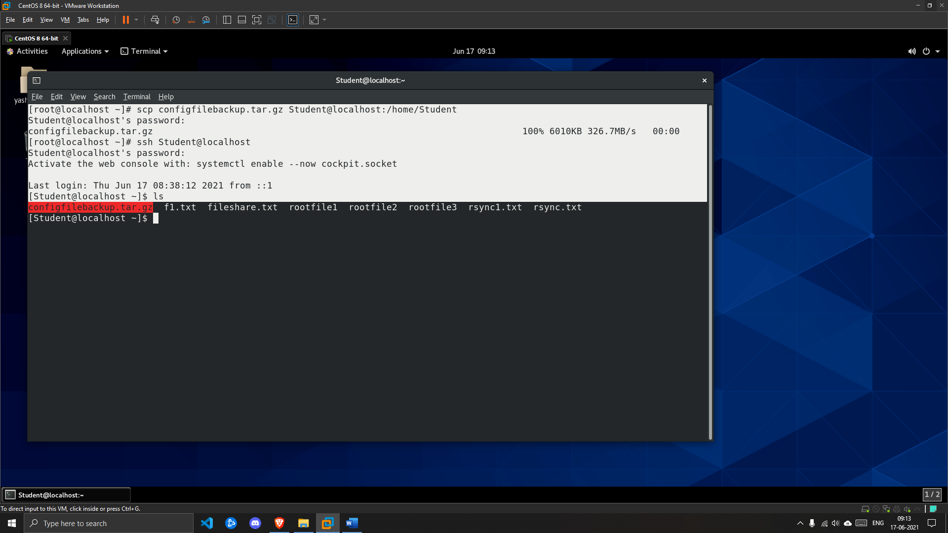

4. On localhost, extract the contents of the **/home/student/configfilebackup.tar.gz** archive to the **/tmp/savedconfig/** directory.

***SOLUTION***

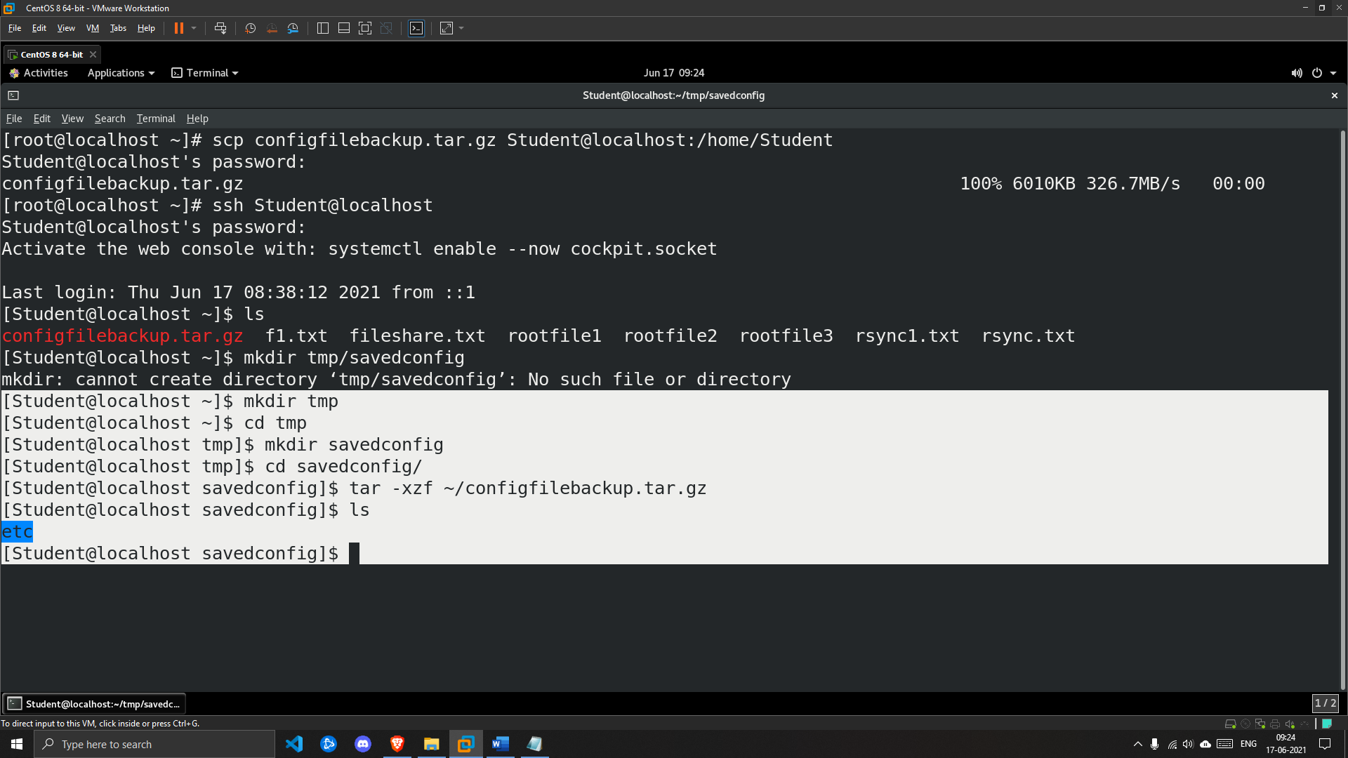

5. On localhost return to the student home directory.

[student@localhost savedconfig]$ cd

***SOLUTION***

