Institute of Computer Technology

B. Tech Computer Science and Engineering

Subject: BOSS (2CSE204)

**PRACTICAL-12**

**AIM: - To learn about accessing linux file systems.**

**Commands:**

* **lsblk -** to see the disk partitions
* **du -** for seeing file sizes of currect working directory
* **mount -** to create a mount point of partitions
* **umount -** to remove mount point from partitions
* **updatedb –** to update the database for using locate command.
* **locate -** works on pre generated database for searching files/directories.
* **find -** works runtime for searching files/directories.

**Exercise:**

**1. On localhost as root, identify the UUID for /dev/sda1 and mount /dev/sda1 by its UUID on the /mnt/freespace directory.**

***SOLUTION***

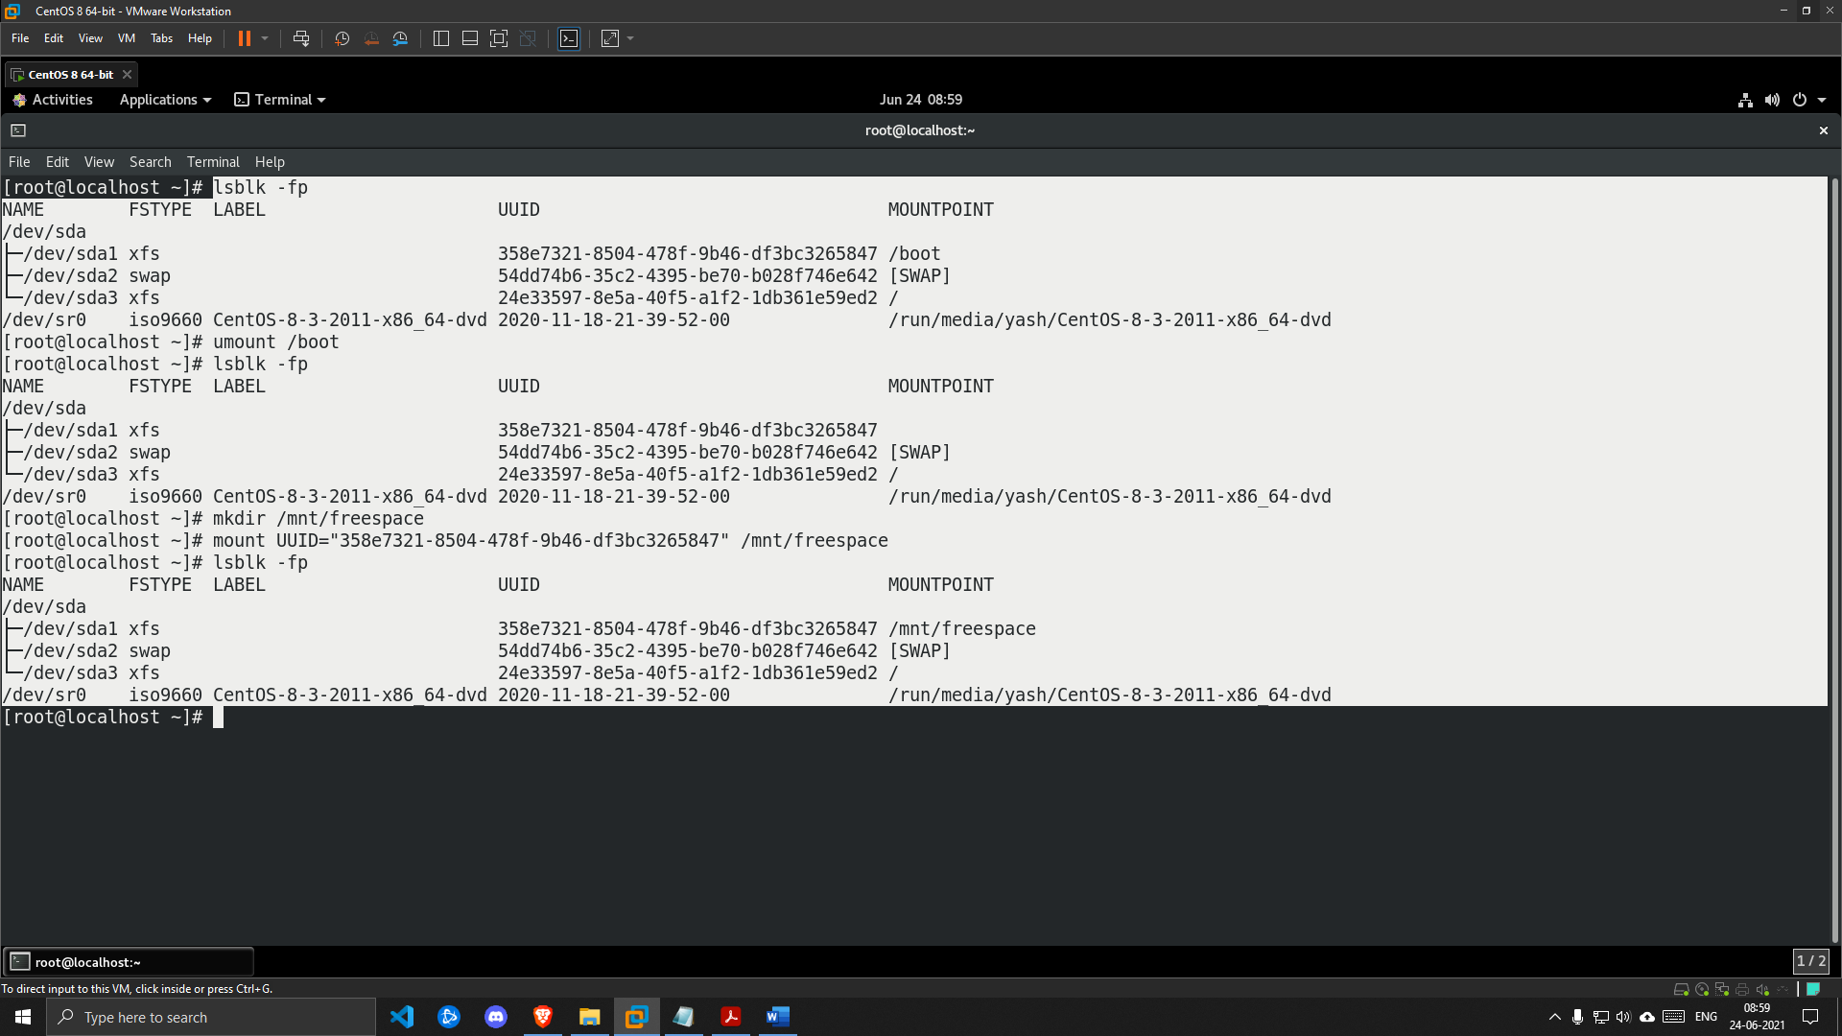

**2. Generate a disk usage report of the /usr/share directory, and save the result in the**

**/mnt/freespace/results.txt file.**

***SOLUTION***

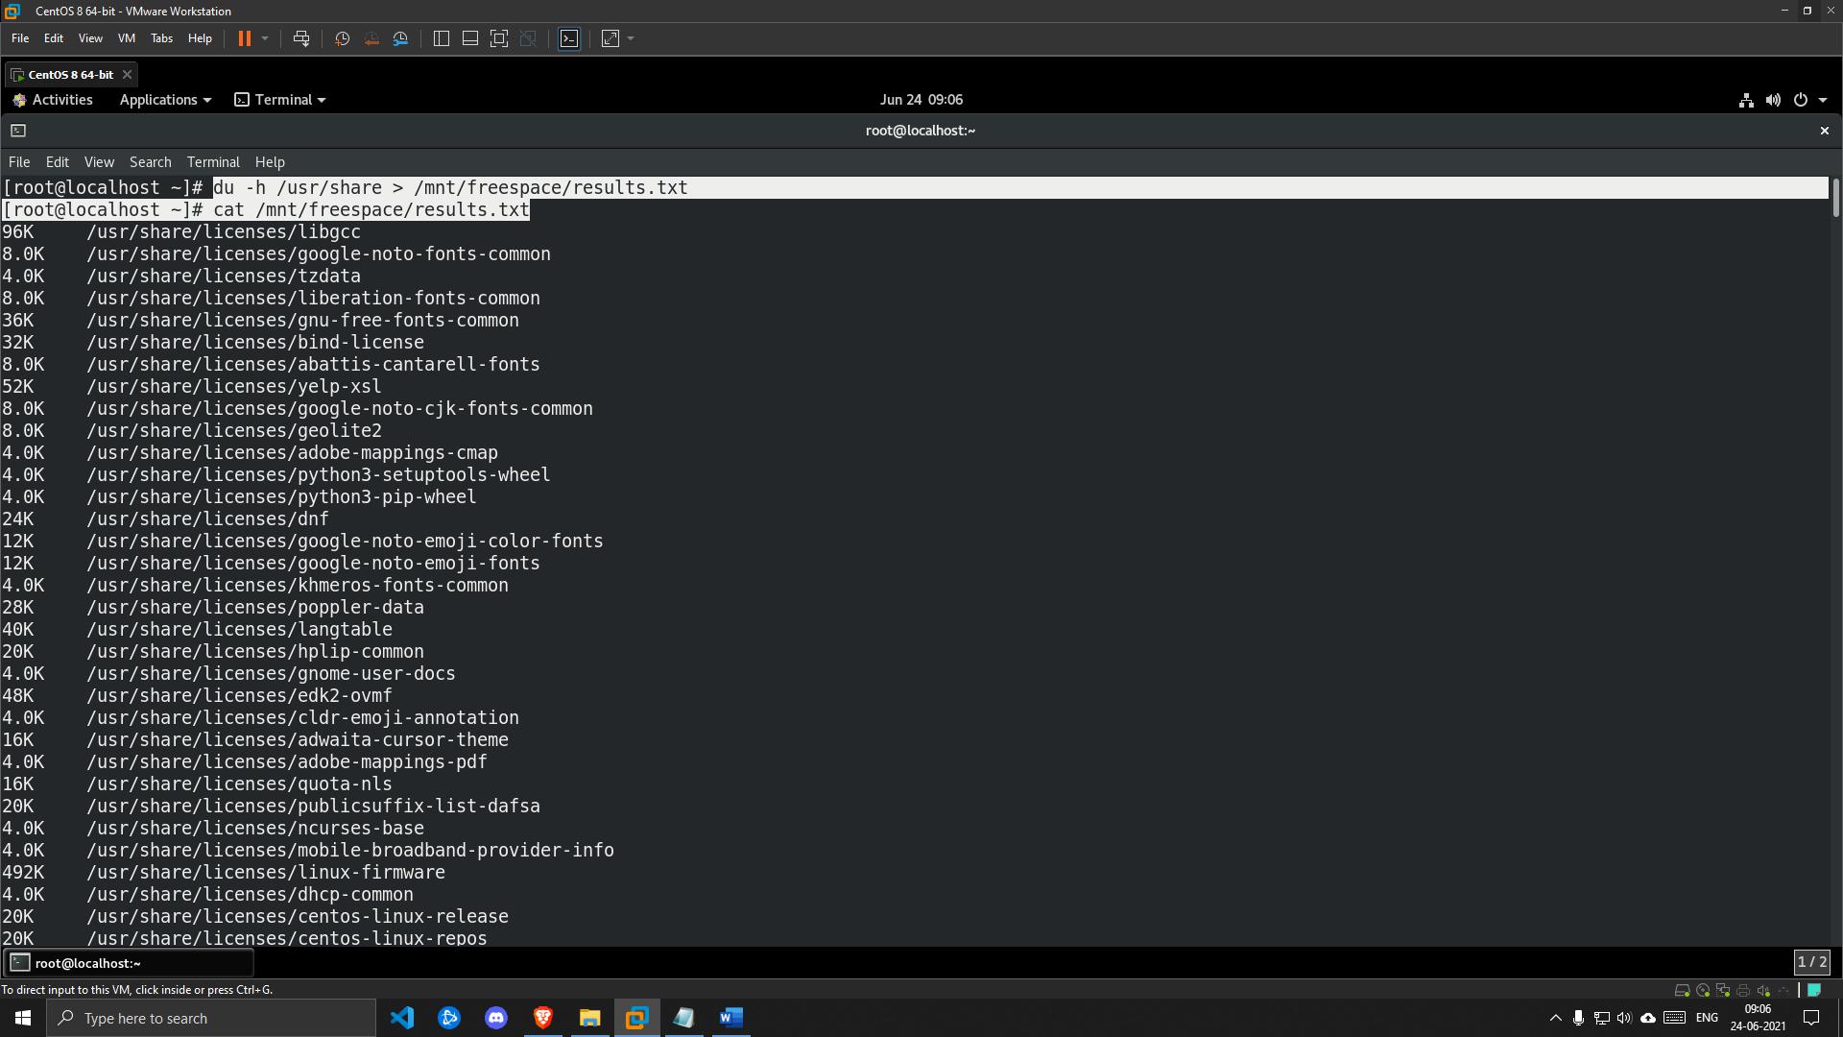

**3. Use the locate command to find all rsyslog.conf configuration files and store the result in the /mnt/freespace/search1.txt file.**

***SOLUTION***

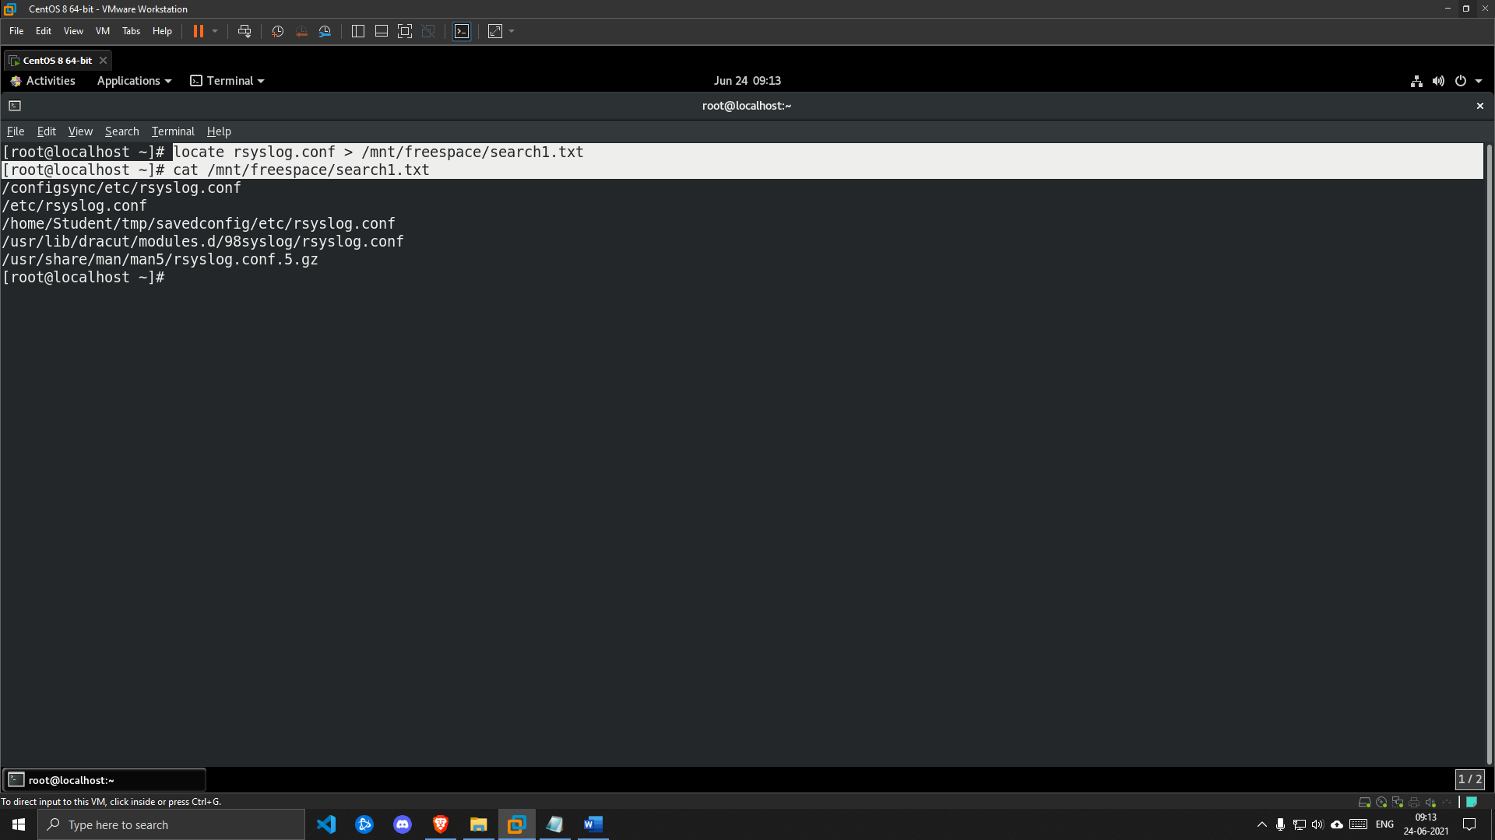

**4. Store the search result of all files in the /usr/share directory that is greater than 1 MB and less than 3 MB in the /mnt/freespace/search2.txt file.**

***SOLUTION***

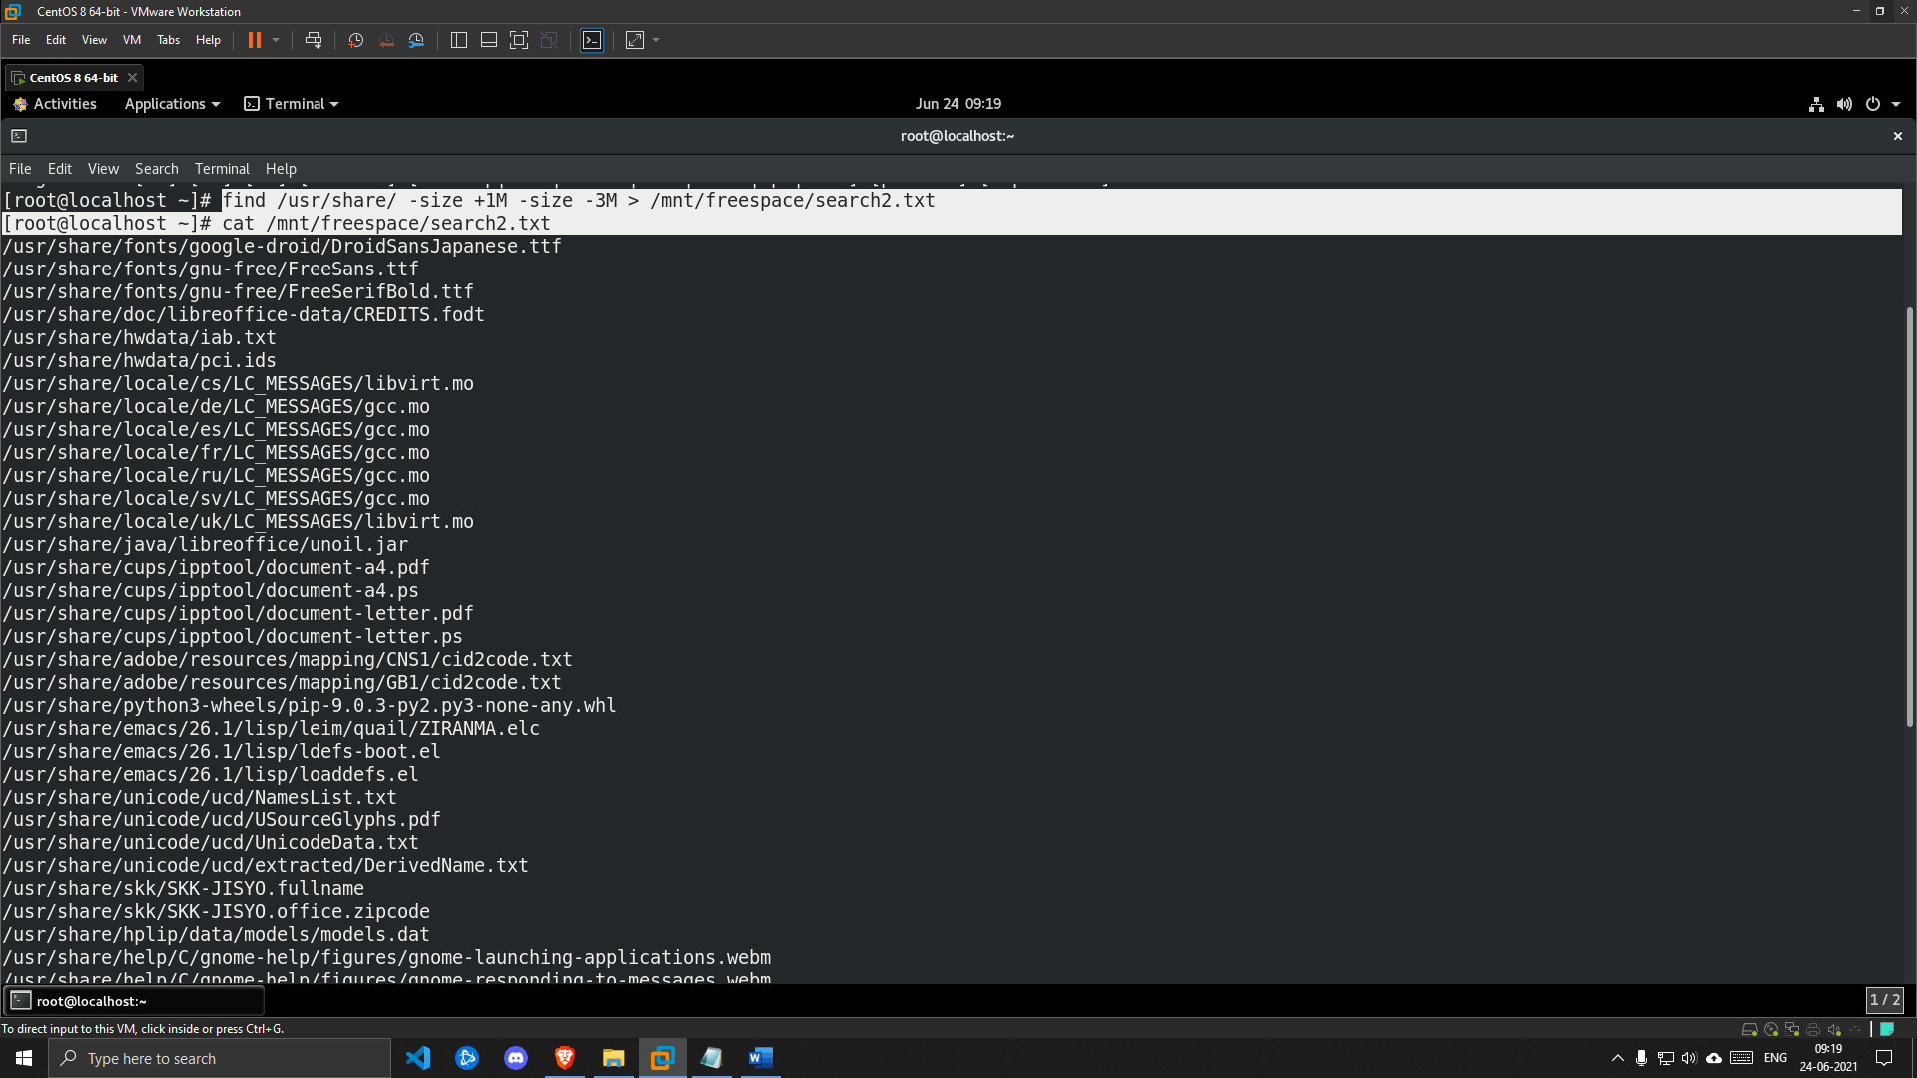

**5. Exit from root.**

***SOLUTION***

