Institute of Computer Technology

B. Tech Computer Science and Engineering

Subject: BOSS (2CSE204)

**PRACTICAL-13**

**AIM: - To learn about shell scripting in linux.**

**Exercise:**

1. **Implement a shell script to create directory ICT_Branch and sub directories CS, CBA, BDA and AI.**

***SOLUTION***

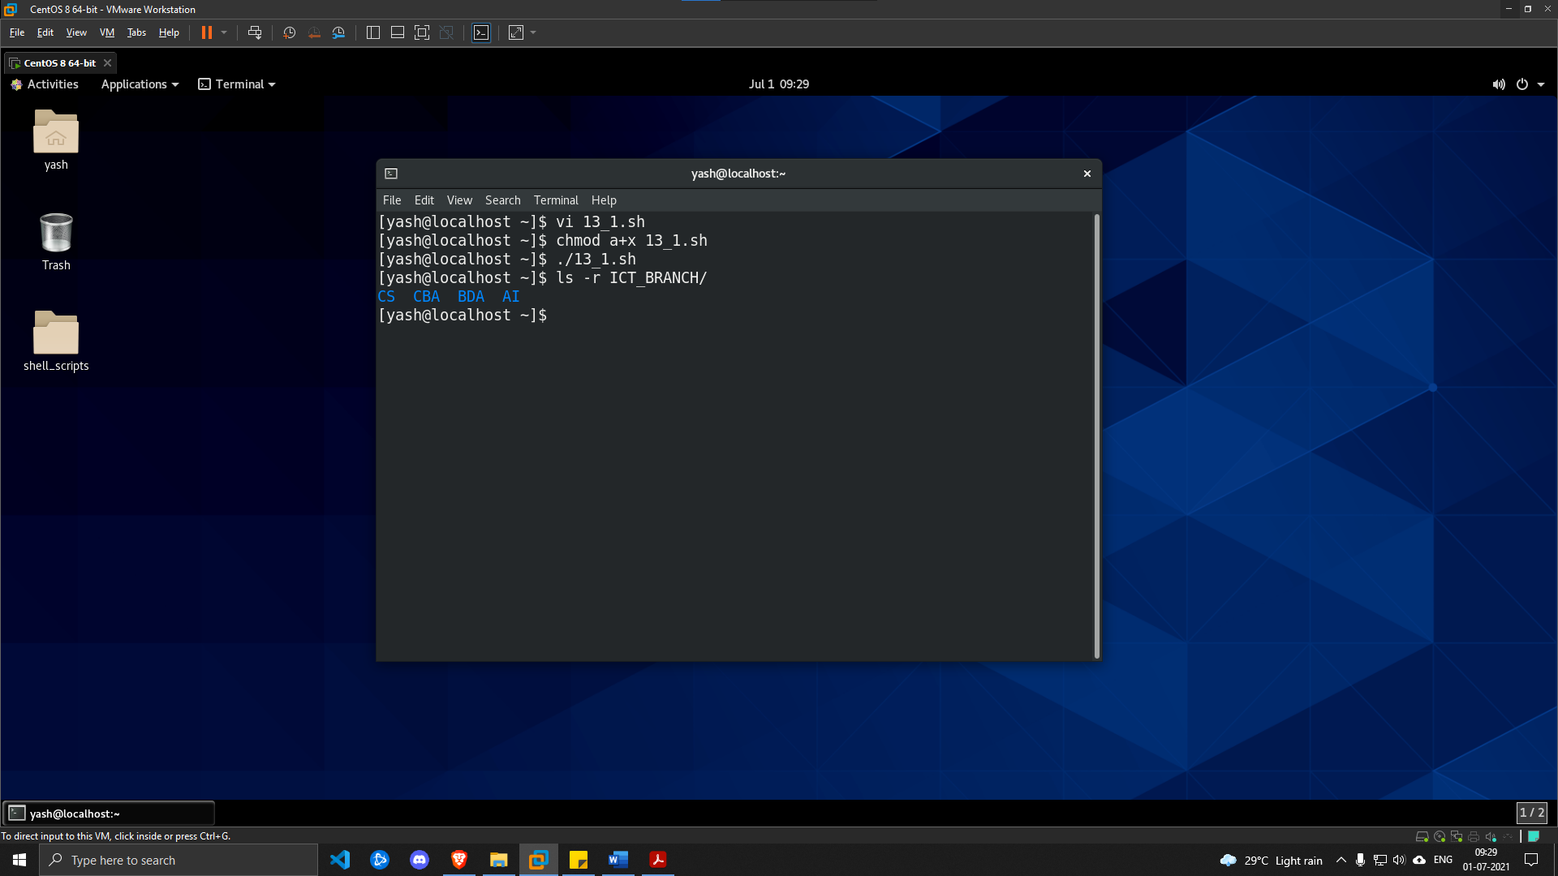

1. **Implement a shell script to print current logged in user and current date and time.**

***SOLUTION***

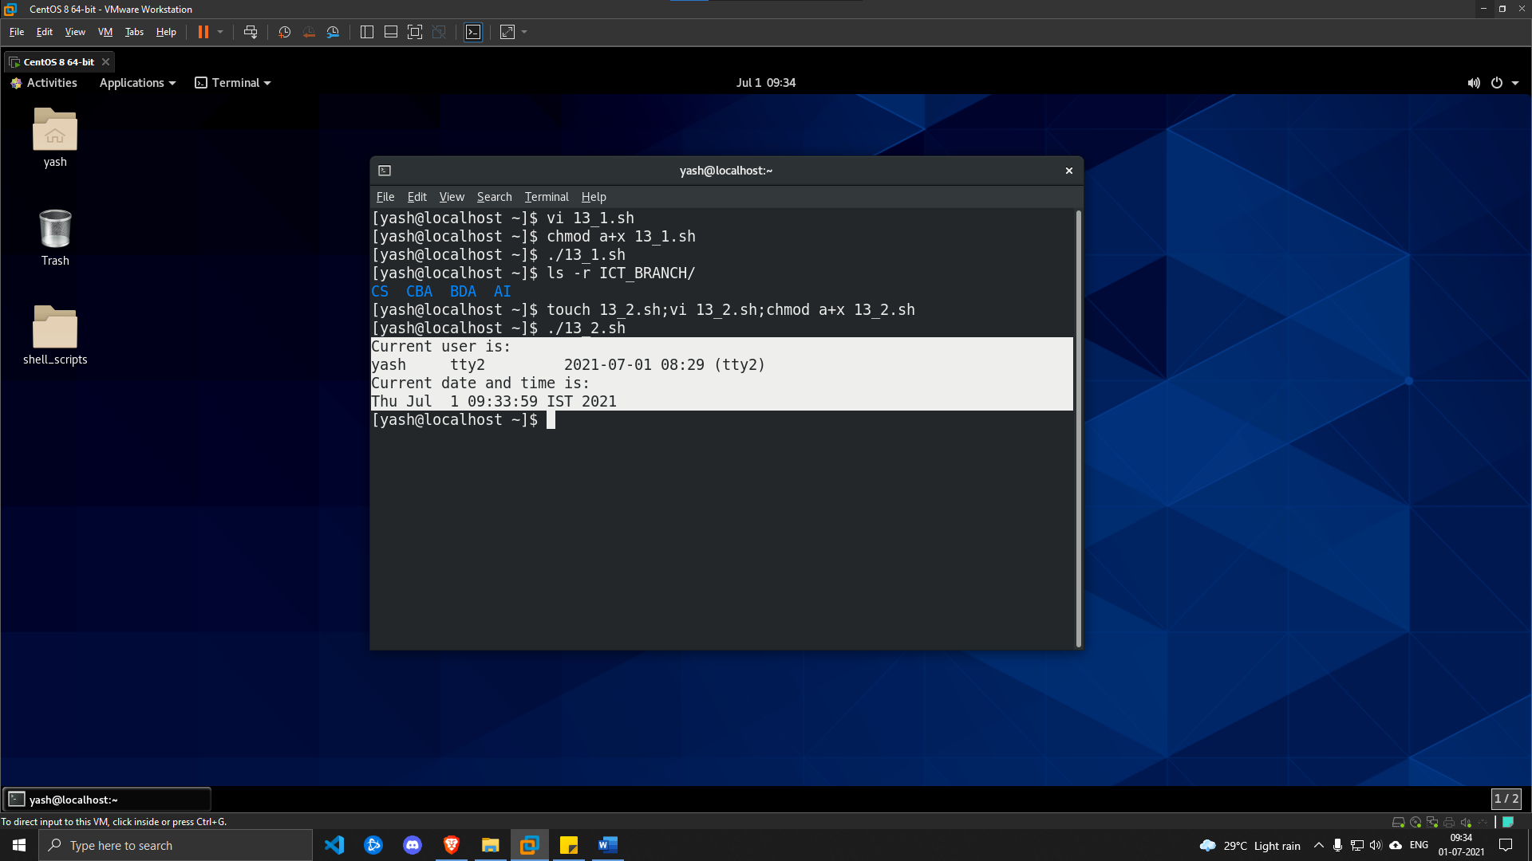

1. **Implement a shell script to print your name and your enrollment-using command line interface.**

***SOLUTION***

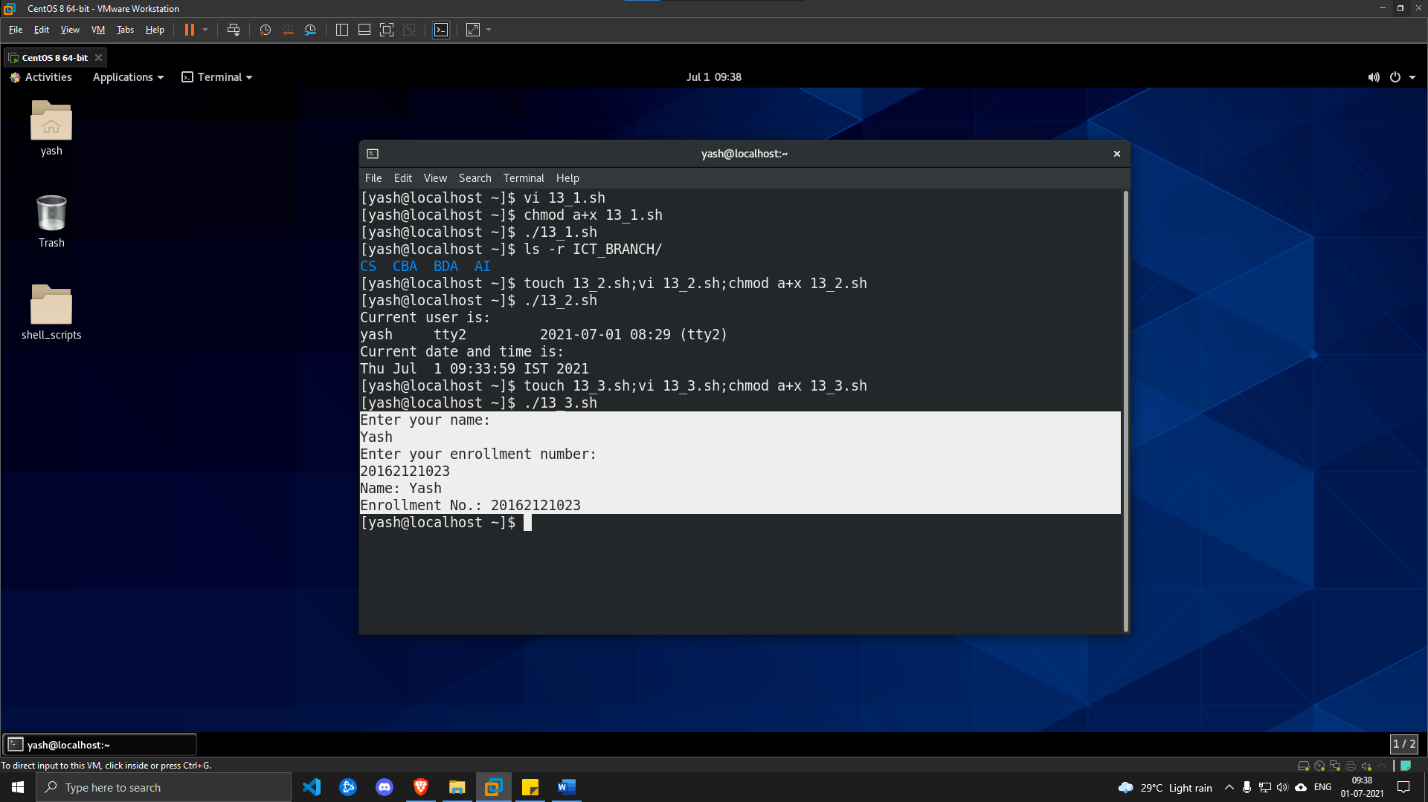

1. **Implement a shell script to list all files of home directory and store output into prac13.4.txt.**

***SOLUTION***

