Institute of Computer Technology

B. Tech Computer Science and Engineering

Subject: BOSS (2CSE204)

**PRACTICAL-14**

**AIM: - To learn about shell scripting in linux.**

**Exercise:**

1. **Implement a shell script to select choice of ICT_Branch(CBA/BDA/CS) and display following output.**
   1. **BDA: I am student of BDA.**
   2. **CBA: I am student of CBA.**
   3. **CS: I am student of CS.**
   4. **xyz: Wrong choice.**

***SOLUTION***

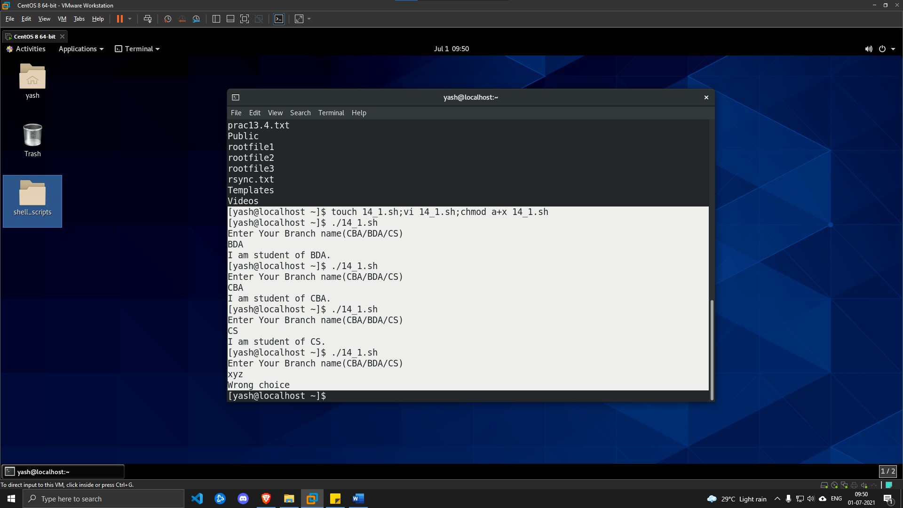

1. **Implement a shell script to create user, delete user and change password using functions.**

***SOLUTION***

