Institute of Computer Technology

B. Tech Computer Science and Engineering

Subject: BOSS (2CSE204)

**PRACTICAL-3**

**AIM: - To learn Creating, Viewing and Editing files from the command line in Linux.**

**Commands:**

➢ *> file* – to overwrite content in a file

➢ *>> file* – to append content in a file

➢ *2> file* – to store error in a file

➢ *2> /dev/null* – To discard an error

➢ *> file 2>&1 or &> file* – to overwrite content or error in file

➢ *>> file 2>&1 or &>> file* – to append content or error in file

➢ *Command-1 | Command-2* – this is used for pipping; it means the output of 1st command is used as input for 2nd command.

➢ *Command-1 | tee Command-2 | Command-3* – in this output of 1st command is stored or display and also used as input for 3rd command.

➢ *Shift + V* – to view in Visual Line

➢ *Ctrl + V* – to view in Visual Block

➢ *v* – to go in visual mode

➢ *x* – to delete/terminate the character

➢ *u* – used to undo changes

➢ :q*!* – to quit vi editor without saving changes in file

**Exercise:**

**1. Rehan wants to create directory Practical3 with 10 files & 3 subdirectories. Assign file name as Practical_exY.txt, Replace Y with exercise 1 to 10 & directory name as TempX, Replace X with 1 to 3.**

***SOLUTION:***

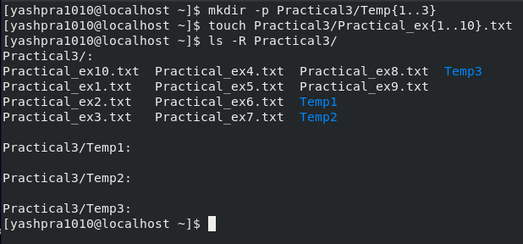

**2. Now, He wants to redirect a long listing of all content in the Practical3 directory, including hidden directories and files, into a file named editing_final_lab.txt.**

***SOLUTION:***

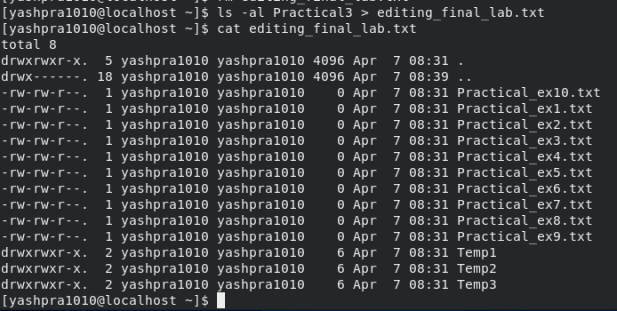

**-----------------------------------------------------------------------------------------------------------------------**

**3. Edit the file using Vi.**

***SOLUTION:***

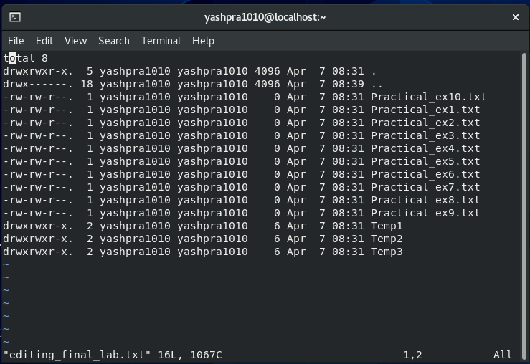

**4. He wants to remove the first three lines. Enter line-based visual mode with uppercase V.**

***SOLUTION:***

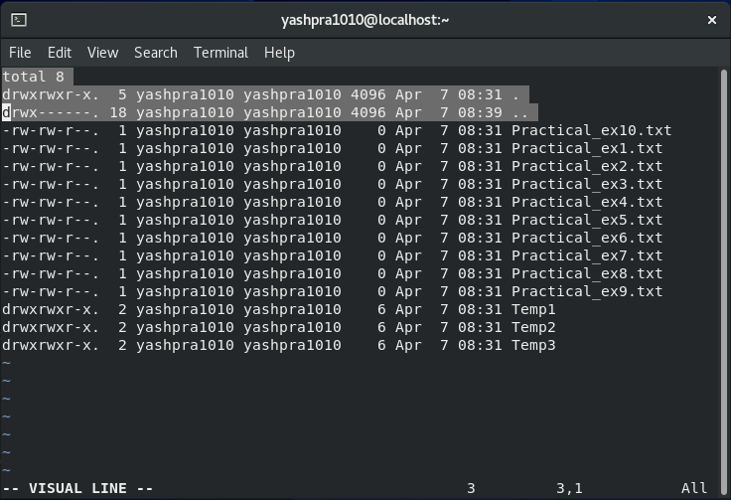

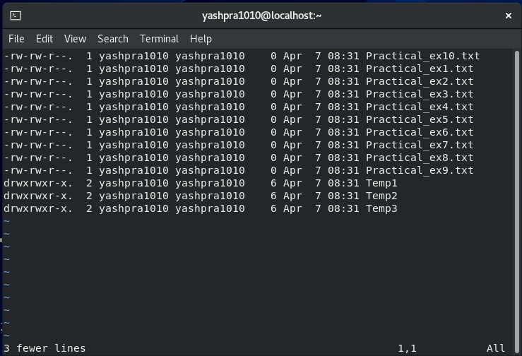

**5. Also, he wants to remove columns on the first line. Enter visual mode with lowercase v. Lowercase v selects characters on a single line only. The columns after -rw- should be deleted.**

***SOLUTION:***

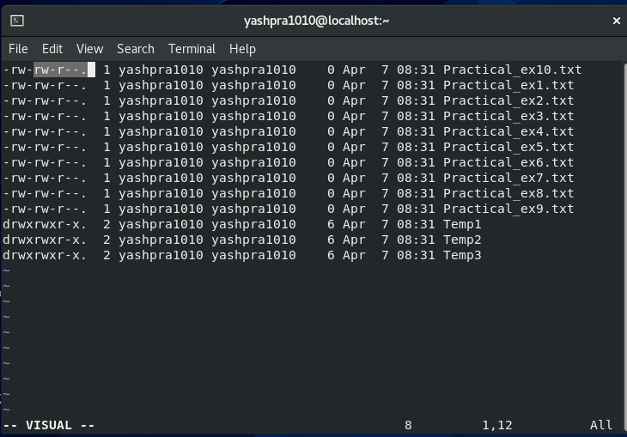

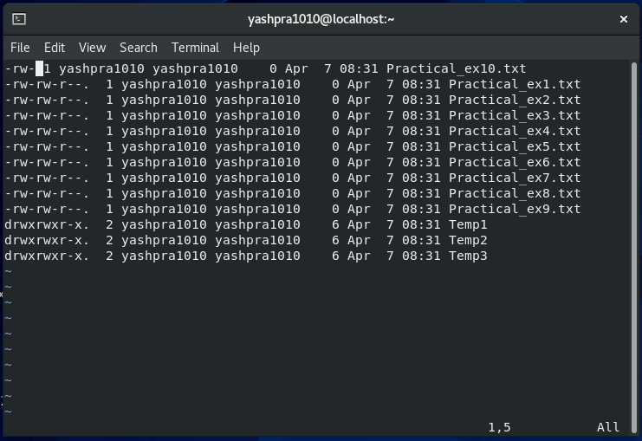

**-----------------------------------------------------------------------------------------------------------------------**

**6. Remove columns, and the subsequent dot (".") on the remaining lines. Use the visual block mode. Enter visual block with the control sequence Ctrl+V. Use this key sequence to select a block of characters on multiple lines. The columns after -rw- should be deleted.**

***SOLUTION:***

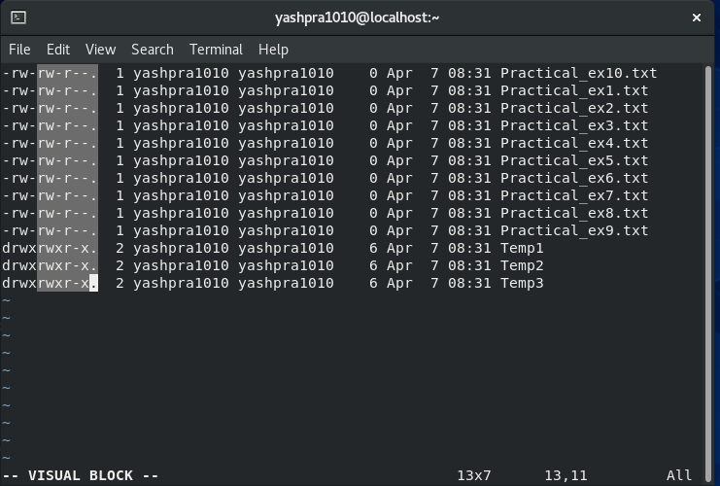

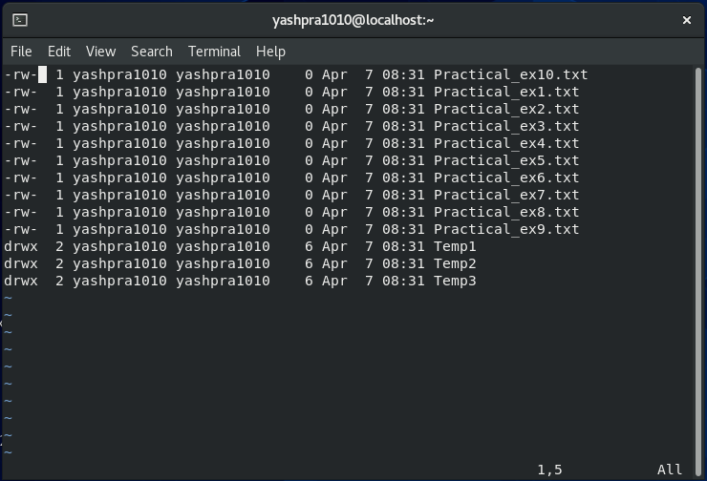

**7. Rehan wants to remove the fourth column. Use appropriate visual mode for the same.**

***SOLUTION:***

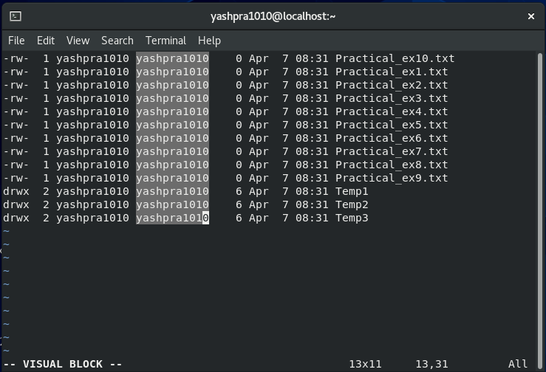

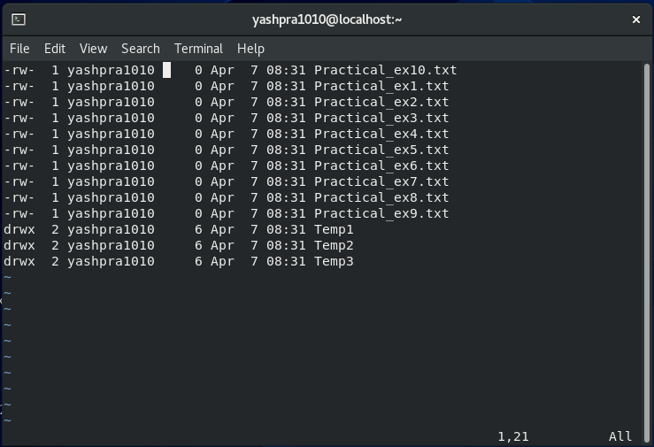

**8. Also, he doesn’t want to use time column, so remove the time column using relevant mode to delete column data, leaving the month and day on all lines.**

***SOLUTION:***

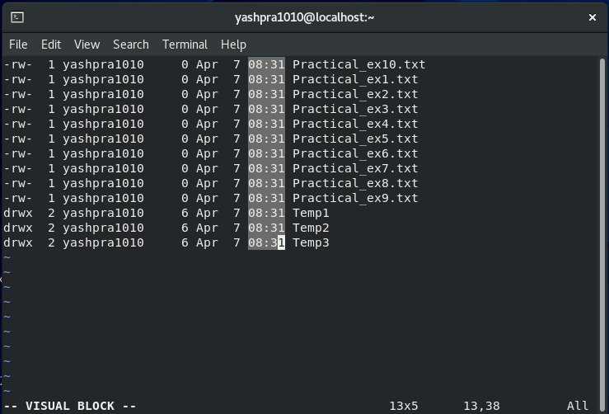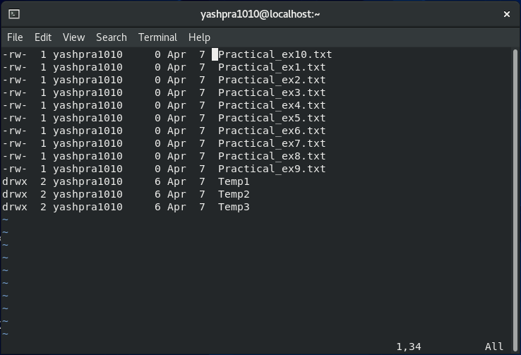

**9. Remove the Practical_ex10.txt and Temp3 rows using appropriate visual mode.**

***SOLUTION:***

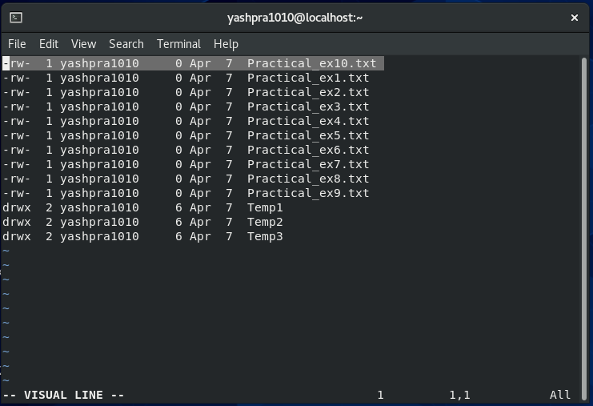

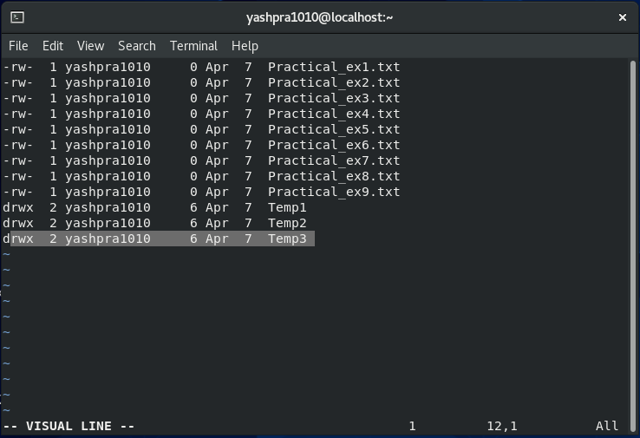

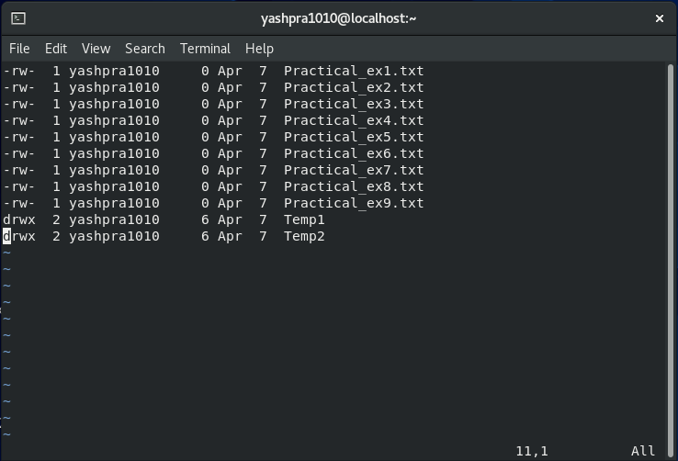

**-----------------------------------------------------------------------------------------------------------------------**

**10. Now he wants to save the changes and exit from the file. Also wants to keep a backup file of modified file, using the date (in seconds) to create a unique file name.**

***SOLUTION:***

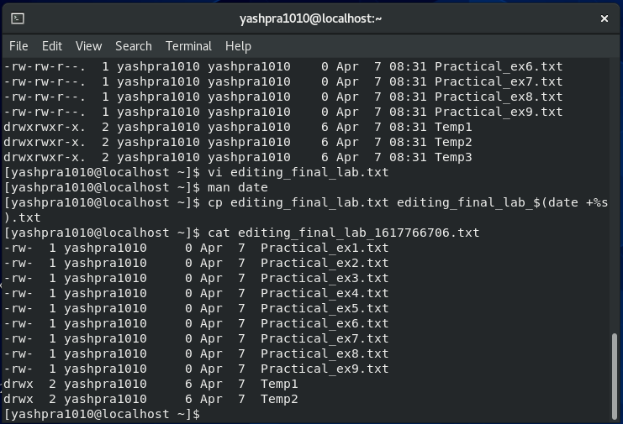

**11. He wants to append a dashed line into the file. The dashed line should contain at least 12 dashes.**

***SOLUTION:***

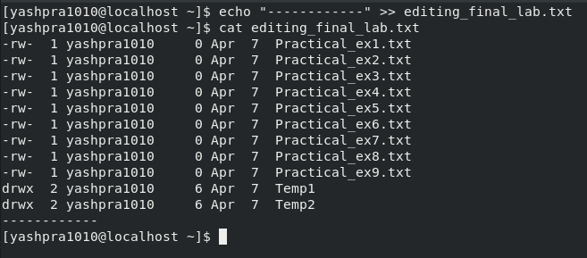

**-----------------------------------------------------------------------------------------------------------------------**

**12. Also need to append a directory listing of the Documents directory. List the directory listing on the terminal and send it to the editing_final_lab.txt file with one command line.**

***SOLUTION:***

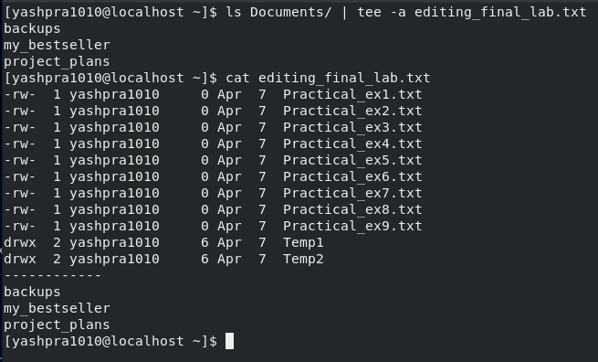

**13. Confirm that the directory listing is at the bottom of the lab file.**

***SOLUTION:***

