Institute of Computer Technology

B. Tech Computer Science and Engineering

Subject: BOSS (2CSE204)

**PRACTICAL-4**

**AIM: - To learn about managing local users and groups from the command line in Linux.**

**Commands:**

**useradd –** to add user

**usermod –** to do modification in user values

**userdel –** to delete user

**groupadd –** to add group

**groupdel –** to delete group

**chage –** to do modification in values of password

**Exercise:**

**Jakarta Pvt Ltd is an IT Company they are using Linus system for their work. They want to perform some operations as per below. Kindly refer it an provide appropriate solution for the same.**

**1. They want to set password for only 30 days for newly created accounts in their Linux. How they can set and ensure that newly created users have passwords that must be changed every 30 days.**

***CODE:*** vi /etc/login.defs

***ANSWER:***

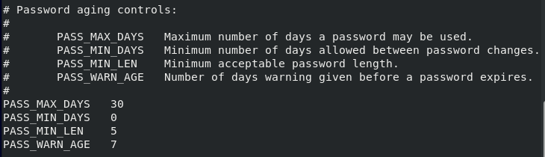

**2. Create the new group consultants with a GID of 35000.**

***ANSWER:***





**3. Configure administrative rights for all members of consultants to be able to execute any command as any user.**

***ANSWER:***

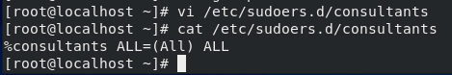

**4. Create the consultant1, consultant2, and consultant3 users with consultants as their supplementary group.**

***ANSWER:***

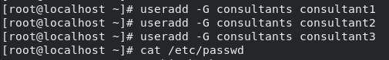



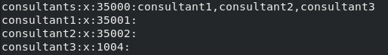

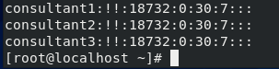

**5. Set the consultant1, consultant2, and consultant3 accounts to expire in 90 days from the current day.**

***ANSWER:***

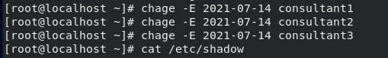

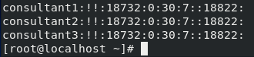

**6. Change the password policy for the consultant2 account to require a new password every 15 days.**

***ANSWER:***



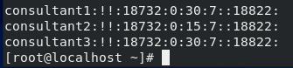

**7. Additionally, force the consultant1, consultant2, and consultant3 users to change their passwords on the first login.**

***ANSWER:***

