Institute of Computer Technology

B. Tech Computer Science and Engineering

Subject: BOSS (2CSE204)

**PRACTICAL-5**

**AIM: - To learn about controlling access to files in Linux.**

**Commands:**

umask – to controls how file permissions are set for newly created file

chown – to change the user or group ownership of file

chmod – to change user/group/others permission/values of file

**Exercise:**

* **Nishant wants to create directory techdocs and he wants to set permission as per his requirement for file and directory. Refer the below listed tasks and provide appropriate solution.**

**1. Create one group techdocs and three users tech1, tech2 & database1.**

***SOLUTION:***

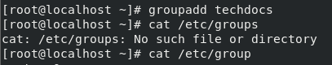

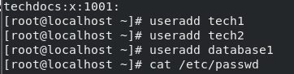

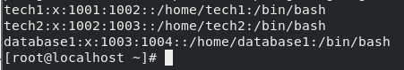

**2. Add techdocs group as supplementary group for users tech1 & tech2.**

***SOLUTION:***





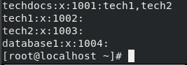

**3. He wants to create a directory called dtechdocs.**

***SOLUTION:***

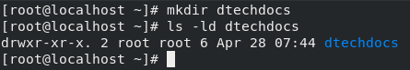

**4. Now, Change the group ownership of the dtechdocs directory to the techdocs group.**

***SOLUTION:***

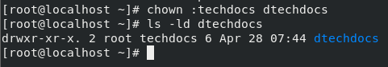

**5. Verify that users in the techdocs group can create and edit files in the dtechdocs directory.**

***SOLUTION:***

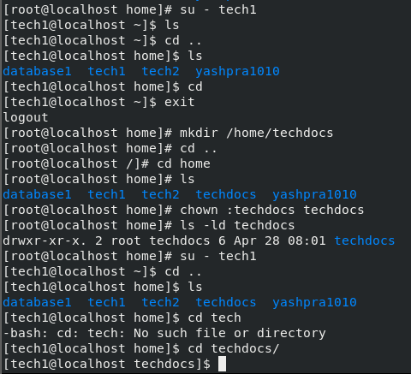

**6. Set permissions on the dtechdocs directory. On the dtechdocs directory, configure setgid (2), read/write/execute permissions (7) for the owner/user and group, and no permissions (0) for other users.**

***SOLUTION:***

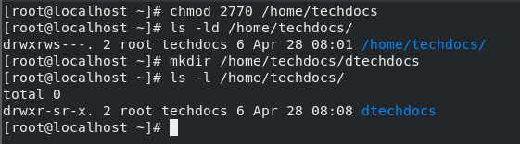

**7. Verify that the permissions are set properly.**

***SOLUTION:***

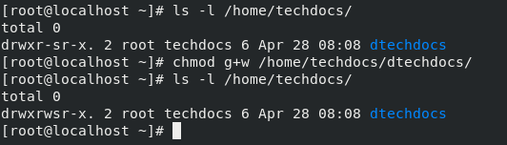

**8. Confirm that users in the techdocs group can now create and edit files in the dtechdocs directory. Users not in the techdocs group cannot edit or create files in the dtechdocs directory. Users tech1 and tech2 are in the techdocs group. User database1 is not in that group.**

***SOLUTION:***

