Institute of Computer Technology

B. Tech Computer Science and Engineering

Subject: BOSS (2CSE204)

**PRACTICAL-6**

**AIM: - To learn about monitoring and managing Linux processes.**

**Commands:**

1. **top –** It is used to show the processes in linux.
2. **ps –** It is used to show information of running processes in linux.
3. **kill –** It is used to kill/terminate the process in linux.
4. **pkill -** It is used to kill/terminate the process using process name in linux.
5. **jobs –** It is used to list the running jobs in linux.
6. **fg –** It changes the process to foreground environment.
7. **bg –** It is used to place foreground processes to background.

**Exercise:**

**1. Create new user student and set password “student123”.**

***SOLUTION:***

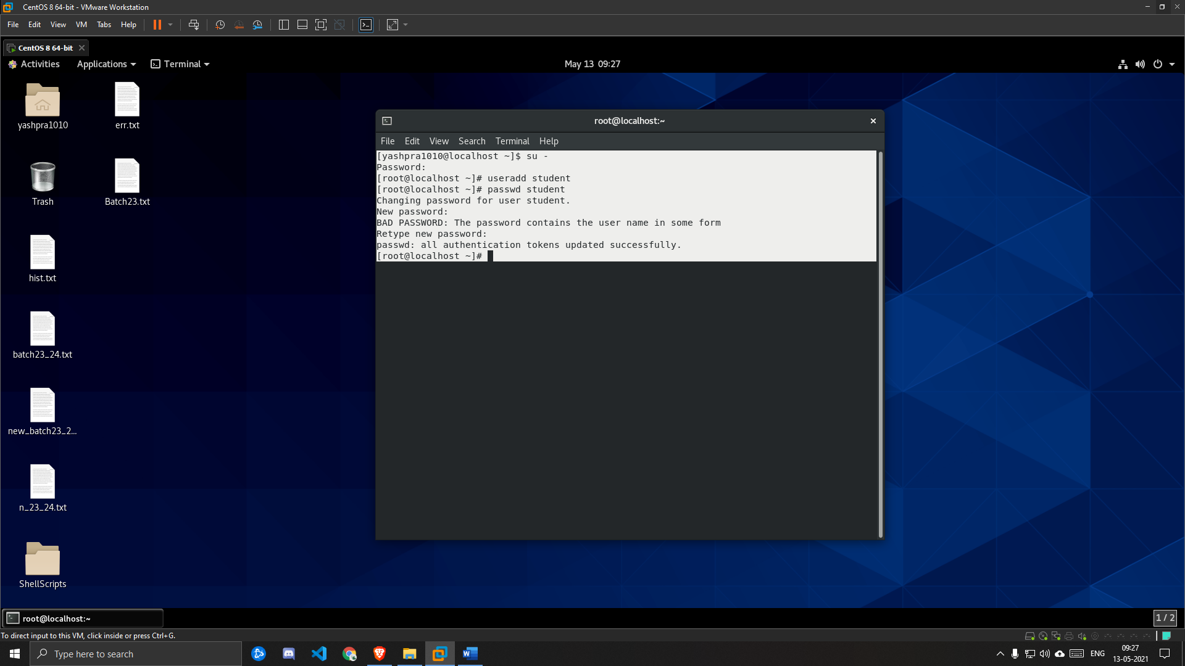

**2. Switch to student user. Open two terminal windows side by side. In this section, these terminals are referred to as left and right. Create a script called process101, which will generate artificial CPU load. Create the script in the /home/student/bin directory.**



***SOLUTION:***

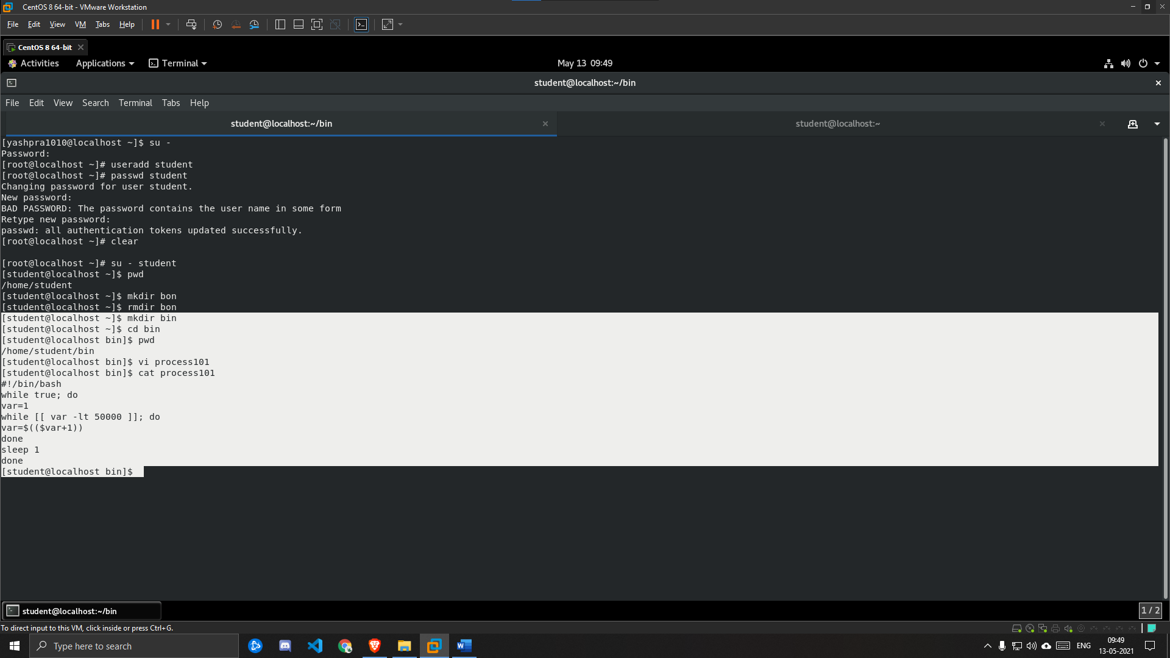

**3. In the right window, run the top utility.**

***SOLUTION:***

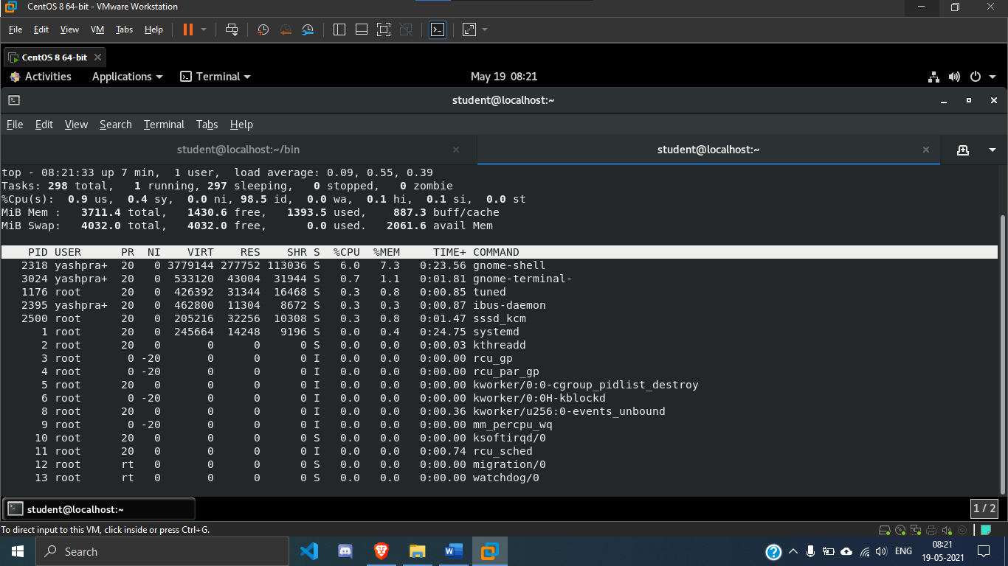

**4. In the left terminal shell, determine the number of logical CPUs on the virtual machine. Run the process101 script in the background.**

***SOLUTION:***

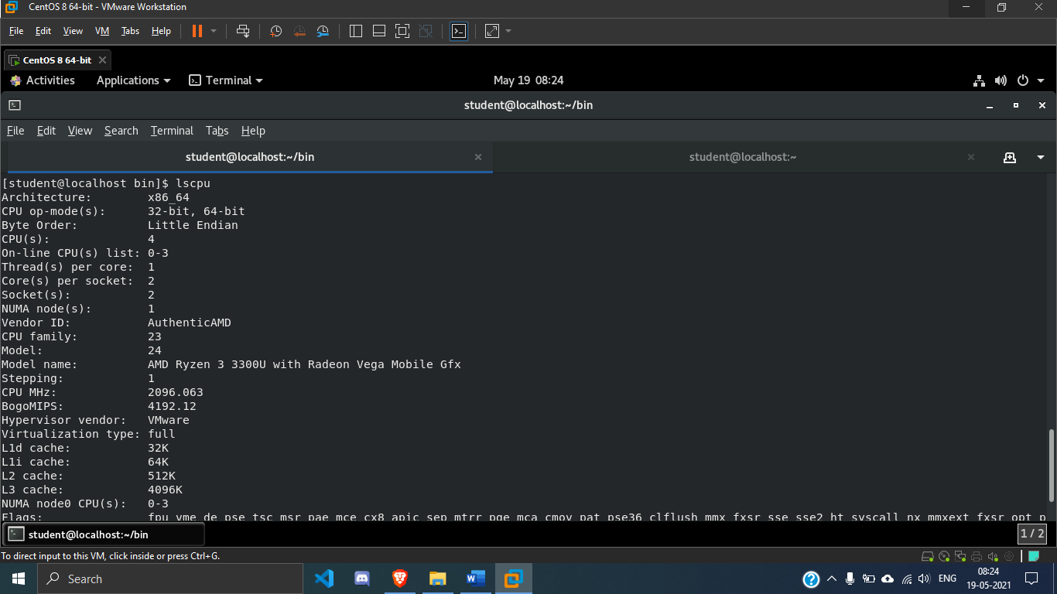

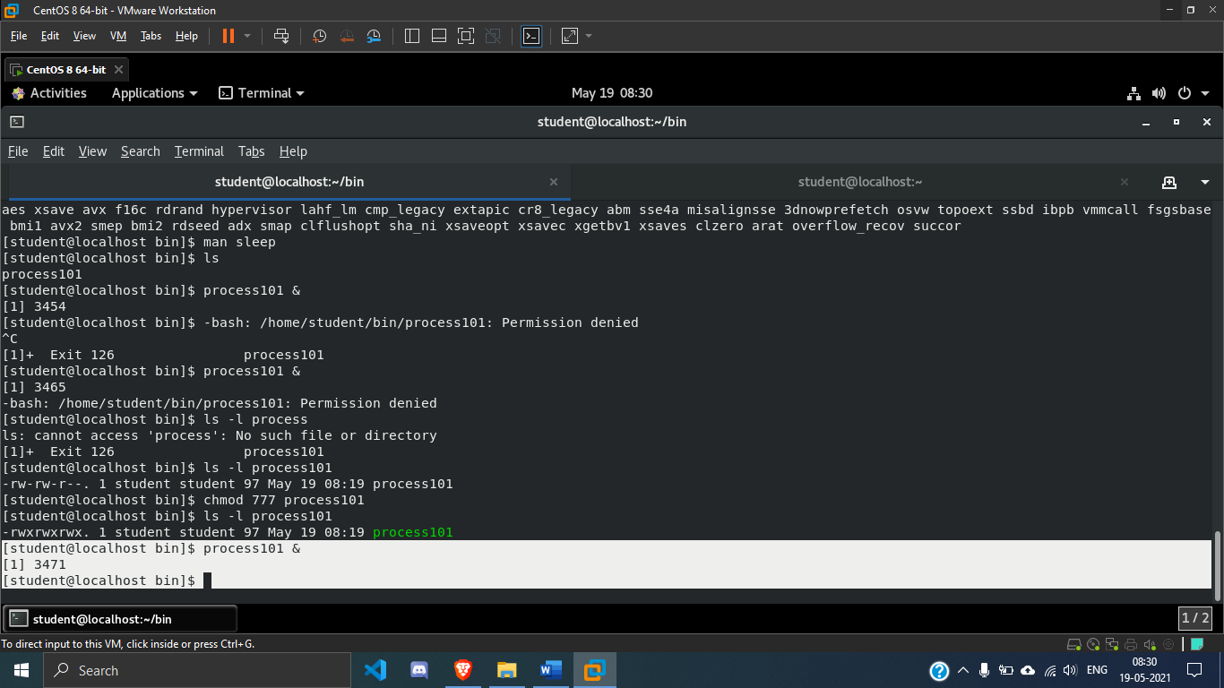

**5. In the right terminal shell, observe the top display, running tasks & CPU load.**

***SOLUTION:***

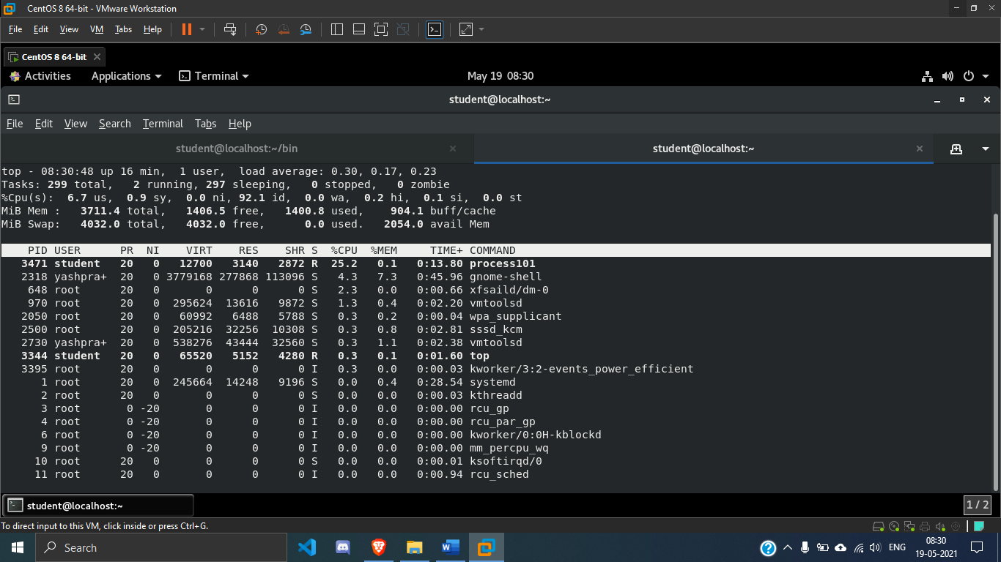

**6. Copy the process101 script to a new file called process102. Edit the script to create more artificial CPU load. Increase the load from fifty thousand to one hundred thousand. Start the process102 process in the background.**

***SOLUTION:***

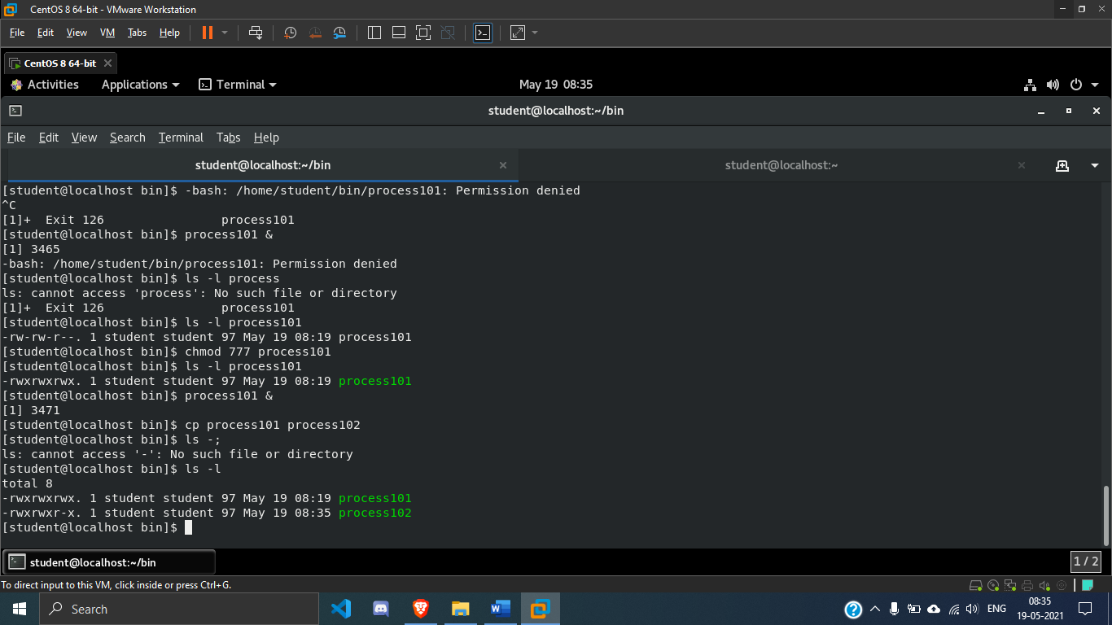

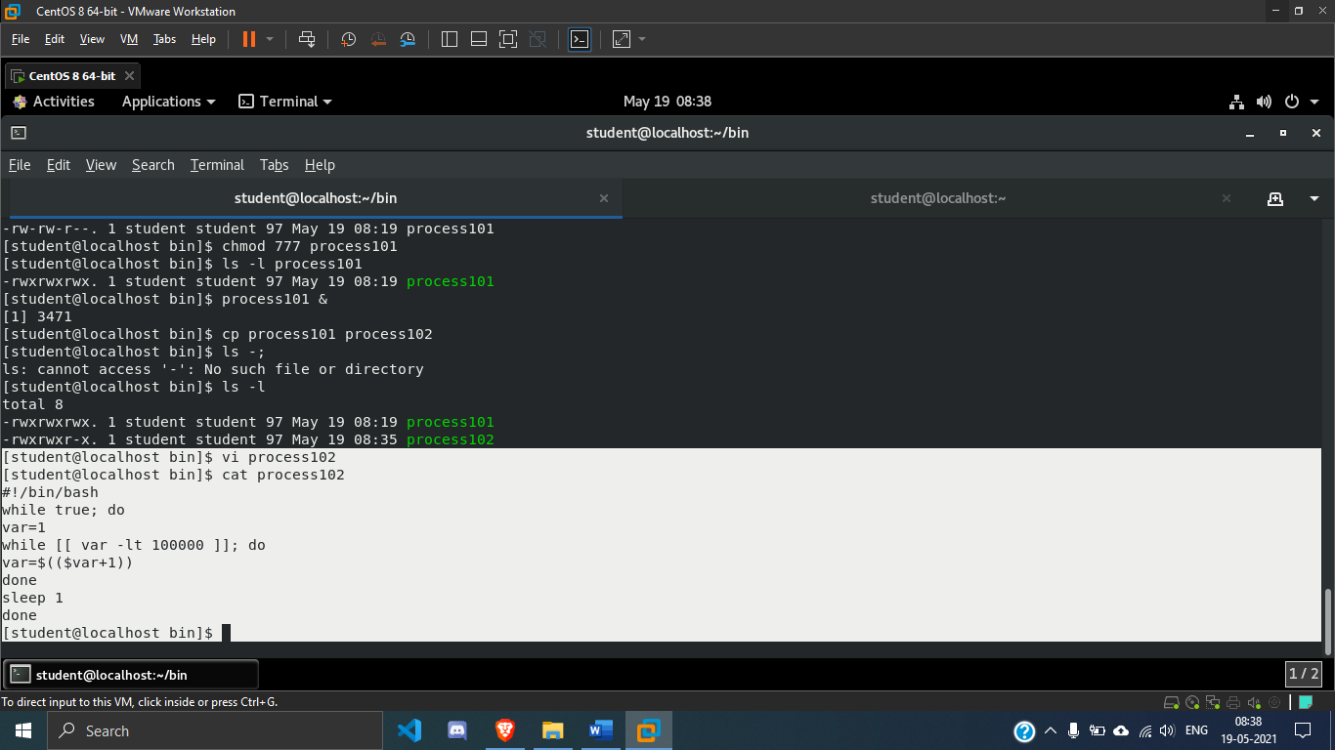

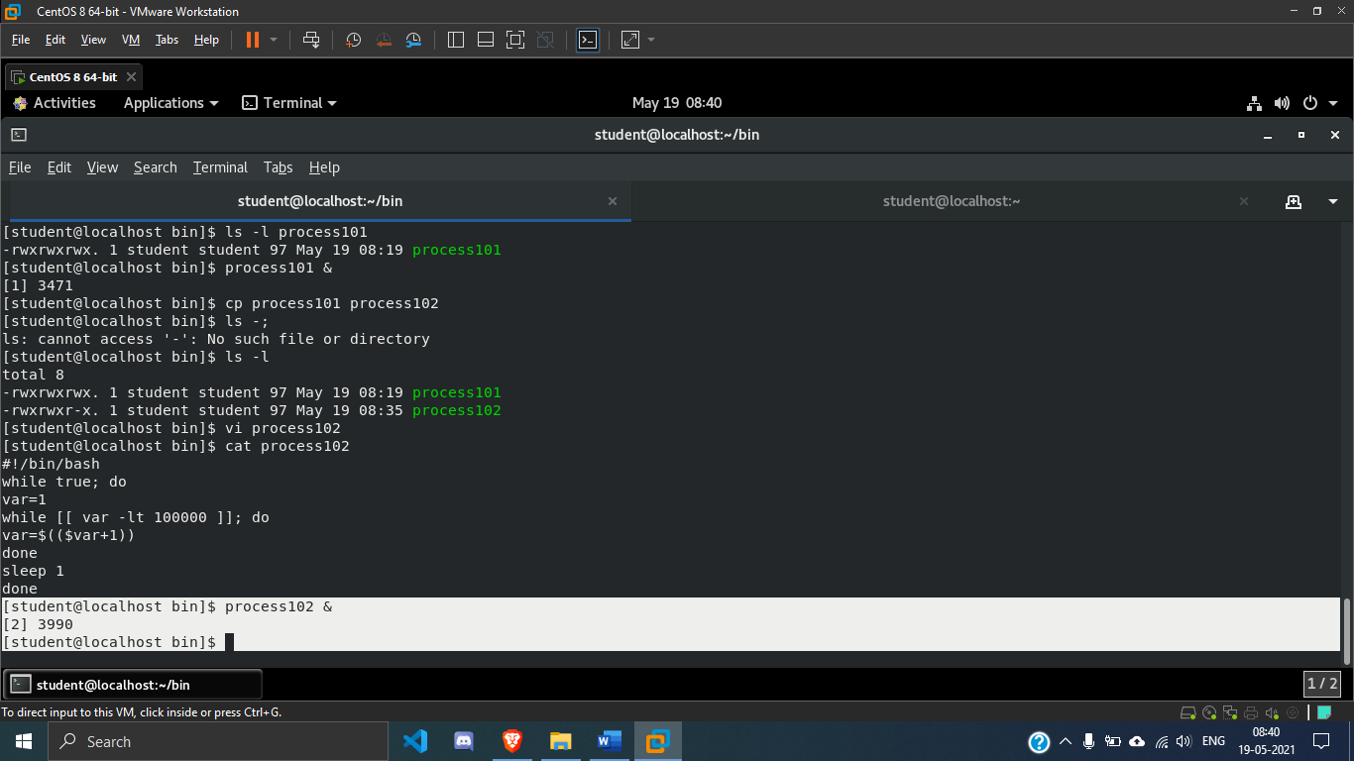

**7. In the right terminal shell, confirm that the process is running and using the most CPU resources.**

***SOLUTION:***

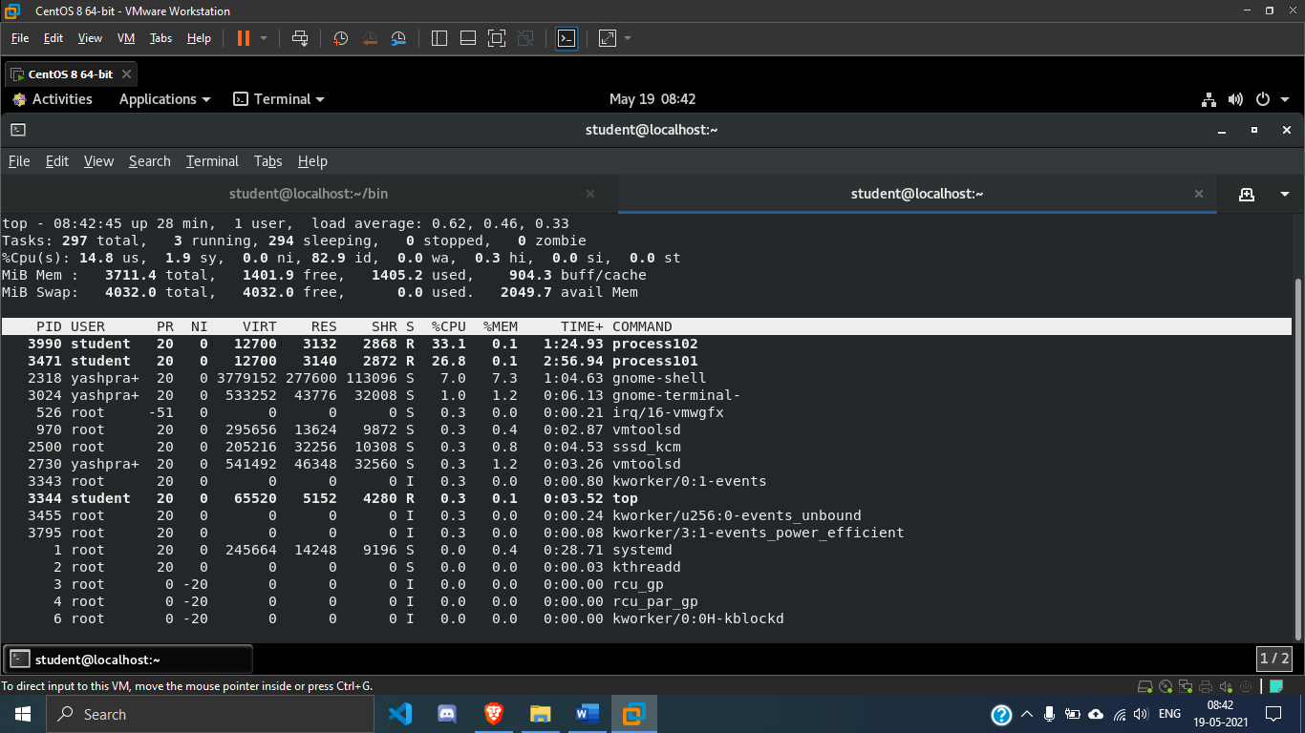

**8. Copy process101 to a new script called process103. Increase the addition count to eight hundred thousand. Start process103 in the background. Confirm that the load average is above 1. It may take a few minutes for the load average to change.**

***SOLUTION:***

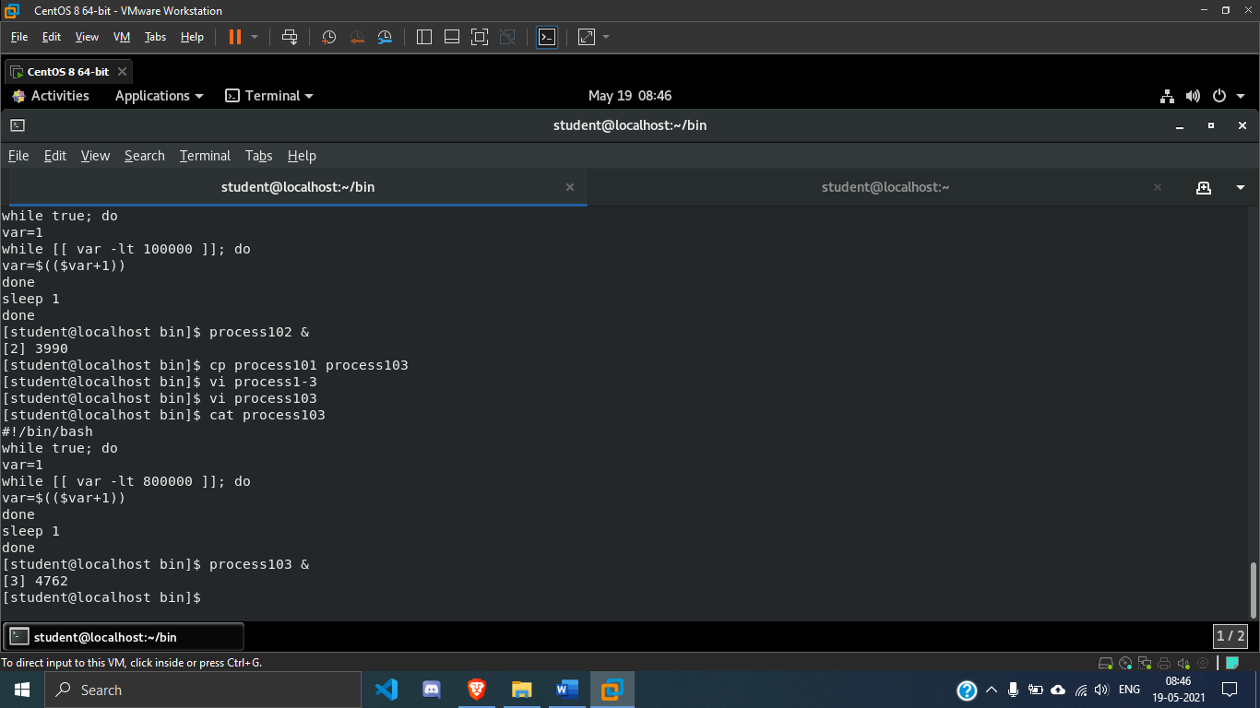

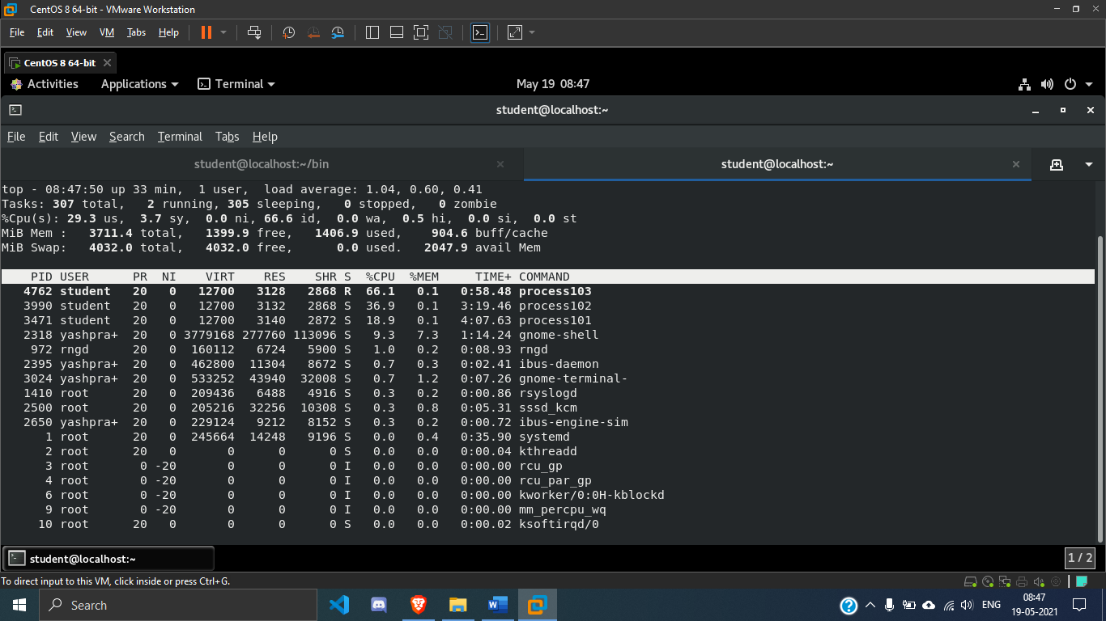

**9. In the left terminal shell, become root. Suspend the process101 process. List the remaining jobs. Observe that the process state for process101 is now T.**

***SOLUTION:***

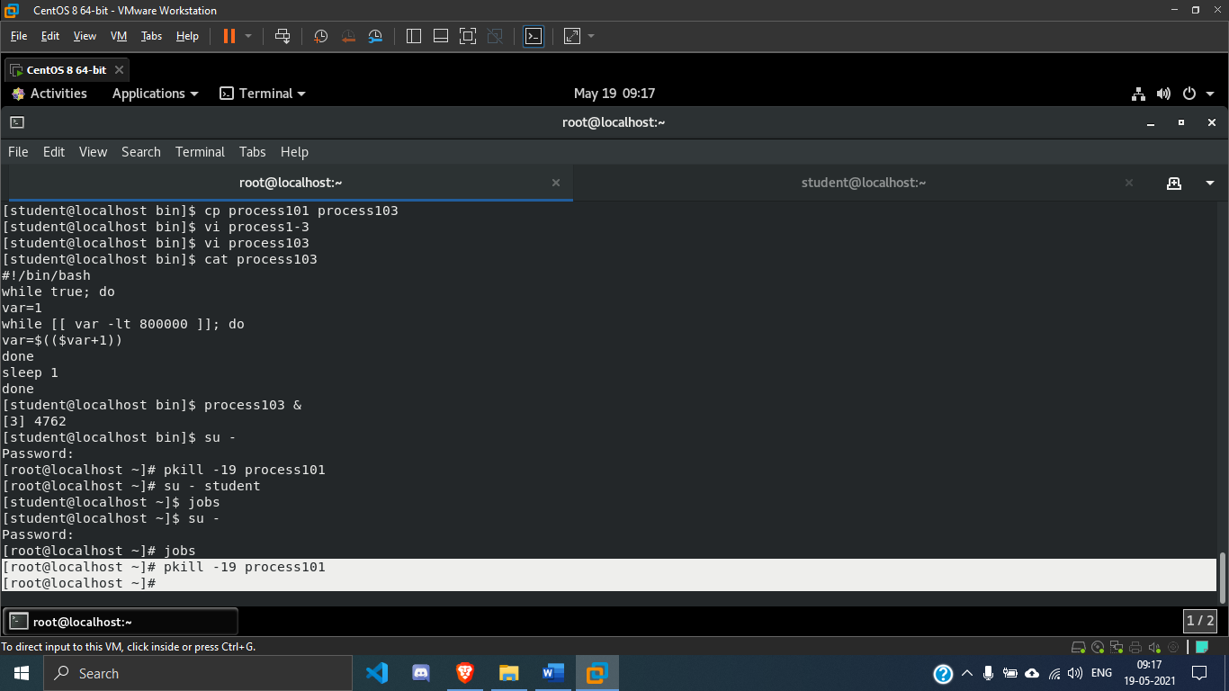

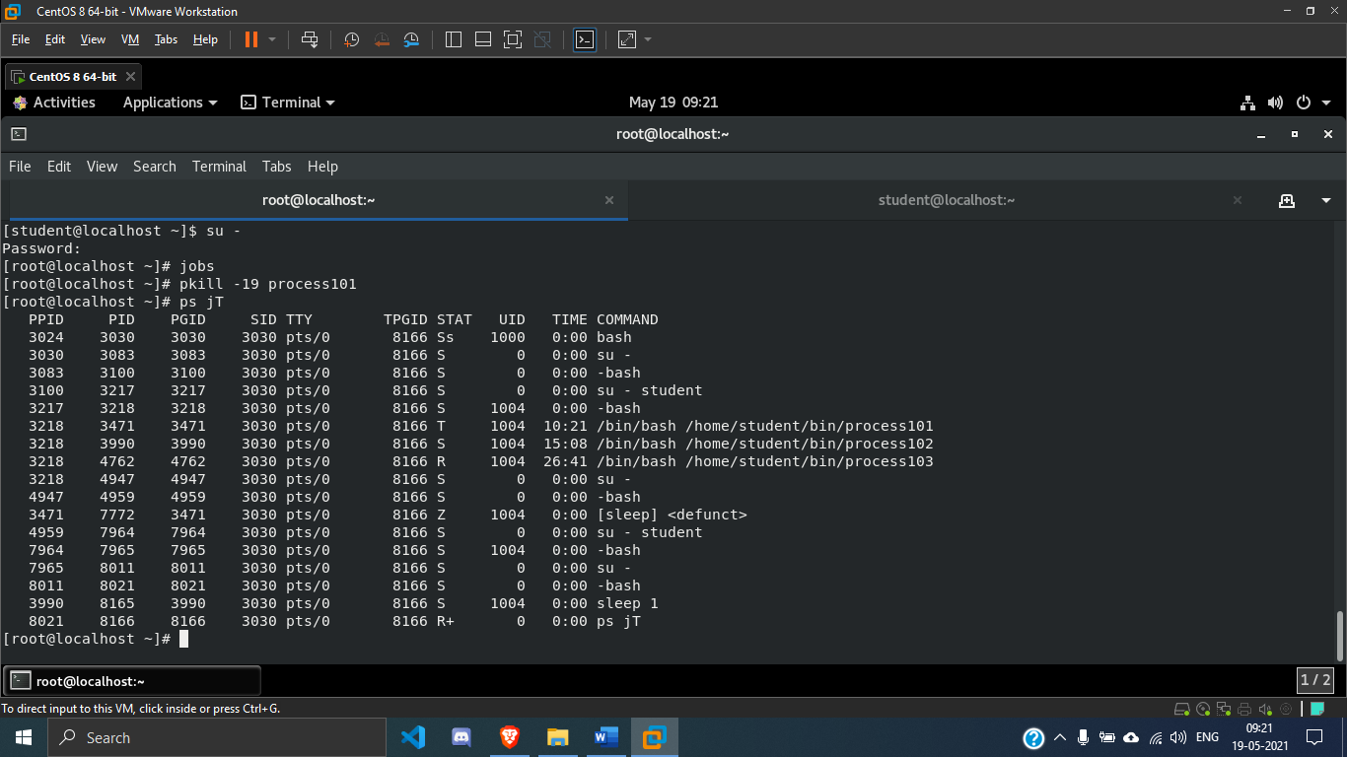

**10. Resume the process101 process.**

***SOLUTION:***

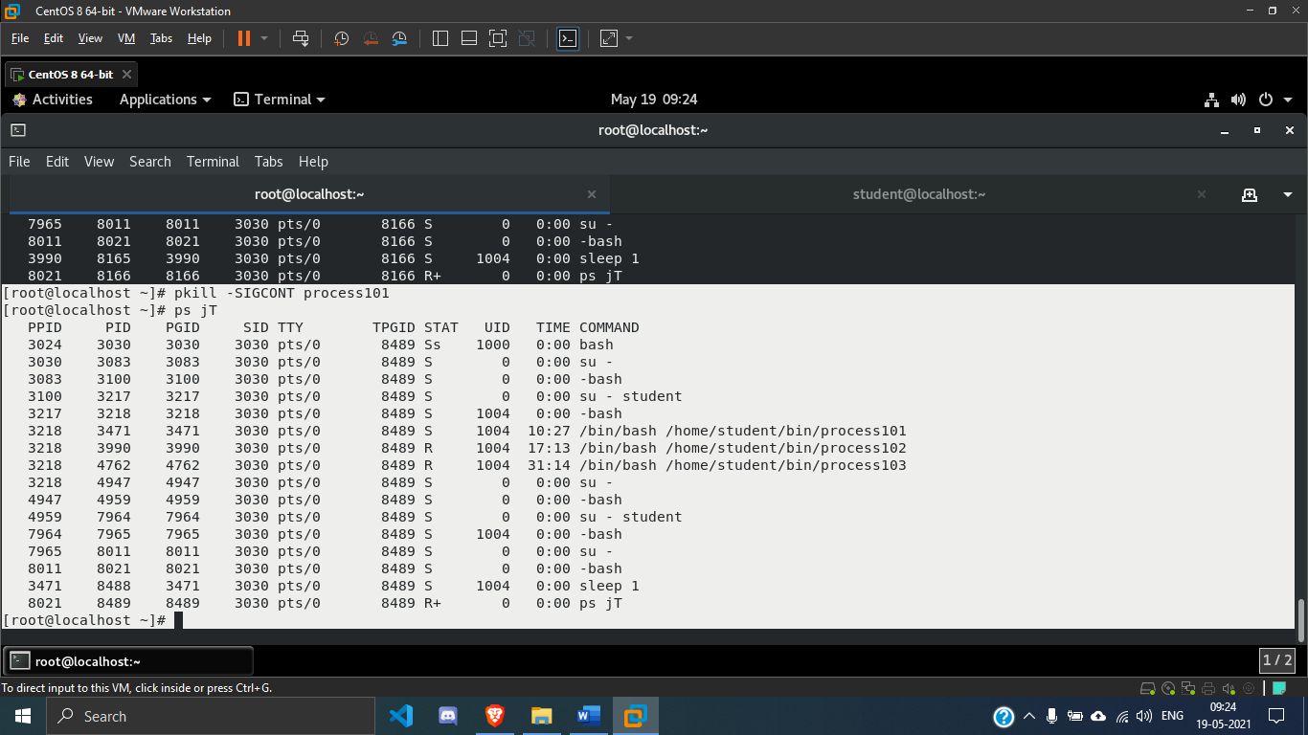

**11. Terminate process101, process102, and process103 using the command line. Confirm that the processes no longer display in top.**

***SOLUTION:***

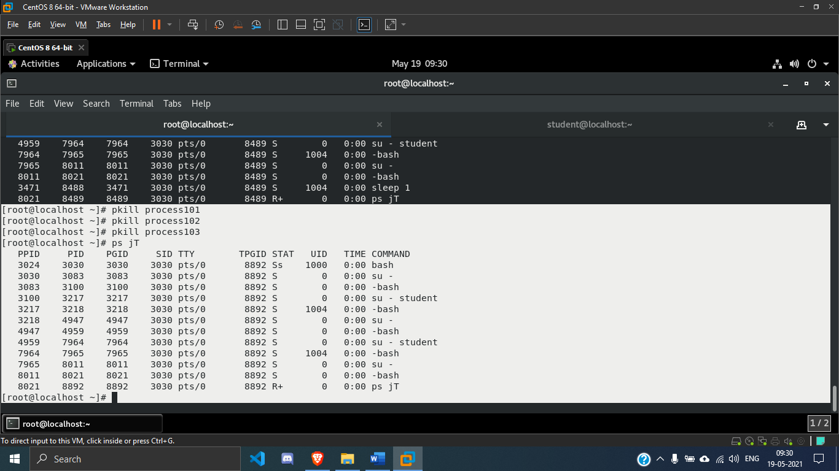

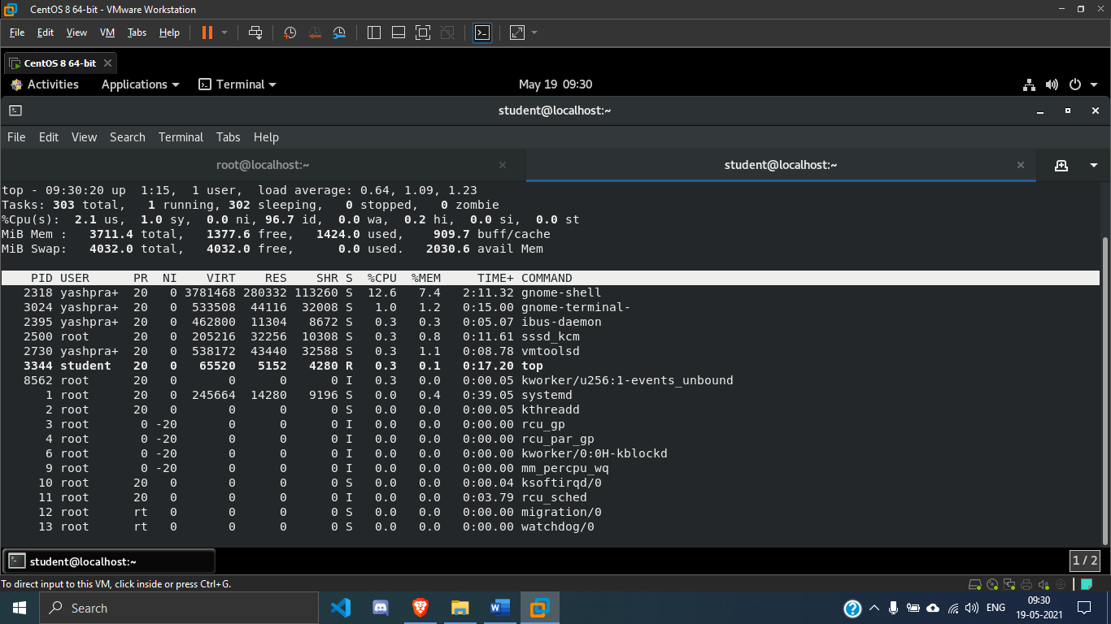

**12. In the left terminal shell, exit from the root user. In the right terminal shell stop the top command.**

***SOLUTION:***

