Institute of Computer Technology

B. Tech Computer Science and Engineering

Subject: BOSS (2CSE204)

**PRACTICAL-7**

**AIM: - To learn about controlling Services and Daemons in linux.**

***Commands***

**Systemctl –** It is used to manage services and controlling it in linux.

**Exercise:**

**1. Switch to root user, Start the psacct service.**

***SOLUTION***

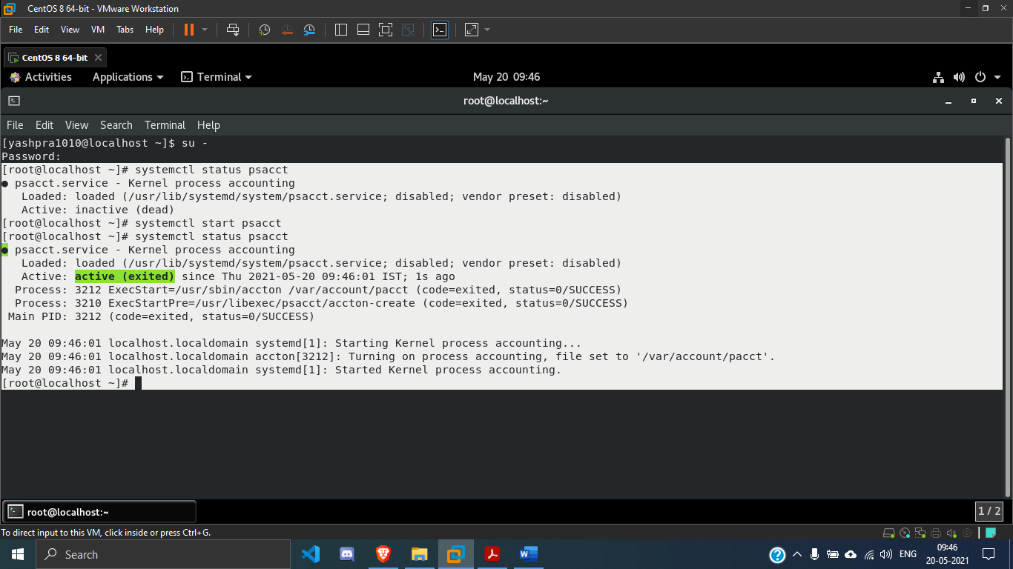

**2. Configure the psacct service to start at system boot.**

***SOLUTION***

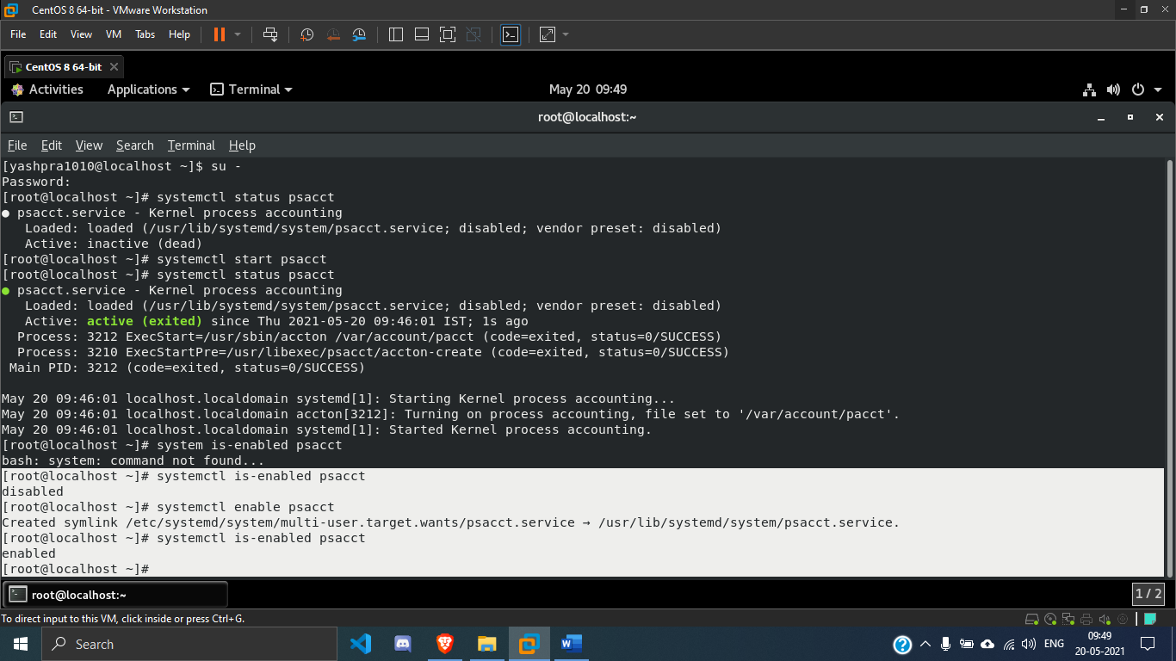

**3. Stop the rsyslog service.**

***SOLUTION***

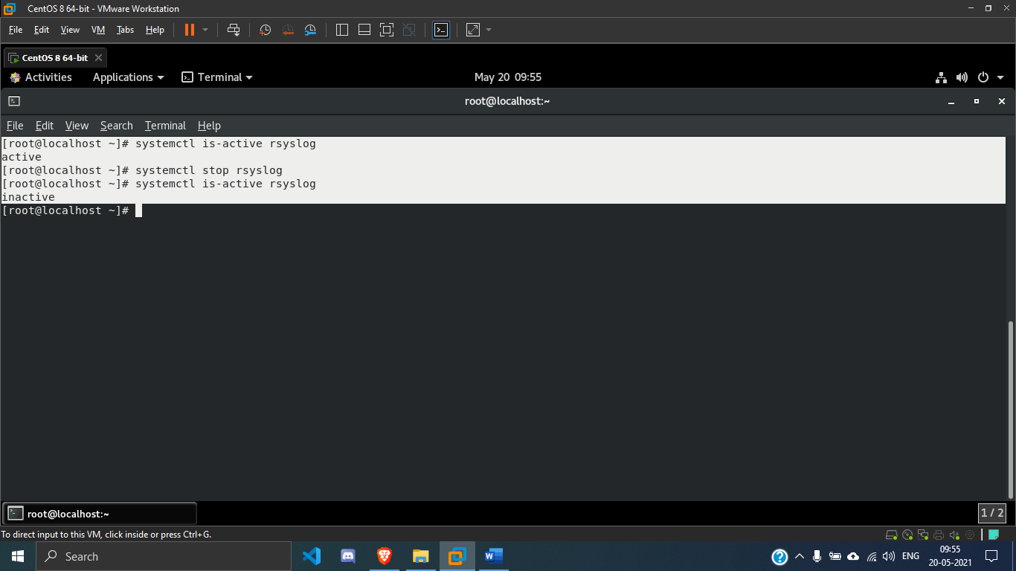

**4. Configure the rsyslog service so that it does not start at system boot.**

***SOLUTION***

