Institute of Computer Technology

B. Tech Computer Science and Engineering

Subject: BOSS (2CSE204)

**PRACTICAL-8**

**AIM: - To learn about configuring and securing SSH in linux.**

**Commands:**

* **ssh user@remotehost –** This command is used to create remote connections on remote users.
* **ssh-keygen –** To create public keygen of localhost.
* **ssh-copy-id –** To share public keygen to remote user.

**Exercise:**

**1. Create two users student and student1. Set their passwords “student123”.**

***SOLUTION***

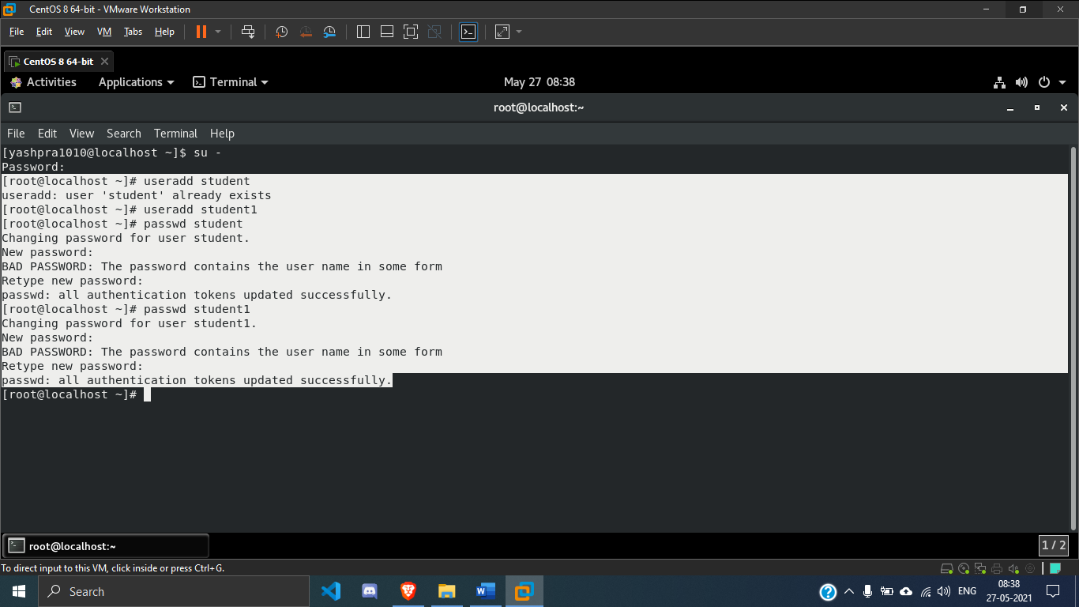

**2. Open an SSH session to localhost as student.**

***SOLUTION***

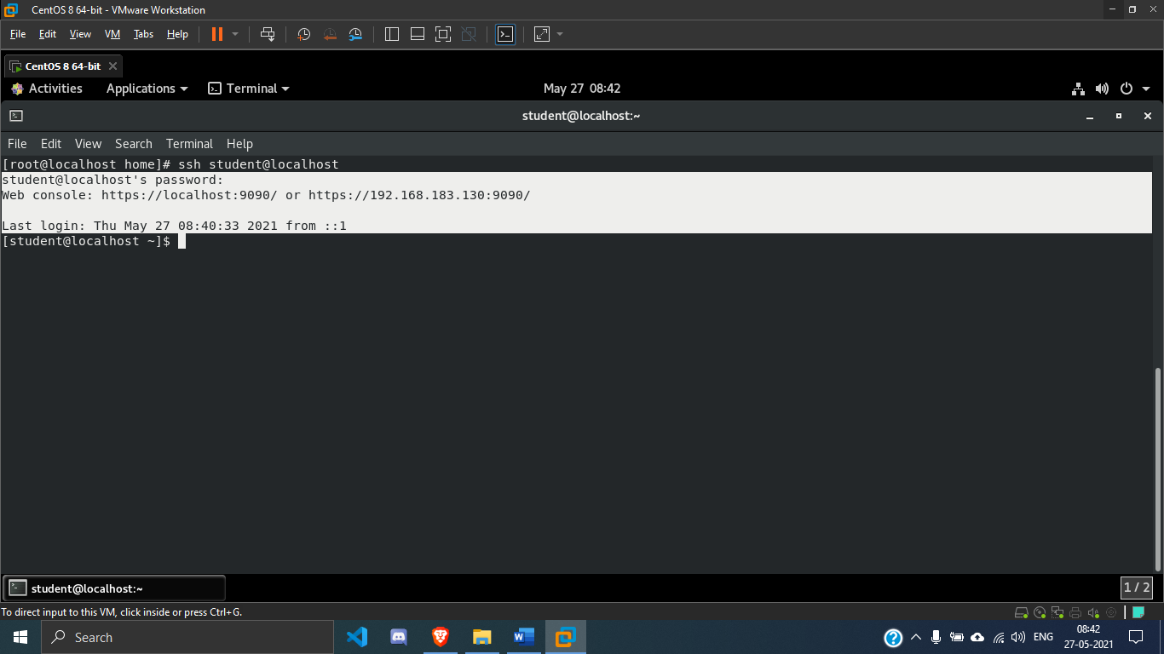

**3. Use the ssh-keygen command to generate SSH keys for student on localhost.**

***SOLUTION***

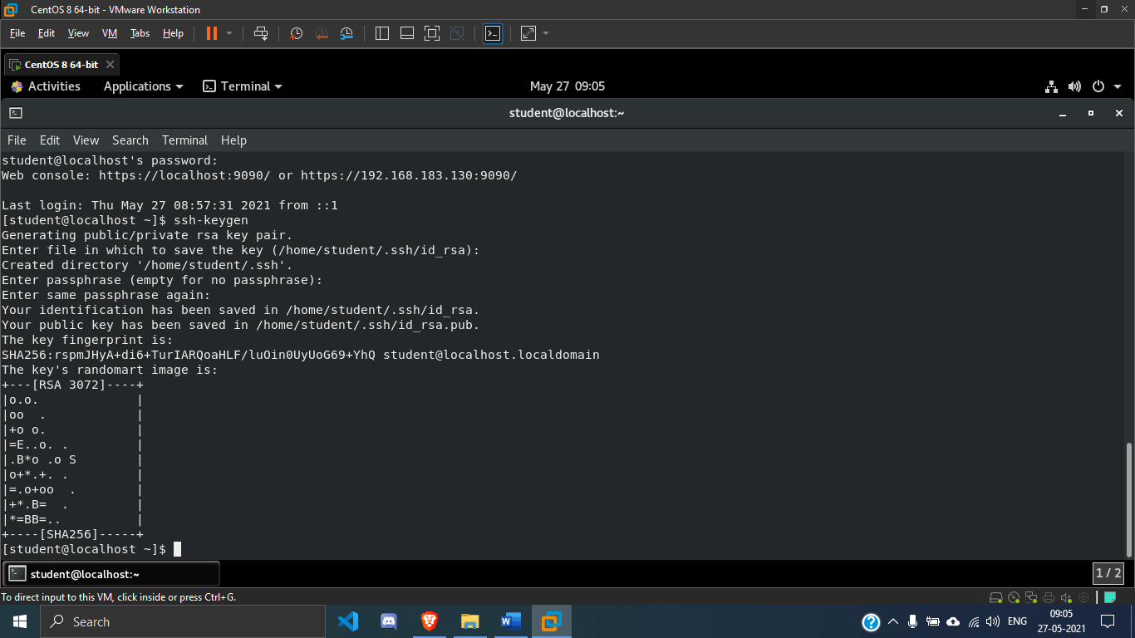

**4. Use the ssh-copy-id command to send the public key of the SSH key pair to student1 on localhost.**

***SOLUTION***

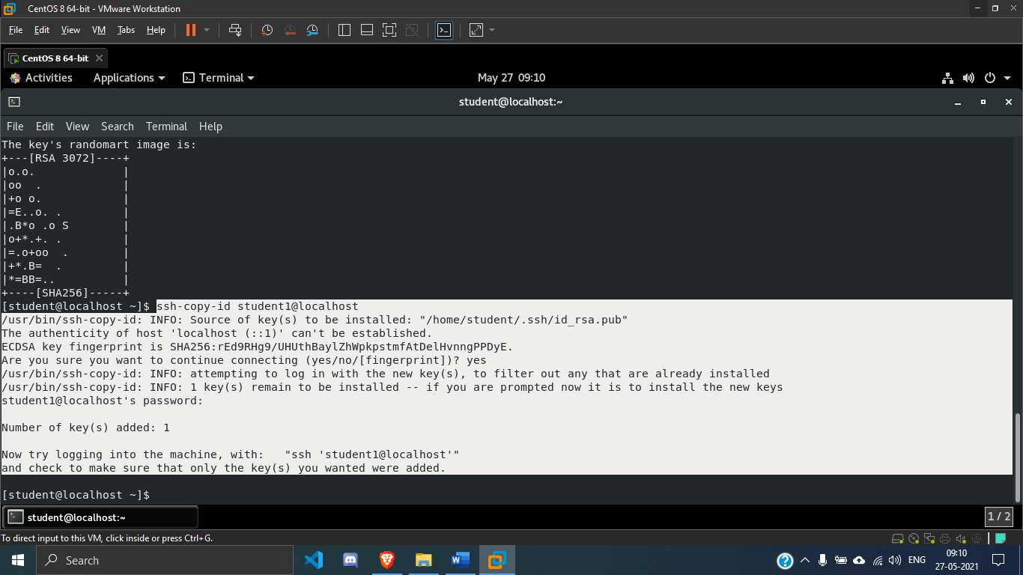

**5. Confirm that student can successfully log in to student1 using the SSH keys.**

***SOLUTION***

