Institute of Computer Technology

B. Tech Computer Science and Engineering

Subject: ESFP-II (2CSE203)

**PRACTICAL-10**

**AIM: - To learn about Strings and Strings functions in C++.**

**1. Sanju wants to write a C++ program to check whether two characters present equally in a given string.**

**Example: 2 Characters are a,e**

**Input: aabcdeef**

**Output: True**

***CODE:***

#include <iostream>

#include <cstring>

using namespace std;

int main()

{

int charA=0;

int charB=0;

char arr[20];

char char1;

char char2;

cout<<"Enter any string: ";

cin>>arr;

cout<<"Enter 1st character: ";

cin>>char1;

cout<<"Enter 2nd character: ";

cin>>char2;

for (int i = 0; i < 20; i++)

{

if (arr[i] == char1)

{

charA++;

}

if (arr[i] == char2)

{

charB++;

}

}

if (charA == charB)

{

cout<<"\nTrue";

}

else

{

cout<<"\nFalse";

}

return 0;

}

***OUTPUT:***

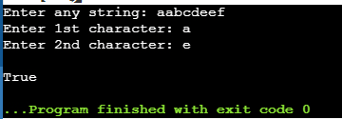

**2. A teacher has decided to make a c++ program to insert a dash character (-) between two odd numbers in a given string of numbers.**

**Example:**

**Sample Input: 1345789**

**Sample Output: Result-> 1-345-789**

***CODE:***

#include <iostream>

#include <cstring>

using namespace std;

int main()

{

string numbStr;

cout<<"\nEnter any number: ";

cin>>numbStr;

for (int i = 0; i < numbStr.length(); i++)

{

if ((numbStr[i] == '1' || numbStr[i] == '3' || numbStr[i] == '5' || numbStr[i] == '7' || numbStr[i] == '9') && (numbStr[i + 1] == '1' || numbStr[i + 1] == '3' || numbStr[i + 1] == '5' || numbStr[i + 1] == '7' || numbStr[i + 1] == '9'))

{

numbStr.insert(i+1,"-"); numbStr = numbStr;

}

}

cout<<"\nResult -> "<<numbStr<<endl;

return 0;

}

***OUTPUT:***

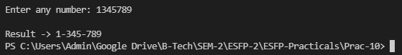

**3. Write a program that takes your full name as input and displays the abbreviations of the first name, middle names and the last name in UPPERCASE only.**

**Expected input-Sachin Ramesh Tendulkar**

**Expected output-S R T**

***CODE:***

#include <iostream>

#include <cstring>

using namespace std;

int main()

{

char name[50];

cout<<"\nEnter your name: ";

cin.getline(name,50);

name[0]=toupper(name[0]);

cout<<name[0]<<" ";

for (int i = 0; i < strlen(name); i++)

{

if (name[i] == ' ')

{

cout<<(char) toupper(name[i+1])<<" ";

}

}

return 0;

}

***OUTPUT:***

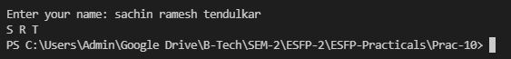

**Post Practical Task**

**1. Write an efficient program in C++ to check if two String is an anagram of each other. An anagram contains are of the same length and contains the same character, but in a different order, for example, "Army" and "Mary" is the anagram. Your program should return true if both Strings are the anagram, false otherwise.**

***CODE:***

#include <bits/stdc++.h>

using namespace std;

bool Anagram(string str1, string str2)

{

int n1 = str1.length();

int n2 = str2.length();

if (n1 != n2)

{

return false;

}

sort(str1.begin(), str1.end());

sort(str2.begin(), str2.end());

if(str1.compare(str2))

{

return true;

}

return true;

}

int main()

{

string str1;

string str2;

cout<<"\nEnter first word: ";

cin>>str1;

cout<<"\nEnter second word: ";

cin>>str2;

if (Anagram(str1, str2))

{

cout << "\nTrue";

}

else

{

cout << "\nFalse";

}

return 0;

}

***OUTPUT:***

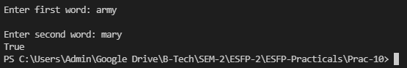

**2. What will be the output of the following C++ code?**

**#include <iostream>**

**#include <cstring>**

**using namespace std;**

**int main () {**

**char str1[10] = "Hello";**

**char str2[10] = "World";**

**char str3[10];**

**int len ;**

**strcpy( str3, str1);**

**strcat( str1, str2);**

**len = strlen(str1);**

**cout << len << endl;**

**return 0;**

**}**

a) 5

b) 55

c) 11

***d) 10***

***OUTPUT:***

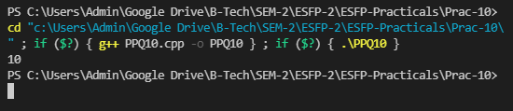

**3. What will be the output of the following C++ code?**

**#include <iostream> #include <string> using namespace std; int main () { string str ("nobody does like this"); string key ("nobody"); size_t f; f = str.rfind(key); if (f != string::npos) str.replace (f, key.length(), "everybody"); cout << str << endl; return 0; }**

a) nobody does like this

b) nobody

c) everybody

***d) everybody does like this***

***OUTPUT:***



**4. What will be the output of the following C++ code?**

**#include <iostream>**

**#include <string>**

**using namespace std;**

**int main() {**

**string str {"Steve jobs"};**

**cout << str.capacity() << "\n"; return 0;**

**}**

a) 9

***b) 10***

c) 11

d) Not Fix

***OUTPUT:***

