Institute of Computer Technology

B. Tech Computer Science and Engineering

Subject: ESFP-II (2CSE203)

**PRACTICAL-11**

**AIM: - To learn about File Management in C++.**

**1. Make a menu driven program to scan, append, modify and view Employee records of a Binary file as follows:**

**Choose your choice**

**NOTE: one choice for one record(except viewing data)**

**1. Scanning initial records**

**2. Appending records**

**3. Modifying or append records**

**4. Viewing records**

**5. Exit**

***CODE:***

#include <iostream>

#include <fstream>

static int totrec=0;

using namespace std;

void getDATA()

{

char name[20];

int age;

char lang[20];

ofstream outfile;

outfile.open("p11o1",ios::out);

cout<<"\n\nPlease enter the details as per demand: -";

cout<<"\nEnter name: ";

cin>>name;

outfile<<name<<endl;

cout<<"\nEnter age: ";

cin>>age;

outfile<<age<<endl;

cout<<"\nEnter preferred language: ";

cin>>lang;

outfile<<lang<<endl;

totrec=totrec+1;

outfile.close();

}

void append()

{

char name[20];

int age;

char lang[20];

ofstream outfile;

outfile.open("p11o1",ios::app);

cout<<"\n\nPlease enter the details as per demand: -";

cout<<"\nEnter name: ";

cin>>name;

outfile<<name<<endl;

cout<<"\nEnter age: ";

cin>>age;

outfile<<age<<endl;

cout<<"\nEnter preferred language: ";

cin>>lang;

outfile<<lang<<endl;

totrec=totrec+1;

outfile.close();

}

void modify()

{

char name[20];

int age;

char lang[20];

ofstream outfile;

outfile.open("p11o1",ios::ate);

cout<<"\n\nPlease enter the details as per demand: -";

cout<<"\nEnter name: ";

cin>>name;

outfile<<name<<endl;

cout<<"\nEnter age: ";

cin>>age;

outfile<<age<<endl;

cout<<"\nEnter preferred language: ";

cin>>lang;

outfile<<lang<<endl;

totrec=totrec+1;

outfile.close();

}

void showDATA()

{

ifstream infile;

infile.open("p11o1",ios::in);

const int size=80;

char line[size];

int counter=totrec;

while(counter > 0)

{

infile.getline(line,size);

cout<<"\n\nNAME : "<<line<<endl;

infile.getline(line,size);

cout<<"AGE : "<<line<<endl;

infile.getline(line,size);

cout<<"LANGUAGE : "<<line<<endl;

counter--;

}

infile.close();

}

int main()

{

while (totrec>=0)

{

int choice;

cout<<"\nChoose your choice: ";

cout<<"\n1. Scanning initial records";

cout<<"\n2. Appending records";

cout<<"\n3. Modifying or append records";

cout<<"\n4. Viewing records";

cout<<"\n5. Exit";

cout<<"\n\nEnter your choice: ";

cin>>choice;

switch (choice)

{

case 1:

getDATA();

break;

case 2:

append();

break;

case 3:

modify();

break;

case 4:

showDATA();

break;

case 5:

return 0;

break;

default:

cout<<"ERROR!";

return 0;

break;

}

}

return 0;

}

***OUTPUT:***

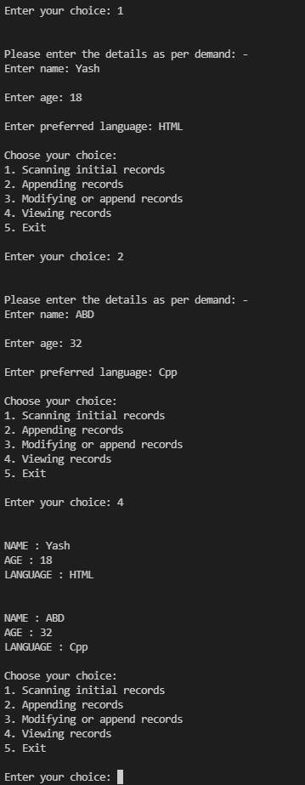

**2. A program to create a file which has information Name, Account number, Balance and perform following operations:**

**a. Add record**

**b. Display content of file**

**c. Display name of person having balance > 10,000.**

***CODE:***

#include<iostream>

#include<stdio.h>

#include<string.h>

#include<cstdlib>

using namespace std;

struct Person

{

char name[20];

int accno;

float balance;

};

int main()

{

struct Person p;

FILE *fp;

char c;

int ch;

while(1)

{

cout<<"\n\n 1. Add Records in the File";

cout<<"\n 2. Display Content of File";

cout<<"\n 3. Display Name of Person whose Balance is Greater than 10,000";

cout<<"\n 4. Exit";

cout<<"\n\n Enter Your Choice : ";

cin>>ch;

switch(ch)

{

case 1:

fp=fopen("person.txt","ab");

while (1)

{

cout<<"\n Enter Person Name : ";

cin>>p.name;

fflush(stdin);

cout<<"\n Enter Account No. : ";

cin>>p.accno;

fflush(stdin);

cout<<"\n Enter Balance : ";

cin>>p.balance;

fflush(stdin);

fwrite(&p,sizeof(p),1,fp);

fflush(stdin);

cout<<"\n\n Do You Want to Continue?(Y/N) : ";

cin>>c;

if(c=='n' || c=='N')

break;

}

fclose(fp);

break;

case 2:

fp=fopen("person.txt","rb");

while (fread(&p,sizeof(p),1,fp))

{

while(1)

{

cout<<"\n Account No : "<<p.accno;

cout<<"\n Name : "<<p.name;

cout<<"\n Balance : "<<p.balance<<endl;

break;

}

}

fclose(fp);

break;

case 3:

fp=fopen("person.txt","rb");

while(fread(&p,sizeof(p),1,fp))

{

if(p.balance>10000)

{

while(1)

{

cout<<"====================";

cout<<"\n Account No : "<<p.accno;

cout<<"\n Name : "<<p.name;

cout<<"\n Balance : "<<p.balance<<endl;

break;

}

}

}

fclose(fp);

break;

case 4:

exit(0);

default:

cout<<"\n Invalid Choice";

}

}

return 0;

}

***OUTPUT:***

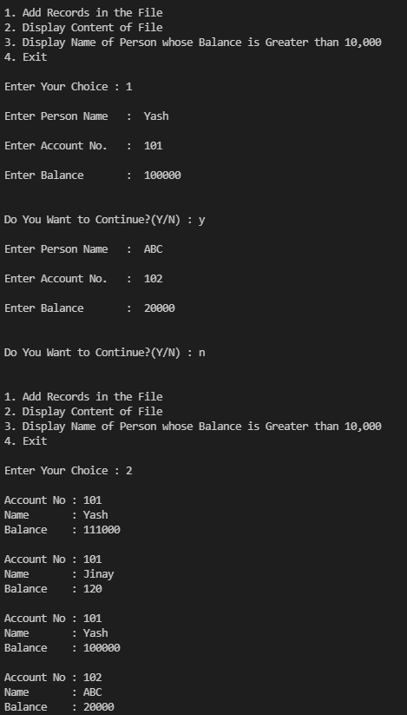

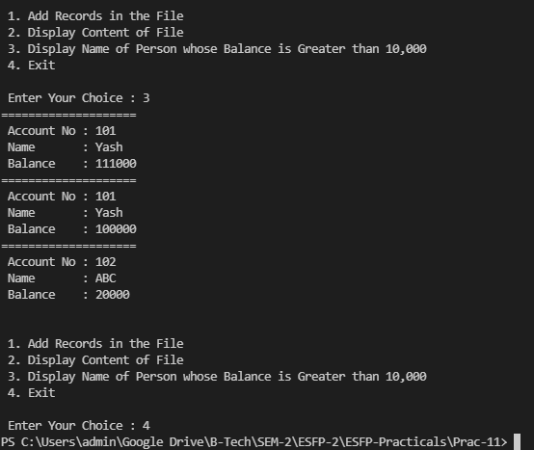

**Post Practical Task**

**1. Write a Menu driven telephone directory program (Binary File handling) having**

**following:**

**\*\*\*\*\*Phone Book\*\*\*\*\***

**1) Add New Record**

**2) Display All Records**

**3) Search Telephone No.**

**4) Search Person Name**

**5) Update Telephone No.**

**6) Exit**

***CODE:***

#include<iostream>

#include<fstream>

#include<string.h>

using namespace std;

class A{

public:

long long int num;

char name[20];

};

fstream fp;

A st;

void first(){

fp.open("PB.txt",ios::out | ios::binary | ios::app);

char ch='y';

while(ch=='y'){

cout<<"Enter name : ";

cin>>st.name;

cout<<"Enter phone no. : ";

cin>>st.num;

cout<<endl;

fp.write((char*)&st,sizeof(st));

cout<<"Do you want to continue (y/n) : ";

cin>>ch;

cout<<endl;

}

fp.close();

}

void second(){

fp.open("PB.txt",ios::in | ios::binary);

while(fp.read((char*)&st,sizeof(st))){

cout<<"NAME : "<<st.name<<endl;

cout<<"PHONE NO. : "<<st.num<<endl;

cout<<endl;

}

fp.close();

}

void third(){

fp.open("PB.txt",ios::out | ios::in | ios::binary);

long long int a;

int clk=0;

cout<<"Enter the number you want to search : ";

cin>>a;

cout<<endl;

while(fp.read((char*)&st,sizeof(st))){

if(st.num==a){

cout<<"NAME : "<<st.name<<endl;

cout<<"PHONE NO. : "<<st.num<<endl;

cout<<endl;

clk=1;

}

}

fp.close();

if(clk==0)

{

cout<<"Number not found";

}

}

void fourth(){

fp.open("PB.txt",ios::out | ios::in | ios::binary);

char a[20];

int clk=0;

cout<<"Enter the name you want to search : ";

cin>>a;

cout<<endl;

while(fp.read((char*)&st,sizeof(st))){

if(strcmp(st.name,a)==0){

cout<<"NAME : "<<st.name<<endl;

cout<<"PHONE NO. : "<<st.num<<endl;

cout<<endl;

clk=1;

}

}

fp.close();

if(clk==0)

{

cout<<"Data not found";

}

}

void fifth(){

fp.open("PB.txt",ios::binary | ios::in | ios::out);

fp.seekg(0);

long long int a;

int clk=0;

cout<<"Enter number for search : ";

cin>>a;

cout<<endl;

while(fp.read((char*)&st,sizeof(st))){

if(st.num==a){

cout<<"NAME : "<<st.name<<endl;

cout<<"PHONE NO. : "<<st.num<<endl;

cout<<endl;

clk=1;

cout<<"**Enter new data to update**"<<endl;

cout<<"Enter name : ";

cin>>st.name;

cout<<endl;

cout<<"Enter phone no. : ";

cin>>st.num;

cout<<endl;

fp.seekp(-sizeof(st),ios::cur);

fp.write((char *)&st,sizeof(st));

}

}

fp.close();

if(clk==0){

cout<<"Data not found";

}

fp.open("PB.txt",ios::binary | ios::in);

while(fp.read((char*)&st,sizeof(st))){

cout<<"NAME : "<<st.name<<endl;

cout<<"PHONE NO. : "<<st.num<<endl;

cout<<endl;

}

fp.close();

}

int main()

{

int choice;

while(1){

cout<<"**Phone Book**"<<endl;

cout<<"1) Add New Record"<<endl;

cout<<"2) Display All Records"<<endl;

cout<<"3) Search Telephone No."<<endl;

cout<<"4) Search Person Name"<<endl;

cout<<"5) Update Telephone No."<<endl;

cout<<"6) Exit"<<endl<<endl;

cout<<"Enter your choice : ";

cin>>choice;

cout<<endl;

switch(choice)

{

case 1 :

first();

break;

case 2 :

second();

break;

case 3 :

third();

break;

case 4 :

fourth();

break;

case 5 :

fifth();

break;

case 6 :

exit(0);

default :

cout<<"Invalid choice";

}

}

return 0;

}

***OUTPUT:***

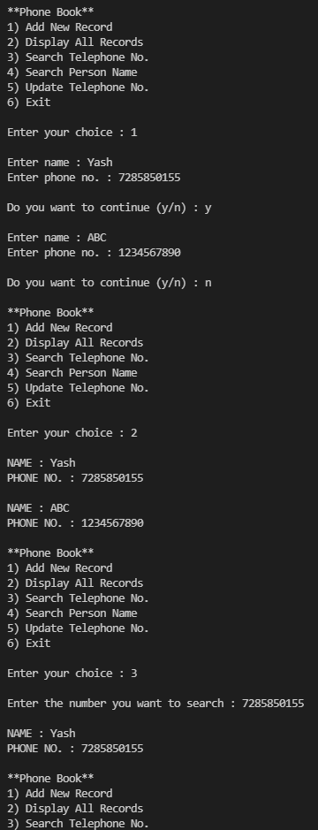

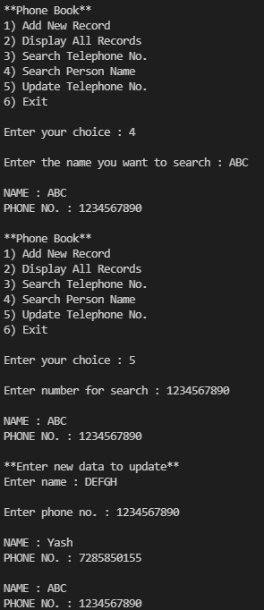

**2. What is the output of this program?**

**Note: Includes all required header files**

**using namespace std;**

**int main ()**

**{**

**int l;**

**char * b;**

**ifstream i;**

**i.open ("find.txt", ios :: binary );**

**i.seekg (0, ios :: end);**

**l = i.tellg();**

**i.seekg (0, ios :: beg);**

**b = new char [l];**

**i.read (b, l);**

**i.close();**

**cout.write (b, l);**

**delete[] b;**

**return 0;**

**}**

A. Error

B. find

C. This is find

***D. Runtime error***

**3. What is the output of this program?**

**Note:Includes all required header files**

**using namespace std;**

**int main ()**

**{**

**char fine, course;**

**cout << "Enter a word: ";**

**fine = cin.get();**

**cin.sync();**

**course = cin.get();**

**cout << fine << endl;**

**cout << course << endl;**

**return 0;**

**}**

A. course

B. fine

***C. Returns fine 2 letter or number from the entered word***

D. None of the mentioned