Institute of Computer Technology

B. Tech Computer Science and Engineering

Subject: ESFP-II (2CSE203)

**PRACTICAL-12**

**AIM: - To learn about creation of function template and class template in C++.**

**1. Simran wants to implement a program in C++ to create a template which finds the largest among two integer, floating values & character values.**

***CODE:***

#include <iostream>

using namespace std;

template <typename Y>

void Large(Y a, Y b)

{

Y largest;

largest=0;

if (a>b)

{

largest=a;

}

else

{

largest=b;

}

cout<<"\nLargest number is: "<<largest;

}

int main()

{

int a,b;

float c,d;

char e,f;

cout<<"\nEnter an integer number: ";

cin>>a;

cout<<"\nEnter an integer number: ";

cin>>b;

Large(a,b);

cout<<"\nEnter a float number: ";

cin>>c;

cout<<"\nEnter a float number: ";

cin>>d;

Large(c,d);

cout<<"\nEnter a char number: ";

cin>>e;

cout<<"\nEnter a char number: ";

cin>>f;

Large(e,f);

return 0;

}

***OUTPUT:***

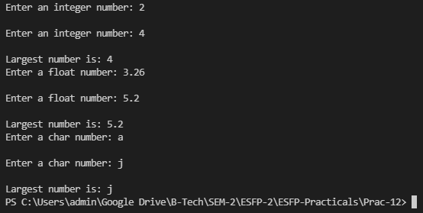

**2. Create one class template and use it for to implement PUSH & POP operations of stack.**

***CODE:***

#include <iostream>

#include <cstdlib>

using namespace std;

#define SIZE 10

template <class X>

class stack

{

X *arr;

int top;

int capacity;

public:

stack(int size = SIZE);

void push(X);

X pop();

X peek();

int size();

bool isEmpty();

bool isFull();

~stack() {

delete[] arr;

}

};

template <class X>

stack<X>::stack(int size)

{

arr = new X[size];

capacity = size;

top = -1;

}

template <class X>

void stack<X>::push(X x)

{

if (isFull())

{

cout << "Overflow\nProgram Terminated\n";

exit(EXIT_FAILURE);

}

cout << "Inserting " << x << endl;

arr[++top] = x;

}

template <class X>

X stack<X>::pop()

{

if (isEmpty())

{

cout << "Underflow\nProgram Terminated\n";

exit(EXIT_FAILURE);

}

cout << "Removing " << peek() << endl;

return arr[top--];

}

template <class X>

X stack<X>::peek()

{

if (!isEmpty()) {

return arr[top];

}

else {

exit(EXIT_FAILURE);

}

}

template <class X>

int stack<X>::size() {

return top + 1;

}

template <class X>

bool stack<X>::isEmpty() {

return top == -1; // or return size() == 0;

}

template <class X>

bool stack<X>::isFull() {

return top == capacity - 1; // or return size() == capacity;

}

int main()

{

stack<string> pt(2);

pt.push("A");

pt.push("B");

pt.pop();

pt.pop();

pt.push("C");

cout << "The top element is " << pt.peek() << endl;

cout << "The stack size is " << pt.size() << endl;

pt.pop();

if (pt.isEmpty()) {

cout << "The stack is empty\n";

}

else {

cout << "The stack is not empty\n";

}

return 0;

}

***OUTPUT:***

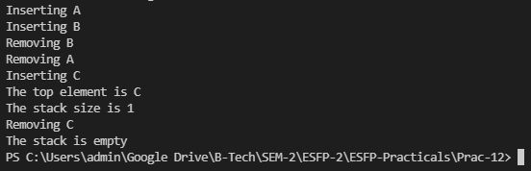

**3. Demonstrate a C++ Program to show Example of Static member variable of template class.**

***CODE:***

#include <iostream>

using namespace std;

template<class T> class XYZ{

public:

void putPri();

static T ipub;

private:

static T ipri;

};

template <class T>

void XYZ<T>::putPri()

{

cout<< ipri++ <<endl;

}

template <class T> T XYZ<T>::ipub=1;

template <class T> T XYZ<T>::ipri=1.2;

int main()

{

XYZ<int> aaa;

XYZ<float> bbb;

aaa.putPri();

cout<<aaa.ipub<<endl;

bbb.putPri();

return 0;

}

***OUTPUT:***

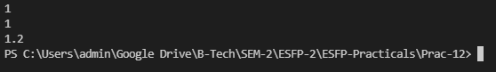

***Post Practical Task***

**1. Implement a program in C++ template class to multiply 3 by 3 matrix with different data types.**

***CODE:***

#include<iostream>

#include<conio.h>

using namespace std;

int main( )

{

int mat1 [3][3], mat2[3][3],mat3[3][3], i ,j, k, sum;

cout<<"\nEnter values for first 3 x 3 matrix:\n";

for ( i = 0 ; i <= 2 ; i++ )

{

for (j = 0 ; j <= 2 ; j++ )

cin>>mat1 [i][j] ;

}

cout<<"\n Enter values for second 3 x 3 matrix:\n";

for ( i = 0 ; i <= 2 ; i++ ){

for ( j = 0 ; j <= 2 ; j++ )

cin>>mat2[i][j] ;

}

cout<<"\n The first 3 x 3 matrix entered by you is:\n";

for ( i = 0 ; i <= 2 ; i++ )

{

for ( j = 0 ; j <= 2 ; j++ )

cout<<"\t"<< mat1[i][j] ;

cout<<"\n";

}

cout<<"\n the second 3 x 3 matrix entered :\n";

for ( i = 0 ; i <= 2 ; i++ )

{

for ( j = 0 ; j <= 2 ; j++ )

cout<<"\t"<< mat2[i][j] ;

cout<<"\n";

}

for ( i = 0 ; i <= 2 ; i++ )

{

for ( j = 0 ; j <= 2 ; j++ )

{

sum = 0;

for ( k = 0 ; k <=2 ; k++ )

sum = sum + mat1 [i][k] * mat2[k][j];

mat3[i][j] = sum ;

}

}

cout<<"\nThe product of the above two matrices is:\n";for ( i = 0 ;i<= 2 ; i++ )

{

for ( j = 0 ; j <= 2 ; j++ )

cout<<"\t"<<mat3[i][j] ;

cout<<"\n";

}

cout<<"\n Press any key to exit.";

return 0;

}

***OUTPUT:***

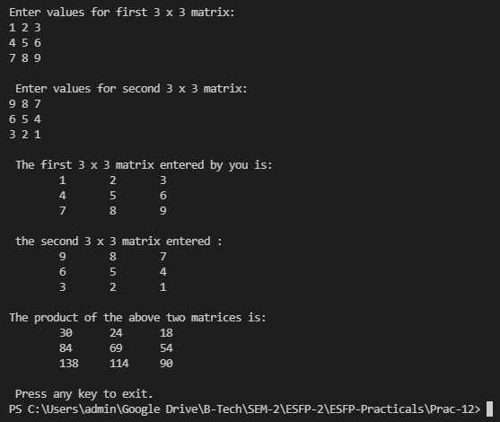

**2. Predict the output?**

**#include <iostream>**

**using namespace std;**

**template <typename T>**

**void fun(const T&x)**

**{**

**static int count = 0;**

**cout << "x = " << x << " count = " << count << endl;**

**++count;**

**return;**

**}**

**int main()**

**{**

**fun<int> (1);**

**cout << endl;**

**fun<int>(1);**

**cout << endl;**

**fun<double>(1.1);**

**cout << endl;**

**return 0;**

**}**

***A) x = 1 count = 0***

***x = 1 count = 1***

***x = 1.1 count = 0***

B) x = 1 count = 0

x = 1 count = 0

x = 1.1 count = 0

C) x = 1 count = 0

x = 1 count = 1

x = 1.1 count = 2

D) Compiler Error

***OUTPUT:***

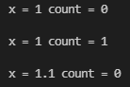

**3. Output of following program?**

**Assume that the size of int is 4 bytes and size of double is 8 bytes, and there is no alignment done by the compiler.**

**#include<iostream>**

**#include<stdlib.h>**

**using namespace std;**

**template<class T, class U, class V=double>**

**class A {**

**T x;**

**U y;**

**V z;**

**static int count;**

**};**

**int main()**

**{**

**A<int, int> a;**

**A<double, double> b;**

**cout << sizeof(a) << endl;**

**cout << sizeof(b) << endl;**

**return 0;**

**}**

***A. 16 24***

B. 8 16

C. 20 28

D. Compiler Error: template parameters cannot have default values.

***OUTPUT:***

