Institute of Computer Technology

B. Tech Computer Science and Engineering

Subject: ESFP-II (2CSE203)

**PRACTICAL-13**

**AIM: - To learn about exception handling in C++.**

**1. Mr. John want to write an exception handling class program in C++, for that accept age of a man from user and check age is greater than or equal to 18 or not, if yes then that man is eligible for vote otherwise throw exception. [Implement the concept of try, catch and throw concept.]**

**Input: Enter your age :45**

**Output: You are eligible for vote.**

**Input: Enter your age: 17**

**Output: Exception: You are not eligible for vote: Your age is only 17.**

***CODE:***

#include <iostream>

#include <exception>

#include<stdexcept>

using namespace std;

int main()

{

int age;

cout<<"\nEnter your age: ";

cin>>age;

try

{

if (age>=18)

{

cout<<"\nYou are aligible for vote.";

}

else if(age < 18)

{

throw age;

}

}

catch(int age)

{

cout<<"\nYou are not eligiblie for voting."<<'\n';

cout<<"Your age is only "<<age;

}

return 0;

}

***OUTPUT:***

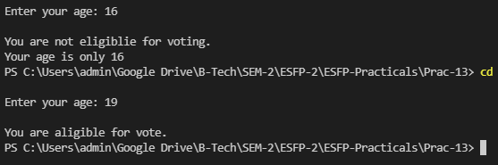

**2. Write a class program with the following:**

1. **A function to read two double type number from keyboard.**
2. **A function to calculate the division of the two number.**
3. **A try block to throw an exception when a wrong type of data is keyed in.**
4. **A try block throw an exception, if the condition "divide - by - zero" occurs.**

**5. Appropriate catch block to handle the exception thrown.**

***CODE:***

#include <iostream>

#include <exception>

#include <stdexcept>

using namespace std;

class A{

public:

double num1, num2, ans;

double getData()

{

int j;

cout<<"Enter first number: ";

cin>>num1;

cout<<"Enter second number: ";

cin>>num2;

try

{

if (cin.fail())

{

throw j;

}

if(num2==0)

{

throw num2;

}

}

catch(double num2)

{

cout<<"\nCannot divide number with zero. MATH ERROR!";

return 0;

}

catch(int j)

{

cout<<"\nIncompatible datatype entered.";

return 0;

}

divide();

}

double divide()

{

ans=num1/num2;

cout<<"\nAnswer: "<<ans;

return 0;

}

};

int main()

{

A obj;

try

{

obj.getData();

}

catch(...)

{

cout<<"\nEXCEPTION HANDLED";

}

return 0;

}

***OUTPUT:***

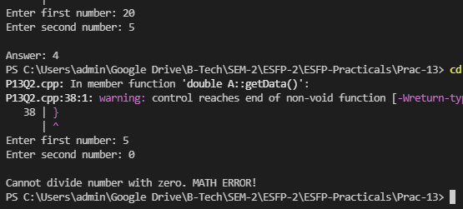

**Post Practical Task**

**1. Make a program, to demonstrate the concept of rethrowing mechanism in an exception handling.**

***CODE:***

#include <iostream>

#include <exception>

#include<stdexcept>

using namespace std;

void abc(int a,int b)

{

try

{

if(b==0)

{

throw b;

}

else

{

cout<<"\nDivision: "<<(a/b);

}

}

catch(int i)

{

cout<<"\nCaught interger inside function "<<i;

throw;

}

cout<<"\nEnd of function.";

}

int main()

{

cout<<"\nI am inside main";

try

{

{

abc(10,5);

}

}

catch(int num)

{

cout<<"\nCaught integer inside main "<<num;

}

cout<<"\nEnd of main function.";

return 0;

}

***OUTPUT:***

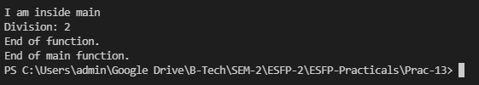

**2. Make a program using exception handling in C++, where you have to show the use**

**Implementation of exception using class constructor and destructor.**

***CODE:***

#include <iostream>

#include <exception>

#include<stdexcept>

using namespace std;

class A{

int num1,num2;

public:

A()

{

int j;

cout<<"Enter first number: ";

cin>>num1;

cout<<"Enter second number: ";

cin>>num2;

try

{

if(num2==0)

{

throw num2;

}

else

{

cout<<"\nAnswer: "<<num1/num2;

}

}

catch(int num2)

{

cout<<"\nCannot divide number with zero. MATH ERROR!";

}

}

~A()

{

cout<<"\nDestructor called."<<endl;

}

};

int main()

{

A a;

return 0;

}

***OUTPUT:***

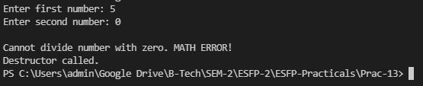

**3. Find output from given below program:**

**#include <iostream>**

**#include <exception>**

**using namespace std;**

**class Test: public exception**

**{**

**virtual const char* what() const throw()**

**{**

**return "Exception arised";**

**}**

**} obj;**

**int main ()**

**{**

**try**

**{**

**throw obj;**

**}**

**catch (exception& e)**

**{**

**cout << e.what() << endl;**

**}**

**return 0;**

**}**

1. ***a. Exception arised***
2. b. Compile time error
3. c. Run time error
4. d. None of the above.

**5. Find output from the given below program:**

**# include <iostream>**

**using namespace std;**

**double div(int a, int b)**

**{**

**if ( b == 0 )**

**{**

**throw "Denominator never be zero for division!";**

**}**

**return (a / b);**

**}**

**int main ()**

**{**

**int x = 10; int y = 0;**

**double z = 0;**

**try**

**{**

**z = div(x, y);**

**cout << z << endl;**

**}**

**catch (const char* ch)**

**{**

**cout << ch << endl;**

**}**

**return 0;**

**}**

1. a. 2
2. b. 50
3. ***c. Denominator never be zero for division!***
4. d. None of the above.