Institute of Computer Technology

B. Tech Computer Science and Engineering

Subject: ESFP-II (2CSE203)

**PRACTICAL-2**

**AIM: - To learn about operators in C++.**

***Exercise*:**

**1. Calculate the fare for the passengers traveling in a bus. When a Passenger enters the bus, the conductor asks “What distance will you travel?” On knowing distance from the passenger (as an approximate integer), the conductor mentions the fare to the passenger according to following criteria.**

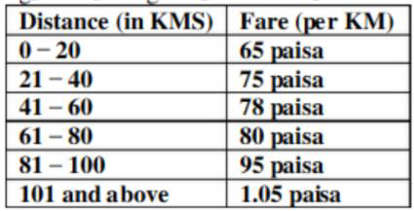

***CODE:***

#include <iostream>

using namespace std;

int main() {

    float fare, dist;

    cout<<"What distance will you travel?\n";

    cin>>dist;

    if (dist>101)

    {

        fare=dist*1.05;

        cout<<"Fare of distance "<<dist<<" kms: "<<fare<<" Rs";

    }

    else if (dist>=81 && dist<100)

    {

        fare=dist*0.95;

        cout<<"Fare of distance "<<dist<<" kms: "<<fare<<" Rs";

    }

    else if (dist>=61 && dist<=80)

    {

        fare=dist*0.8;

        cout<<"Fare of distance "<<dist<<" kms: "<<fare<<" Rs";

    }

    else if (dist>=41 && dist<=60)

    {

        fare=dist*0.78;

        cout<<"Fare of distance "<<dist<<" kms: "<<fare<<" Rs";

    }

    else if (dist>=21 && dist<=40)

    {

        fare=dist*0.75;

        cout<<"Fare of distance "<<dist<<" kms: "<<fare<<" Rs";

    }

    else {

        fare=dist*0.65;

        cout<<"Fare of distance "<<dist<<" kms: "<<fare<<" Rs";

    }

    return 0;

}

***OUTPUT:***

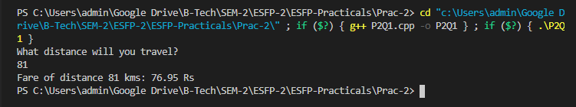

**-------------------------------------------------------------------------------------------------------------------**

**2. Use suitable code to produce the output as shown below:**

**x value y value expressions results**

**10 | 5 | x=y+3 | x=8**

**10 | 5 | x=y-2 | x=3**

**10 | 5 | x=y*5 | x=25**

**10 | 5 | x=x/y | x=2**

**10 | 5 | x=x%y | x=0**

***CODE:***

#include <iostream>

using namespace std;

int main() {

    int x=10,y=5;

    cout<<"Result:\n";

    cout<<"x value\t"<<"y value\t"<<"Expressions\t"<<"Result\n";

    cout<<x<<" \t|"<<y<<" \t|"<<"x=y+3\t"<<"\t|"<<y+3<<"\n";

    cout<<x<<" \t|"<<y<<" \t|"<<"x=y-2\t"<<"\t|"<<y-2<<"\n";

    cout<<x<<" \t|"<<y<<" \t|"<<"x=y*5\t"<<"\t|"<<y*5<<"\n";

    cout<<x<<" \t|"<<y<<" \t|"<<"x=x/y\t"<<"\t|"<<x/y<<"\n";

    cout<<x<<" \t|"<<y<<" \t|"<<"x=x%y\t"<<"\t|"<<x%y<<"\n";

    return 0;

}

***OUTPUT:***

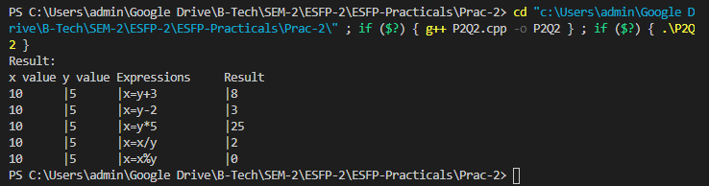

**-----------------------------------------------------------------------------------------------------------------------**

**3. Prompt the user to input the integral value of a and print out the result as shown below:**

**The value of a is: 35**

**……………………..**

**The value of ++a is: 36**

**Now the value of a is: 36**

**The value of a++ is: 36**

**Now the value of a is: 37**

**The value of --a is:36**

**Now the value of a is:36**

**The value of a-- is: 36**

**Now the value of a is: 35**

***CODE:***

#include <iostream>

using namespace std;

int main() {

int a;

cout<<"Enter a value: ";

cin>>a;

cout<<"The value of a is: "<<a;

cout<<"\n...........................\n";

cout<<"The value of ++a is: "<<++a;

cout<<"\nNow the value of a is: "<<a;

cout<<"\n\nThe value of a++ is: "<<a++;

cout<<"\nNow the value of a is: "<<a;

cout<<"\n\nThe value of --a is: "<<--a;

cout<<"\nNow the value of a is: "<<a;

cout<<"\n\nThe value of a-- is: "<<a--;

cout<<"\nNow the value of a is: "<<a;

return 0;

}

***OUTPUT:***

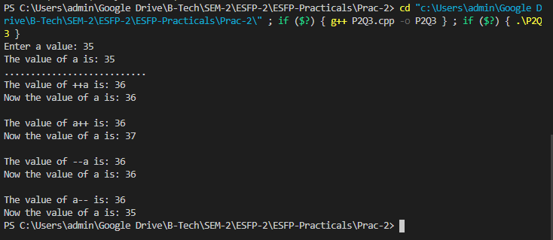

**-----------------------------------------------------------------------------------------------------------------------**

**4. Given the following pseudo code, write a c++ code that executes it.**

**a. read x**

**b. read y**

**c. compute p=x*y**

**d. compute s=x+y**

**e. total=s2+p*(s-x)*(p+y)**

**f. print total**

***CODE:***

#include <iostream>

using namespace std;

int main() {

int x,y,s,p,total;

cout<<"Enter value of x: ";

cin>>x;

cout<<"Enter value of y: ";

cin>>y;

p=x*y;

s=x+y;

total=(s*s)+p*(s-x)*(p+y);

cout<<"Total: "<<total;

return 0;

}

***OUTPUT:***

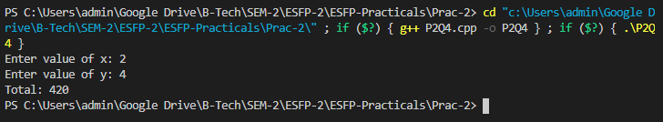

**-----------------------------------------------------------------------------------------------------------------------**

**Post Practical Questions:**

**Write output of given programs:**

**1. #include <stdio.h>**

**using namespace std;**

**int main()**

**{**

**int a = 21;**

**int c ;**

**c = a++;**

**cout << c;**

**return 0;**

**}**

***OUTPUT:* 21**

**2. #include <stdio.h>**

**using namespace std;**

**int main()**

**{**

**int x = 5, y = 5;**

**cout << ++x << --y << endl;**

**return 0;**

**}**

***OUTPUT:* 64**

**3. #include <stdio.h>**

**using namespace std;**

**int main()**

**{**

**int num1 = 5;**

**int num2 = 3;**

**int num3 = 2;**

**num1 = num2++;**

**num2 = --num3;**

**cout << num1 << num2 << num3;**

**return 0;**

**}**

***OUTPUT:* 311**