Institute of Computer Technology

B. Tech Computer Science and Engineering

Subject: ESFP-II (2CSE203)

**PRACTICAL-3**

**AIM: - To learn about branching, looping and logical operators in C++.**

**1. Determines a student’s grade make a program which will read three types of scores (quiz, mid-term, and final scores) and determine the grade based on the following rules:**

**-if the average score =90% =>grade=A**

**-if the average score >= 70% and <90% => grade=B**

**-if the average score>=50% and <70% =>grade=C**

**-if the average score<50% =>grade=F**

***CODE:***

#include <iostream>

using namespace std;

int main() {

int quiz,mid_term,final,avg;

cout<<"\nEnter Marks of Quiz: ";

cin>>quiz;

cout<<"\nEnter Marks of Mid-Term: ";

cin>>mid_term;

cout<<"\nEnter Final Score: ";

cin>>final;

avg=(quiz+mid_term+final)/3;

if (avg>=90)

{

cout<<"\nGrade-A";

}

else if (avg<90 && avg>=70)

{

cout<<"\nGrade-B";

}

else if (avg<70 && avg>=50)

{

cout<<"\nGrade-C";

}

else

{

cout<<"\nGrade-F";

}

return 0;

}

***OUTPUT:***

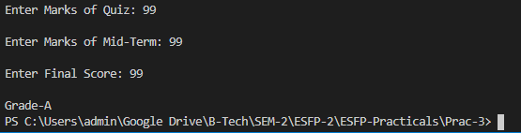

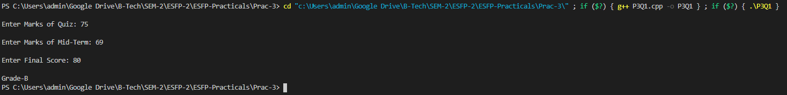

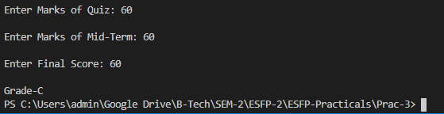

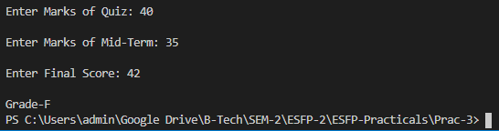

**-----------------------------------------------------------------------------------------------------------------------**

**2. Compute the real roots of the equation: ax2+bx+c=0.**

**The program will prompt the user to input the values of a, b, and c. It then computes the real roots of the equation based on the following rules:**

**-if a and b are zero=> no solution**

**-if a is zero=>one root (-c/b)**

**-if b2-4ac is negative=>no roots**

**-Otherwise=> two roots**

**The roots can be computed using the following formula: x1=-b+(b2-4ac)1/2/2a x=-b-(b2-4ac)1/2/2a**

***CODE:***

#include <iostream>

#include <cmath>

using namespace std;

int main() {

    float a,b,c,root,delta,x,x1,r,i;

    cout<<"\nEnter co-efficient of x^2: ";

    cin>>a;

    cout<<"\nEnter co-efficient of x: ";

    cin>>b;

    cout<<"\nEnter value for c: ";

    cin>>c;

    if (a==0)

    {

        cout<<"\nThis is not a quadratic equation.";

        return 0;

    }

    else if (a==0 && b==0)

    {

        cout<<"\nThis is not a quadratic equation.";

        return 0;

    }

    cout<<"\nThe equation is "<<"("<<a<<")"<<"x^2+"<<"("<<b<<")"<<"x+"<<"("<<c<<")";

    delta=((b*b)-4*a*c);

    if (delta>=0)

    {

        if (delta==0)

        {

            x1=x=(-b/2*a);

            cout<<"\nReal and same roots: "<<x1<<" & "<<x;

        }

        else {

            x,x1=0;

            x1=(((-b)+ sqrt(delta))/(2*a));

            x=(((-b)- sqrt(delta))/(2*a));

            cout<<"\nEquation has two different real roots: -";

            cout<<"\n1st Root: "<<x1;

            cout<<"\n2nd Root: "<<x;

        }

    }

    if (delta<0)

    {

        r=((-b)/2*a);

        i= (sqrt(-delta)/(2*a));

        cout<<"\nThis equation has two imaginary roots";

        cout<<"\nRoot 1: "<<r<<" + "<<i<<"i";

        cout<<"\nRoot 2: "<<r<<" - "<<i<<"i";

    }

    return 0;

}

***OUTPUT:***

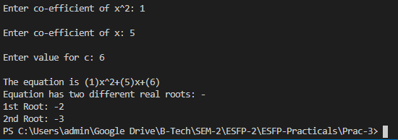

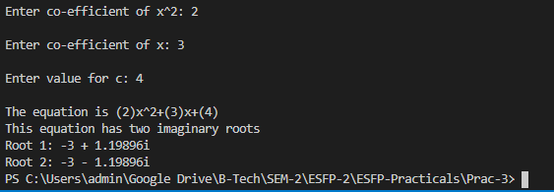

**3. Follow the given pattern and write a code for it.**

**\***

**\*\*\***

**\*\*\*\*\***

**\*\*\*\*\*\*\***

**\*\*\*\*\*\*\*\*\***

**\*\*\*\*\*\*\*\*\***

**\*\*\*\*\*\*\***

**\*\*\*\*\***

**\*\*\***

**\***

***CODE:***

#include<iostream>

using namespace std;

int main()

{

int n, i , j;

n=9;

for(i = 1; i <= n; i=i+2) {

for(j = 1; j <= i; j++) {

cout << "*";

}

cout<<"\n";

}

for(i = n; i >= 1; i=i-2) {

for(j = 1; j <= i; j++) {

cout << "*" ;

}

cout<<"\n";

}

return 0;

}

***OUTPUT:***

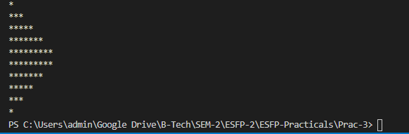

**4. Take n positive numbers as a user input. The program will terminate if one of those number is not positive.**

***CODE:***

#include <iostream>

using namespace std;

int main() {

int n;

for(;;) {

cout<<"Enter any positive number: ";

cin>>n;

if (n<0)

{

cout<<"This program will not accept any negative number...";

break;

}

}

}

***OUTPUT:***

