Institute of Computer Technology

B. Tech Computer Science and Engineering

Subject: ESFP-II (2CSE203)

**PRACTICAL-4**

**AIM: - To learn about Constructor and Destructor in C++.**

**1. Write a C++ program to create a class FD a/c which contains member (fdno, name, amt, interest rate, maturity amt &amp; No. of months). Write parameterized constructor where interest rate should be default argument. Calculate maturity amt using interest rate &amp; display all the details.**

***CODE:***

#include<iostream>

#include<cstring>

#include<cmath>

using namespace std;

class FD

{

int fdno,time;

float amt, irate, m_amt;

char nm[20];

public:

FD(int fno, int mnt, float am, float rt, char *name)

{

fdno=fno;

time=mnt;

amt=am;

irate=rt;

strcpy(nm, name);

}

void display()

{

m_amt=amt*pow((1+irate/100), time);

cout<<"\n FdNo.: "<<fdno;

cout<<"\n Month: "<<time;

cout<<"\n Amount: "<<amt;

cout<<"\n Interest rate: "<<irate;

cout<<"\n Maturity Amount: "<<m_amt;

cout<<"\n Name: "<<nm;

}

};

int main()

{

int fdno, time;

float amt, irate;

char nm[20];

cout<<"\nEnter FD No.: ";

cin>>fdno;

cout<<"\nEnter Month: ";

cin>>time;

cout<<"\nEnter Amount: ";

cin>>amt;

cout<<"\nEnter irate: ";

cin>>irate;

cout<<"\nEnter Name: ";

cin>>nm;

FD f1(fdno, time, amt, irate, nm);

f1.display();

return 0;

}

***OUTPUT:***

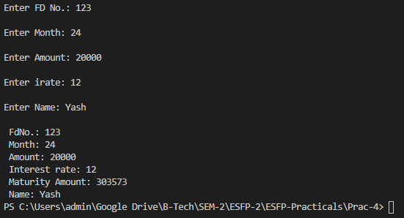

**2. Write a C++ program to read information about plant like plant-name, plant-code, plant-type and price. Construct the database with suitable member functions for initialization and destroying the data via constructor and destructor.**

***CODE:***

#include <iostream>

#include <cstring>

using namespace std;

class plant {

public:

int plant_code;

char plant_name[50];

char plant_type[50];

float price;

public:

plant(int pcode, char *pname,char *ptype, float pprice) {

plant_code=pcode;

strcpy(plant_name,pname);

strcpy(plant_type,ptype);

price=pprice;

}

void input();

void display();

plant(){}

};

void plant::input(){

cout<<"\nPlant code: ";

cin>>plant_code;

cout<<"Plant Name: ";

cin>>plant_name;

cout<<"Plant Type: ";

cin>>plant_type;

cout<<"Plant Price: ";

cin>>price;

}

void plant::display(){

cout<<"\n===============================";

cout<<"\nPlant code: "<<plant_code;

cout<<"\nPlant Name: "<<plant_name;

cout<<"\nPlant Type: "<<plant_type;

cout<<"\nPlant Price: "<<price;

cout<<"\n===============================\n";

}

int main() {

int count,i;

cout<<"\nEnter no. of plant details you want: ";

cin>>count;

for (i = 0; i < count; i++)

{

plant p(p.plant_code, p.plant_name, p.plant_type, p.price);

p.input();

p.display();

}

return 0;

}

***OUTPUT:***

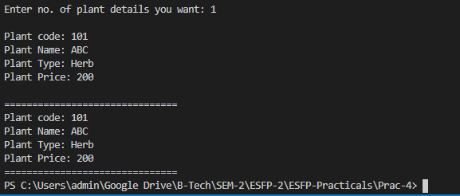

***Post Practical Task***

**1. Define a class Travelplan in C++ with the following descriptions:**

**Private Members:**

**Plancode of type long Place of type character array(string)**

**Number_of_travellers of type integer**

**Number_of_buses of type integer**

**Public Members: A constructer to assign initial values of**

**PlanCode as 1001, Place as“agra”,**

**Number_of_travellers as 5,Number_of_buses as 1 A function**

**NewPlan() which allows user to enter PlanCode, Place and Number_of travelers. Also, assign the value of Number_of_buses as per the following:**

**conditions:**

**Number_of_travellers less than 20**

**Number_of_buses 1**

**Equal to or more than 20 and less than 40-2**

**Equal to 40 or more than 40 - 3**

**A function ShowPlan() to display the content of all the data members on the screen.**

***CODE:***

#include <iostream>

#include <cstring>

using namespace std;

class Travelplan

{

long Plancode;

char Place[21];

int Number_of_travellers,Number_of_buses;

public:

Travelplan( )

{

Plancode=1001;

strcpy(Place,"Agra");

Number_of_travellers=5;

Number_of_buses=1;

}

void NewPlan()

{

cout<<"\nEnter the Plan Code: ";

cin>>Plancode;

cout<<"\nEnter the Place to Travel: ";

fflush(stdin);

gets(Place);

cout<<"\nEnter the Number of Travellers: ";

cin>>Number_of_travellers;

if(Number_of_travellers>=40)

{

Number_of_buses=3;

}

else if(Number_of_travellers>=20)

{

Number_of_buses=2;

}

else

{

Number_of_buses=1;

}

}

void ShowPlan()

{

cout<<"\nThe Plan Code: "<<Plancode;

cout<<"\nThe Place of Travel: "<<Place;

cout<<"\nNumber of Travellers: "<<Number_of_travellers;

cout<<"\nNumber of Buses: "<<Number_of_buses;

}

};

int main()

{

Travelplan T;

T.NewPlan();

T.ShowPlan();

return 0;

}

***OUTPUT:***

