Institute of Computer Technology

B. Tech Computer Science and Engineering

Subject: ESFP-II (2CSE203)

**PRACTICAL-5**

**AIM: - To learn about arrays & strings in C++.**

**1. Follow the given details for inquiries about student data.**

**The program will display a menu that enables the users to choose whether they want to view all students ’records or view only the records of a specific student by the student’s id. See sample below.**

**MENU**

**1. View all students’ records 2. View a student’s records by ID 3. Show the highest and the lowest final scores Please enter your choice: 1**

**|StudentID | Quiz1 | Quiz2 | Mid-Term | Final | ==================================================**

**|1232 | 10 | 23 | 45 | 56 |**

**|2343 | 45 | 43 | 24 | 78 |**

**|2343 | 34 | 45 | 45 | 45 |**

**|3423 | 67 | 06 | 65 | 56 |**

**Note: These records will be stored in a two-dimensional array**

***CODE:***

#include <cstdlib>

#include <iostream>

using namespace std;

void ShowHeading();

int HighMarks(int stu[4][5]);

int LowMarks(int stu[4][5]);

void displaymenu(){

cout<<"\n";

cout<<"========================================================"<<"\n";

cout<<" MENU "<<"\n";

cout<<"========================================================"<<"\n";

cout<<" 1.View all student records"<<"\n";

cout<<" 2.View a student records by ID"<<"\n";

cout<<" 3.Show the highest and the lowest scores"<<"\n"<<endl;

}

void ShowAll(int stu[4][5]){

int i,j;

ShowHeading();

for(i=0;i<4;i++){

for(j=0;j<5;j++) {

cout<<stu[i][j]<<"\t\t";

}

cout<<"\n";

}

}

void SearchByID(int stu[4][5]){

int id,i,j;

cout<<"Please enter a student's ID:";

cin>>id;

for(i=0;i<4;i++){

if(stu[i][0]==id){

ShowHeading();

for(j=0;j<5;j++){

cout<<stu[i][j]<<"\t\t";

}

cout<<"\n";

}

}

}

void HighLow(int stu[4][5]){

cout<<"The higest final score is:"<<HighMarks(stu);

cout<<"\n";

cout<<"The lowest final score is:"<<LowMarks(stu);

cout<<"\n";

}

void ShowHeading(){

cout<<"=======================================================================\n";

cout<<"StudentID Quiz1 Quiz2 Mid-term Final\n";

cout<<"=======================================================================\n";

}

int HighMarks(int stu[4][5]){

int *max,i;

max=&stu[0][4];

for(i=0;i<4;i++)

{

if(*max<stu[i][4]){

*max=stu[i][4];

}

}

return(*max);

}

int LowMarks(int stu[4][5]){

int *min,i;

min=&stu[0][4];

for(i=0;i<4;i++)

{

if(*min>stu[i][4])

{

*min=stu[i][4];

}

}

return(*min);

}

int main(int argc, char *argv[]) {

int stu[4][5]={{1232,32,34,43,43},{2345,34,34,54,35},{3432,45,54,56,34},{3456,56,34,34,56}};

displaymenu();

int yourchoice;

char confirm;

do

{

cout<<"Enter your choice(1-3):";

cin>>yourchoice;

switch(yourchoice){

case 1:

ShowAll(stu);

break;

case 2:

SearchByID(stu);

break;

case 3:

HighLow(stu);

break;

default:

cout<<"invalid";

}

cout<<"Press y or Y to continue:";

cin>>confirm;

} while(confirm=='y'||confirm=='Y');

return 0;

}

***OUTPUT:***

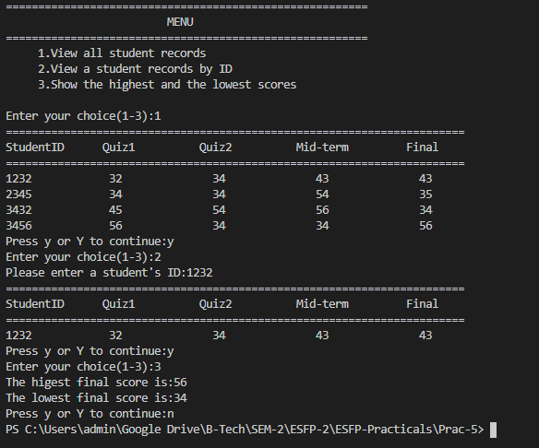

**2. In this C++ exercise, your are about to display a matrix as shown below. The diagonal of the matrix fills with 0. The lower side fills will -1s and the upper side fills with 1s.**

**0 1 1 1 1**

**-1 0 1 1 1**

**-1 -1 0 1 1**

**-1 -1 -1 0 1**

**-1 -1 -1 -1 0**

***CODE:***

#include <iostream>

using namespace std;

int main() {

int mat[5][5];

int i,j;

for (i = 0; i < 5; i++)

{

for (j = 0; j < 5; j++)

{

if(i>j) {

mat[i][j]=-1;

}

else if (i<j)

{

mat[i][j]=1;

}

else {

mat[i][j]=0;

}

}

}

for (i = 0; i < 5; i++)

{

for (j = 0; j < 5; j++)

{

cout<<mat[i][j]<<"\t";

}

cout<<endl;

}

return 0;

}

***OUTPUT:***

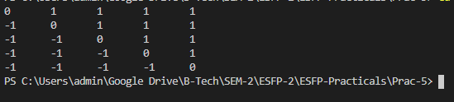

**3. Me trying to write a program that change every letter in a given string with the letter following it in the alphabet (ie. a becomes b, p becomes q, z becomes a).**

**Example:**

**Sample Input: w3resource**

**Sample Output: x3sftpvsdf**

***CODE:***

#include <iostream>

#include <cstring>

using namespace std;

int main()

{

char a[30];

int code,i,l;

cout<<"\nEnter String: ";

gets(a);

cout<<"\n\nInput: "<<a;

l=sizeof(a);

for (i = 0; i < l; i++)

{

code = int(a[i]);

if (code == 122)

{

a[i] = char(97);

}

else if (code == 90)

{

a[i] = char(65);

}

else if (code >= 65 && code <= 90 || code >= 97 && code <= 122)

{

a[i] = char(code + 1);

}

}

cout<<"\nOutput: "<<a;

return 0;

}

***OUTPUT:***

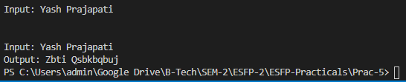

***Post Practical Work:***

**1. Find how many times and in which year an entered birth Day has same day within**

**a span of 100 years?**

**Example:**

**Input**

**Enter Your Birthday: 23- 7 -1998**

**Output**

**Your Birthday was on Friday and will be repeated 7 times**

**2007, 2022, 2036, 2059, 2071,2083, 2091.**

***CODE:***

#include <iostream>

using namespace std;

class date

{

public:

int d,m,y,sd,sm,sy,sday,gd;

int wd[7]={0,1,2,3,4,5,6};

char wkd[7]={'S','M','T','W','t','F','s'};

int month[12]={1,2,3,4,5,6,7,8,9,10,11,12};

int day[12]={31,28,31,30,31,30,31,31,30,31,30,31};

void accept() {

cout<<"Enter the Date (dd):- ";

cin>>d;

cout<<"Enter the Month (mm):- ";

cin>>m;

cout<<"Enter the Year (yyyy):- ";

cin>>y;

}

void getTime() {

time_t now = time(0);

tm *ltm = localtime(&now);

sy=1900 + ltm->tm_year;

sm=1 + ltm->tm_mon;

sd=ltm->tm_mday;

sday= ltm->tm_wday;

cout<<sy<<endl;

cout<<sm<<endl;

cout<<sd<<endl;

cout<<sday<<endl;

}

void calculate() {

int i,ctrl=0,ty,tm,td,total;

int c;

for(i=y+1;i<sy;i++){

if((i%4==0&&i%100!=0)||i%400==0){

ctrl++;

}

ty=sy-y+1-ctrl;

}

for(i=m+1;i<=12;i++) {

tm+=day[i];

while(i==2) {

if((y%4==0&&y%100!=0)||y%400==0) {

tm+=1;

}

break;

}

}

for(i=1;i<sm;i++) {

tm+=day[i];

while(i==2) {

if((sy%4==0&&sy%100!=0)||sy%400==0){

tm+=1;

}

break;

}

}

td=sd+day[m]-d+1;

total=ty*365+ctrl*366+tm+td;

gd=total%7;

if(gd<sday) {

gd=sday-gd;

cout<<wkd[gd]<<endl;

}

else {

gd=sday+7-gd;

cout<<wkd[gd];

}

}

void getYears() {

int i,td=gd;

cout<<"Repeating Years with the same Weekday are: "<<endl;

for(i=y+1;i<=y+100;i++) {

if((i%4==0&&i%100!=0)||i%400==0) {

td+=2;

}

else {

td+=1;

td=td%7;

}

if(td==gd) {

cout<<i<<endl;

}

}

}

};

int main() {

fflush(stdin);

date ob;

ob.accept();

ob.getTime();

ob.calculate();

ob.getYears();

}

***OUTPUT:***

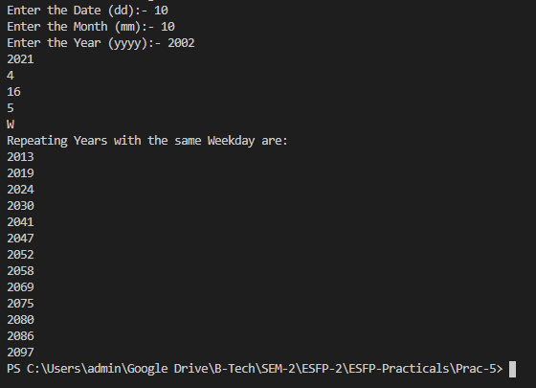

**2. Write the output of the following program. Assume that all necessary header files are included.**

**void Encrypt(char T[])**

**{**

**for (int i = 0; T[i] != '\0'; i += 2)**

**if (T[i] == 'A' || T[i] == 'E')**

**T[i] = '#';**

**else if (islower(T[i]))**

**T[i] = toupper(T[i]);**

**else**

**T[i] = '@';**

**}**

**int main()**

**{**

**char text[]="SaVE EArtH";**

**Encrypt(text);**

**cout << text << endl;**

**return 0;**

**}**

***OUTPUT:***



**3. include<iostream>**

**using namespace std;**

**void main()**

**{**

**int num[]={1,2,3,4,5,6};**

**num[1]==[1]num ? cout<<"Success" : cout<<"Error";**

**}**

***OUTPUT:* No Output, there is syntax error. It should be num[1], not [1]num.**

***OUTPUT (after correction):***



**4. Implement a program to insert a dash character (-) between two odd numbers in a given string of numbers.**

**Example:**

**Sample Input: 1345789**

**Sample Output: Result-> 1-345-789**

***CODE:***

#include <iostream>

#include <string>

using namespace std;

string Insert_dash(string num_str) {

string result_str = num_str;

for (int x = 0; x < num_str.length() - 1; x++) {

if ((num_str[x] == '1' || num_str[x] == '3' || num_str[x] == '5' || num_str[x] == '7' || num_str[x] == '9') && (num_str[x + 1] == '1' || num_str[x + 1] == '3' || num_str[x + 1] == '5' || num_str[x + 1] == '7' || num_str[x + 1] == '9'))

{

result_str.insert(x+1,"-"); num_str = result_str;

}

}

return result_str;

}

int main() {

cout << "\nOriginal number-1345789 : Result-> "<< Insert_dash("1345789") << endl;

return 0;

}

***OUTPUT:***



**5. Find errors, if any, in the following function definition for displaying a matrix:**

**void display(int A[][], int m, int n)**

**{**

**for(i=0; i<m; i++)**

**for(j=0; j<n; j++)**

**cout<<" "<<A[i][j];**

**cout<<"\n";**

**}**

***CORRECTED CODE:***

#include <iostream>

using namespace std;

int main()

{

    int A[10][10];

    int m;

    int n;

    for(int i=0; i<m; i++)

        {

        for(int j=0; j<n; j++)

        {

            cout<<" "<<A[i][j];

            cout<<"\n";

        }

        }

        return 0;

}

***OUTPUT:***

**Non-Terminating Loop**

