Institute of Computer Technology

B. Tech Computer Science and Engineering

Subject: ESFP-II (2CSE203)

**PRACTICAL-9**

**AIM: - To learn about Class type pointer in C++.**

**Exercise**

**1. Write a C++ program to find the max of an integral data set. The program will ask the user to input the number of data values in the set and each value. Then your program will show the max of the data set. See example below. Your C++ program will use a function that accepts the array of data values and its size. The return from the function is the pointer that points to the max value.**

**Enter number of data values: 3**

**Enter value 1: 21**

**Enter value 2: 12**

**Enter value 3: 4**

**The max is 21.**

***CODE:***

#include<iostream>

using namespace std;

int Maximum(int n)

{

int i,j,arr[i];

int max=0;

int *p= &max;

{for(i=1;i<=n;i++)

{

cout<<"Enter value of "<<i<<" : ";

cin>>arr[i];

}

for (j=1;j<=n;j++)

{

if(arr[j]>max)

{

max=arr[j];

}

}

cout<<"\nThe max is: "<<*p;}

}

int main()

{

int n,i,arr[10];

cout<<"\nEnter number of data values: ";

cin>>n;

Maximum(n);

return 0;

}

***OUTPUT:***

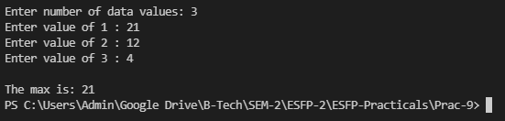

**2. Implement a class in C++ having private variables quantity and price, now make parameterized constructors to initialize these values. Make a public function called display_total_price() which must return total price(quantity * price).Make class type pointer to access these members.**

***CODE:***

#include <iostream>

using namespace std;

class A

{

private:

int qty;

float price;

public:

A(int a,float b)

{

qty=a;

price=b;

}

int display_total_price()

{

float total_p=price*qty;

cout<<"Total Price is: "<<total_p;

return total_p;

}

};

int main()

{

A A1(450,8);

A *ptr;

ptr=&A1;

ptr->display_total_price();

return 0;

}

***OUTPUT:***

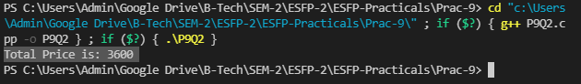

**Post Practical Task**

**1. Implement a class having private variables as radius and height, now make setdata() public function to setdata into radius and height. Make display_Volume () function to return Volume of cylinder. Make class type array and assign it into class type pointer to display volume of 3 cylinders.**

***CODE:***

#include <iostream>

using namespace std;

class Calc

{

private:

float radius,height;

public:

float setdata()

{

cout<<"\nEnter the value of radius: ";

cin>>radius;

cout<<"\nEnter the value of height: ";

cin>>height;

}

float display_Volume()

{

float cy_Vol;

cy_Vol=3.14*radius*radius*height;

cout<<"Volume is: "<<cy_Vol;

return cy_Vol;

}

};

int main()

{

Calc *ptr[3];

Calc obj[3];

for (int i = 0; i < 3; i++)

{

ptr[i]=&obj[i];

ptr[i]->setdata();

ptr[i]->display_Volume();

}

return 0;

}

***OUTPUT:***

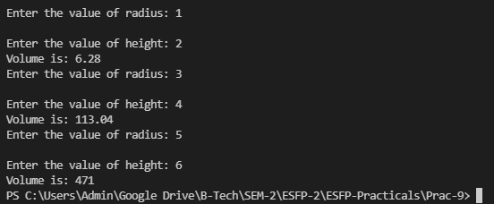

**2. What is the output of this program?**

**#include <iostream>**

**using namespace std;**

**int main()**

**{**

**int x = 1, y = 3, z = 5;**

**int *lfc[ ] = {&x, &y, &z};**

**cout << lfc[1];**

**return 0;**

**}**

A.1

B.3

C.5

**D. it will return some random number**

***OUTPUT:***

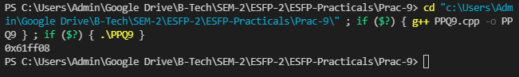

**3. What is the output of this program?**

**#include <iostream>**

**using namespace std;**

**int main()**

**{**

**char lfc[20];**

**int i;**

**for(i = 0; i < 10; i++)**

**\*(lfc + i) = 65 + i;**

**\*(lfc + i) = ' ';**

**cout << lfc;**

**return(0);**

**}**

**A. ABCDEFGHIJ**

B. AAAAAAAAAA

C. JJJJJJJJ

D. None of the mentioned

***OUTPUT:***

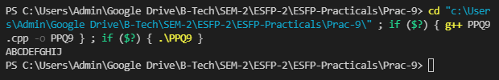

**4. Which of the following is true about the following program**

**#include <iostream>**

**using namespace std;**

**int main()**

**{**

**int i;**

**char *lfc[] = {"C", "C++", "Java", "VBA"};**

**char *(*ptr)[4] = &lfc;**

**cout << ++(*ptr)[2];**

**return 0;**

**}**

**A. ava**

B. java

C. c++

D. compile time error

***OUTPUT:***

