Institute of Computer Technology

B. Tech Computer Science and Engineering

Subject: OOP (2CSE303)

**ASSIGNMENT-2**

**1. Aashvi was assigned to create a registration portal for a college-based application with the following requirements: enrollment number, student name, marks for subject 1, subject 2 and subject 3 along with the computation of average of the three subject marks. The details entered within the registration portal should be stored within a table ‘StudentData’ through JDBC.**

**Input: Enrollment number, student name, subject marks1, subject marks2, subject marks3**

**Output: Average of the three subject marks, insertion of the records within the table.**

***SOLUTION***

package assignment2;

/**

*

* @author YashPrajapati

*/

import java.sql.*;

import java.util.*;

public class A2Q1 {

public static void main(String[] args) {

Scanner sc = new Scanner(System.in);

String create, insert, id, name;

int i, n;

double mark1, mark2, mark3, avg;

try {

Class.forName("com.mysql.jdbc.Driver");

Connection con = DriverManager.getConnection("jdbc:mysql://localhost:3306/oop_assign2", "root", "");

create = "create table StudentPortal(enroll varchar(20),name varchar(20),mark1 double(10,2),mark2 double(10,2),mark3 double(10,2),Avg double(10,2))";

PreparedStatement obj = con.prepareStatement(create);

obj.execute();

insert = "insert into StudentPortal values(?,?,?,?,?,?)";

PreparedStatement obj1 = con.prepareStatement(insert);

System.out.print("Enter number of Data ypu want to insert:");

n = sc.nextInt();

for (i = 0; i < n; i++) {

System.out.print("Enter Enrollment number:");

id = sc.next();

System.out.print("Enter Name:");

name = sc.next();

System.out.print("Enter marks of subject 1:");

mark1 = sc.nextDouble();

System.out.print("Enter marks of subject 2:");

mark2 = sc.nextDouble();

System.out.print("Enter marks of subject 3:");

mark3 = sc.nextDouble();

avg = (mark1 + mark2 + mark3) / 3;

obj1.setString(1, id);

obj1.setString(2, name);

obj1.setDouble(3, mark1);

obj1.setDouble(4, mark2);

obj1.setDouble(5, mark3);

obj1.setDouble(6, avg);

obj1.executeUpdate();

System.out.println("Student-" + (i + 1) + " average:" + avg);

System.out.println("Data inserted to table");

}

obj1.close();

obj.close();

con.close();

sc.close();

} catch (Exception e) {

System.out.print(e);

}

}

}

***OUTPUT***

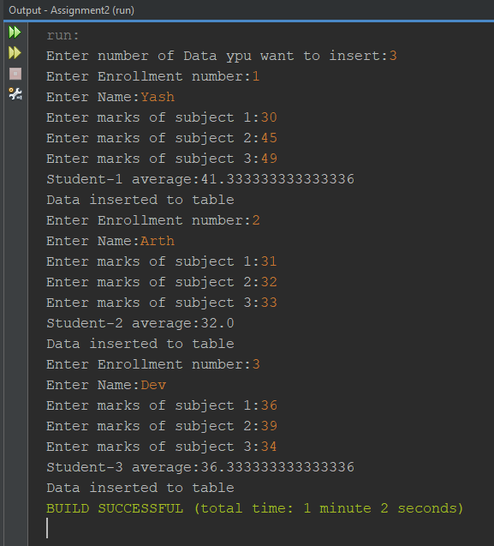

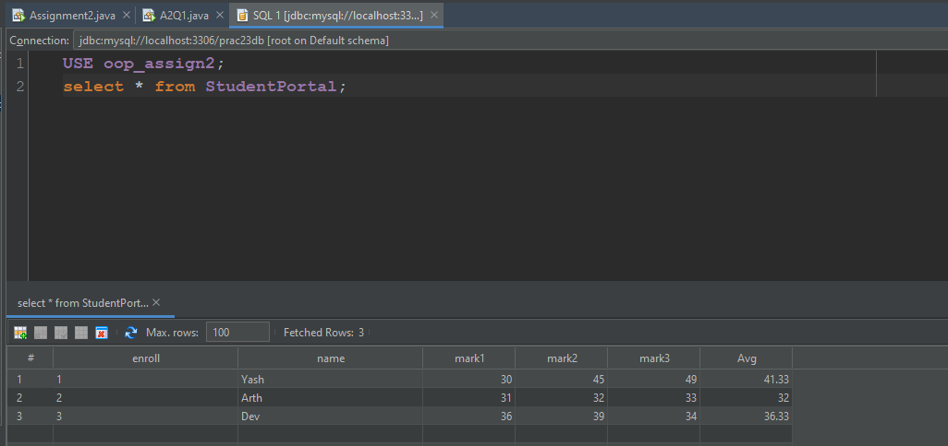

**2. As a team member of the project development team, Aradhana was assigned the task to develop a login portal wherein if the enrollment number entered matches with any of the student enrollments registered, then the details of respective students such as marks and average of marks should be displayed through JDBC.**

**Input: Enrollment number**

**Output: Record fetched based on enrollment number**

***SOLUTION***

package assignment2;

/**

*

* @author YashPrajapati

*/

import java.sql.*;

import java.util.*;

public class A2Q2 {

public static void main(String[] args) {

Scanner sc = new Scanner(System.in);

String find;

int enrollment;

try {

Class.forName("com.mysql.jdbc.Driver");

Connection con = DriverManager.getConnection("jdbc:mysql://localhost:3306/oop_assign2", "root", "");

System.out.print("Enter enrollment number whose details you want to display:");

enrollment = sc.nextInt();

find = "select * from StudentPortal where enroll=" + enrollment;

PreparedStatement obj = con.prepareStatement(find);

ResultSet rs = obj.executeQuery();

while (rs.next()) {

System.out.println(rs.getInt(1) + " " + rs.getString(2) + " " + rs.getDouble(3) + " " + rs.getDouble(4)

+ " " + rs.getDouble(5) + " " + rs.getDouble(6));

}

obj.close();

con.close();

sc.close();

} catch (Exception e) {

System.out.println(e);

}

}

}

***OUTPUT***

