Institute of Computer Technology

B. Tech Computer Science and Engineering

Subject: OOP (2CSE303)

**PRACTICAL-20**

**AIM: - Anne was assigned to develop a text editor module which helps calculate the count of characters, words, lines, digits, white spaces and other characters in a given file.**

**Input format: File with some alphanumeric contents, whitespaces and other symbols**

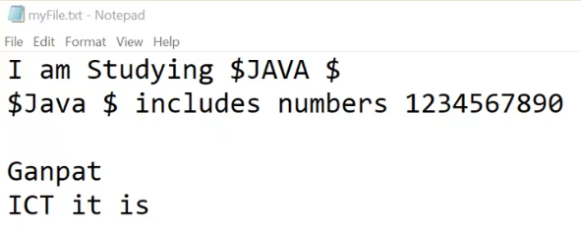

**Output format: Count of characters, lines, characters, numbers, spaces and symbols if any.**

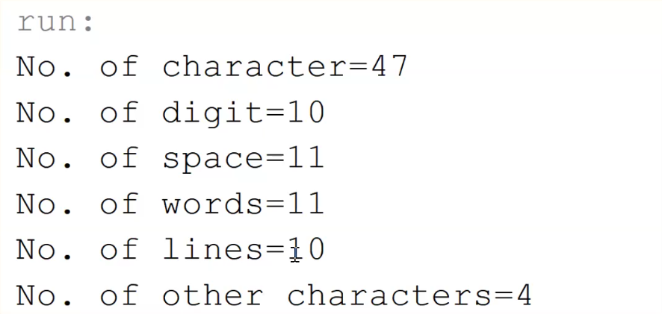

***SOLUTION***

package practicals;

import java.io.*;

/**

*

* @author YashPrajapati

*/

public class prac20 {

public static void main(String[] args) throws Exception {

FileReader fr = new FileReader(

"C:\\Users\\admin\\Google Drive\\B-Tech\\guni-sem3-data\\SEM-3\\OOP\\OOP_Practicals\\Prac-20\\myFile.txt");

BufferedReader br = new BufferedReader(fr);

String temp;

int letter = 0, digit = 0, space = 0, line = 0, other = 0, word = 0;

while ((temp = br.readLine()) != null) {

String[] words = temp.split("\\s");

word += words.length;

line++;

for (int i = 0; i < temp.length(); i++) {

if (Character.isLetter(temp.charAt(i))) {

letter++;

} else if (Character.isDigit(temp.charAt(i))) {

digit++;

} else if (Character.isWhitespace(temp.charAt(i))) {

space++;

} else {

other++;

}

}

}

fr.close();

System.out.println("No. of characters = " + letter);

System.out.println("No. of digit = " + digit);

System.out.println("No. of space = " + space);

System.out.println("No. of words = " + word);

System.out.println("No. of lines = " + line);

System.out.println("No. of other characters = " + other);

}

}

***OUTPUT***

