Institute of Computer Technology

B. Tech Computer Science and Engineering

Subject: OOP (2CSE303)

**PRACTICAL-21**

**AIM: - Athiya was assigned a task to categorize the odd and even numbers from a set of numbers read collectively which were present in a file. Develop the module in such a way that the storage of odd numbers and even numbers take place in separate files respectively.**

***INPUT***

***File:* Number.txt**

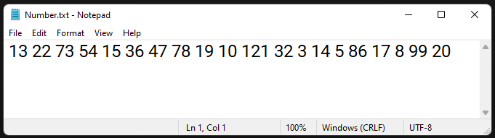

***SOLUTION***

package practicals;

import java.io.*;

/**

*

* @author YashPrajapati

*/

public class prac21 {

public static void main(String[] args) throws IOException {

FileWriter f1 = new FileWriter(

"C:\\Users\\admin\\Google Drive\\B-Tech\\guni-sem3-data\\SEM-3\\OOP\\OOP_Practicals\\Prac-21\\odd.txt");

FileWriter f2 = new FileWriter(

"C:\\Users\\admin\\Google Drive\\B-Tech\\guni-sem3-data\\SEM-3\\OOP\\OOP_Practicals\\Prac-21\\even.txt");

FileReader fs = new FileReader(

"C:\\Users\\admin\\Google Drive\\B-Tech\\guni-sem3-data\\SEM-3\\OOP\\OOP_Practicals\\Prac-21\\Number.txt");

BufferedReader br = new BufferedReader(fs);

String temp = "";

while ((temp = br.readLine()) != null) {

String[] words = temp.split("\\s");

for (String w : words) {

if (Integer.parseInt(w) % 2 == 0) {

f2.write(w + " ");

System.out.println("Even No : " + w + " ");

} else {

f1.write(w + " ");

System.out.println("Odd No : " + w + " ");

}

}

}

br.close();

f1.close();

f2.close();

}

}

***OUTPUT***

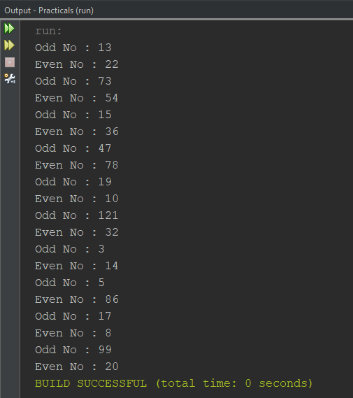

***File:* even.txt**

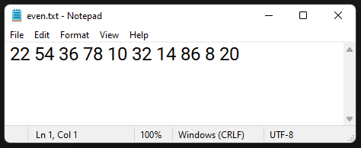

***File:* odd.txt**

