Institute of Computer Technology

B. Tech Computer Science and Engineering

Subject: OOP (2CSE303)

**PRACTICAL-8**

**AIM: - Aashka is designing a module for an office management system which will help her colleagues reduce their work by detecting the duplicate values in their data. Design a java program to implement the concept of array and print duplicate values from two arrays, if any.**

***SOLUTION***

import java.util.*;

public class Prac8 {

public static void main(String[] args) {

System.out.println("Enter size of Array 1: ");

Scanner yash=new Scanner(System.in);

int num1=yash.nextInt();

int arr1[]=new int[num1];

int i,j=0;

for(i=0;i<num1;i++)

{

System.out.println("\nEnter element "+(i+1)+" of Array 1:");

arr1[i]=yash.nextInt();

}

System.out.println("Enter size of Array 2: ");

int num2=yash.nextInt();

int arr2[]=new int[num2];

for(i=0;i<num2;i++)

{

System.out.println("\nEnter element "+(i+1)+" of Array 2:");

arr2[i]=yash.nextInt();

}

System.out.println("Array 1: " + Arrays.toString(arr1));

System.out.println("Array 2: " + Arrays.toString(arr2));

System.out.println("\nCommon Elements Are: ");

for (i = 0; i < 8; i++) {

for (j = 0; j < 8; j++) {

if (arr1[i] == arr2[j]) {

System.out.println(arr1[i]);

}

}

}

}

}

***OUTPUT***

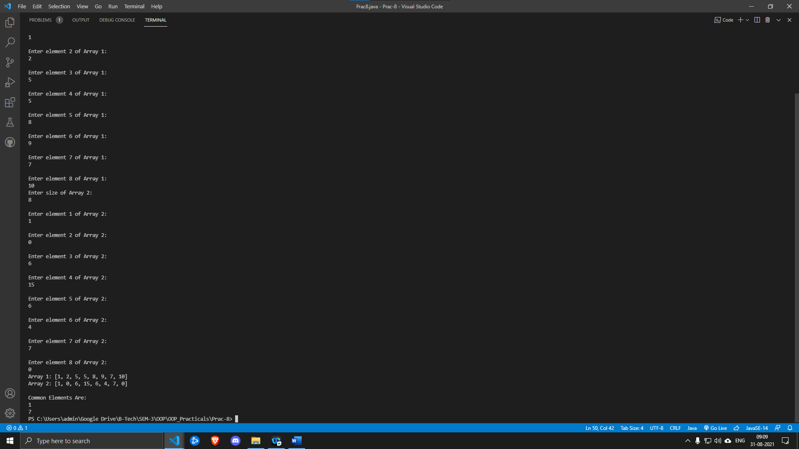

***//My netbeans is not working so I am doing practicals in VS code.***