Institute of Computer Technology

B. Tech Computer Science and Engineering

Subject: OOP (2CSE303)

**PRACTICAL-9**

**AIM: - Rehana has her mathematics assignment deadline today, where she is asked to compute the addition of following values [12,24,1,4] and [2,12,13,21]. Design a java program to help her complete the assignment through a java program implementation.**

***SOLUTION***

import java.util.*;

public class Prac9 {

public static void main(String[] args)

{

int i,j=0;

Scanner yash = new Scanner(System.in);

System.out.println("Enter number rows for 2D array: ");

int a=yash.nextInt();

System.out.println("Enter number columns for 2D array: ");

int b=yash.nextInt();

int array1[][]=new int[a][b];

int array2[][]=new int[a][b];

int sum[][]=new int[a][b];

System.out.println("Input elements of matrix 1: -");

for(i=0;i<a;i++)

{

for(j=0;j<b;j++)

{

array1[i][j]=yash.nextInt();

}

}

System.out.println("Input elements of matrix 2: -");

for(i=0;i<a;i++)

{

for(j=0;j<b;j++)

{

array2[i][j]=yash.nextInt();

}

}

for(i=0;i<a;i++)

{

for(j=0;j<b;j++)

{

sum[i][j]=array1[i][j]+array2[i][j];

}

}

System.out.println("----| OUTPUT |----");

System.out.println("Sum of the matrices: -");

for(i=0;i<a;i++)

{

for(j=0;j<b;j++)

{

System.out.println(sum[i][j]+"\t");

}

System.out.println("\n");

}

}

}

***OUTPUT (formatting for matrix is there in code but maybe its because of compiler that it is not showing output in matrix format)***

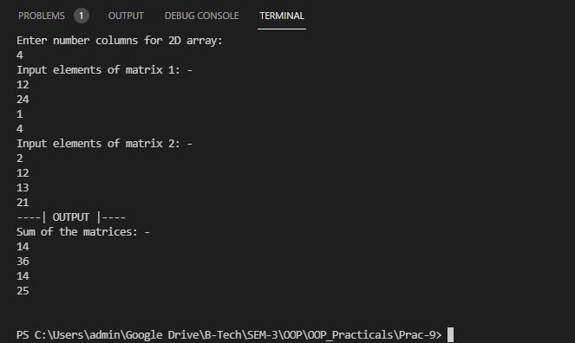

***//My netbeans is not working so I am doing practicals in VS code.***