Chapter: 1
Introduction

1.1 Organization Profile

Name : RadixWeb- Radix Software Services Pvt Ltd

Address : B/H Nirma University, Ekyarth, Near Vandemataram Fabula, Malabar County Rd, Chharodi, Gujarat 382481

Phone: 079 3520 0685

Email : biz@radixweb.in



About :
Radixweb is a globally acclaimed IT consulting and offshore software development leader. Our talented developers, functional knowledge, superior code quality, and expertise around a wide array of programming languages — from .Net to Node.js to React helped thousands of customers outperform.

1.2 System Details

Instagram is a social media platform that allows users to share photos and videos with their followers. It was founded in 2010 and acquired by Facebook in 2012. As of 2021.The platform allows users to create a profile, follow other users, like and comment on posts, and use hashtags to categorize content. Instagram also offers features such as Stories, Reels, IGTV, and Live videos.

1.3 Scope of the System

1. Content Management: This includes features such as creating, editing, and deleting content, as well as content moderation tools to ensure the platform remains safe and appropriate for all users.
2. Messaging: This includes features for direct messaging between users, as well as tools for managing and organizing message threads.
3. Analytics: This includes features for tracking and analyzing user engagement, post performance, and audience demographics.
4. Advertising: This includes features for creating and managing advertising campaigns on the platform, as well as tracking and analyzing campaign performance and ROI.
5. E-commerce: This includes features for businesses to sell products directly to users through the platform, such as product tagging in posts, shopping carts, and in-app checkout.
6. Mobile App: This includes the development and maintenance of the mobile app itself, including user interface design, feature development, and app performance optimization.

1.4 Objectives

1 Social Networking: Instagram is a social media platform that allows users to connect with friends, family, and other people from around the world. It aims to create a community of people who share similar interests, passions, and lifestyles.
2. Visual Storytelling: Instagram's primary objective is to provide a platform for visual storytelling. Users can share their life experiences, adventures, and creativity through photos, videos, and stories.
3. Marketing: Instagram also serves as a marketing platform for businesses and individuals. It allows brands to showcase their products and services, reach out to potential customers, and engage with their audience.
4. Influencer Marketing: Instagram has become a hub for influencer marketing, where individuals with a significant following can promote products and services and influence their followers' purchasing decisions.
5. Entertainment: Instagram's objective is also to provide entertainment to its users. Users can follow their favorite celebrities, watch entertaining videos, and stay updated with the latest trends and news.

CHAPTER: 2
PROPOSED SYSTEM REQUIREMENT GATHERING

CHAPTER: 3
SYSTEM MANAGEMENT AND PLANNIG

3.1 Feasibility Study:
Feasibility is the study of impact, which happens in the organization by the development of a system. The impact can be either positive or negative. When the positives nominate the negatives, then the system is considered feasible.
The main objective of the feasibility study is to test the Technical, Operational and Economical feasibility for adding new modules and debugging old running system. There are aspects in the feasibility study portion of the preliminary investigation:
- Technical Feasibility
- Operation Feasibility
- Economic Feasibility

3.1.1 Technical Feasibility:
- The technical feasibility study focuses on how you will deliver a product or service how you will deliver a product or service through which technology?
- There are number of features which are included into this system the main technologies and the tools which are connected with this system is :
- angular
- nodejs
- mysql
- sequelize
- It is a web based user interface. Thus it provides an easy access to the users.
- To access the system, internet connectivity is must require, because it is web Based websites.
- From these, it is clear that current system developed is technically feasible.

3.1.2 Economical Feasibility:

- Economic feasibility is based on cost and be benefits.
- The cost of hardware and software for the class of application being considered.
- The benefits in the form of reduced costs of fewer costly errors.
- The cost if nothing change (i.e. the proposed system is not developed).
- We are using the open source platform to build our system.
- Thus, the project is economically feasible for both client and us.

3.1.3 Operational feasibility:
- Operational feasibility states how the requirements are satisfied and also provides possible solutions.
- By doing so there is no need for the company either to recruit some special individual to run the system or spend a huge amount to train some individual.
- Thus, the project is operationally individual.
- This project well-planned design would ensure the optimal utilization of the resources and would help in the improvement of performance status.

3.2 Hardware – Software Requirements
Hardware (Recommended)
- Processor: Pentium Microprocessor and above
- Hard Disk: 40 GB or above
- RAM: 2 GB or More
Software (Recommended)
- Windows XP,7,8,8.1,10 or any higher versions of OS
- My SQL
- Any Web Browser
- Internet Connectivity
Technology Used
- Frontend Technology:
- HTML
- CSS
- Angular
- Talwind

- Frontend Tools:
- Subline
- Visual studio code

- Backend Technology:
- Nodejs
- MySQL

- Backend Framework:
- Express

Chapter : 4
System Analysis and Design

4.1 UML (unified modeling language)

4.1.1 Use case
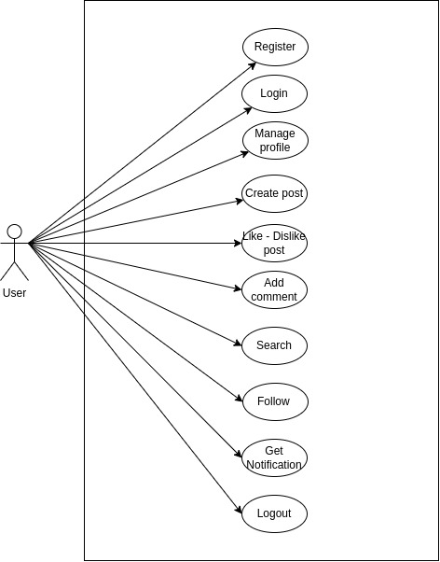

4.1.2Activity diagram

- Start: User opens app - The diagram starts with the user opening the Instagram app.
- User logs in or signs up - The user is prompted to either log in with their existing account credentials or sign up for a new account.
- User sees home feed - Once the user is logged in, they are taken to the home feed where they can see a list of posts from other users they follow.
- User clicks on a post - The user can click on a post from their home feed to view it in more detail.
- User views post details - This step shows that the user can see more information about a post, including the photo or video, caption, likes, and comments.
- User leaves a comment - If the user wants to, they can leave a comment on the post they are viewing.
- User likes the post - The user can also choose to like the post they are viewing.
- User shares the post - If the user wants to share the post with their own followers, they can choose to do so.
- User follows a profile - The user can choose to follow the profile of the user who posted the content they liked or shared.
- User searches for a user - The user can search for other users they may be interested in following by typing in their username or name in the search bar.
- User views their profile - The user can view their own profile to see the posts they have shared, the number of followers they have, and other information.
- User edits their profile - If the user wants to make changes to their own profile, they can do so by selecting the "Edit Profile" option.
- End: User logs out - The user can choose to log out of their account to end the session

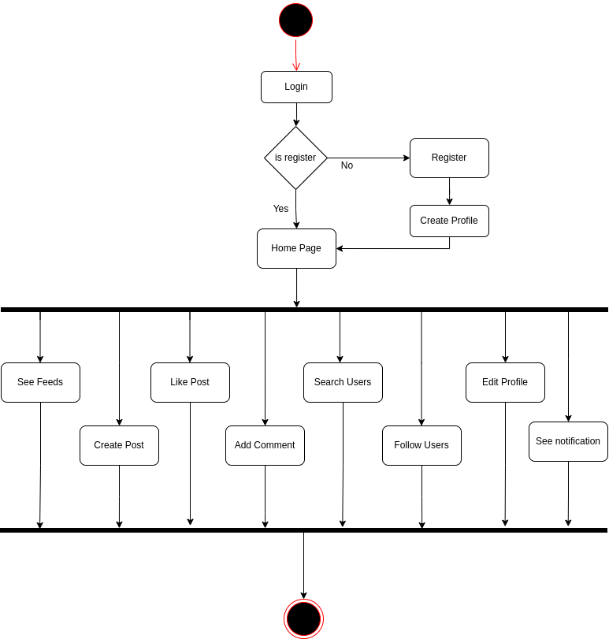

4.2 System Flow Diagram

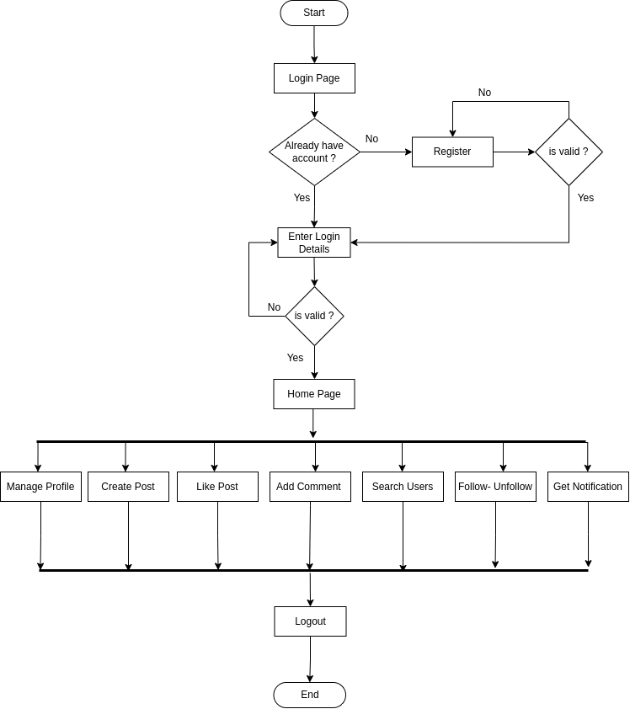

4.3 Data Dictionary

Table name: User Table
Field | Type | Null | Key | Default
id | int | No | PRI | auto_increment
username | varchar(255) | No | Unique
firstname | varchar(255) | No | Forign_key
lastname | varchar(255) | No
mobile | varchar(255) | No | Unique
email | varchar(255) | No | Unique
password | varchar(255) | No
isActive | Boolean | No |  | False
created_at | Datetime | No |  | current_timestamp
updated_at | Datetime | Yes

Table name: UserProfile Table

Field | Type | Null | Key | Default
id | int | No | PRI | auto_increment
userId | int | No | Forign_key
profile_img | varchar(255) | yes |  | Avtar.png
bio | Text | yes
dob | Datetime | yes
gender | varchar(255) | No
city | varchar(255) | Yes
country | varchar(255) | Yes
no_of_followers | int | No |  | 0
no_of_following | int | No |  | 0
created_at | Datetime | No |  | current_timestamp
updated_at | Datetime | Yes

Table name: OtpStorage Table

Field | Type | Null | Key | Default
id | int | No | PRI | auto_increment
userId | int | No | Forign_key
otp | varchar(255) | No
created_at | Datetime | No |  | current_timestamp
updated_at | Datetime | Yes

Table name: Followers Table

Field | Type | Null | Key | Default
id | int | No | PRI | auto_increment
userId | int | No | Forign_key
followerId | int | No | Forign_key
status | varchar(255) | No |  | Pending
created_at | Datetime | No |  | current_timestamp
updated_at | Datetime | Yes

Table name: Post Table

Field | Type | Null | Key | Default
id | int | No | PRI | auto_increment
userId | int | No | Forign_key
content | text | Yes
created_at | Datetime | No |  | current_timestamp
updated_at | Datetime | Yes

Table name: PostImages Table

Field | Type | Null | Key | Default
id | int | No | PRI | auto_increment
postId | int | No | Forign_key
imagePath | text | No
created_at | Datetime | No |  | current_timestamp
updated_at | Datetime | Yes

Table name: LikesPost Table

Field | Type | Null | Key | Default
id | int | No | PRI | auto_increment
postId | int | No | Forign_key
likedBy | int | No | Forign_key
created_at | Datetime | No |  | current_timestamp
updated_at | Datetime | Yes

Table name: CmtsPost Table

Field | Type | Null | Key | Default
id | int | No | PRI | auto_increment
postId | int | No | Forign_key
cmtBy | int | No | Forign_key
comment | text | No
parentId | Int | No | Forign_key
created_at | Datetime | No |  | current_timestamp
updated_at | Datetime | Yes

Table name: Notification Table

Field | Type | Null | Key | Default
id | int | No | PRI | auto_increment
userId | int | No | Forign_key
type | varchar(255) | No
notificationId | int | No | Forign_key(llike,cmt,follow)
message | text | No
isRead | Boolean | No |  | false
created_at | Datetime | No |  | current_timestamp
updated_at | Datetime | Yes

