**CORE BANKING- BATCH 56**

**Name: Yash Prasad**

**Resume number: 22856820**

**Role: Bank staff (Modify account details, Credit Money to account, Queue/ Report of account)**

#include<iostream>

#include<fstream>

#include<cctype>

#include<iomanip>

using namespace std;

class account

{

int acno;

char name[50];

int deposit;

char type;

public:

void create_account();

void show_account() const;

void modify();

void dep(int);

void report() const;

int retacno() const;

int retdeposit() const;

};

void account::create_account()

{

cout<<"\nEnter The account No. : ";

cin>>acno;

cout<<"\n\nEnter The Name of The account Holder : ";

cin.ignore();

cin.getline(name,50);

cout<<"\nEnter Type of The account (C/S) : ";

cin>>type;

type=toupper(type);

cout<<"\nEnter The Initial amount(>=500 for Saving and >=1000 for current ) : ";

cin>>deposit;

cout<<"\n\n\nAccount Created..";

}

void account::show_account() const

{

cout<<"\nAccount No. : "<<acno;

cout<<"\nAccount Holder Name : ";

cout<<name;

cout<<"\nType of Account : "<<type;

cout<<"\nBalance amount : "<<deposit;

}

void account::modify()

{

cout<<"\nAccount No. : "<<acno;

cout<<"\nModify Account Holder Name : ";

cin.ignore();

cin.getline(name,50);

cout<<"\nModify Type of Account : ";

cin>>type;

type=toupper(type);

cout<<"\nModify Balance amount : ";

cin>>deposit;

}

void account::dep(int x)

{

deposit+=x;

}

void account::report() const

{

cout<<acno<<setw(10)<<" "<<name<<setw(10)<<" "<<type<<setw(6)<<deposit<<endl;

}

int account::retacno() const

{

return acno;

}

int account::retdeposit() const

{

return deposit;

}

void write_account();

void modify_account(int);

void display_all();

void deposit_withdraw(int);

void intro();

int main()

{

char ch;

int num;

intro();

do

{

system("cls");

cout<<"\n\n\n\tMAIN MENU";

cout<<"\n\n\t01. NEW ACCOUNT";

cout<<"\n\n\t02. DEPOSIT AMOUNT";

cout<<"\n\n\t05. ALL ACCOUNT HOLDER LIST";

cout<<"\n\n\t07. MODIFY AN ACCOUNT";

cout<<"\n\n\t08. EXIT";

cout<<"\n\n\tSelect Your Option (1-8) ";

cin>>ch;

system("cls");

switch(ch)

{

case '1':

write_account();

break;

case '2':

cout<<"\n\n\tEnter The account No. : "; cin>>num;

deposit_withdraw(num);

break;

case '5':

display_all();

break;

case '7':

cout<<"\n\n\tEnter The account No. : "; cin>>num;

modify_account(num);

break;

case '8':

cout<<"\n\n\tThanks for using bank managemnt system";

break;

default :cout<<"\a";

}

cin.ignore();

cin.get();

}while(ch!='8');

return 0;

}

void write_account()

{

account ac;

ofstream outFile;

outFile.open("account.dat",ios::binary|ios::app);

ac.create_account();

outFile.write(reinterpret_cast<char *> (&ac), sizeof(account));

outFile.close();

}

void modify_account(int n)

{

bool found=false;

account ac;

fstream File;

File.open("account.dat",ios::binary|ios::in|ios::out);

if(!File)

{

cout<<"File could not be open !! Press any Key...";

return;

}

while(!File.eof() && found==false)

{

File.read(reinterpret_cast<char *> (&ac), sizeof(account));

if(ac.retacno()==n)

{

ac.show_account();

cout<<"\n\nEnter The New Details of account"<<endl;

ac.modify();

int pos=(-1)*static_cast<int>(sizeof(account));

File.seekp(pos,ios::cur);

File.write(reinterpret_cast<char *> (&ac), sizeof(account));

cout<<"\n\n\t Record Updated";

found=true;

}

}

File.close();

if(found==false)

cout<<"\n\n Record Not Found ";

}

void display_all()

{

account ac;

ifstream inFile;

inFile.open("account.dat",ios::binary);

if(!inFile)

{

cout<<"File could not be open !! Press any Key...";

return;

}

cout<<"\n\n\t\tACCOUNT HOLDER LIST\n\n";

cout<<"====================================================\n";

cout<<"A/c no. NAME Type Balance\n";

cout<<"====================================================\n";

while(inFile.read(reinterpret_cast<char *> (&ac), sizeof(account)))

{

ac.report();

}

inFile.close();

}

void deposit_withdraw(int n)

{

int amt;

bool found=false;

account ac;

fstream File;

File.open("account.dat", ios::binary|ios::in|ios::out);

if(!File)

{

cout<<"File could not be open !! Press any Key...";

return;

}

while(!File.eof() && found==false)

{

File.read(reinterpret_cast<char *> (&ac), sizeof(account));

if(ac.retacno()==n)

{

ac.show_account();

cout<<"\n\n\tTO DEPOSITE AMOUNT ";

cout<<"\n\nEnter The amount to be deposited";

cin>>amt;

ac.dep(amt);

int pos=(-1)*static_cast<int>(sizeof(ac));

File.seekp(pos,ios::cur);

File.write(reinterpret_cast<char *> (&ac), sizeof(account));

cout<<"\n\n\t Record Updated";

found=true;

}

}

File.close();

if(found==false)

cout<<"\n\n Record Not Found ";

}

void intro()

{

cout<<"\n\n\n\t BANK";

cout<<"\n\n\tMANAGEMENT";

cout<<"\n\n\t SYSTEM";

cout<<"\n\n\n\nMADE BY : Yash Prasad";

cout<<"\n\n Press any key to continue";

cin.get();

}

**Output**

**Project Interface**

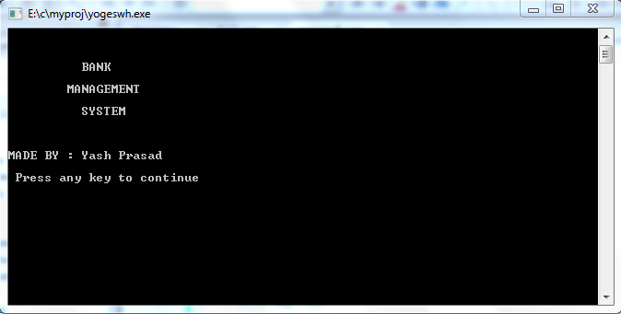

**Main Menu**

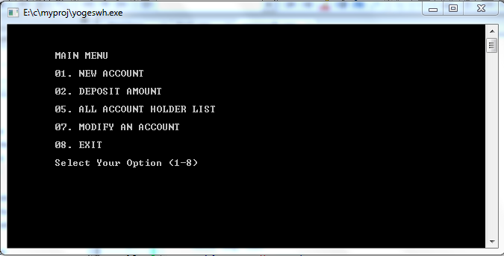

**New Account**

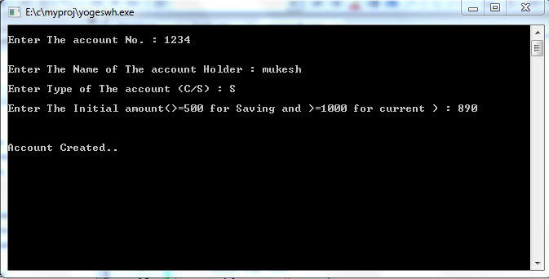

**Deposit Amount**

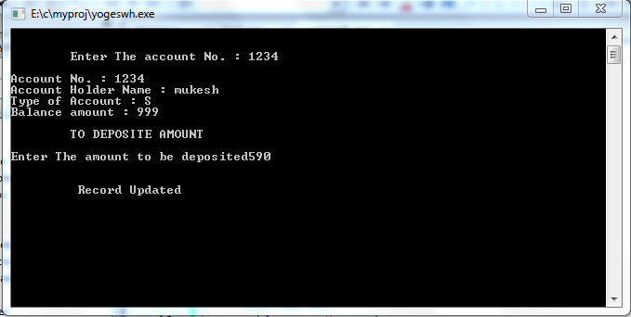

**Account holder list**

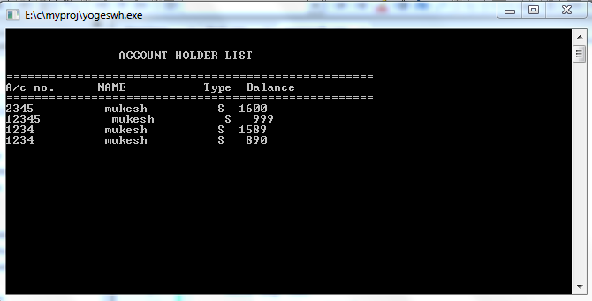

**Modify Account**

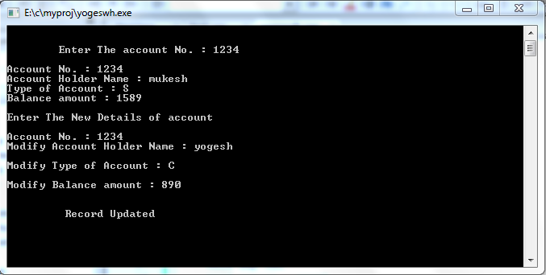

**End Screen**

