**● Write SQL query to solve the problem given below.**

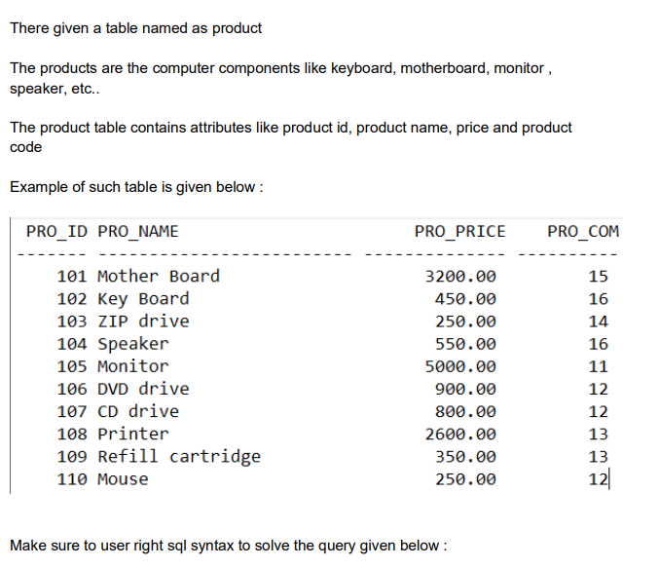

**\*CREATE PRODUCT TABLE:**

CREATE TABLE product

(

pro_id int,

pro_name varchar (50),

PRO_price float,

pro_com INT

);

**\*INSERT VALUE IN PRODUCT TABLE:**

INSERT INTO product VALUES (101,'Mother Board','3200.00',15);

INSERT INTO product VALUES (102,'Key Board','450.00',16);

INSERT INTO product VALUES (103,'ZIP drive','250.00',14);

INSERT INTO product VALUES (104,'Speaker','550.00',16);

INSERT INTO product VALUES (105,'Moniter','5000.00',11);

INSERT INTO product VALUES (106,'DVD drive','900.00',12);

INSERT INTO product VALUES (107,'CD drive','800.00',12);

INSERT INTO product VALUES (108,'Printer','2600.00',13);

INSERT INTO product VALUES (109,'Refill Cartirdge','350.00',13);

INSERT INTO product VALUES (110,'Mouse','250.00',12);

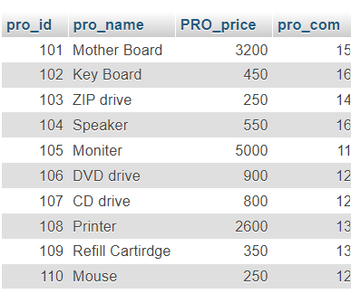

**● Write SQL query to find the items whose prices are higher than or equal 250rs.**

**ANS:** SELECT pro_name, PRO_price FROM product WHERE PRO_price>=250;

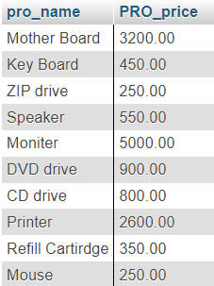

**● Order the result by product price in descending, then product name in ascending. Return pro_name and pro_price.**

**ANS**: SELECT PRO_price, pro_name FROM product ORDER BY PRO_price DESC,pro_name ASC;

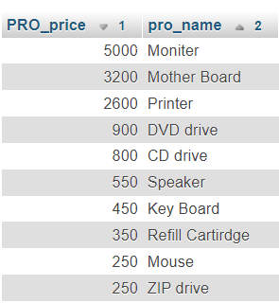

**● Write a SQL query to find the cheapest item. Return pro_name and pro_price.**

**ANS**: SELECT pro_name, MIN(PRO_price) FROM product;



**● Write the SQL query to calculate the average price of the items for each company. Return average price and company code.**

**ANS**: SELECT pro_com, AVG(PRO_price) FROM product GROUP BY pro_com;

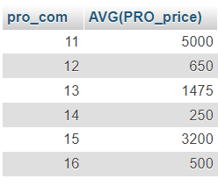

**● Write the SQL query to find the average total for all the product mention in the table.**

**ANS**: SELECT AVG(PRO_price) FROM product;

