# **Overview of IT**

# 1)what is software? what is software Engineering?

Answer:

-Software is set of instruction and command to execute computer or execute set of tasks.

-which describe the logical aspect of computer.

**\*Software Engineering:**

-software engineering is the process of designing, developing, testing, and maintaining software.

-it is Systematic and disciplined approach to software development that aims to create high quality, reliable, and manageable software.

**2)Explain types of software.**

-there are types of software.

**\*Types**

1.Application Software

2.System Software

3.Driver software

4.middleware

5.programming software

**1.Application Software:**

-A software which is made by developer is called Application software.

-Popular web browser like Google chrome, Firefox are example of Application software.

-In application software also available mobile app like WhatsApp, Instagram, Facebook.

**2.System Software**

-System software is type of computer program that is designed to run a computer’s hardware and application programs.

-It is in-built system.

-Ex: operating system (like Android, macOS, windows), notepad, calendar.

**3.Driver software:**

-Also known as device driver.

-It controls the devices.

-Driver software is making communication between application and hardware.

-It is bridge between different components.

-Ex: keyboard, headphone, printer, USB devices etc.

4.**middleware:**

**-** It mediates between application and system software or two application software.

-A web server is middleware that connects website to the backend database.

**5.programming software:**

-Computer programmers use programming software to write code.

-Programming software and programming tools enable developers to develop, write, test, and debug other software programs.

-It includes compilers, assemblers, debuggers, interpreters.

-Ex: turbo c, visual studio, Eclipse.

# **3)what is SDLC? Explain each phase of SDLC.**

Answer.

-SDLC stand for software development life cycle.

-SDLC is step by step process that is used to Design, Develop, and test good quality software.

-It is based on time and cost.

**\*Phases of SDLC.**

1.planning

2.analysis

3.desing

4.implementation

5.testing and integration

6.maintanance

*Diagram

-The main goal of SDLC is make good quality product which is manageable based on user’s requirement.

**1.planning-**

-In first phase you are gathering information from client is call planning.

-we decide timelines in planning for ensure the project is completed on time.

**2.analysis-**

-Second phase is analysis.

-In analysis you have to get information about client requirement from client.

-And gathering materials and tools before starting to build.

**3.design-**

-The design phase of software development life cycle is creating the design of project.

-In this phase, we create a detailed design of how the software will look and function.

-It’s like making blueprint before building a house.

-Data Flow Diagrams (DFD), use case diagram and flow chart is available to design.

**4.implementation-**

-This phase is start after the system’s design is accepted by the user.

-The implementation phase involves putting the project plan into action.

-Developer write code based on the design.

**5.testing & integration-**

-Once the software is ready then components are integrated and tested by testing team.

-This phase is useful for finding the bug and fixing the bug.

-It’s like all code is working.

**6.maintenance-**

-It is last stage of SDLC life cycle.

-Where the product is updated and fixed after it is released.

-Software needs maintenance to keep it running smoothly.

-It also adds new features in software.

3)what is DFD? create a DFD diagram on Flipkart.

Answer:

-A Data Flow Diagram (DFD) maps out the flow of information for any process or system.

-It is a graphical tool, useful for communicating with user, manager and other.

**\*It provides an overview of**

-What data is system processes.

-What transformation are performed.

-What data are stored.

-what result are produced.

**\*The Data Flow Diagram has 4 components.**

1)process

2)Data Flow

3)Data Store

4)External Entity

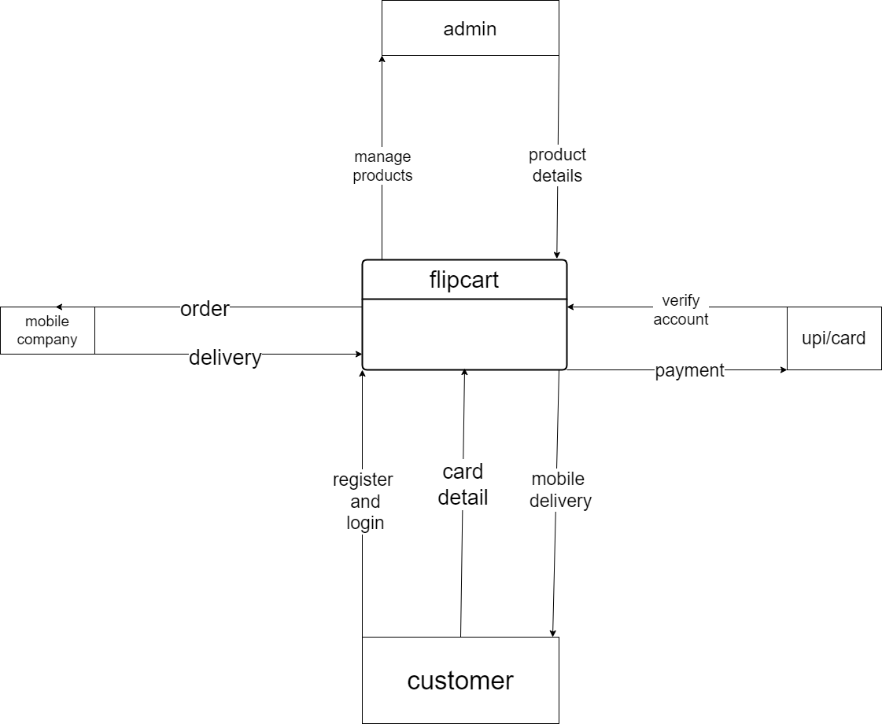

**Fig: Zero level DFD diagram**

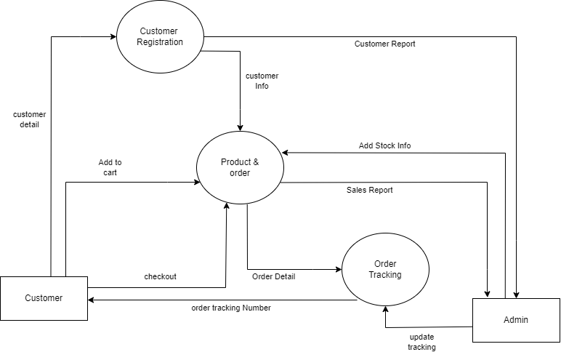

**Fig: First level DFD diagram**

5)what is Flow chart? Create a Flow chart to make Addition of two numbers.

Answer:

-A Flowchart is a type of diagram that Represents a process.

-It is step by step process for solving task.

-It uses symbol, shape and Arrows to show process.

-It Arrange the Activity in proper way.

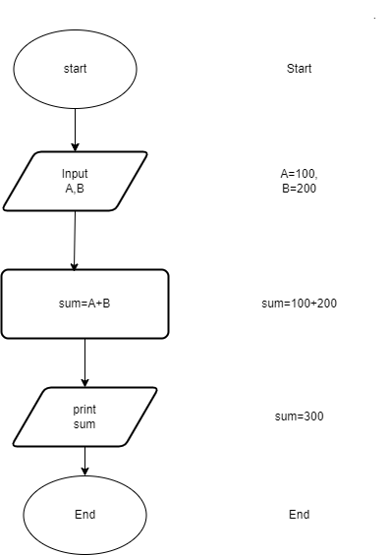

**Fig: Flowchart of Addition**

6) What is Use case Diagram? Create a use-case on bill payment on Paytm.Answer:-A use case diagram is Represents how user interact with a system.

-It is type of UML (User Modeling Language) diagram.

*Component of use case

-Actor

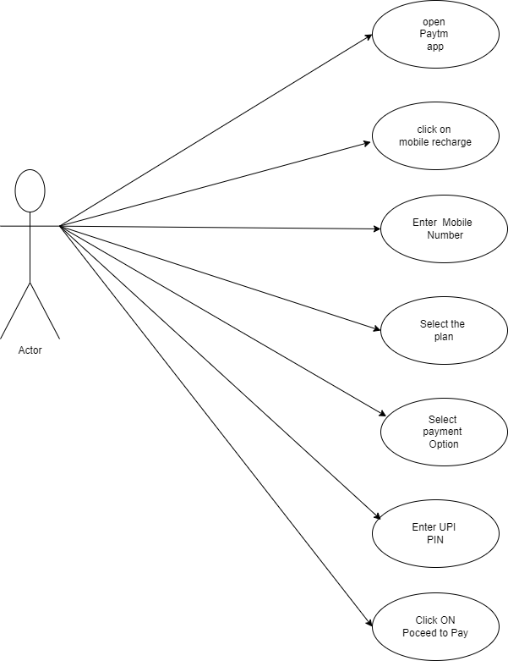-Use Case

-Associations

**Fig: use-case Diagram on Mobile Recharge**