**YASH RAJ MISHRA- Backend development and structure of website.**

**(20BCE10872)**

I have constructed the structure of website as well as the schema of table of the website.

This includes working with PHP, LARAVEL and Vuejs which are the key technologies I have used to build the project.

Using vue js in template I have made the structure of the pages

Using Laravel table schema and model, migration ,controller I have formed the tables of data of users and made the database for our users.

Using ROUTE of Laravel I have defined the url and their corresponding views blade.html

I have used controller also for giving some functionality to the database like request enteries and input and their processing for their respected results ..etc. these controllers have helped me in fetching the data as well as getting it into database.

**ARCHITECTURE OF WEBSITE:**

->THIS website provides the bot which are accessible to the user any time user wants.

Using <form> tag in html we have created this “yes” and “no” which is provides user the option of whether he/ she wants to get that bot or not.

Now if the user selects “yes” the this means he wants and then it goes to the sign-in page where if his records matches with any of the record of the database the he can download the bot and then finally after putting his inputs if his records matches then he will be redirected to download page where he can just click over the download and can download the bot.

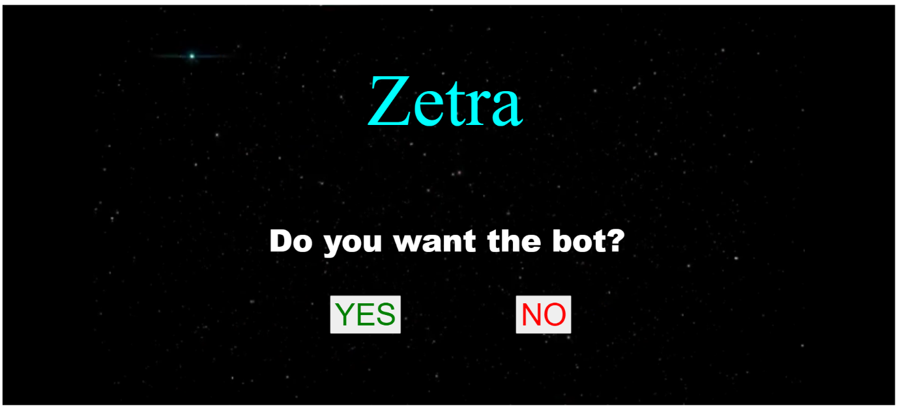Fig-4:

In this image : The website is asking whether user wants to use bot or not….



Fig-5

here user will sign in its data and if the data matches with the current database records then only user can sign in



Fig-6

This image shows the page where one can download the bot after authentication and can then manage their parking lots.

**YASHRAJ SINGH- Backend development**

I have contributed in backend development including queries in SQL. I have also contributed somewhat in the database tables along with Yash raj Mishra who is team mate in this project.

I have also contributed in HTML design and structure to the website and given important contributions through my ideas and skills related to Html and SQl.