**Backend:**

**index.js**

const express = require("express")  
app = express();  
app.use(express.json());  
  
app.use(function (req, res, next) {  
    // Website you wish to allow to connect  
    res.setHeader('Access-Control-Allow-Origin', '*');  
    // Request methods you wish to allow  
    res.setHeader('Access-Control-Allow-Methods', 'GET, POST, OPTIONS, PUT, PATCH, DELETE');  
    // Request headers you wish to allow  
    res.setHeader('Access-Control-Allow-Headers', 'X-Requested-With,content-type');  
    // Set to true if you need the website to include cookies in the requests sent  
    // to the API (e.g. in case you use sessions)  
    res.setHeader('Access-Control-Allow-Credentials', true);  
    // Pass to next layer of middleware  
    next();  
});  
  
var data = {  
    firstName: "",  
    lastName:"",  
    age:"",  
    college:""  
}  
app.get("/", (req, res) => {  
    res.status(200).json(data);  
})  
[app.post](http://app.post/)("/", (req, res) => {  
    const userData = req.body  
    data = userData;  
  
    console.log(data)  
    res.status(200).json(data);  
});  
  
app.listen(3000, () => {  
    console.log("[http://localhost:3000](http://localhost:3000/)")  
});

**package.json**

{  
  "name": "backend",  
  "version": "1.0.0",  
  "description": "",  
  "main": "index.js",  
  "scripts": {  
    "test": "nodemon index.js"  
  },  
  "keywords": [],  
  "author": "",  
  "license": "ISC",  
  "dependencies": {  
    "express": "^4.18.2"  
  },  
  "devDependencies": {  
    "nodemon": "^2.0.20"  
  }  
}

**Frontend:**

**index.html**

<!doctype html>

<html lang="en">

<head>

<title>Assignment 1B</title>

<meta charset="utf-8">

<meta name="viewport" content="width=device-width, initial-scale=1, shrink-to-fit=no"> <link href="https://cdn.jsdelivr.net/npm/bootstrap@5.2.1/dist/css/bootstrap.min.css" rel="stylesheet" integrity="sha384-iYQeCzEYFbKjA/T2uDLTpkwGzCiq6soy8tYaI1GyVh/UjpbCx/TYkiZhlZB6+fzT" crossorigin="anonymous">

<script src="https://ajax.googleapis.com/ajax/libs/jquery/3.6.3/jquery.min.js"></script>

</head>

<body>

<div class="container my-4">

<main id="output" class="bg-dark text-light p-4 rounded mb-4 w-50 mx-auto" style="letter-spacing: 2px;">

</main>

<div class="w-50 mx-auto mb-4 text-end">

<button class="btn btn-dark" onclick="fetchData()">Reload</button>

</div>

<form id="addNumberForm" class="p-4 border shadow-sm w-50 mx-auto"><div class="mb-2"><label for="firstName" class="form-label">First Name</label><input value="sumit" type="text" class="form-control" name="firstName" required id="firstName" aria-describedby="helpId" placeholder="Enter Your First Name">

</div>

<div class="mb-2">

<label for="lastName" class="form-label">Last Name</label>

<input value="kawale" type="text" class="form-control" name="lastName" required id="lastName" aria-describedby="helpId" placeholder="Enter Your Last Name">

</div>

<div class="mb-2">

<label for="age" class="form-label">Age</label>

<input value="21" type="text" class="form-control" name="age" required id="age" aria-describedby="helpId" placeholder="Enter Your Age"></div><div class="mb-3">

<label for="college" class="form-label">College Name</label>

<input value="pict" type="text" class="form-control" name="college" required id="college" aria-describedby="helpId" placeholder="Enter Your College Name">

</div>

<button type="submit" class="btn btn-primary">Submit</button>

<hr>

<small class="small text-success" id="msg"></small>

</form>

</div>

<script>

const output = document.getElementById("output");

function fetchData() {

var xhttp = new XMLHttpRequest();

xhttp.onreadystatechange = function() {

if (this.readyState == 4 && this.status == 200) {

let data = JSON.parse(xhttp.responseText)

let string = `name: ${data.firstName} ${data.lastName} <hr>age: ${data.age}<hr>college: ${data.college}`;

output.innerHTML = string;

w = window.open();

w.document.body.innerHTML = "<h1>User Details</h1><h3>";

w.document.body.innerHTML += string;

w.document.body.innerHTML += "</h3>";

}

};

xhttp.open("GET", "http://localhost:3000/", true);

xhttp.send();

}

document.body.onload = () => {

fetchData()

document.forms.addNumberForm.addEventListener("submit", (event) => {

event.preventDefault();

const firstName = event.target.firstName.value;

const lastName = event.target.lastName.value;

const age = event.target.age.value;

const college = event.target.college.value;

$("#msg").html("")

$.ajax({

type: 'post',

url: 'http://localhost:3000/',

data: JSON.stringify({

firstName, lastName, age, college

}),

contentType: "application/json; charset=utf-8",

traditional: true,

success: function(data) {

fetchData();

$("#msg").html("User Details Updated")

}

});

})

};

</script>

</body>

</html>

**OUTPUT:**

**Home Page Before submitting any response:**

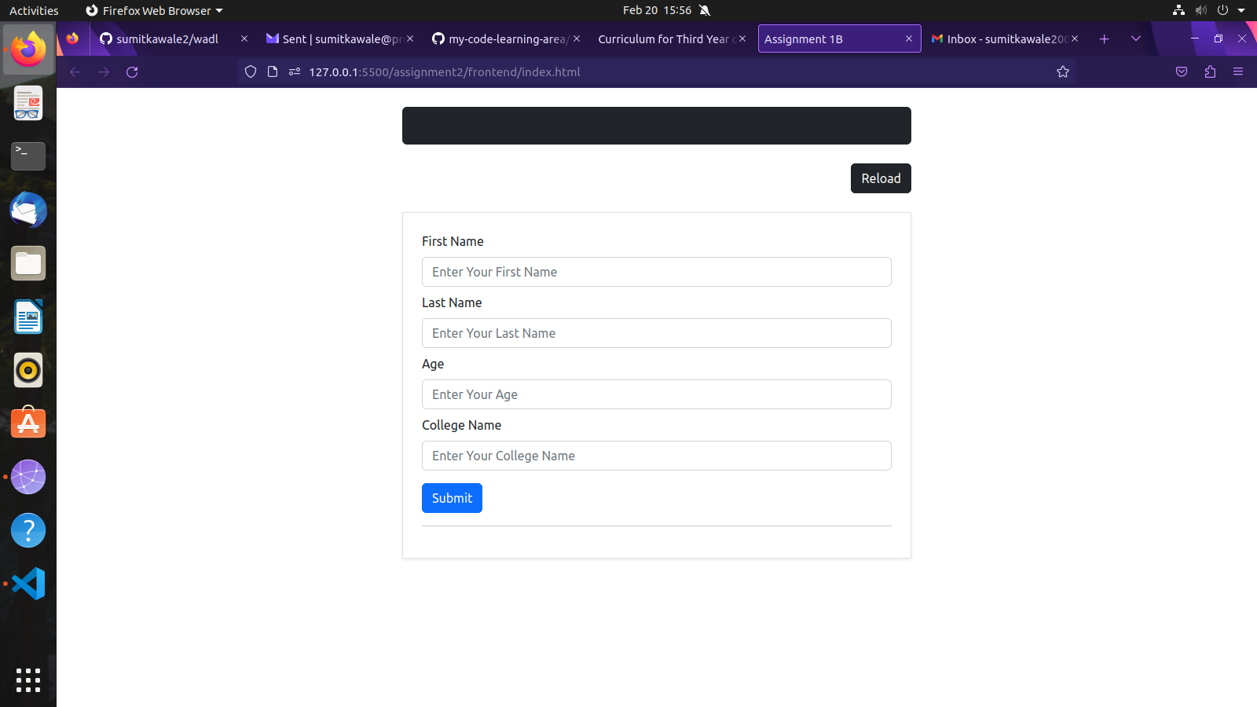

After Submitting the form:

Home Page After Submitting form:

