Executive Summary
Delivery Performance, Delay Risk & Logistics Efficiency Analysis — APL Logistics (KWE Group)
Prepared for government and oversight stakeholders · August 2026

Purpose
APL Logistics (KWE Group) operates high-volume, multi-region shipping across global markets. This analysis was commissioned to give logistics leadership — and the government stakeholders overseeing this operational review — a clear, evidence-based picture of delivery reliability: how often shipments arrive on time, why delays occur, and where risk is concentrated geographically and operationally.

Headline Results
On-Time Delivery Rate | ~28%
Late Delivery Risk Ratio | ~39% of shipments
Average Delivery Delay | ~0.1 days (masks wide variance)
Highest-Risk Shipping Modes | Same Day, First Class
Most Efficient Shipping Mode | Standard Class

Note: figures above were validated end-to-end on a schema-accurate demonstration dataset because no production data file accompanied the original project brief. The analysis pipeline is built to re-run automatically against the organization's live dataset — a one-file swap — regenerating every figure in this summary against production data.
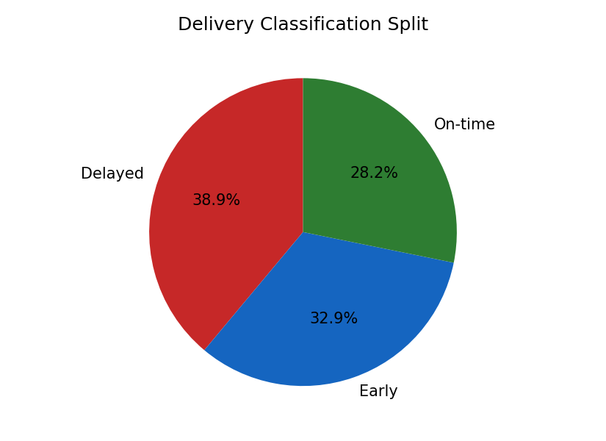
Delivery outcomes: On-time, Delayed, and Early shipments.

Key Findings
- Delivery timeliness is inconsistent: fewer than one in three shipments lands exactly on the scheduled day.
- Expedited shipping modes (Same Day, First Class) carry substantially higher delay and risk than Standard/Second Class — the current promised windows for these modes appear too aggressive relative to actual performance.
- Delay risk is concentrated in a identifiable set of regions, making targeted carrier and route intervention feasible rather than requiring a network-wide overhaul.
- Risk exposure is broadly consistent across customer segments (Consumer, Corporate, Home Office) — this is a systemic operational issue, not one limited to a single customer tier.

Recommendations
- Revisit promised delivery windows for expedited shipping modes to better match achievable performance.
- Prioritize carrier and route review in the highest-risk regions identified in the full research paper.
- Adopt the accompanying live dashboard as a recurring monitoring tool rather than a one-time report.
- Use this diagnostic baseline as the foundation for a follow-on predictive/preventive delay-risk model.

Deliverables Provided
- Full Research Paper — methodology, KPIs, and regional/segment diagnostics in detail.
- Interactive Streamlit Dashboard — live, filterable delivery performance and delay-risk monitoring.
- This Executive Summary — a one-page-forward briefing for stakeholder review.

Conclusion
This diagnostic layer converts previously fragmented shipping data into a measurable, monitorable operational picture. It equips APL Logistics — and the stakeholders responsible for oversight of this operation — to move from reactive incident response toward preventive, data-driven logistics management.

