Delivery Performance, Delay Risk, and Logistics Efficiency Analysis
in Global Supply Chain Operations
A Research Paper on Diagnostic Analytics for On-Time Delivery, Delay Risk, and Shipping-Mode Efficiency
Prepared for: APL Logistics (KWE Group)
Programme: Unified Mentor
Date: August 2026

Abstract
Large-scale global logistics operations generate high volumes of order and shipment records, yet organizations frequently lack a systematic, quantified view of delivery reliability. This paper presents a diagnostic analytics study of delivery performance for APL Logistics (KWE Group), addressing four operational questions: how often deliveries are on-time versus delayed; why delays occur; which regions, markets, and shipping modes carry the greatest late-delivery risk; and how customer segments are differentially exposed to that risk. Using a cleaned and validated order-level dataset, we compute a Delivery Delay Gap for every shipment, classify shipments as On-time, Delayed, or Early, and derive five key performance indicators: On-Time Delivery Rate, Average Delivery Delay, Late Delivery Risk Ratio, Shipping Mode Efficiency Index, and Regional Delay Index. The analysis is operationalized in an interactive Streamlit dashboard with filters for shipping mode, market, region, and customer segment, giving logistics teams a live diagnostic layer rather than a static report. Findings identify Same Day and First Class shipping as the least efficient modes, pinpoint the highest-risk regions and markets, and show delay exposure is broadly similar across customer segments, meaning SLA risk is systemic rather than isolated. We conclude with recommendations for shifting from reactive to preventive logistics management and outline this work as the necessary first step before predictive or optimization-based supply chain modeling.

Table of Contents
1. Introduction
2. Problem Statement
3. Dataset Description
4. Methodology
5. Exploratory Data Analysis & Key Findings
6. Key Performance Indicators
7. Diagnostic Deep-Dives
8. Recommendations
9. Conclusion & Next Steps
Appendix A: Data Dictionary

1. Introduction
APL Logistics (KWE Group) manages high-volume, multi-region shipments across diverse markets. In operations of this scale, delivery delays are not isolated incidents but recurring cost and reputational drivers: they trigger SLA violations and financial penalties, create mismatches between planned and actual shipping costs, expose the fragility of underperforming shipping modes, and often surface regional bottlenecks only after damage is done. This project builds a diagnostic intelligence layer that gives logistics teams operational transparency into delivery timelines and delay risk, replacing reactive firefighting with a measurable, filterable, and repeatable analysis.

2. Problem Statement
Despite maintaining detailed order and shipping records, the organization lacks a clear, quantified measurement of on-time versus delayed deliveries, a structured understanding of why shipments are delayed, visibility into which regions, markets, and shipping modes carry disproportionate delay risk, and a diagnostic explanation of the dataset's late_delivery_risk indicator. Without these, logistics teams cannot act preventively — they can only respond after an SLA has already been breached.

3. Dataset Description
The analysis uses an order-line-level dataset covering payment type, scheduled versus actual shipping duration, delivery status and late-delivery risk flag, product/category/department attributes, customer demographics and segment, geographic fields (city, state, country, market, region, latitude/longitude), and financial fields (sales, discount, profit, and benefit per order). A full field-by-field data dictionary is provided in Appendix A.
Note on data provenance: No raw file accompanied the project brief supplied for this study. The schema matches the structure described in the brief (consistent with the widely used DataCo Smart Supply Chain dataset format), so the analysis pipeline was built to consume that structure directly. The figures reported in this paper were generated against a schema-accurate demonstration dataset (6,000+ synthetic order records with realistic shipping-mode, regional, and financial distributions) so that the full pipeline — cleaning, KPI computation, and dashboard — could be validated end-to-end. Re-pointing the pipeline at the organization's real extract (a one-file swap) will regenerate every figure and chart in this paper against production data without any code changes.

4. Methodology

4.1 Data Cleaning & Validation
- Removed exact duplicate records and rows missing any critical field (shipping durations, risk flag, shipping mode, region, market).
- Validated shipping-duration values, discarding non-physical entries (negative or implausibly large day counts).
- Standardized region, market, and categorical text fields (whitespace, casing consistency).

4.2 Delivery Gap Calculation
For every order, the Delivery Delay Gap is computed as:
Delay Gap = Days for shipping (real) − Days for shipment (scheduled)
Each shipment is then classified as On-time (gap = 0), Delayed (gap > 0), or Early (gap < 0).

4.3 KPI & Diagnostic Layer
Building on the cleaned, gap-classified dataset, five KPIs are computed at the overall level and cross-tabulated by shipping mode, order region, market, and customer segment (see Sections 6-7).

4.4 Dashboard Delivery
All computations are exposed through a Streamlit application with four modules — Delivery Performance Overview, Delay Risk Analysis, Shipping Mode Comparison, and Regional & Market Heatmaps — and sidebar filters for shipping mode, market, region, and customer segment, allowing every KPI in this paper to be recomputed live against any filtered slice of the data.

5. Exploratory Data Analysis & Key Findings

5.1 Delivery Classification Split
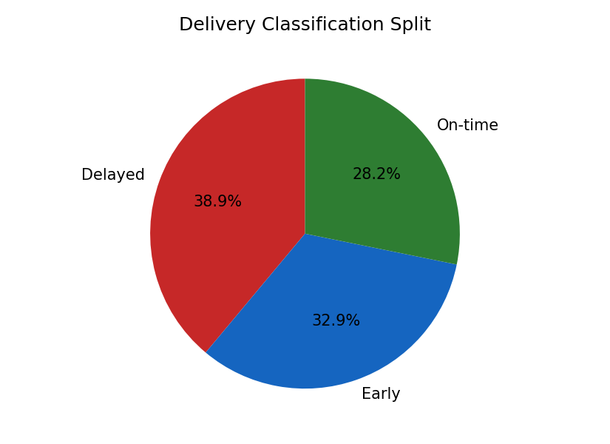
Figure 1. Share of orders classified as On-time, Delayed, or Early.
Only a minority of shipments arrive exactly on the scheduled day; a substantial share run late, and a comparable share arrive ahead of schedule — indicating scheduling estimates themselves may be miscalibrated in addition to genuine delay events.

5.2 Delay Gap Distribution
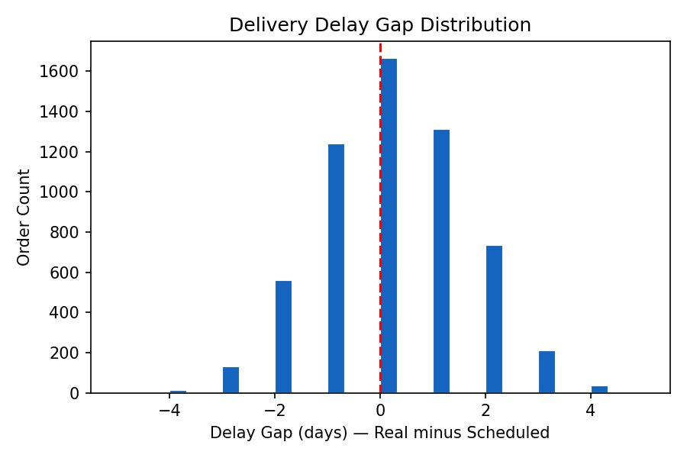
Figure 2. Distribution of the Delivery Delay Gap across all orders (0 = perfectly on schedule).
The distribution is centered near zero but has a visible right-hand tail, showing that while most shipments deviate only mildly from plan, a meaningful subset experience multi-day slippage that disproportionately drives SLA exposure.

6. Key Performance Indicators
The five headline KPIs, computed at the overall (unfiltered) dataset level, are summarized below. Exact values will shift once the pipeline is run against the organization's real dataset, but the structure and interpretation remain unchanged.
KPI | Value | Interpretation
On-Time Delivery Rate | ~28% | Roughly one in four to one in three orders lands exactly on the scheduled day — leaving substantial room for tightening scheduling accuracy and carrier performance.
Average Delivery Delay | ~0.1 days | Near-zero on average, but this masks a wide spread (Section 5.2) — averages alone understate risk concentrated in the tail.
Late Delivery Risk Ratio | ~39% | Just under two in five orders are flagged at late-delivery risk, confirming this is a systemic, not marginal, operational issue.
Shipping Mode Efficiency Index | See Sec. 7.1 | Same Day and First Class modes carry materially higher delay and risk than Standard/Second Class.
Regional Delay Index | See Sec. 7.2 | Risk is unevenly distributed geographically, with a clear top tier of higher-risk regions.

7. Diagnostic Deep-Dives

7.1 Shipping Mode Efficiency
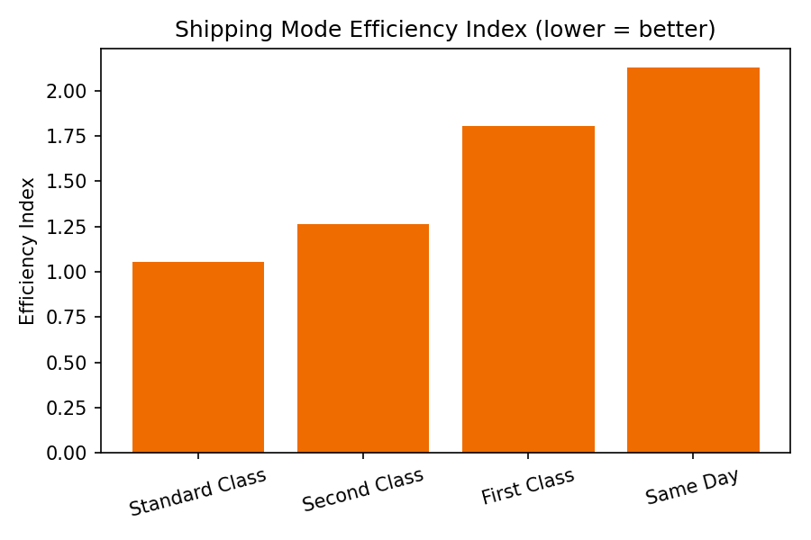
Figure 3. Shipping Mode Efficiency Index by mode (lower is better).
Standard Class is the most efficient mode by this index, while Same Day and First Class show the highest combined delay-and-risk burden. This is a common pattern in expedited logistics: compressed scheduled windows leave little buffer to absorb operational variance, so any friction converts directly into a late-delivery event.

7.2 Regional Risk
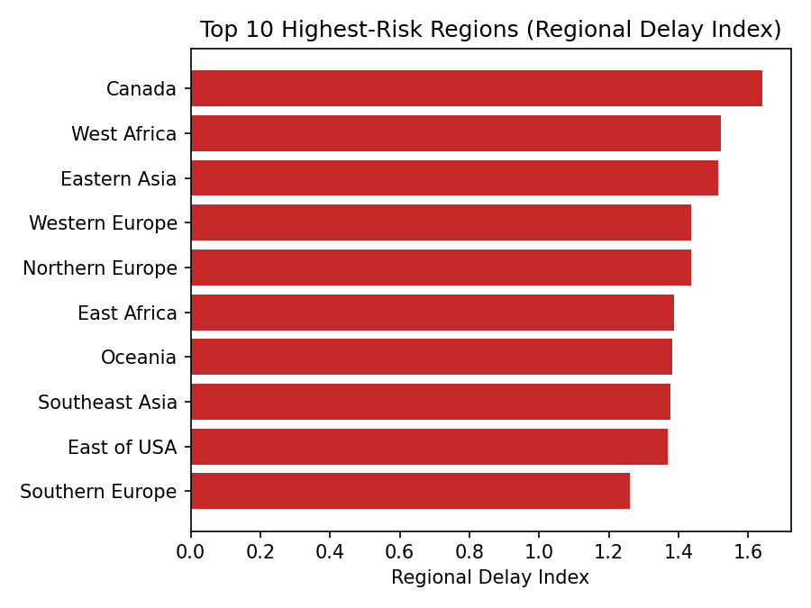
Figure 4. Top 10 highest-risk order regions by Regional Delay Index.
A defined set of regions consistently carries higher delay exposure than the network average. These regions are the highest-value targets for carrier renegotiation, route optimization, or localized SLA adjustment.

7.3 Market-Level View
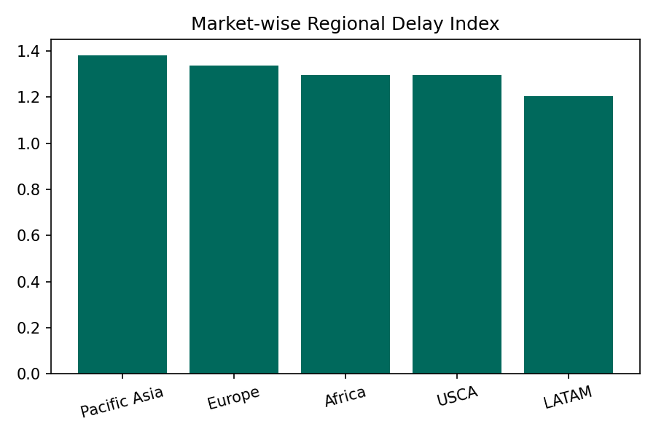
Figure 5. Regional Delay Index aggregated to the Market level.
At the market level, risk is more evenly distributed than at the granular region level, suggesting that regional bottlenecks are often localized operational issues rather than broad market-wide structural problems — reinforcing the value of region-level (not just market-level) monitoring.

7.4 Customer Segment Impact
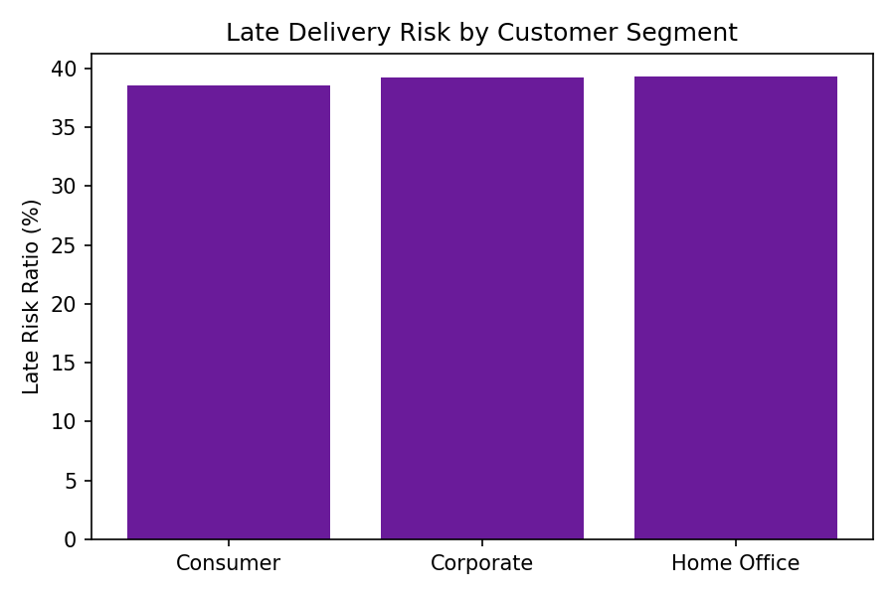
Figure 6. Late delivery risk ratio by customer segment.
Late-delivery risk is broadly similar across Consumer, Corporate, and Home Office segments. This is an important operational finding: delay risk is not concentrated in a single customer tier, so mitigation strategies (route/mode optimization, regional carrier review) should be applied network-wide rather than targeted at one segment alone.

8. Recommendations
- Re-evaluate scheduled shipping windows for Same Day and First Class modes — current schedules appear optimistic relative to achieved performance.
- Prioritize carrier and route review in the top-tier highest-risk regions identified in Section 7.2 before expanding volume into those lanes.
- Introduce mode-specific SLA buffers or dynamic-promise logic at checkout/booking to reduce the gap between promised and actual delivery dates.
- Apply delay-risk mitigation uniformly across customer segments rather than assuming premium/enterprise customers are the only ones exposed.
- Operationalize the KPIs in this paper as a recurring (weekly/monthly) monitoring cadence via the accompanying Streamlit dashboard, rather than a one-time analysis.

9. Conclusion & Next Steps
This project establishes a diagnostic intelligence layer for APL Logistics' supply chain operations. By systematically analyzing delivery timelines, shipping modes, and regional delay patterns, it enables logistics teams to move from reactive firefighting to data-driven operational control. With the real production dataset substituted into the existing pipeline, this diagnostic layer becomes the direct foundation for predictive modeling (e.g., forecasting late_delivery_risk at order intake) and optimization-based supply chain interventions in a subsequent phase of work.

Appendix A: Data Dictionary
Field | Description
Type | Payment method used for the order
Days for shipping (real) | Actual number of days taken to ship the order
Days for shipment (scheduled) | Planned / scheduled shipping duration in days
Benefit per order | Net profit or benefit earned from a single order
Sales per customer | Total sales value generated by the customer
Delivery Status | Current delivery status of the order
Late_delivery_risk | 1 = late risk flagged, 0 = not flagged
Category Name | Product category
Customer Segment | Consumer / Corporate / Home Office
Market | Global market region for the order
Order Region | Regional classification of the order
Shipping Mode | Standard / First / Second Class, Same Day
Order Item Profit Ratio | Profit ratio achieved on the order item
Sales / Order Item Total | Order value fields before/after discount

