

**School of Computer Science and Engineering**

**Predicting and studying sea level rise**

*A project submitted*

*in partial fulfillment of the requirements for the degree of*

*Bachelor of Technology in Computer Science and Engineering*

## By

Yashraj Agarwal (18BCI0183)

Saad Mohammed (18BCI0241)

Shuvam Mullick (18BCL0051)

Leo Bendang (18BCL0157)

## Course Instructor Dr. Ramesh Babu K Professor

## UNDERTAKING

This is to declare that the project entitled “*Predicting and studying sea level rise*” is an original work done by undersigned, in partial fulfillment of the requirements for the degree “Bachelor of Technology in Computer Science and Engineering” at School of Computer Science and Engineering, Vellore Institute of Technology (VIT), Vellore.

All the analysis, design and system development have been accomplished by the undersigned. Moreover, this project has not been submitted to any other college or University.

Yashraj Agarwal (18BCI0183)

Saad Mohammed (18BCI0241)

Shuvam Mullick (18BCL0051)

Leo Bendang (18BCL0157)

## ABSTRACT

*An enormous portion of the total populace lives in beach front regions, according to later appraises almost 2.4 billion individuals live inside 100KM of the ocean. Many major urban areas are based on the coast as they have generally took into account simpler exchange, bringing about a thriving exchanging urban areas and the number of inhabitants in these urban communities is on the rise. With more individuals jamming into seaside urban areas, the tension on both land what's more, ocean assets is just going to increment. Since the mechanical upset the measure of nursery gasses have as it were expanded in the climate, which has prompted an expansion in earth's temperature by more than 1 over the most recent two centuries ℃ and thusly the Global-mean ocean level rose at any rate 10 cm during the twentieth Century, and this ascent is relied upon to proceed and in all likelihood quicken because of human-actuated warming during the 21st Century. Intergovernmental Panel on Climate Change (IPCC) gauges thechange to be between 9 cm to 8cm till the year 2100 with the middle worth being 48cm. This ocean level ascent is by all accounts unavoidable except if solid and prompt advances are taken to control our nursery discharges. Such an ascent in ocean level will annihilate costalsettlements and numerous enterprises that rely uponthe oceans, for example, the travelindustry, dispatching, fishing and so forth and the numerous individuals that depend on these enterprises for their job.Seaside flooding will likewise influence the framework that has been worked over hundreds of years, extraordinary urban areas like Mumbai, New York and Tokyo are based on the coastwhat's more, will be influenced by hefty flooding.In certain spots the impacts of ocean level ascent are as of now being felt as soil disintegration and undermined farmland, lodging or amusement regions. The flooding of wetlands and contamination of springs is additionally occurring, influencing the verdure and fauna of each spot.*

**Table of Content**

|  |
| --- |
| **1. Introduction** |
| 1.1 Background |
| 1.2 Objective |
| 1.3 Motivation |
| **2. Literature Survey** |
| 3.1 Background |
| 3.2 Literature Review |
| **4. Proposed Methodology** |
| 4.1 Machine Learning/ |
| 4.2 Data Visualization |
| **5. Architecture/Design** |
| **6. Tools** |
| 6.1 Introduction |
| 6.2 Results |
| **Experimental Results and Analysis** |
| 6.2 Results |
| **7. Conclusion and Future Work** |
| 7.1 Conclusion |
| 7.2 Future Work |
| **8. Contributions in the project** |
| **References** |

**Introduction**

**1.Background**

Sea-level rise is one of the most significant effects of climate change. High projected rates of future sea-level rise have captured the attention of the world. Particularly, countries which are located in low-lying areas as well as small islands are concerned that their land areas would be decreased due to inundation and coastal erosion and, at worst, a large proportion of their population may be forced to migrate to other countries. Therefore, this issue has resulted in heightened attention internationally, as the effects of climate change become apparent. The level of the sea varies with time and space due to physical processes, such as tide and waves. Mean sea level at a given position is defined as the height of the sea surface averaged over a period of time, such as a month or a year, long enough that fluctuations caused by tide and waves are largely removed.[1](https://www.ncbi.nlm.nih.gov/pmc/articles/PMC3758961/#r01)) Mean sea level has also spatial distribution in the world. The mean sea level averaged over the global oceans is called global mean sea level (GMSL). The changes in local mean sea level usually differ from that of GMSL, because phenomena dominating in regional and local scales modify the global mean change. When we refer to sea-level change (rise) in this paper, it means the change (increase) in mean sea level, including both global and local, in a general sense. A specific word such as “global (local) sea-level rise” is used to denote the increase in global (local) mean sea level, where it is necessary to distinguish the two terms.

**2.Objective**

We have used a Data Analysis tools that will take data in the form of ice cap melting rate, earth’s temperature etc. and use all this to predict the extent of sea level rise. We also look at the different predictions made by scientist and see how it differs from how it differs from the model we used. We also have some case studies done some case studies for different countries and how they are impacted and how they will be affected in the future.

**3.Motivation**

The causes of changes in sea level are not limited to those related to climate change. It is well known that the mean sea level has repeatedly had a large fluctuation due to the alternation of glacial and interglacial periods for the past several hundred thousand years in the Holocene. This fluctuation of mean sea level reached about 120 m. There are also much shorter-term fluctuations in sea level, such as tide, waves and tsunamis. Among such a wide range of fluctuations, climate change-related sea-level change has its own unique characteristics. Given its potential significant effects, there are many questions which scientific research is expected to answer. They include: To what extent did climate change contribute to GMSL rise in the past? How much will GMSL increase in the future due to climate change? How serious are the impacts of the expected sea-level rise, and can human society respond properly to them? This paper aims to give answers to these questions, based on a review of recent research in the relevant areas. First, the present status of observed sea-level rise, analyses of its causes, and future projections are summarized. Then this paper will examine the impacts of sea-level rise along with other factors of climate change.

**Literature Survey**

|  |  |  |
| --- | --- | --- |
| **Author** | **Research Paper** | **Conclusion** |
| Stefan Rahmstorf | ASemi-Empirical Approach to Projecting Future Sea-Level Rise. | A semi-empirical relation is presented that connects global sea-level rise toglobal mean surface temperature. It is proposed that, for time scales relevant toanthropogenic warming, the rate of sea-level rise is roughly proportional to the magnitude of warming above the temperatures of the pre–Industrial Age.10 to30 m per °C. The initial rate of rise is expected to be proportional to thetemperature increase dH/dt = a (T- T0) where H is the global mean sea level, t istime, a is the proportionality constant, T is the global mean temperature, and T0  is the previous equilibrium temperature value. The sea-level rise above theprevious equilibrium state can be computed as H(t) = a ∫ T (t - ta ) dt where ta istime variable. . This holds to good approximation for temperature and sea-levelchanges during the 20th century, with a proportionality constant of 3.4millimetres/year per °C. When applied to future warmingscenarios of Intergovernmental Panel on Climate Change, this relationship results in aprojected sea-level rise in 2100 of 0.5 to 1.4 meters above the 1990 level. |
| Robert J. Nicholls and Anny Cazenave | Sea-Level Rise and Its Impact on Coastal Zones | Global sea levels have risen through the 20th century. These rises will almostcertainly accelerate through the 21st century and beyond because of globalwarming, but their magnitude remains uncertain. Key uncertainties include thepossible role of the Greenland and West Antarctic ice sheets and the amplitudeof regional changes in sea level. Although mean sea level remained nearly stablesince the end of the last deglaciationtidegauge measurements available sincethe late 19th century indicate that sea level has risen by an average of 1.7 ± 0.3mm/year. Accelerated loss of ice sheet mass partly results from rapid outletglacier flow along some margins of Greenland and West Antarctica where thegrounding line is below sea level, and further iceberg discharge into thesurrounding ocean. Depending on some model variants, these studies yield SLRbetween ~30 and 180 cm by 2100.The physical impacts of SLR are well known.  Although the impacts of sea-level rise are potentially large, the application andsuccess of adaptation are large uncertainties that require more assessment and  consideration. |
| Kiyoshi HORIKAWA | Sea-level rise caused by climate change and its implications for society | Sea-level rise could be a major result of global climate change. Its drawninternational attention, as a result of higher ocean levels within the future wouldcause serious impacts in numerous elements of the globe. There are queriesrelated to lowland rise that science has to answer. To what extent did globalclimate change contribute to lowland rise within the past? What quantity canworld mean water level increase within the future? However serious are theimpacts of the anticipated lowland rise possible to be, and might human societyanswer them? This paper aims to answer these queries through a comprehensivereview of the relevant literature. First, this standing of discovered lowland rise,analysis of its causes, and future projections are summarized. Then the impactsare examined beside alternative consequences of global climate change, fromeach world and Japanese views. Finally, responses to adverse impacts are goingto be mentioned so as to clarify the implications of the lowland rise issue forhuman society. |

**Proposed Methodology**

**Methodology used**

**Data Analysis and Interpretation and Machine Learning–**

We will use machine learning model that will take data in the form of ice cap melting rate, earth’s temperature etc. and use all this to predict the extent of sea level rise. We will also look at the different predictions made by scientist and see how it differs from how it differs from the model we used.

**Data Visualization –**

We also aim to develop the charts and graphs to study the parameters we will use to develop the machine learning model

## Architecture/Design

We are using Data Visualization and Interpretation to predict the Sea-Level rise using the various data and conditions playing in the real world. There is no-design since we are not having any website for our project, it is a RAW code which will allow us visualize the predictions accordingly.

## Tools

These are the open source tools and libraries which we will be using.

**SciPy**: SciPy (pronounced “Sigh Pie”) is a Python-based ecosystem of open-source software for mathematics, science, and engineering.

**NumPy**: NumPy is the fundamental package for scientific computing in Python. It is a Python library that provides a multidimensional array object, various derived objects (such as masked arrays and matrices), and an assortment of routines for fast operations on arrays, including mathematical, logical, shape manipulation, sorting, selecting, I/O, discrete Fourier transforms, basic linear algebra, basic statistical operations, random simulation and much more.

**DimArray**: "Dimension of an Array" is the number of indices, or subscripts, that you need in order to specify an individual element of the array.

**Pandas** : It is a fast, powerful, flexible and easy to use open source data analysis and manipulation tool built on top of the Python programming language.

**Matplotlib** : Matplotlib is a comprehensive library for creating static, animated, and interactive visualizations in Python.

**Jupyter:** The Jupyter Notebook is an open-source web application that allows you to create and share documents that contain live code, equations, visualizations and narrative

**netCDF4** : format files offer new features such as groups, compound types, variable length arrays, new unsigned integer types, parallel I/O access, etc. None of these new features can be used with classic or 64-bit offset files.

## Modules

**RCP**

**RCP2.6**

The RCP2.6 emission and concentration pathway is representative of the literature on mitigation scenarios aiming to limit the increase of global mean temperature to 2°C. These scenarios form the low end of the scenario literature in terms of emissions and radiative forcing. They often show negative emissions from energy use in the second half of the 21st century. The RCP2.6 scenario is shown to be technically feasible in the IMAGE integrated assessment modeling framework from a medium emission baseline scenario, assuming full participation of all countries.

**RCP4.5**

The RCP 4.5 scenario is a stabilization scenario, which means the radiative forcing level stabilizes at 4.5 W/m2 before 2100 by employment of a range of technologies and strategies for reducing greenhouse gas emissions.

**RCP8.5**

RCP 8.5 refers to the concentration of carbon that delivers global warming at an average of 8.5 watts per square meter across the planet. The RCP 8.5 pathway delivers a temperature increase of about 4.3˚C by 2100, relative to pre-industrial temperatures.

**Monte Carlo Sampling Method**

Monte Carlo is a computational technique based on constructing a random process for a problem and carrying out a NUMERICAL EXPERIMENT by N-fold sampling from a random sequence of numbers with a PRESCRIBED probability distribution.

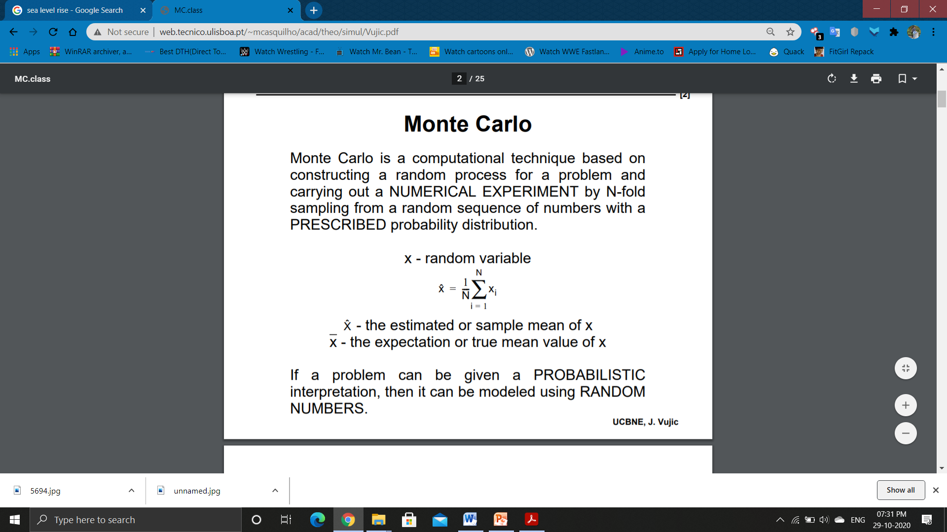

If a problem can be given a PROBABILISTIC interpretation, then it can be modeled using RANDOM NUMBERS.

**Experimental Results and Analysis**

**Output Screenshots**

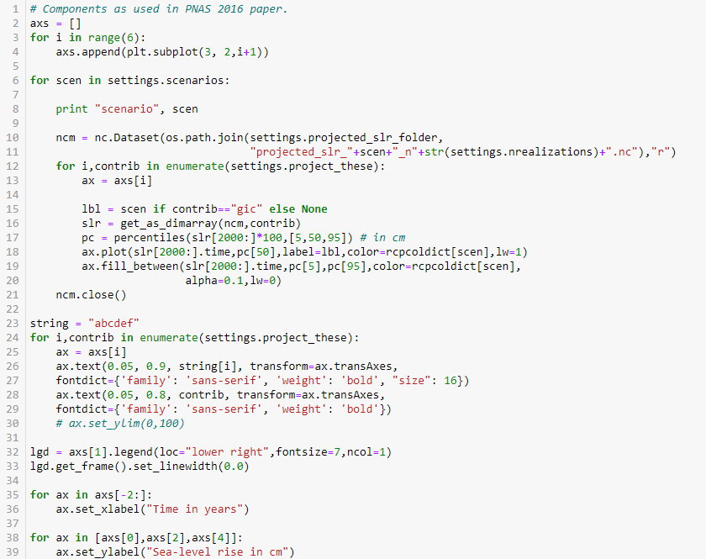

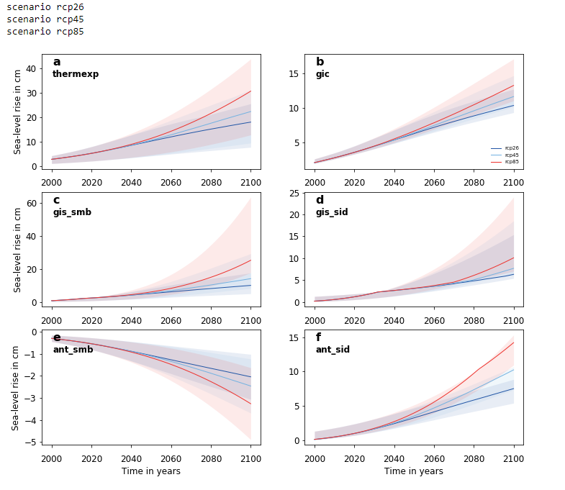

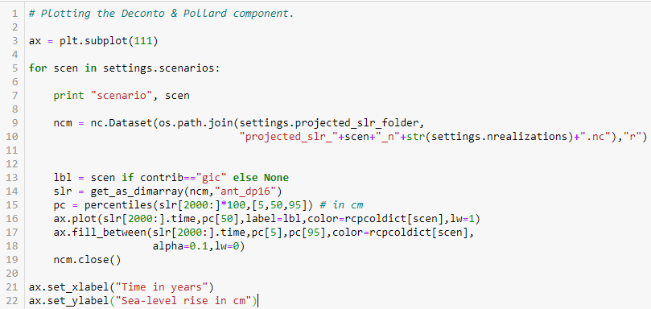

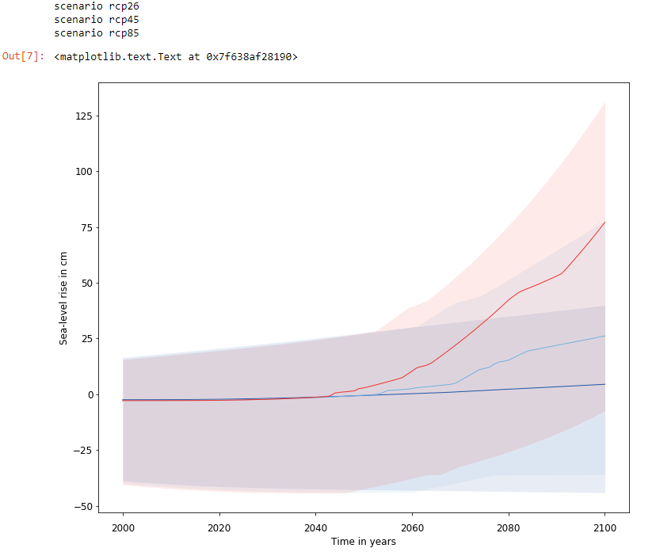

## Team Members Contribution

(Only Applicable for Group Project)

|  |  |  |
| --- | --- | --- |
| **Register Number** | **Name** | **Contribution / Role in this Project** |
| 18BCI0183 | Yashraj Agarwal | Did the implementation of dataset cleaning and Applying monte-carlo-sampling Algorithm |
| 18BCI0241 | Saad Mohammad Shafi | Did the implementation and plotting of the rcp's in the graph |
| 18BCL0157 | Leo Bendang Khongwar | Did the factor that affect the global sea level rise and the effects caused by it |
| 18BCL0051 | Shuvam Mullick | Did the Factors and Solutions and designing of the PPTS. |

## Conclusion

With the ever increasing concentrations of carbon emissions and increasing temperature along with its increase in sea level, with the current progress of how the population is dealing with it, coastal areas and the general population living in areas near the oceans or seas will suffer immensely. With the increase in sea level, large amounts of land will be submerged and lost, destroying the lives of residents, people and locals in the coastal regions. Our project aims to predict the level of rise within the upcoming years to create awareness about the dangers and consequences brought by the current level of carbon emissions leading to the various problems that would substantially increase the level of water in oceans and seas which would result in the eminent destruction and submergence of lands in the coastal regions and along with, erratic storm surges and violent disasters

**Future Enhancements and Solutions**

Reduce your footprint.

Greenhouse gasses are a major contributor to sea level rise. Calculate your “Carbon Footprint” at www.carbonfootprint.com to learn how to reduce the amount of greenhouse gases you produce each day.

Protect wetlands.

Wetlands act as natural buffers for coastal areas during rainstorms and hurricanes. They absorb precipitation and storm surge waters. Learn about wetland restoration activities in your area and get involved.

Plant more plants and save trees.

Plants clean the air and soak up rain. Reduce paper use to prevent trees from being cut down. Set all computers and printers to double-sided printing and reuse one-sided copies as scrap paper.

 Push for a Climate Action Plan.

Many cities and states do not have plans to address climate change, which is the primary cause of current sea level rise. Contact your local elected officials and encourage them to take action now

### References

1. Mimura N. Sea-level rise caused by climate change and its implications for society.Proc Jpn Acad Ser B Phys Biol Sci. 2013;89(7):281‐301. doi:10.2183/pjab.89.281

2. Olshansky, R. B. (2018). Recovery After Disasters: How Adaptation to Climate Change Will Occur. In C. Murphy, P. Gardoni, & R. McKim (Eds.), Climate Change and Its Impacts: Risks and Inequalities (pp. 195-207). (Climate Change Management).

Springer. <https://doi.org/10.1007/978-3-319-77544-9_12>

3. Operational use of machine learning models for sea-level modeling : http://nopr.niscair.res.in/bitstream/123456789/50466/3/IJMS%2048%289%29%201427-1434.pdf

4. Estimating the effect of climate change on global and local sea level rise :http://cs229.stanford.edu/proj2015/346_report.pdf

5. Tackling Climate Change with Machine Learning:

https://towardsdatascience.com/tackling-climate-change-with-machinelearning-78d1e185b3ec

6. A Tidal Level Prediction Approach Based on BP Neural Network and Cubic B-Spline Curve with Knot Insertion Algorithm: https://www.hindawi.com/journals/mpe/2018/9835079/

7. Global Sea Level Rise by BRUCE C. DOUGLAS : Published in JOURNAL OF GEOPHYSICAL RESEARCH, VOL. 96, NO. C4, PAGES 6981-6992, APRIL 15, 2012.

8. A Semi-Empirical Approach to Projecting Future Sea-Level Rise by Stefan Rahmstor. DOI : 10.1126/science.1135456

9. Sea-Level Rise and Its Impact on Coastal Zones by Roberet.J.Nicholas,Amy Cazenave publish in Science 18jun,2014,vol 328, issue 5985,pp 1517-1520

DOI :0.1126/science.1185782

10. Orsi MJ, Santos JR. Probabilistic modeling of workforcebased disruptions and input-output analysis of interdependent ripple effects. Economic Systems Research, 2010

11: 3–18. 22. Haimes YY, Horowitz BM, Lambert JH, Santos JR, Lian C, Crowther KG. Inoperability input-output model (IIM) for interdependent infrastructure sectors: Theory and methodology. Journal of Infrastructure Systems, 2005

12: 67–79. 23. Haimes YY, Santos JR, Lian, C, Crowther KG, Barker KA. Letter to the editor. Risk Analysis, 2012.

13: 3–6. 24. Santos JR. Inoperability input-output modeling of disruptions to interdependent economic systems. Systems Engineering, 2006 .

14: 20–34. 25. Barker T, Fingleton B, Homenidou BK, Lewney R. The regional Cambridge multisectoral dynamic model of the U.K. economy (Chapter 5). Pp. 79–96 in Clarke G, Madden M (eds). Regional Science in Business. Heidelberg: Springer-Verlag, 2001. 26. Miller RE, Blair PD. Input-Output Analysis: Foundations and Extensions 2nd ed. New York: Cambridge University Press, 2009.

1

2