Customer Shopping
Behaviour Analysis
Project Report by ~ Yashraj Somnath Kakade
Dataset: 3,900 Customers | 18 Features | Retail domain

1. Project Overview
This project analyzes customer shopping behavior using a retail dataset of 3,900 transactions. The goal is to uncover patterns across demographics, categories, payment methods, and purchase frequency to support data-driven retail decisions. A Power BI interactive dashboard was built on top of the cleaned dataset.

2. Dataset Summary
The dataset contains 3,900 records and 18 features covering customer demographics, purchase details, and behavioral attributes.

3,900  Total Records | 18  Features | $59.8  Avg Purchase (USD) | 3.75 ★  Avg Review Rating
27%  Subscribers | 43%  Discount Applied | 18–70  Age Range | 4  Product Categories

Feature Description
Feature | Type | Description
Customer ID | Identifier | Unique customer identifier
Age | Numeric | Customer age (18–70 years)
Gender | Categorical | Male / Female
Item Purchased | Categorical | Name of product bought
Category | Categorical | Clothing, Footwear, Outerwear, Accessories
Purchase Amount (USD) | Numeric | Transaction value ($20–$100)
Location | Categorical | US state of purchase
Season | Categorical | Spring, Summer, Fall, Winter
Review Rating | Numeric | Customer rating (1.0–5.0)
Subscription Status | Binary | Yes / No
Shipping Type | Categorical | 6 shipping options
Discount Applied | Binary | Yes / No
Promo Code Used | Binary | Yes / No
Previous Purchases | Numeric | Count of past orders
Payment Method | Categorical | PayPal, Credit Card, Cash, etc.
Frequency of Purchases | Categorical | Weekly to Annually

3. Key Findings

3.1 Category & Revenue
Category | Transactions | Share | Avg Purchase
Clothing | 1,737 | 44.5% | $60.0
Accessories | 1,240 | 31.8% | $59.8
Footwear | 599 | 15.4% | $60.3
Outerwear | 324 | 8.3% | $57.2

3.2 Customer Demographics
Metric | Value
Male customers | 2,652 (68%)
Female customers | 1,248 (32%)
Average customer age | 44.1 years
Largest age group | 36–45 (most active buyers)

3.3 Payment & Shipping
Payment Method | Transactions
PayPal | 677
Credit Card | 671
Cash | 670
Debit Card | 636
Venmo | 634
Bank Transfer | 612

Shipping preferences are nearly uniformly distributed across all six options (Free Shipping, Standard, Store Pickup, Next Day Air, Express, 2-Day Shipping), indicating no strong customer preference for any single shipping method.

3.4 Purchase Frequency
Customers are spread almost evenly across all purchase frequencies, from weekly buyers to annual shoppers. The most common frequency is "Every 3 Months" (584 customers), while "Weekly" buyers represent the smallest segment (539), suggesting the base is predominantly occasional shoppers.

3.5 Seasonality
Season | Transactions | Avg Purchase
Spring | 999 | $60.2
Fall | 975 | $59.8
Winter | 971 | $59.6
Summer | 955 | $59.4

4. Power BI Dashboard
The interactive dashboard was built in Microsoft Power BI with two views: an Overview panel covering transactions, revenue, category breakdown and payment methods; and a Demographics panel covering age groups, gender, shipping preferences and review ratings.

Dashboard View 1 – Overview

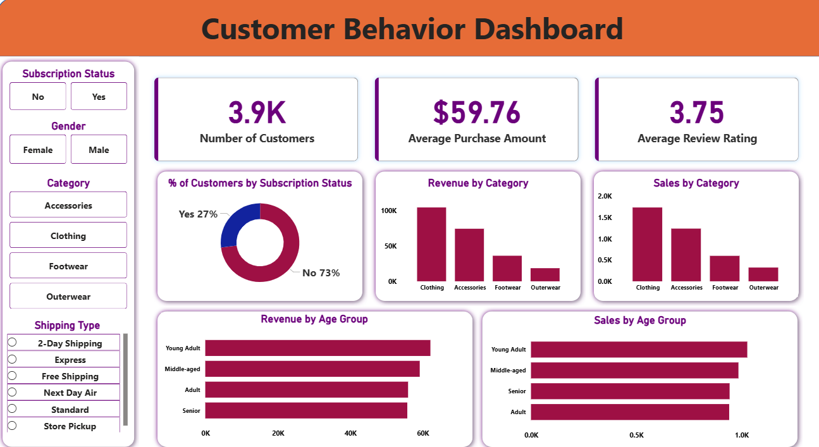

5. Conclusions
Clothing dominates the product mix at 44.5% of all purchases. Purchase amounts are remarkably stable across categories ($57–$60), seasons, and age groups — indicating consistent spending behavior regardless of context.

Payment methods are balanced, suggesting customers value choice. Only 27% of customers are subscribers, pointing to a growth opportunity for loyalty programs. 43% of transactions involved a discount, making promotional strategy a key driver of conversion.

The near-uniform seasonal and frequency distributions suggest year-round demand, which supports steady inventory planning rather than heavy seasonal stocking.

End of Report

