**C**

**Go**

**Java Android**

**Python**

**Google App Engine**

**HTML CSS & JS**

Experience

**BetaCraft - Intern** June - July 2015

* Added backend functionalities for restaurant app **'Ressy'** in Golang.
* Developed Linux uInput device driver in C for Multitouch and mouse for product **'Twist'.**

Skills

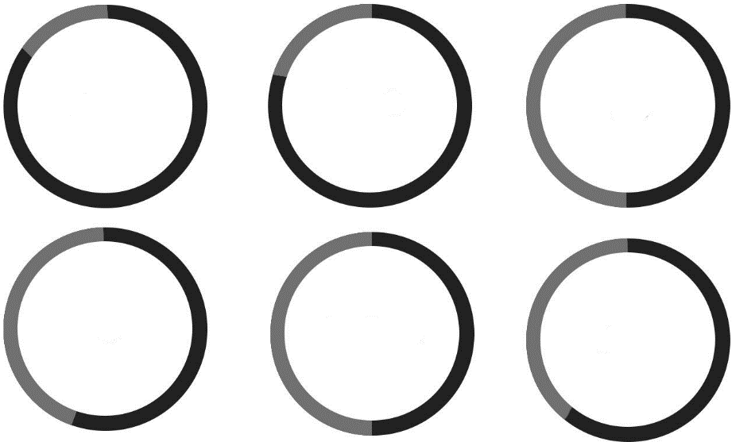

About

I am a passionate developer and a quick learner. Have good time management, communications and planning skills with the ability to learn quickly and multi-task in a fast paced environment. Passionate about programming and possess excellent analytical and problem-solving skills.

Projects

**TellMeWeatherNow!** 2015

* Build a web-application in Golang that provides real time weather updates concurrently for 5 cities.
* Won Scholarship for **GopherConIndia 2015** Conference in Bangalore. One of the only 3 stu­dents who won the scholarship.

**Equilibrium – gcdc2013** 2014

* Build a web-application written in python on Google Cloud Platform for managing project deadlines quickly.
* Won 1000$ from Google as an International finalist in **Google Cloud Developers Challenge** 2013.

**ideaPad** (Android) 2014

**RockStarOfDesign Competition** (Website-design - Finalist) 2013

Education

**Jaypee University of Engineering and Technology, Guna (M.P.), India**2012-2016Computer Science & Engineering6.4 CGPA (71%)**Bishop Conrad Senior Secondary School, Bareilly (U.P.), India**10th &12th CBSE73.4% & 65.4%

Languages



Contact

|  |  |
| --- | --- |
|  | +91-8223918059 |
|  | mail.yashrajsingh  @gmail.com |
|  | 174-A, Civil Lines, Station Road, Kamla Colony, Bareilly-243001 |
|  | yashrajsingh.net |

Punjabi, Chinese.

Travelling, Exploring

Hollywood, Bollywood.

Football, Table Tennis.

Interests

