**Java Android**

**C**

**Go**

**Python**

**Google App Engine**

**HTML CSS & JS**

Experience

**BetaCraft** 2015

* Internship for 6 weeks.
* Worked on Backend for restaurant app **'Ressy'** in Golang.
* Developed Linux uInput device driver in C for Multitouch and mouse for product **'Twist'.**

Skills

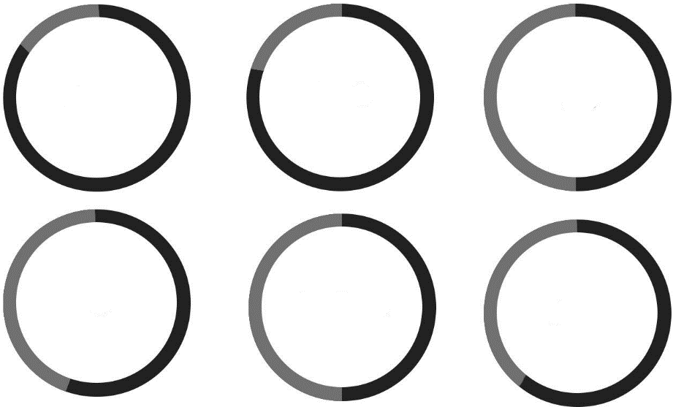

About

My name is Yash Raj Singh. I am a Passionate developer, designer and learner. Have Good time management, communications, decision-making, leadership and planning skills with the ability to learn quickly and multi-task in a fast paced environment. Passionate about coding and possess excellent analytical and problem-solving skills.

Contact

|  |  |
| --- | --- |
|  | +91-8223918059  +91-7895705312 |
|  | mail.yashrajsingh  @gmail.com |
|  | 174-A, Civil Lines, Station Road, Kamla Colony, Bareilly 243001 |
|  | yashrajsingh.net |

Education

Jaypee University of Engineering and Technology, Guna (M.P.)2012-2016Computer Science6.2(69%)Bishop Conrad Senior Secondary School, Bareilly (U.P.)10th &12th73.4% & 65.4%

Punjabi, Chinese.

Travelling, Exploring

Hollywood, Bollywood.

Football, Table Tennis.

Projects

**TellMeWeatherNow!** 2015

* Build web-app in Golang that provides real time weather updates concurrently for 5 cities.
* Won Scholarship for **GopherConIndia 2015** Conference in Bangalore. One of the only 3 stu­dents who won the scholarship.

**Equilibrium – gcdc2013** 2014

* Web-app written in python on Google Cloud Platform for managing project deadlines quickly.
* Won 1000$ from Google as a finalist from India in **Google Cloud Developers Challenge** 2013.

**ideaPad** (Android) 2014

**RockStarOfDesign Competition** (Web-design - Finalist) 2013

Interests



Languages

