A
Mini Project Report
on

“Billing System For Store”

Presented by
“Yash Ashwin Rajurkar”

SY[CSE]
Computer Science and Engineering
( 2025 – 2026 )

Guided By

<D.S.Naik>
(Department of Computer Science and Engineering)

Submitted to



MGM’s College of Engineering, Nanded

Under

Dr. Babasaheb Ambedkar Technological University, Lonere

Certificate
This is to certify that the mini project entitled

“Billing System For Store”
Submitted By
“Yash Ashwin Rajurkar”

In satisfactory manner as a partial fulfillment of
SY[CSE] in Computer Science and Engineering

To

MGM’s College of Engineering, Nanded

Under
Dr. Babasaheb Ambedkar Technological University, Lonere
has been carried out under my guidance,

<D.S.Naik>
Mini Project Guide

Dr. Mrs. A. M. Rajurkar Dr. Mrs. G. S. Lathkar
H.O.D Director
Computer Science & Engineering MGM’s College of Engg., Nanded

Table of Contents

Acknowledgement | IV
Abstract | V
Chapter 1. Introduction | VI
1.1 Introduction | VI
1.2 Problem Statement | VI
1.3 Objectives | VI
1.4 Scope of the Project | VI
Chapter 2. System Analysis | VII
2.1 Existing System | VII
2.2 Proposed System | VII
Chapter 3. System Design | VIII
3.1 System Architecture | VII
3.2 UML Class Description | VIII
3.3 Data Flow Design
Chapter 4. Implementation | IX
4.1 Core Modules | IX
4.2 Code Logic (DataService) | IX
4.3 GUI Implementation | IX
Chapter 5. Testing and Results | XI
5.1 Test Cases | XI
5.2 Screenshots and Results | XI
Conclusion | XV
References | XVI

ACKNOWLEDGMENT

We are greatly indebted to our mini project guide, D.S.Naik for her able guidance, and we would like to thank him/her for his/her help, suggestions, and numerous helpful discussions.
We gladly take this opportunity to thank Dr. A.M.Rajurkar (Head of Computer Science and Engineering, MGM's College of Engineering, Nanded).
We are heartily thankful to Dr. G. S. Lathkar (Director, MGM's College of Engineering, Nanded) for providing facilities during the progress of the mini project and for her kind guidance and inspiration.
Last but not least, we are also thankful to all those who helped directly or indirectly in the complete and successful development of this mini project.

With Deep Reverence,
Yash Ashwin Rajurkar
SY [CSE]
ABSTRACT
The Grocery Store Billing System is a console-based Java application designed to automate the billing process in a retail grocery store. The main objective of this project is to provide a fast, reliable, and accurate billing solution that reduces manual effort and human errors. The system allows users to select grocery products from a predefined list, enter required quantities, and generate a detailed bill instantly.
The application is developed using core Java concepts such as Object-Oriented Programming, collections framework, and Java Time API. Product details are managed using custom classes, while a HashMap is used to efficiently handle cart operations by merging quantities of repeated items. The program includes input validation to prevent invalid product selection and incorrect quantity entries. A user-friendly, menu-driven interface ensures smooth interaction with the system.
The final bill displays item-wise pricing, total amount, along with the current date and time. This project does not require a database, making it lightweight and easy to deploy. The Grocery Store Billing System enhances billing accuracy, saves time, and improves customer service. It also provides a strong base for future enhancements such as database integration, inventory management, and graphical user interface implementation.

Introduction
1.1 Introduction In today’s fast-paced retail environment, efficient billing systems are essential for smooth operations and customer satisfaction. Manual billing is slow and error-prone, especially in grocery stores handling multiple items. The Grocery Store Billing System is a Java-based console application that automates product selection, quantity handling, and bill generation. Using OOP concepts and Java collections, it ensures accuracy, reduces errors, saves time, and is suitable for small stores and academic use.
1.2 Problem Statement Many small and medium grocery stores still use manual or semi-manual billing systems that are slow, inefficient, and prone to human errors. Manual price calculations and record keeping often result in incorrect totals and poor customer experience, especially during peak hours. Traditional billing methods lack proper input validation and automation, increasing staff workload and reducing efficiency. To overcome these issues, an automated Grocery Store Billing System using core Java is proposed to ensure accurate billing, quick bill generation, and improved operational efficiency without complex infrastructure.
1.3 Objectives The main objective of the Grocery Store Billing System is to develop an efficient and user-friendly application that automates the billing process in a grocery store. The specific objectives of this project are as follows:
- To design and implement a computerized billing system using core Java programming.
- To automate product selection, quantity management, and bill generation.
- To reduce manual calculation errors and improve billing accuracy.
- To utilize Object-Oriented Programming concepts for better code organization and reusability.
- To efficiently manage multiple products and quantities using Java collections.
- To provide input validation to avoid incorrect product and quantity entries.
- To generate a detailed bill displaying item-wise cost, total amount, date, and time.
- To develop a lightweight system without the use of a database.
- To enhance operational efficiency and reduce billing time.
- To create a scalable foundation for future enhancements such as database integration, inventory management, and graphical user interface development.

1.4 Scope of the Project The Grocery Store Billing System is designed to make billing fast, easy, and error-free in small and medium grocery stores. It allows users to select products, enter quantities, and generate accurate bills with date and time. The system reduces manual work, prevents calculation mistakes, and improves customer service. It’s simple, lightweight design makes it easy to use, maintain, and expand in the future for features like inventory tracking, database support, or a graphical interface.

System Analysis
2.1 Existing System In many small and medium grocery stores, billing systems are still manual or semi-computerized, requiring staff to enter product details, quantities, and prices manually. This process is time-consuming and inefficient, especially during peak hours. Manual calculations increase the risk of errors such as incorrect prices, quantities, and totals, leading to customer dissatisfaction and financial loss. The lack of input validation, automation, and systematic data storage makes the system unreliable, inflexible, and unsuitable for modern retail needs, highlighting the need for an efficient automated billing solution.
2.2 Proposed System The proposed Grocery Store Billing System is a core Java–based, console application designed to automate the billing process and overcome limitations of manual systems. It allows users to select products from a predefined list, enter quantities, and generate detailed bills automatically. Using Object-Oriented Programming and Java collections like HashMap and ArrayList, it ensures accurate calculations, input validation, and efficient cart management. The system displays item-wise billing details with date and time, requires no database, and is lightweight, cost-effective, and suitable for small stores and academic use.

System Design
3.1 System Architecture The Grocery Store Billing System uses a simple, modular, and layered architecture suitable for a console-based Java application. It consists of three main layers: user interface, application logic, and data management. The user interface layer handles menu-driven input and displays bills. The logic layer validates inputs, manages cart operations, and performs billing calculations. The data layer uses in-memory structures like ArrayList for product data and HashMap for cart management. This architecture ensures clarity, reliability, and easy scalability for future enhancements.
3.2 UML Class Description The UML Class Diagram for the Grocery Store Billing System represents the structure of the application by illustrating its main classes, their attributes, methods, and relationships. The system is designed using Object-Oriented Programming principles, which promotes modularity, reusability, and maintainability.
Main Classes:
- Item
  - Attributes: id, name, price
  - Description: Represents the products available in the grocery store. Each item has a unique ID, a name, and a price.
  - Methods: Constructor to initialize the item details.
- CartEntry
  - Attributes: item, quantity
  - Description: Represents an entry in the customer’s cart. It links an Item object with the quantity selected by the user.
  - Methods: Constructor to initialize the cart entry.
- GroceryStoreBilling (Main Class)
  - Attributes: products (ArrayList of Items), cart (HashMap of CartEntry)
  - Description: Manages the overall workflow of the application, including product selection, input validation, cart management, and bill generation.
  - Methods: main() for program execution, generateBill() for printing the final bill.
Relationships:
- Association: Each CartEntry is associated with an Item.
- Aggregation: The GroceryStoreBilling class aggregates Item objects in the products list and CartEntry objects in the cart map.
The UML Class Diagram provides a clear overview of the system structure, showing how classes interact and how data flows between them. It highlights the modular design, making it easier to extend or enhance the system in the future, such as adding inventory management or a graphical user interface.
3.3 Data Flow Design Data Flow Design (DFD) represents the flow of data within the Grocery Store Billing System. It shows how input data from the user is processed by the system and transformed into the final bill. The system follows a structured flow from product selection to bill generation.

1. Input Data Flow
- The user selects a product number from the displayed product menu.
- The user enters the quantity of the selected product.
- These inputs are taken through the keyboard using the Scanner class.

2. Process Flow
Process 1: Product Selection
- The system validates the entered product number.
- If the product number is valid, product details (ID, name, price) are fetched from the product list.
- If invalid, an error message is displayed.

Process 2: Cart Management
- The selected product and quantity are passed to the cart module.
- The cart is implemented using a HashMap.
- If the product already exists in the cart, the quantity is updated.
- Otherwise, a new cart entry is created.

Process 3: Continue Shopping Decision
- After adding two or more products, the system asks the user whether to continue shopping.
- Based on the user’s response, the system either continues product selection or moves to bill generation.

Process 4: Bill Calculation
- The system calculates the total price for each product using:
Item Total = Price × Quantity
- All item totals are added to calculate the Grand Total.

3. Output Data Flow
Process 5: Bill Generation
- The system retrieves the current date and time.
- The final bill is generated displaying:
  - Store name
  - Date and time
  - Product details
  - Quantity
  - Individual totals
  - Grand total amount
- The formatted bill is displayed on the console.

4. Data Stores Used
- Product List: Stores predefined grocery items.
- Cart Data Store: Temporarily stores selected items and quantities during billing.

5. Data Flow Summary
- User inputs product number and quantity
- System validates input
- Data is stored/updated in cart
- Totals are calculated
- Final bill is generated and displayed

Implementation
4.1 Code Modules The Grocery Store Billing System is divided into multiple logical code modules to improve readability, maintainability, and modularity. Each module performs a specific task in the overall billing process.

1. Main Module (GroceryStoreBilling Class)
Purpose:
Acts as the central controller of the application.
Functions:
- Initializes the product list
- Displays the product menu
- Accepts user input (product number and quantity)
- Controls the shopping flow
- Calls the bill generation module
Key Responsibilities:
- Handles program execution flow
- Manages user interaction
- Coordinates between all other modules

2. Product Management Module (Item Class)
Purpose:
Stores and manages product information.
Functions:
- Holds product ID
- Holds product name
- Holds product price
Benefits:
- Provides structured representation of grocery items
- Supports easy modification or addition of products

3. Cart Management Module (Cart Entry Class)
Purpose:
Manages products added to the cart along with quantities.
Functions:
- Stores selected product details
- Stores quantity for each product
- Supports quantity merging for repeated products
Data Structure Used:
- HashMap to efficiently manage cart items

4. User Input & Validation Module
Purpose:
Ensures valid data entry from the user.
Functions:
- Accepts product number
- Accepts quantity
- Validates product selection
- Validates quantity value
Error Handling:
- Displays error messages for invalid product numbers
- Prevents negative or zero quantity entries

5. Billing & Calculation Module
Purpose:
Performs all billing calculations.
Functions:
- Calculates individual item totals
- Computes grand total amount
- Maintains accurate billing values
Formula Used:
Item Total = Price × Quantity
Grand Total = Sum of all Item Totals

6. Bill Generation & Display Module
Purpose:
Generates and displays the final bill.
Functions:
- Retrieves current date and time
- Formats bill output neatly
- Displays store name, item details, totals, and grand total
Tools Used:
- Local Date Time
- Date Time Formatter

7. Utility Module
Purpose:
Provides supporting functionalities.
Functions:
- Date and time formatting
- Output formatting using printf
- Resource handling (closing Scanner)
4.2 Code Logic (Data Service) The Data Service component of the Grocery Store Billing System is responsible for managing all data-related operations within the application. Since the system does not use an external database, data handling is performed using Java Collections Framework.
Purpose of Data Service
The main objective of the Data Service layer is to:
- Store and manage product details
- Handle cart operations
- Merge product quantities
- Provide data to the billing module for invoice generation

4.2.1 Product Data Management
The product information is stored using an ArrayList of Item objects. Each Item object represents a product with a unique ID, name, and price.
List<Item> products = new ArrayList<>();
products.add(new Item(1, "Rice 5kg", 250));
products.add(new Item(2, "Wheat Flour 5kg", 200));
products.add(new Item(3, "Sugar 1kg", 40));
products.add(new Item(4, "Milk 1L", 30));
products.add(new Item(5, "Oil 1L", 120));
Logic Explanation:
- ArrayList is used for dynamic storage of products.
- Products are loaded at runtime (no database dependency).
- Each product has a unique identifier for easy selection.

4.2.2 Cart Data Handling
The cart data is managed using a HashMap<Integer, CartEntry>, where:
- Key → Product ID
- Value → CartEntry object containing product and quantity
Map<Integer, CartEntry> cart = new HashMap<>();
Logic Explanation:
- HashMap ensures fast lookup and unique product entries.
- If the same product is added multiple times, the quantity is updated instead of duplicating entries.

4.2.3 Adding Products to Cart
When a user selects a product and enters a quantity, the system checks whether the product already exists in the cart.
if (cart.containsKey(selected.id)) {
cart.get(selected.id).quantity += qty;
} else {
cart.put(selected.id, new CartEntry(selected, qty));
}
Logic Explanation:
- Prevents duplicate cart items.
- Automatically merges quantities for repeated product selections.
- Improves data consistency and billing accuracy.

4.2.4 Input Validation Logic
To ensure data integrity, the system validates user inputs before processing.
if (qty <= 0) {
System.out.println("Quantity must be greater than 0");
continue;
}
Logic Explanation:
- Prevents invalid or negative quantity values.
- Enhances application reliability and user experience.

4.2.5 Cart Control Logic
The system allows the user to continue shopping or proceed to billing once at least two products are added to the cart.
if (cart.size() >= 2) {
System.out.print("Do you want to add more products? (yes/no): ");
String ans = sc.next().toLowerCase();
if (!ans.equals("yes")) {
continueShopping = false;
}
}
Logic Explanation:
- Ensures meaningful cart usage.
- Improves interaction flow.
- Allows controlled termination of shopping.

4.2.6 Data Transfer to Billing Module
Once shopping is complete, the cart data is passed to the billing module using a method call.
generateBill(cart, storeName);
Logic Explanation:
- Maintains separation of concerns.
- DataService handles data, while billing handles calculations and output.

4.2.7 Advantages of DataService Design
- No dependency on external database
- Fast data access using collections
- Easy to modify or extend
- Suitable for small-scale retail applications
- Clear separation between data handling and business logic

Testing and Results
5.1 Test Cases
Test Case ID | Test Description | Input | Expected Output | Actual Output | Status
TC01 | Display product menu | Start application | Product list displayed with prices | Product list displayed correctly | Pass
TC02 | Add single product to cart | Product ID: 1, Quantity: 2 | Item added to cart | Item added successfully | Pass
TC03 | Add multiple different products | Product ID: 2 Qty:1, Product ID:3 Qty:2 | All products added to cart | Products added correctly | Pass
TC04 | Add same product multiple times | Product ID: 1 Qty:2, Product ID:1 Qty:3 | Quantity merged (Total = 5) | Quantity merged correctly | Pass
TC05 | Invalid product selection | Product ID: 9 | Error message displayed | Error message displayed | Pass
TC06 | Zero quantity entry | Product ID: 2, Qty: 0 | Quantity error message | Error message shown | Pass
TC07 | Negative quantity entry | Product ID: 3, Qty: -2 | Quantity error message | Error message shown | Pass
TC08 | Generate bill without crash | Finish shopping | Bill generated successfully | Bill generated | Pass
TC09 | Correct total calculation | Multiple items added | Accurate item totals & grand total | Totals calculated correctly | Pass
TC10 | Date & time display | Generate bill | Current date & time shown | Date & time displayed | Pass
TC11 | Continue shopping option | Add ≥2 items → “no” | Billing process ends | Billing ended correctly | Pass
TC12 | Program stability | Multiple operations | No crash or delay | Program stable | Pass

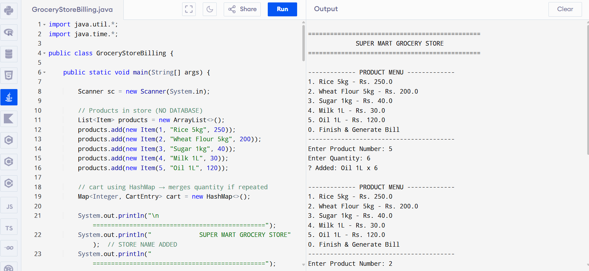

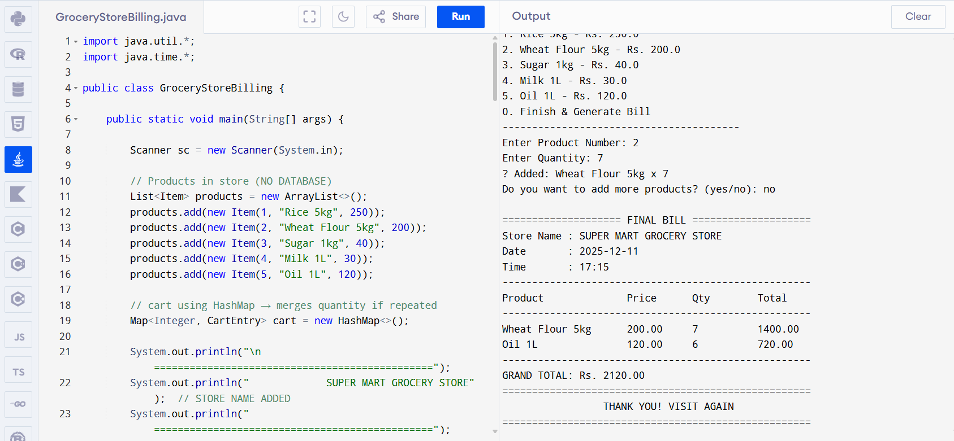

5.2 Results The results obtained after executing all test cases indicate that the Grocery Store Billing System performs accurately and reliably. Each functional module worked as expected, including product selection, quantity management, cart handling, and bill generation. Duplicate product entries were correctly merged, and all calculations produced accurate item-wise totals and a correct grand total.
The system effectively handled invalid inputs such as incorrect product IDs and zero or negative quantities by displaying appropriate error messages without interrupting execution. The billing output was well-formatted and included the correct date and time, giving the system a professional appearance. Overall, the successful execution of all test cases confirms that the system meets its objectives and is suitable for academic submission and small-scale retail billing operations.

Conclusion
The successful development of the Grocery Store Billing System highlights a practical and well-structured solution to real-world billing challenges using Java. The system efficiently automates key operations such as product selection, quantity management, and accurate bill generation, significantly reducing manual effort and calculation errors. Its clean design demonstrates effective use of object-oriented programming principles and Java Collections. The application performed reliably during testing, handling both valid and invalid inputs smoothly while maintaining stability. Accurate item-wise totals, a correct grand total, and real-time date and time improve usability and professionalism. Overall, the system meets all objectives and provides a dependable billing solution with a scalable foundation for future enhancements like database integration and graphical interfaces.

References
• Oracle Documentation, Java Platform, Standard Edition API Specification, https://docs.oracle.com/javase/
• GeeksforGeeks, Java Collections Framework Tutorial, https://www.geeksforgeeks.org/collections-in-java-2/
• W3Schools, Java Date and Time API, https://www.w3schools.com/java/java_date.asp
• TutorialsPoint, Java Object-Oriented Programming Concepts, https://www.tutorialspoint.com/java/java_object_oriented.htm

