University of West London  School of Computing & Engineering | 

Assignment

Name | Rathod Yash Ajaykumar
Student ID | 21591733

Module | Applied Cryptography
Module Code | CP50087E
Module Leader | Alireza Esfahani

2024
Table of Contents
Introduction: 3
RSA Encryption & Decryption code: 4
Running the code: 10
Conclusion: 16
References: 17

Introduction:

In the realm of modern cryptography, the RSA encryption algorithm stands as a cornerstone of secure communication. Which is named for its creators, Ron Rivest, Adi Shamir, and Leonard Adleman.
The confidentiality and integrity of data sent over the Internet are crucially ensured by RSA, which is essential to the safe flow of information.
For example, it is a fundamental part of protocols like safeguard Sockets Layer (SSL) and Transport Layer Security (TLS), which are used to safeguard internet conversations millions of times every day.
The basic purpose of RSA is to securely send session keys for symmetric cryptosystems, which in turn secure continuous communication. (Bertaccini, 2022)
The implementation of the RSA algorithm is examined in this report, with a focus on its usefulness in encryption and decryption procedures and its importance in modern cryptography.

RSA Encryption & Decryption code:

1. To start with, the figure 1, where all the necessary functions and modules are imported from the library.
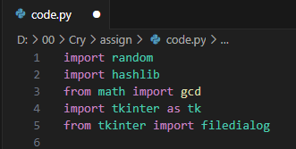
Figure 1 importing functions from the library
2. In this figure 2: print formatting functions are created, to display the main title, the headings, sections, labels of the messages, and the success and error texts.
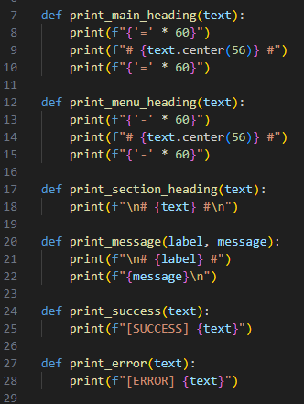
Figure 2 making print formatting functions

3. Figure 3: here, is_prime function checks whether the number is prime or not.
And generate_prime function generates a prime number between 1 and 99 (I selected this range for the assignment only)
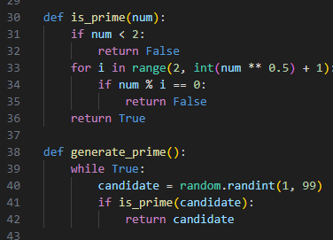
Figure 3 For prime number generation
4. In this figure 4: we are generating keys for RSA,
- First it selects two random prime numbers, p and q. then it computes n = p * q.
- After that it calculates phi (p-1)*(q-1).
- Then it chooses number e such that: 1 < e < phi and e is coprime with phi.
- Further, it finds d (modular inverse of e): (e * d) mod phi = 1.
- Finally, it returns the public (e, n) and private (d, n) keys.
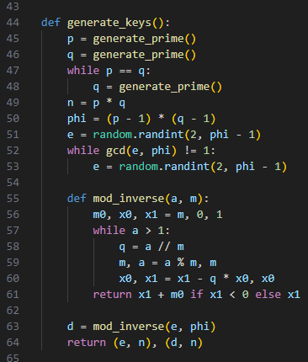
Figure 4 For RSA key generation
5.
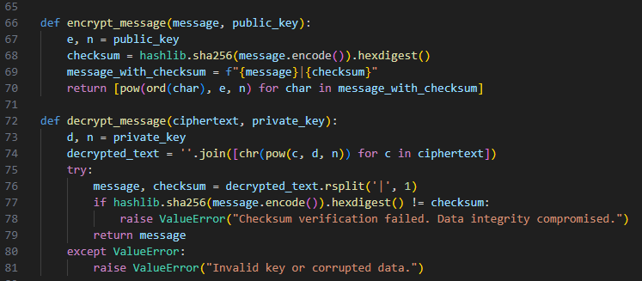
Figure 5 To encrypt and decrypt message
- Here in this figure 5: the encrypt_message, combines the original message with the checksum, which is a has message. And that is converted into combined text into numbers (that are ASCII values).
- And it uses the formula, c = m^e mod n for each character, where (m: ASCII value of the character and c: encrypted value)

- And after that the decrypt_message, which converts the numbers back into text using m = c^d mod n, where (d: private key exponent and n: modulus).

- Then it splits the text into the message and checksum. And it also verifies the checksum matches the decrypted message or not to ensure date integrity.

6. Here in the figure 6: select_file, opens a dialog box, with the help of Tkinter for us to select a file.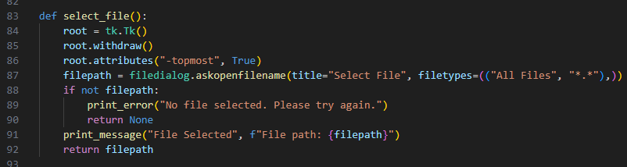
Figure 6 For selecting file

7. In this figure 7: encrypt_file, reads the content of the file, and then encrypts the it using the public key. And it saves it into a new file with .encrypted added to its name.

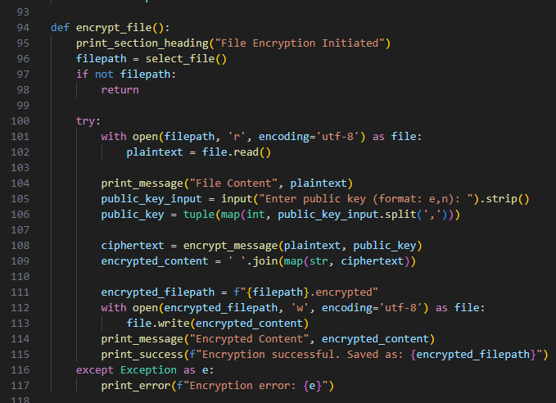
Figure 7 for encrypting file

8.
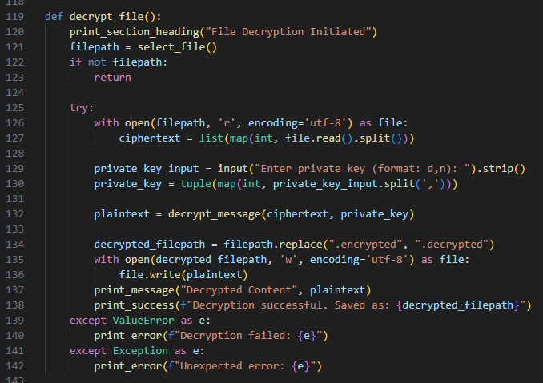
Figure 8 for decrypting file
Here the decrypt_file: reads the encrypted file content and then decrypts it using the private key. And it saves the decrypted content into a new file with .decrypted added to it, which can be seen in the figure 8.

9.
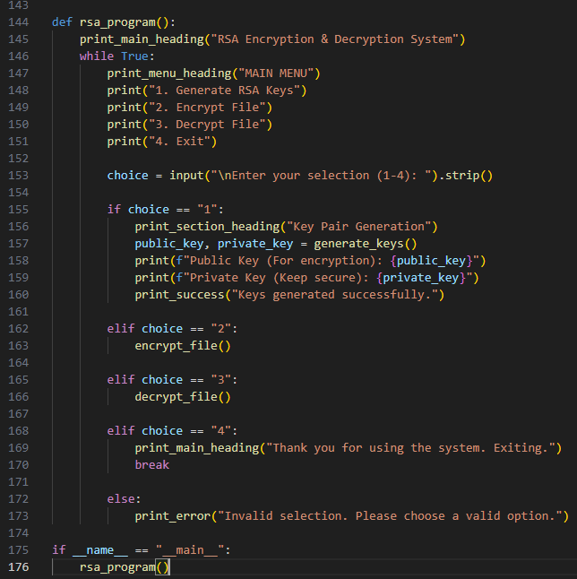
Figure 9 the main program which is going to be the main menu
This figure 9: is the main program of the RSA code, where the we can input any options from 1-4.
The first option, generates and displays the public and private keys
The second option, starts the file encryption process.
The third option, starts the file decryption process.
And the fourth option, exits the program.
Also, the invalid input shows an error message.

Running the code:
1.
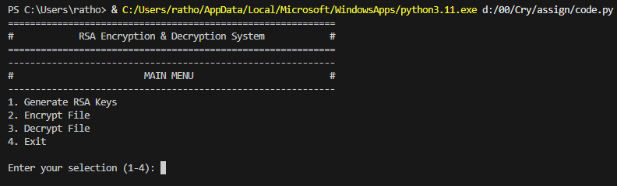
Figure 10 The main menu
- Here in the figure 10: we can observe that the code is running and the main menu has been displayed. Where it is clearly seen, we can select any number 1-4 to the liking of ourself.
2.
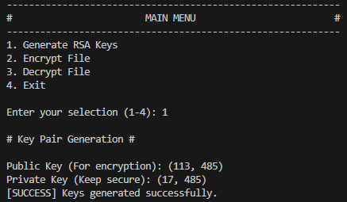
Figure 11 the keys are generated
- After selecting 1, in the figure 11: we can see that the Key pair has been generated.
- Which are: public key- 113, 485 and private key 17, 485

3.
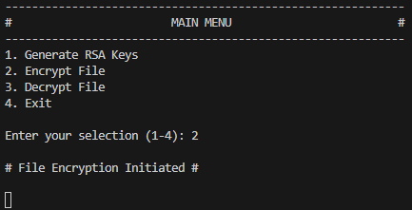
Figure 12 File encryption has initiated
- Here in the figure 12: the encryption process has been initiated, by selecting 2.
4.
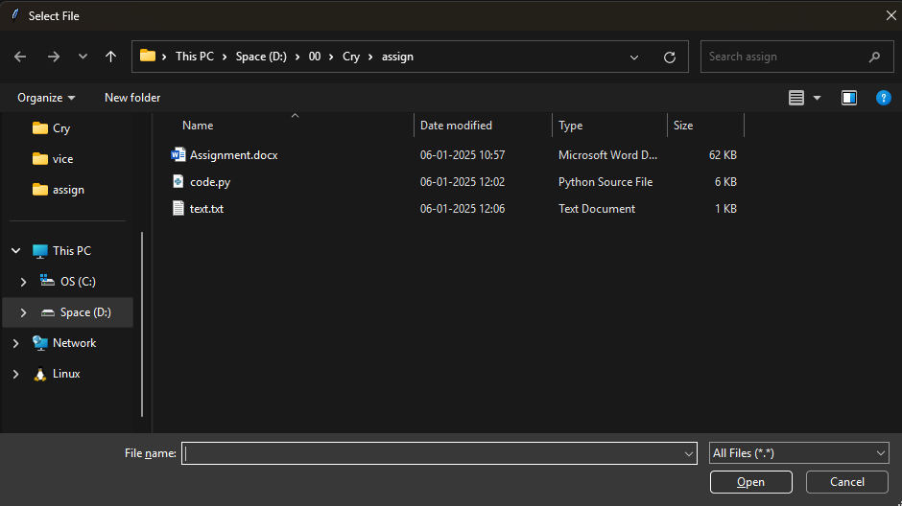
Figure 13 where the text file is located (the dialog box opens)
- In the figure 13: a dialog box appears to help us select the file, which is needed to be encrypted.
- And here, we will select the text.txt file in this folder.

5.
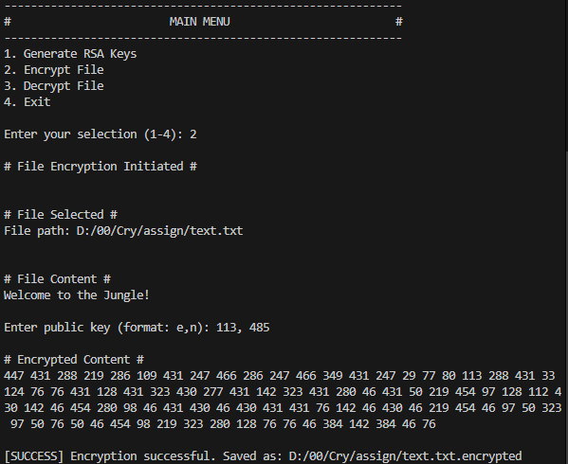
Figure 14 the encryption is done
- Figure 14, shows us the content which is there in the file (original content), then it asks us to input the public key here, which is 133, 485 that is provided in the figure 11.
- After that, it displays the encrypted content which is the cipher text. And the encryption is successful.

6.
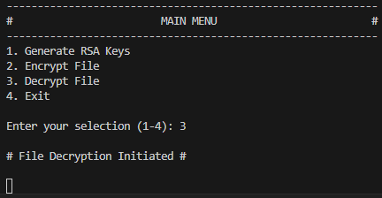
Figure 15 the decryption has initiated
- In this figure 15: our decryption process has started, by selecting 3.
7.
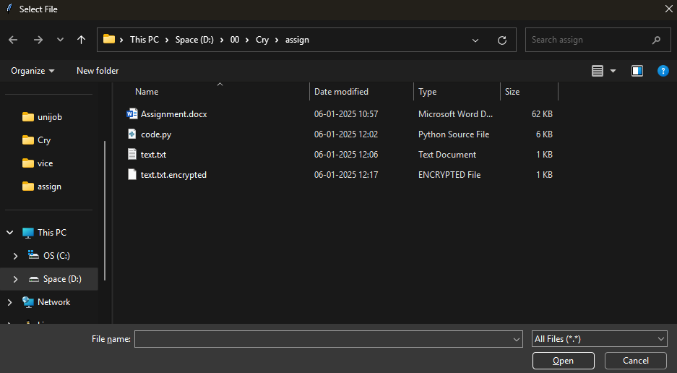
Figure 16 location where the encrypted file is there
- Figure 16 shows us the dialog box, where we are able to select a file to decrypt.

8.
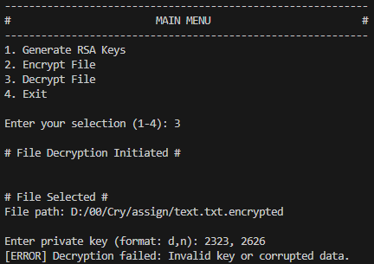
Figure 17 decryption fails because of wrong private key
- Here in the figure 17: the decryption is failed, because I had input the wrong private key to decrypt. And that shows that wrong key can not be used to decrypt the file so, it is secure from the intruder who may try to decrypt the file with a incorrect key.
- I have used 2323, 2626 (some random numbers) to demonstrate this.
9.
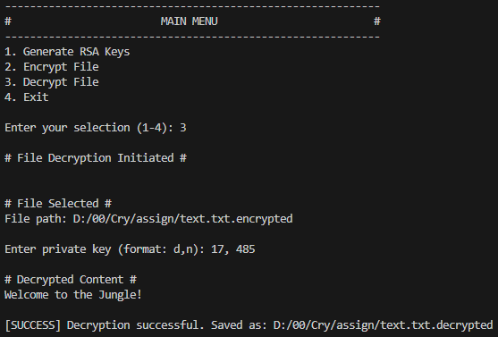
Figure 18 decryption is successful with the correct private key
- In this figure 18: we have used the correct key which is 17, 485 (can be seen in figure 11), so it is successful. And it shows the decrypted content too, which is same as the file content in (figure 14). That is “Welcome to the Jungle!”.
10.
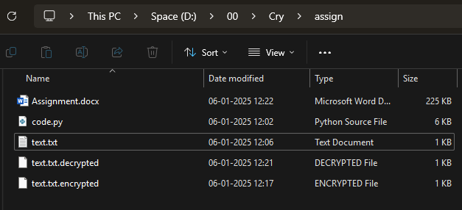
Figure 19 where all the files are saved in the pc
- This figure 19 shows us all the files which are made by the code, that is the encrypted and decrypted files, and the normal txt file. (Also, there are code.py file where the whole code is saved and assignment.docx where this document is there.)
11.
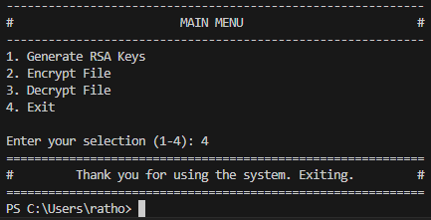
Figure 20 we are exiting the program
- And finally, we exiting the program by selecting 4, which can be seen in the figure 20.

Conclusion:

The architecture and implementation of the RSA encryption algorithm have been examined in this report, with a focus on how it may safeguard data by creating and using cryptographic keys.
The study demonstrated RSA's efficacy in protecting data by using severe procedures for file encryption and decryption.
The outcomes confirmed the algorithm's ability to withstand unwanted access and its crucial function in maintaining data integrity.
At last, the hands-on demonstration highlighted the importance of RSA encryption as a key instrument in the field of applied cryptography.

References:

- Bertaccini, M. (2022) Cryptography Algorithms. 1st edn. Packt Publishing. Available at: https://www.perlego.com/book/3284640 (Accessed: 6 January 2025).

