Task 7 Summary – Conditional Rendering in React
Summary
In this task, I learned how to display different UI elements based on conditions in React using JavaScript. I explored various conditional rendering techniques such as if/else statements, ternary (? :) operator, and logical AND (&&) operator. I also learned how to return null to render nothing, conditionally assign JSX to variables, and write clean, readable conditional code. This helped me understand how to build dynamic user interfaces that respond to different states and conditions.

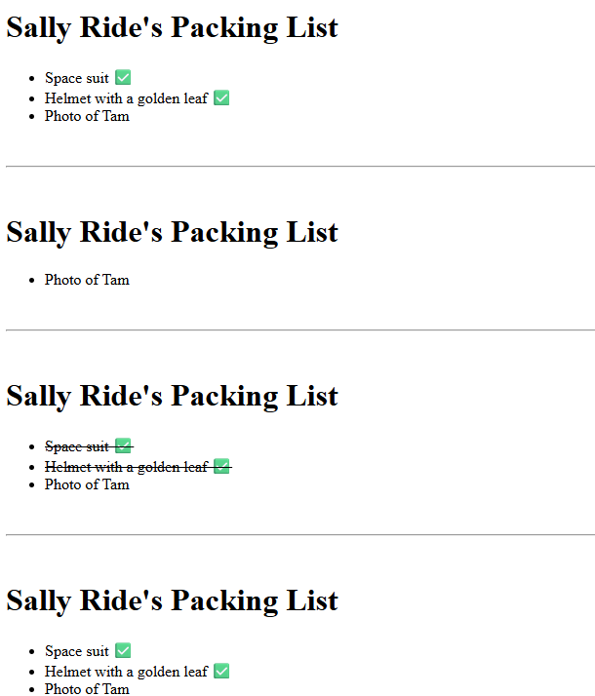

Task 8 Summary – Rendering Lists in React
Summary
In this task, I learned how to render multiple components dynamically using JavaScript arrays in React. I practiced using the map() method to display lists of data and the filter() method to show only specific items based on conditions. I also understood the importance of using unique key props for list items to help React efficiently update and manage the UI. This task improved my understanding of working with dynamic data and rendering collections in React applications.

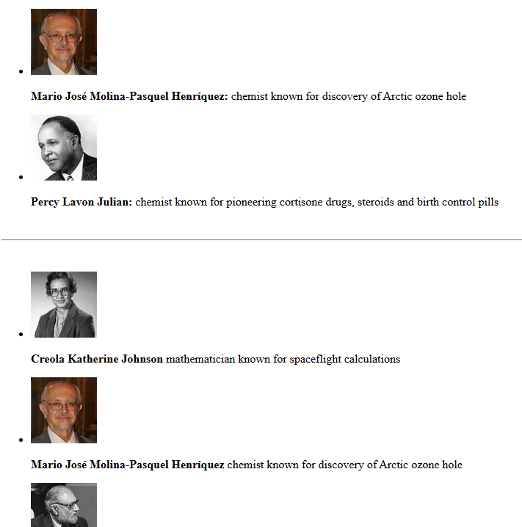
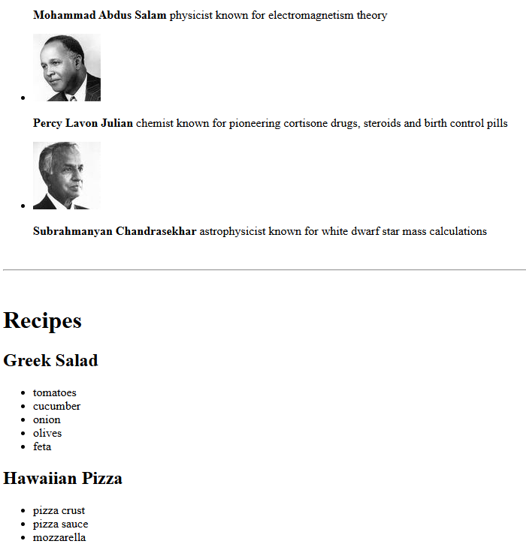
- GITHUB REPO LINK:
https://github.com/yashrathod910/15D_Internship/tree/main/DAY5

