Task 1: Introduction to React & JSX Basics
- Learned what React is and why it is used.
- Understood JSX syntax.Learned about Components.
- Learned how React updates the UI.
- Read the official React documentation.
- Watched the assigned introductory video.

Summary
React is an open-source JavaScript library developed by Meta (Facebook) for building fast, interactive, and reusable User Interfaces (UI). It follows a component-based architecture, where the user interface is divided into small reusable parts called components. This approach makes the code more organized, reusable, and easier to maintain.
JSX (JavaScript XML) is a syntax extension used in React that allows developers to write HTML-like code inside JavaScript. JSX makes React code more readable and simplifies UI development. Although JSX looks similar to HTML, it is not understood directly by web browsers. It is converted into regular JavaScript by Babel before execution.
A React Component is simply a JavaScript function that returns JSX. Components can be reused multiple times within an application, reducing code duplication and making development more efficient.
JSX basic code
function App() {
return (
<h1>Hello World</h1>
);
}

Task 2: Create React App using Vite

Creating a React Project using Vite
To create a React application, Vite provides a fast development environment.
Steps
- Create project using command in terminal: npm create vite@latest
- Select
- Framework → React
- Variant → JavaScript
- Install dependencies
Command: npm install
- Run the project
Command: npm run dev
The development server starts successfully and the project opens in the browser.
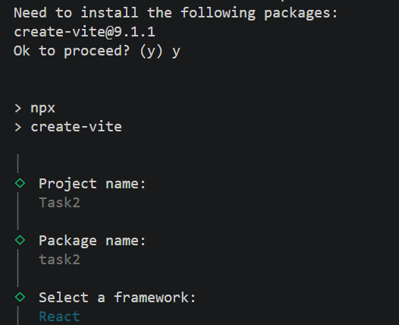
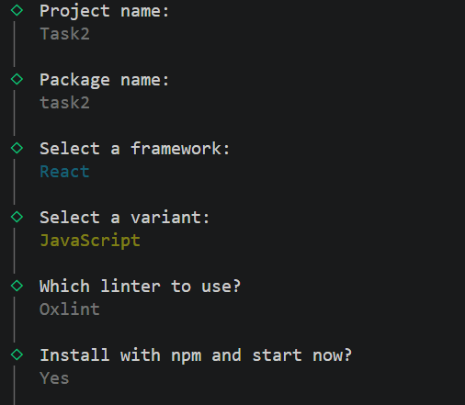
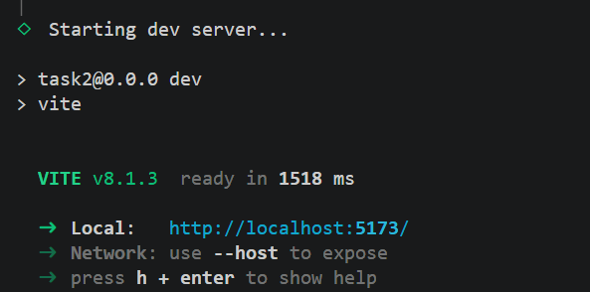

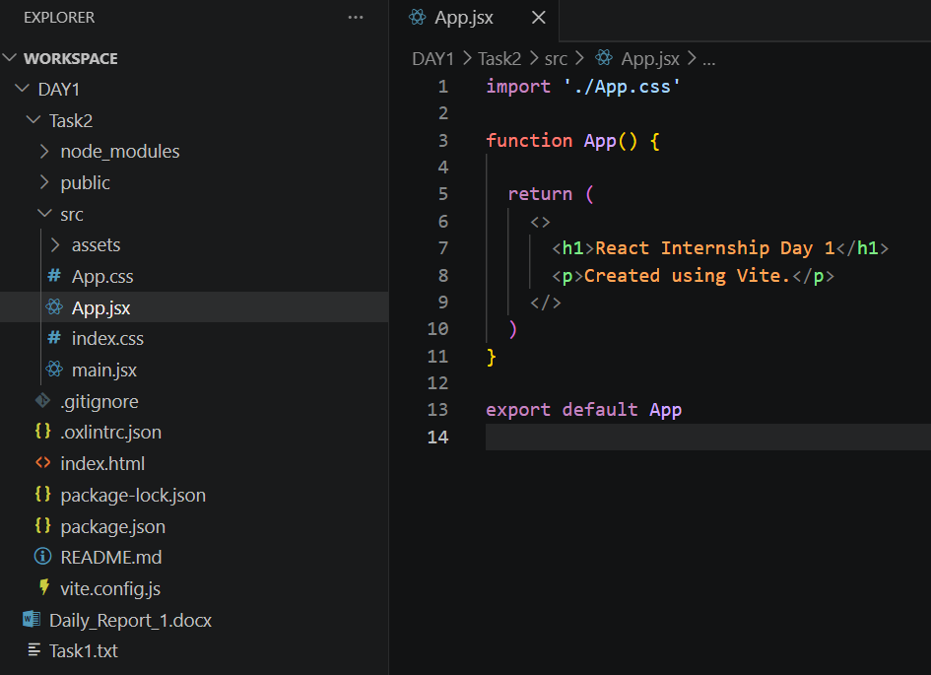
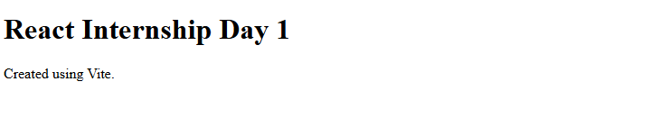

Summary
Important Files in a React Project:
1. App.jsx
- Main component of the application.
- Most of the React code is written here.
- It controls the UI of the application.

2. main.jsx
- Entry point of the React application.
- Renders the App component inside the root element.
Example:
createRoot(document.getElementById("root")).render(
<App />
);

3. index.css
- Contains global CSS styles.
- Applied to the whole application.

4. App.css
- Contains styles specific to the App component.

5.index.html
The index.html file contains
<div id="root"></div>
React renders the entire application inside this root div.

=> JSX Rules:
- Return only one root element.
- Use fragments (<> </>) if multiple elements are required.
- Tags must always be closed.
- JSX is case-sensitive.
- Components should start with a capital letter.
Example using Fragment:
<>
<h1>Hello</h1>
<p>Welcome</p>
</>
Fragments avoid adding unnecessary <div> elements to the DOM.

Import and Export
React uses ES6 modules.
Default Export:
export default App;
Import:
import App from "./App";

Named Export:
export { Title };
Import:
import { Title } from "./Title";

JavaScript inside JSX
JavaScript expressions can be written inside curly braces {}.
Example:
1.const msg = "Hello";
<p>{msg}</p>
Output: Hello
2. <p>{2 * 2}</p>
Output: 4

