**Simulation and Analysis of Denial of Service (DoS) Attacks**

**Executive Summary**

This report presents the findings and analysis from a simulated Denial of Service (DoS) attack conducted in a controlled environment. The primary purpose of this simulation was to understand the mechanics of DoS attacks, assess their impact on server performance, and analyze traffic patterns under attack conditions. The scope of the project included simulating various types of DoS attacks, such as HTTP flooding, UDP flooding, and SYN flooding, using tools like Kali Linux, Hping3, and Slowloris.

Key outcomes include:

* Identification of server vulnerabilities under high-traffic scenarios.
* Analysis of abnormal traffic patterns, including timing and volume.
* Insights into the effectiveness of mitigation strategies, such as rate limiting and firewalls.

This simulation highlights the critical need for proactive security measures to safeguard systems from similar attacks in real-world scenarios.

**Introduction**

Denial of Service (DoS) attacks are a prevalent and damaging form of cyber threat that disrupts the availability of a target system by overwhelming it with an excessive volume of traffic. Unlike data breaches or malware infections, the primary objective of a DoS attack is to render services inaccessible to legitimate users, often resulting in significant downtime and financial losses.

Analyzing and understanding DoS attacks is crucial for enhancing cybersecurity defenses. By simulating such attacks in a controlled environment, organizations can identify weaknesses in their infrastructure, evaluate the impact on system resources, and test the effectiveness of mitigation strategies. This report delves into the mechanics of DoS attacks, their implications, and actionable recommendations to protect systems from these threats.

**Environment Setup**

1. Virtual Machines: Set up two virtual machines for attacker and target.

2. Tools: Kali Linux, Apache/Nginx, Wireshark, Hping3, Slowloris.

3. Network Configuration: Ensure the network is isolated to prevent external impact.

**Attack Simulation**

Include the steps to simulate the following attacks:

1. HTTP Flood Attack using Slowloris

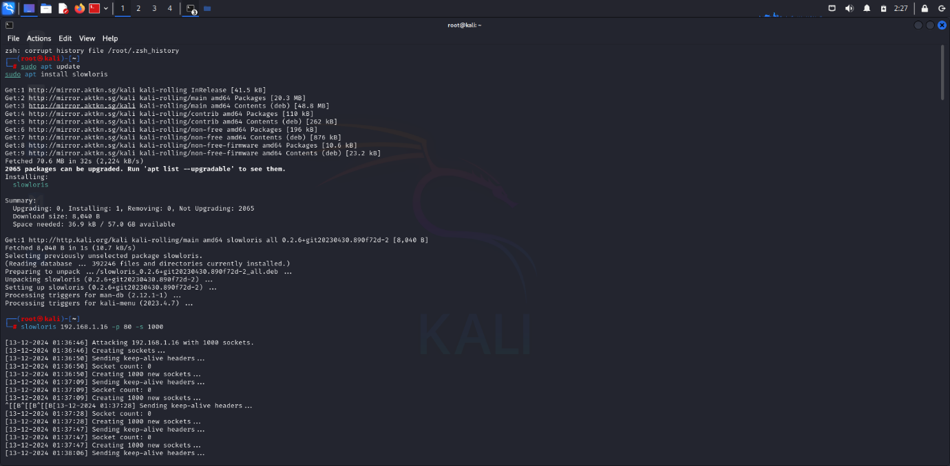

2. UDP Flood Attack using Hping3 &

3. SYN Flood Attack using Hping3

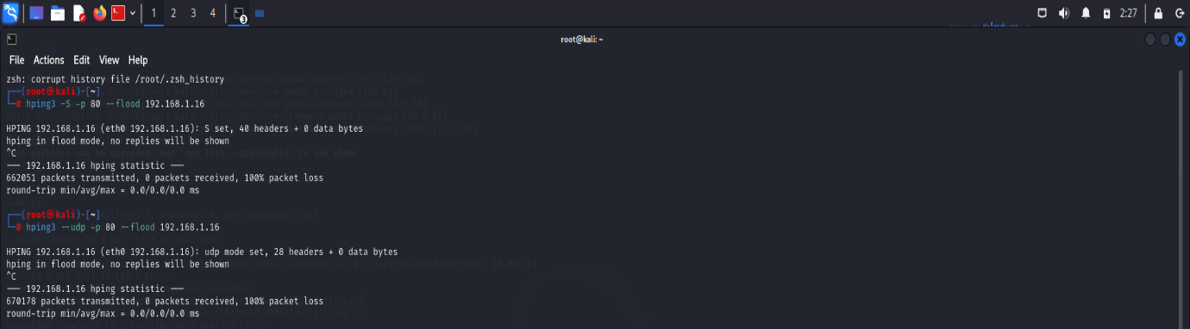

***Traffic Analysis***

*SYN Flooding :*

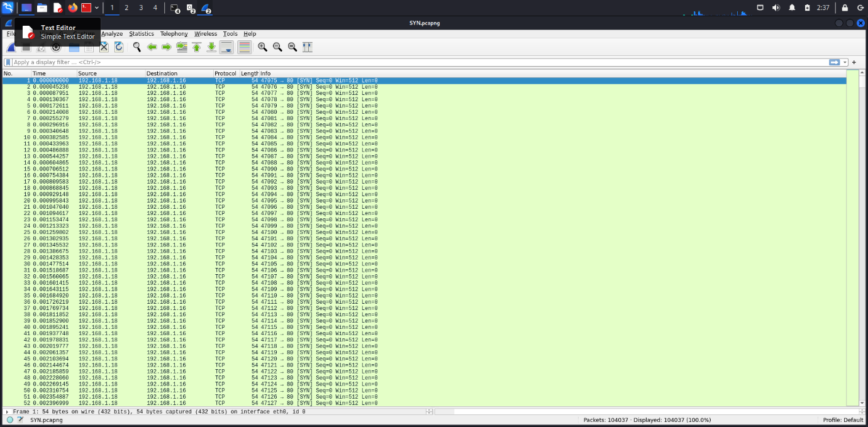

*UDP Flooding :*

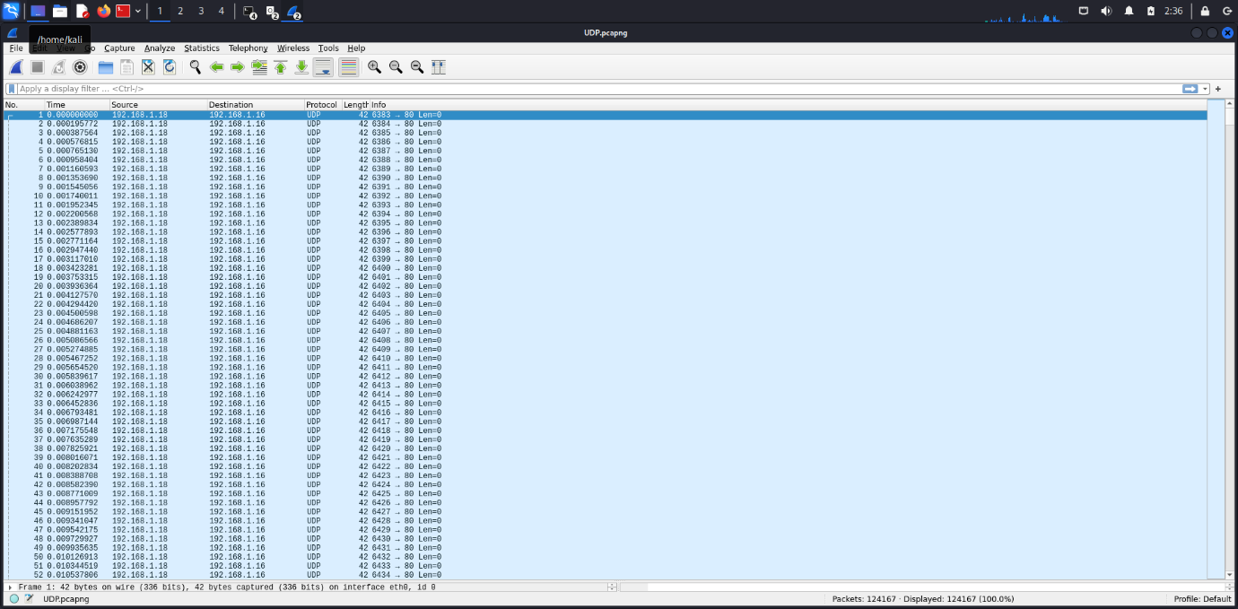

***Findings***

*The simulated Denial of Service (DoS) attacks revealed critical insights into how systems respond under stress and highlighted potential vulnerabilities:*

* ***Server Overload****: The server experienced significant slowdowns and, in some cases, became unresponsive due to resource exhaustion caused by the volume of malicious requests.*
* ***Traffic Patterns****: Abnormally high packet rates and malformed traffic were observed, which overwhelmed the server's capacity to handle legitimate requests.*
* ***Vulnerability Exploitation****: The attacks exploited the lack of rate limiting and insufficient protections against malicious traffic, exposing the system to potential downtime and security breaches.*
* ***Impact on Resources****: CPU, memory, and bandwidth usage spiked, demonstrating the need for robust resource allocation and monitoring mechanisms.*

***Recommendations***

*To mitigate the risk of DoS and DDoS attacks, the following best practices and strategies should be implemented:*

1. ***Firewalls and Access Control***
   * *Deploy web application firewalls (WAF) to filter and block malicious traffic.*
   * *Implement rules to drop malformed or unauthorized packets.*
2. ***Rate Limiting***
   * *Restrict the number of requests allowed from a single IP address in a specified time frame to prevent overwhelming the server.*
3. ***Intrusion Detection and Prevention Systems (IDS/IPS)***
   * *Use IDS/IPS tools to monitor network traffic for patterns indicative of DoS attacks and block them in real-time.*
4. ***Content Delivery Networks (CDNs)***
   * *Distribute network traffic across multiple servers using CDNs, ensuring better load balancing and protection against volumetric attacks.*
5. ***Traffic Monitoring and Alerts***
   * *Regularly monitor network traffic with tools like Wireshark or Splunk to detect anomalies early.*
   * *Configure alerts for sudden spikes in traffic or resource usage.*
6. ***Redundancy and Failover Systems***
   * *Implement redundant servers and load balancers to minimize the impact of an attack on a single system.*
7. ***Regular Security Assessments***
   * *Conduct penetration testing and vulnerability assessments to identify and address weaknesses proactively.*

***Conclusion***

*Simulating and analyzing DoS attacks is vital for understanding system vulnerabilities and improving resilience against cyber threats. These simulations provide invaluable insights into how servers and networks respond under duress, enabling organizations to identify weaknesses and implement effective mitigation strategies. By adopting robust security measures like firewalls, rate limiting, and IDS/IPS, organizations can significantly reduce the risk of downtime and ensure continuous availability of their services. Strengthening defenses against such attacks is an essential step in safeguarding critical infrastructure and maintaining trust with users.*