{{CURRENT_DATE}}

Offer Letter

Further to the personal interview held on {{INTERVIEW_DATE}}, Deco Arte is pleased to offer you employment as {{JOB_TITLE}} starting {{JOINING_DATE}}. You will be stationed at our office at E-204, near Kailash Colony Metro Station, Block E, East of Kailash, New Delhi, Delhi 110065, India
Your salary during probation will be held on {{MONTHLY_SALARY}}, per month.
Please note that this offer is subject to obtaining satisfactory references from your past employer and university and completing other joining formalities, including signing the employment agreement and confidentiality agreement.
The offer is held open for {{OFFER_EXPIRY_DAYS}} days from the date of this letter and shall expire after that unless the Company receives your acceptance within the specified timeframe. Please indicate your acceptance of the terms and conditions in this offer letter by signing it and returning it to the Company.

The Company is a progressive organisation committed to hiring the best candidates and motivating them to stay with us. This commitment is achieved by providing challenging projects using leading-edge technologies and a unique working environment. To those prepared to meet the challenges, it offers financial rewards and the opportunity to advance their careers and substantially consolidate their reputation.

Yours sincerely,

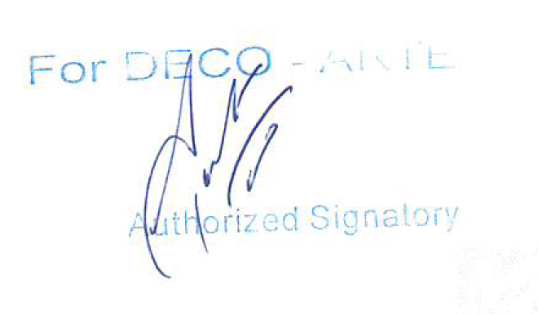

Amardeep Gulri
Principal Designer
Deco Arte

I accept your offer of employment through this offer letter.

Signature: [Your Signature]
[ {{CANDIDATE_NAME}}]

SCHEDULE 1
(Gross Salary)

Deco Arte

Role | {{JOB_TITLE}}
Name | {{CANDIDATE_NAME}}

Compensation & Benefit Components
Basic | {{MONTHLY_SALARY}}, INR per month
Flexible Pay | -
Gross Compensation | {{MONTHLY_SALARY}}, INR per month
Employer's contribution to the Provident Fund | -
Gratuity | -
Fixed Compensation | {{MONTHLY_SALARY}}, INR per month
Approx Value Of Benefits | -
Cost to Company Compensation | {{MONTHLY_SALARY}}, INR per month

Notes
* Flexible pay encompasses allowances, including travel expenses for site visits and provisions for stationery utilised in site-related activities.

