Offer Letter

Dear {{Candidate Name}},

Further to the personal interview held on {{Interview Date}}, The Melange Studio is pleased to offer you employment as {{Job Title}} starting {{Joining Date}}. You will be stationed at our office at C-18, Greater Kailash I, Greater Kailash, Delhi, New Delhi, Delhi 110048.

You will be on a probationary period of {{Probation Period Months}} months commencing from {{Joining Date}}, during which your performance and suitability for the role will be assessed. For Months 1–3 (probation period), you shall be paid a gross monthly compensation of INR {{Probation Monthly Salary – 45000}}. Upon successful completion of the probation period and subject to satisfactory performance review, your gross monthly compensation shall be revised to INR {{Transition Monthly Salary – 55000}} for Months 4–6. From the seventh (7th) month onwards, your fixed gross monthly compensation shall be INR {{Ongoing Monthly Salary – 50000}}. Effective from the fourth (4th) month of employment, you shall also be eligible for a project-based incentive ranging between {{Project Incentive Min %}}% and {{Project Incentive Max %}}%, applicable to projects directly handled by you. The project-based incentive shall be performance-linked, non-recurring, and over and above the fixed monthly compensation, and shall not form part of the guaranteed salary or Cost to Company (CTC).

On the Joining Date, you must complete the necessary paperwork, including signing the employment agreement outlining the terms and conditions of your employment. Additionally, you must review and familiarise yourself with all company policies, including, but not limited to, HR policies, Leave policies and office etiquette policies.

Please note that departure from the Company must be conducted through formal notice. The notice period required for resignation shall be 60 days for senior positions and 45 days for junior positions. You are expected to serve the full notice period unless otherwise agreed in writing by the management. Failure to comply with this requirement may result in forfeiture of certain dues or other actions as per company policy.

This offer is subject to receipt of satisfactory references from previous employers and/or educational institutions and successful completion of all joining formalities, including execution of the employment and confidentiality agreements.

The offer is held open for {{Offer Validity Days}} days from the date of this letter and shall expire after that unless the Company receives your acceptance within the specified timeframe. Please indicate your acceptance of the above terms and conditions by signing and returning a copy of this letter.

The Company is a progressive organisation committed to hiring the best candidates and motivating them to stay with us. This commitment is achieved by providing challenging projects using leading-edge technologies and a unique working environment. To those prepared to meet the challenges, it offers financial rewards and the opportunity to advance their careers and substantially consolidate their reputation.

Yours Sincerely,

Pranvi Jain, Principal Architect
The Melange Studio

I accept your offer of employment through this offer letter.
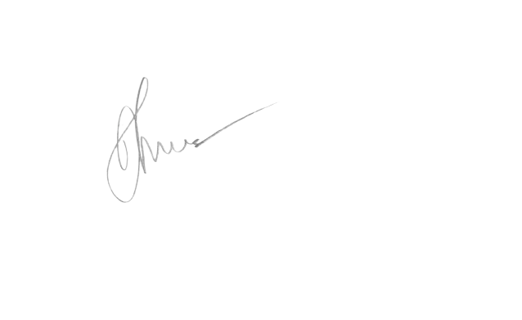

Signature: _______________________________
{{Candidate Name}}
{{Acceptance Date}}

SCHEDULE 1
(Gross Salary)
The Melange Studio
| Role | {{Job Title}} |
| Name | {{Candidate Name}} |
Compensation & Benefit Components | Monthly Amount (INR)
Basic | {{Basic Salary}} INR per month
Flexible Pay | -
Gross Compensation | {{Gross Monthly Salary}} INR per month
Employer's contribution to Provident Fund | -
Gratuity | -
Fixed Compensation | {{Fixed Monthly Salary}} INR per month
Approx Value Of Benefits | -
Cost to Company Compensation | {{CTC Monthly}} INR per month
Notes
- Flexible pay encompasses allowances, including travel expenses for site visits and provisions for stationery utilised in site-related activities.

