February 19, 2026
Offer Letter


Dear Anas Ansari,
Further to the personal interview held on February 19, 2026, The Hookkapani Studio is pleased to offer you employment as Programmer starting February 19, 2026. You will be will be stationed at our office at 427, Dhankar Rd, Block A 1, Neb Sarai, Sainik Farm, New Delhi, Delhi 110068
You will be subject to a 3-month probationary period from your February 19, 2026. Your performance and suitability for the role will be assessed during this time. Your salary during probation will be INR 25,000 per month. After completing the probationary period, your compensation will be subject to renegotiation based on performance and market conditions. The components of the Gross Monthly Salary will be as detailed in Schedule 1, attached hereto.
On the February 19, 2026, you must complete the necessary paperwork, including signing the employment agreement outlining the terms and conditions of your Full-Time. Additionally, you must review and familiarise yourself with all company policies, including, but not limited to, HR policies, Leave policies and office etiquette policies.
Please note that this offer is subject to obtaining satisfactory references from your past employer and university and completing other joining formalities, including signing the employment agreement and confidentiality agreement.
The offer is held open for 7 days from the date of this letter and shall expire after that unless the Company receives your acceptance within the specified timeframe. Please indicate your acceptance of the terms and conditions in this offer letter by signing it and returning it to the Company.

The Company is a progressive organisation committed to hiring the best candidates and motivating them to stay with us. This commitment is achieved by providing challenging projects using leading-edge technologies and a unique working environment. To those prepared to meet the challenges, it offers financial rewards and the opportunity to advance their careers and substantially consolidate their reputation.

Yours Sincerely,
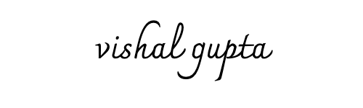
Vishal Gupta,
Founder,
The Hookkapani Studio

I accept your offer of employment through this offer letter.

Signature:
Date:

SCHEDULE 1
(Gross Salary)

The Hookkapani Studio

Role | Programmer
Name | Anas Ansari

Compensation & Benefit Components
Basic | INR 25,000 per month
Flexible Pay | {{FlexiblePayAmount}} | {{GrossCompensationPerMonth}} per month
Employer's contribution to Provident Fund | -
Gratuity | {{Gratuity}}
Fixed Compensation | INR 25,000 per month
Approx Value Of Benefits | -
Cost to Company Compensation | INR 25,000 per month

Notes
* Flexible pay encompasses allowances, including travel expenses for site visits and provisions for stationery utilised in site-related activities.

