Application Security Practical Exam

Name:Yashverdhan Singh

Enro:151060751031

Pratical 1

34 Write a program which asks the user to enter an integer 'n' which would be the total numbers of hours the user worked in a week and calculates and prints the total amount of money the user made during that week. If the user enters any number less than 0 or greater than 168 (n < 0 or n > 168) then your program should print INVALID

Assume that hourly rate for the first 40 hours is $8 per hour.

Hourly rate for extra hours between 41 and 50 (41 <= n <= 50 ) is $9 per hour.

Hourly rate for extra hours greater than 50 is $10 per hour.

Here are a few examples:

if the user enters -5, then your program should print

INVALID

if the user enters 34, then your program should print

YOU MADE 272 DOLLARS THIS WEEK

if the user enters 45, then your program should print

YOU MADE 365 DOLLARS THIS WEEK

if the user enters 67, then your program should print

YOU MADE 580 DOLLARS THIS WEEK

Note that the amount of money made by the user must be an integer (not a float) and your output should exactly match the format specified above (including spaces and capitalization).

ANS:

hours = int(input('how many hours did you work? '))

rate = 40

rate = (hours/2)+hours\*(rate+40)

if hours<40:

print("you earn",rate)

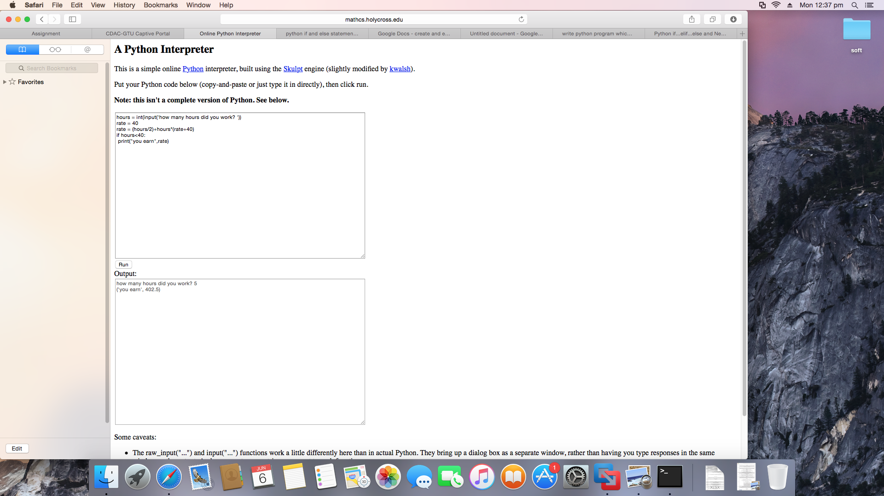

Practical 2

Q3 Write a program using a while loop that asks the user for a number, and prints a countdown from that number to zero.

import time

numTimes = int(input("How Many Seconds Do You Wish To print: "))

def countdown(count):

while (count >= 0):

print ("LiftOff In: ", count)

count -= 1

countdown(numTimes)

print ("!WE HAVE LIFT OFF!")

