RKIT Software Pvt. Ltd.
Desktop Miracle on Cloud
Requirement Analysis Document
User-wise Report + Setup / Provision New Client

Document ID | RA-DMC-001 | Date | 26 June 2026
Prepared By | Miracle Product Team | Reviewed By | Bhavin Chandegra
Modules Covered | (A) User-wise Report (B) Setup / Provision New Client

A User-wise Report

A1. Problem Statement
- The Users screen showed only a basic user list with limited filters and no partner information.
- There was no way to search by partner name or see a summary count at the top of the screen.
- Key fields like User Type, Start Date, and Partner Name were missing from the column layout.
- The Accounts and Support teams had no dedicated report — they relied on the operational screen, which is designed for editing, not reporting.
- Partner Name was not visible anywhere in the user list, making partner-based tracking difficult.

A2. Purpose
- Improve the Users screen to give a complete, well-organised view of all registered accounts.
- Add summary cards, improved filters (including partner name search), and additional table columns.
- Create a clean, read-only User-wise Report that the Accounts and Support teams can use safely for reporting.
- Make partner information visible in the report without needing to open any other screen.

A3. What Has Changed
Summary Cards
- Four cards are shown at the top: Total Customer ID, Total No. of Users, Active Users, and Deactive Users.
- Cards update automatically when a filter is applied or when a record is added or modified.
- Total No. of Users = Active Users + Deactive Users.

Filter Bar
- User Type — filter by New or Additional user.
- Partner Name — free-text keyword search to find accounts by partner name.
- Status — All / Active / Deactive (already existed; behaviour unchanged).

Data Table — New and Updated Columns
- User Type: Shows whether an account is New or Additional.
- Start Date: Subscription start date in DD-MM-YYYY format.
- End Date: Auto-calculated from Start Date (e.g. Start 29/06/2026 → End 28/06/2027). Editable directly in the row.
- Partner Name: Name of the partner linked to the account; shown as a coloured clickable link.
- “Client” column renamed to Account Name.
- Columns removed from default view: ID, Username, Email, Mobile, Server, IP, Active.

Global Search and Navigation
- Search bar added at the top: searches by Account Name, Customer ID, Partner Name, Ukey, or Status.
- Breadcrumb trail added: Desktop Miracle on Cloud → Accounts Export.

Excel Download
- A “Download for Accounts Dept” button is available on the report page.
- Exports the full user data in Excel format in one click, removing the need for manual copying or separate export requests.

A4. Screenshot
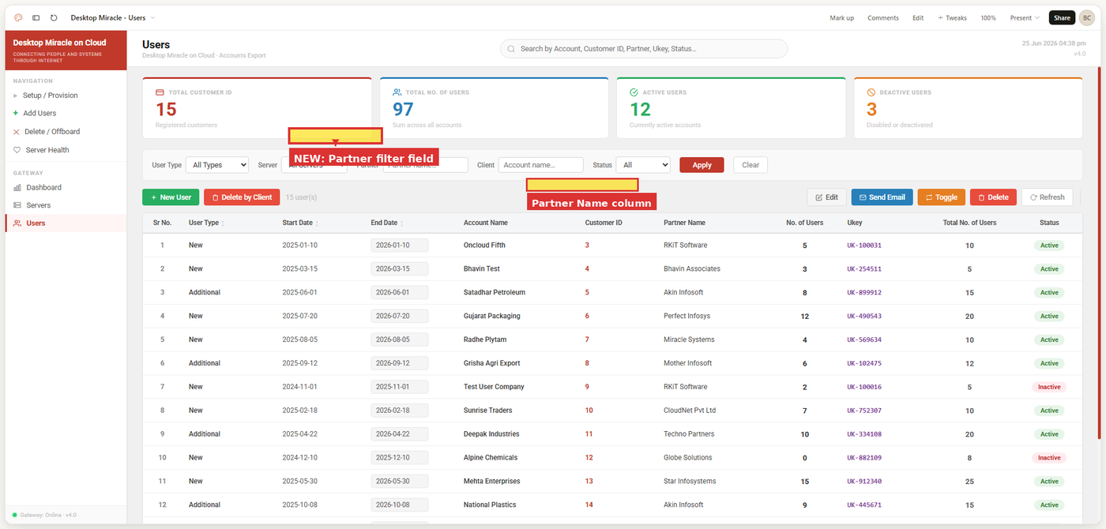
Fig 1 — Updated Users screen showing the summary cards, Partner filter, and Partner Name column

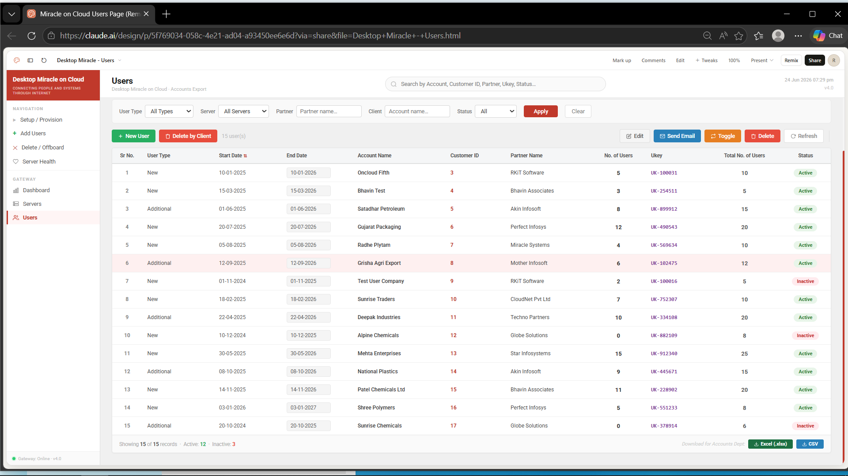
Fig 3 — User-wise Report page showing the Partner Name column and Excel download option

A5. Report Column Reference
# | Column Name | Data Type | What It Shows
1 | Sr. No. | Number | Row index (auto-numbered)
2 ★ | User Type | Text | New or Additional
3 ★ | Start Date | Date | Subscription start date in DD-MM-YYYY format
4 ★ | End Date | Date | Subscription end date (auto calculate based on start date)  E.g., Start Date = 29/06/2026 So End Date = 28/06/2027
5 | Account Name | Text | Name of the registered client account
6 | Customer ID | Number | Client identifier; shown as a coloured clickable link
7 ★ | Partner Name | Text | Name of the partner linked to the account
9 ★ | No. of Users | Number | Number of licensed users for this account
10 | Ukey | Text | Unique key for the account; shown as a blue clickable link
11 ★ | Total No. of Users | Number | Total licence count across all slots for the account
12 | Status | Badge | Active shown in green; Inactive shown in red

A6. How This Helps
- Summary cards give an instant count of active, inactive, and total accounts — no separate query needed.
- Partner name filter narrows the list instantly; the Partner Name column confirms the partner link for each account in the same view.
- Start Date and End Date columns make subscription tracking and renewal follow-up quick and visible.
- End Date is editable directly in the row — no need to open a separate form.
- The User-wise Report replaces the operational screen for reporting, removing the risk of accidental edits.
- Partner Name is visible directly in the report — no need to open another screen or contact a colleague.
- Excel export allows the team to share the report with management or use it for reconciliation with one click.

B1. Problem Statement
When setting up a new client through the Setup / Provision screen, there was no field available to record the partner associated with that client. The form collected client details and customer contact information but did not capture Partner Name or Partner Email ID at the time of provisioning. As a result, the team had to track this information separately, which was time-consuming and led to gaps in partner records.

B2. Purpose
A new Partner Details section has been added to the Setup / Provision form so that the responsible partner can be recorded at the time a client is set up. This ensures partner information is captured from the start and is available in the system immediately, without any separate data entry step.

B3. What Has Changed
- A new Partner Details section has been added to the form, placed between Client Details and Customer Contact.
- Partner Name: Free-text input or master of partner drop down list for the name of the partner linked to this client. Optional.
- Partner Email ID: Email input with format validation. Optional.
- All other sections (Target Server, Client Details, Customer Contact, Pre-Flight Conflict Resolution, Actions) are unchanged.

B4. Screenshot
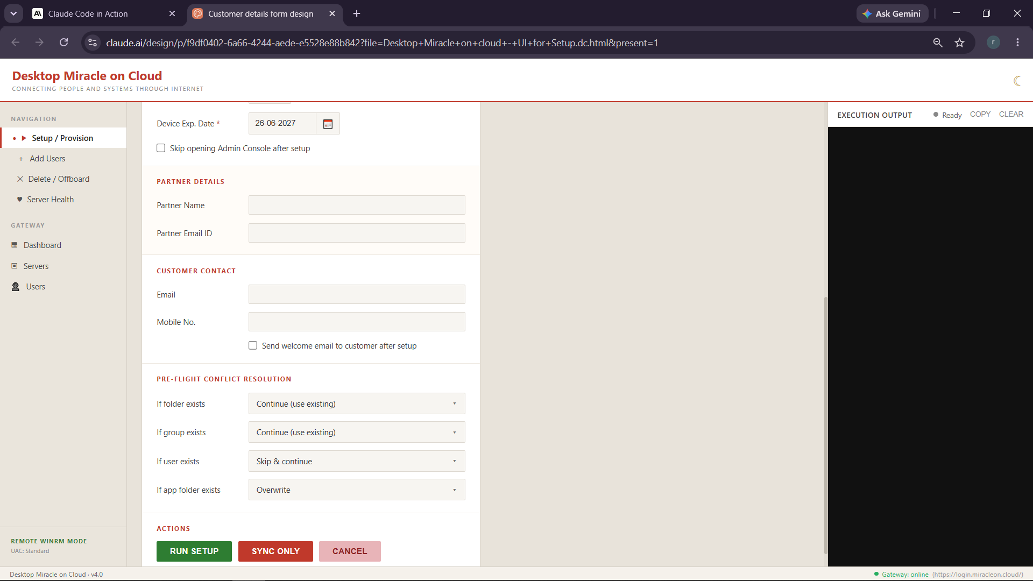
Fig 2 — Setup / Provision form showing the new Partner Details section between Client Details and Customer Contact

B5. How This Helps
- Partner details are captured once at the time of setup — in the same form, no separate step needed.
- Data is immediately available in the User-wise Report and any other part of the system that references partner information.
- Eliminates manual tracking of partner details and reduces gaps caused by separate data entry.

Confidential · RKIT Software Pvt. Ltd. · Miracle Support Team · Draft — Not for Distribution

