**Estimating parameter  
for Covid-19: A Mathematical Approach**

A DISSRETATION SUBMITTED TO

SVKM’S NMIMS (DEEMED TO BE UNIVERSITY)

IN PARTIAL FULFILLMENT FOR THE DEGREE OF

**BACHELORS OF SCIENCE**

**IN**

**DATA SCIENCE**

BY

**VIDIT PARESH SHETH**

**JINAV DHIREN GALA**

**YASH RAJESH SHAH**

UNDER THE SUPERVISION OF

Dr. DEBASMITA MUKHERJEE

SUNANDAN DIVATIA SCHOOL OF SCIENCE

SVKM’s Narsee Monjee Institute of Management Studies

(Deemed-To-Be-University)

V.L. Mehta Rd, Vile Parle (West), Mumbai – 400056

November 2022

**Acknowledgement**

We are using this opportunity to thank the person who has helped us greatly for successful completion of our project “Estimating parameter  
for Covid-19: A Mathematical Approach”. With utmost sincerity, we thank our mentor and teacher, Dr Debasmita Mukherjee ma’am, for her invaluable support and guidance during the project work. We’re grateful for her encouraging wishes and even constructive criticisms.

Also, we would like to thank NMIMS Sunandan Divatia School of Science for providing us with an opportunity to embark on this project.

**Abstract**

The pandemic scenario of COVID-19 with cases all over the world, the outbreak prediction had become extremely complex for the emerging scientific research. Several epidemiological mathematical models of spread to forecast the predictions appropriately are used. In this study, the classical susceptible-infected-recovered (SIR) modeling approach was employed to study the different parameters of this model for India.

# COVID-19

In December 2019, an outbreak of the novel severe acute respiratory syndrome coronavirus 2 (SARS-CoV-2); responsible for coronavirus disease 2019 (COVID-19) occurred in Wuhan City, Hubei Province, China. In January 2020, the World Health Organization (WHO) declared the outbreak a public health emergency of international concern. The first officially confirmed COVID-19 patient in Thailand was reported on January 13, 2020.

The current COVID-19 pandemic has affected people of all ages, including children, adults, and elderly individuals. COVID-19 can affect children, especially those under five years of age, in several ways. In addition to physical illness, many young children’s mental, emotional, and social well-being have been affected. Trauma faced at this developmental stage may have long-term consequences across their lifespan. Among adults and elderly individuals, the risk of severe illness with COVID-19 (hospitalization, admission to the intensive care unit (ICU), intubation or mechanical ventilation, or death) increases with age; however, adults of any age with certain underlying medical conditions (eg, type 2 diabetes mellitus, obesity, heart failure, chronic kidney disease, etc.) are also at an increased risk of severe illness.

Usually, outbreaks of deadly infectious diseases trigger considerable fear and anxiety among the public, especially when the death toll rapidly climbs. The COVID-19 outbreak has had a significant impact on public health and the socioeconomic system in many countries. Many resources (eg, funds, laboratory testing, and medical personnel) are needed to respond to the outbreak. Having recognized the risk of the COVID-19 outbreak, health authorities should be on alert and re-examine their capacity to manage an epidemic if such a mishap should recur in the future. Many governments established various control measures to prevent any further transmission and minimize the number of additional cases. The Thai government applied community-wide containment measures, including increased social distancing among community members, cancelling public gatherings, and implementing mandatory 14-day self-quarantine periods for individuals at risk of infection or those with COVID-19.

As a lesson from the past, quarantine measures have been used to control and eradicate the spread of infectious diseases, such as severe acute respiratory syndrome (SARS), with success. SARS was eventually controlled by interrupting all human-to-human transmission, ie, prompt isolation of patients, strict enforcement of the quarantine of all contacts, and community-level quarantine. Although quarantine measures were effective against the SARS outbreak, they were tarnished by the negative influences of socioeconomic issues, generalized fear, lack of understanding, posttraumatic stress disorder (PTSD), depression, discrimination, and rebellion.

For a better COVID-19 outbreak response, there is a need to understand communities’ knowledge, attitudes, and practices toward COVID-19. The results of a previous study concerning severe respiratory tract infections due to viral pandemics other than COVID-19 suggested that extensive standardized educational health campaigns and assessment of prior knowledge are necessary for preventing disease outbreaks by improving public awareness. In addition, mitigating fear and discrimination directed toward persons infected with SARS can be important in controlling outbreaks.

# SIR MODEL

Developed by Ronald Ross, William Hamer, and others in the early twentieth century; it consists of a system of three coupled non-linear ordinary differential equations

Mathematical models are required to estimate disease transmission, recovery, deaths, and other significant parameters separately for various countries, that is for different, specific regions of high to low reported cases of COVID-19. Different countries have already taken precise and differentiated measures that are important to control the spread of the disease. However, still, now, important factors such as population density, insufficient evidence for different symptoms, transmission mechanism, and unavailability of a proper vaccine, make it difficult to deal with such a highly infectious and deadly disease, especially in high population density countries such as India. Recently, many research articles have adopted the modelling approach, using real incidence datasets from affected countries, and, have investigated different characteristics as a function of various parameters of the outbreak and the effects of intervention strategies in different countries, respective to their current situations.

It is imperative that mathematical models are developed to provide insights and make predictions about the pandemic, to plan effective control strategies and policies. Modelling approaches are helpful to understand and predict the possibility and severity of the disease outbreak and, provide key information to determine the intensity of COVID-19 disease intervention. The susceptible-infected-removed (SIR) model and its extended modifications such as the extended-susceptible-infected-removed (eSIR) mathematical model in various forms have been used in previous studies to model the spread of COVID-19 within communities

Any population that is exposed to an infection can be divided into three categories– Susceptible (S), Infected (I), and Recovered (R), creating the SIR model. The SIR model is a compartmental model where each individual falls into one of the three compartments. Susceptible individuals encounter an infectious individual and can contract the disease (with some probability). Infectious individuals are capable of infecting susceptible individuals. As the infected population increases, susceptible cases will decrease. Recovered classes are those that have been infected and are now removed (immune or deceased). In the simple SIR model, the population remains constant. There are many modifications of the SIR model, including those that include births and deaths. A model could include an exposed period where an individual has no clinical signs of the disease but is infectious (SEIR). There are other models whereupon recovery there is no immunity (SIS model) or where immunity lasts only for a short period (SIRS). The type of compartmental model used depends on the dynamics of the disease. Models also can include reduction strategies, such as quarantine and vaccinations.

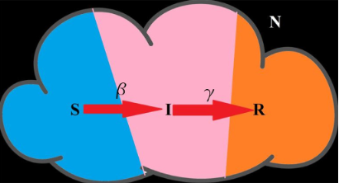

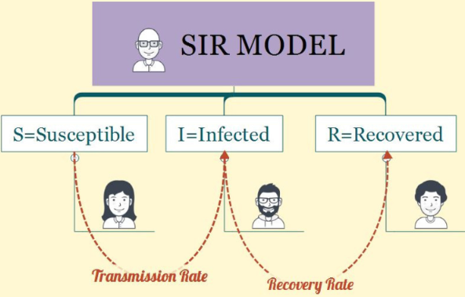

# SIR Model Explanation:

The SIR model consists of 3 differential equations:

* $\frac{dS}{dt}=-\frac{β}{N}SI$--(1)
* $\frac{dI}{dt}=\frac{β}{N}SI-γI$--(2)
* $\frac{dR}{dt}= γI$--(3)

Goal is to estimate the parameter of the system of equation.

Here the parameters are,

* $β:$ expected amount of people an infected person infects per day (Transmission rate)
* $γ$:the proportion of infected recovering per day (γ = 1/D) (Recovery rate)

Other dependent variables:

* S: number of people susceptible
* $I$: number of people infected
* $R$: number of people removed/recovered

Constant:

* $N$: total population

When there is no infection or any recovered ($I$ +R=0), then by substituting N ≈ S in (2):

* $\frac{dI}{dt}\sim I(β-γ)$--(4)

Integrating (4) we get:

* I= $c_{1}$ e(β -γ)t

Here let $I$ at time 0 be $I_{0}$. Then solving for $c_{1}$ we get:

* I= $I_{0}$ e(β -γ)t --(5)

At the onset of infection almost all of the population is susceptible that is S ~ N. Therefore $I_{t}$ first grows exponentially.

* $\frac{dI}{dt}=ml$--(6)

Here $m=(β-γ)$ which is a constant term that represents the difference between the infection rate and recovery rates.

0emt --(7)

Taking log, we get the following equation which can be solved using least squared estimation for the value of m.

$Ln I = mt +ln I_{0}$--(8)

Determination of γ value

Suppose $I_{t}$ = $I_{0}$ (constant); then we obtain:

0 --(9)

Integrating equation 9 we get:

R(t) = γt I0 --(10)

Suppose it takes t=T days to recover, and so $R_{t}=I_{0}$ Then we get:

$γ≈\frac{1}{T}$--(11)

According to the definition of differentiation we can write equation 3 as the following for a change in time $dt=a$:

$\frac{R\left(t+a\right)-R(t)}{a}= γI$--(12)

For a=1 we get:

$γ≈\frac{R\left(t+1\right)-R(t)}{I(t)}$--(13)

Determining Imax

Dividing the equation (2) by (1):

${\left(\frac{dI}{dt}\right)}/{\left(\frac{dS}{dt}\right)}=-1+\frac{γ}{β}N\frac{1}{S}$--(14)

$\frac{dI}{dS}=-1+\frac{γ}{β}N\frac{1}{S}$--(15)

Integrating equation (15) we get:

$I=-S+\frac{γ}{β}NlogS+C$--(16)

At the onset of infection, the value of number of infections is low. Thus S~N. Substituting t=0, I=0 and S~N we get:

$0=-N+\frac{γ}{β}lnN$--(17)

$C=N\left(1-\frac{γ}{β}lnN\right)$--(18)

Substituting value of c in equation (16) we get:

$I=N-S+\frac{γ}{β}N ln\frac{S}{N}$--(19)

Generally, the Infected (I) cases initially increases exponentially, reaches a peak, and then gradually decreases back to zero. We need peak of infection ie maximum number of people who got infected at a particular time within a period. The Eqs. (2) and (19) are the differential equation of infection rate and its solution respectively.

To simplify, assume S=Ns, I=Ni, and R=Nr. Here, s, i, and r represent the fraction of total susceptible, infected, and recovery/removed populations. Thus, we obtained the following equations:

$\frac{di}{dt}=βis-γi=i(βs-γ)$--(20)

And

$i=1-s+\frac{γ}{β}ln s$--(21)

During peak infection at di/dt=0, s is obtained by the following equation:

$s=\frac{γ}{β}$--(22)

Substituting s from equation (22) in equation (21) we get:

max= 1+ $\frac{γ}{β}\left(ln\frac{γ}{β}-1\right)$--(23)

In terms of $R_{0}$,

$i_{max}= 1-\frac{1}{R0}\left(1-ln\frac{1}{R0}\right)$--(26)

imax speaks about maximum percentage of population that will get infected at a particular time.

**Parameter estimation on COVID-19 data for India**

We used the COVID data spanning from onset of cases in India until May 2020 as it was the initial phase of the virus in India. Proper measures needed to be taken according to the parameter: R naught. A snapshot of head of the dataset:

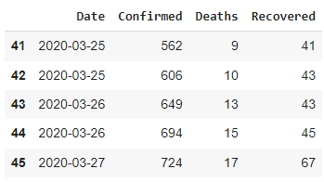

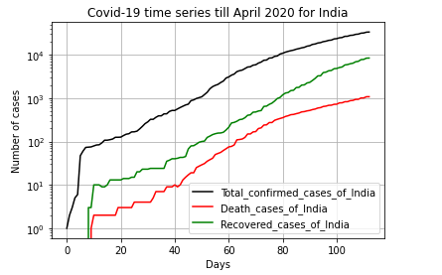

We fitted the SIR model with estimated total population of India taken as 1380004385.

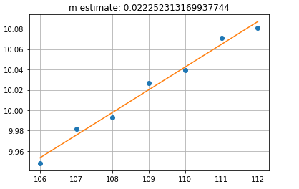

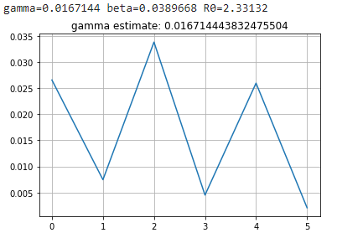

Transmission rate (beta) is 0.0389; which gives the rate at which infection spreads. Recovery rate (gamma) is 0.01671; which gives the rate at which infected people recover.

R naught turns out to be 2.33132. This means that on average, an infected person can spread the infection to 2.33 other people. Also it is greater than 1. That signifies the infection was on rise at that time, and strict measures were necessary. The lockdown and restrictions on number of people gathering were taken at that time owing to this R naught parameter.

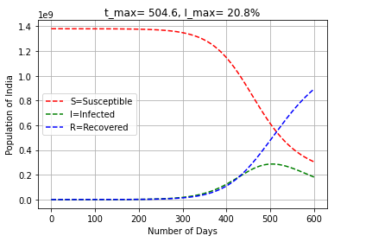

imax is 20.8% at tmax 504.6. That means that the proportion of infected people in the population at a time is 20.8%. And this peak will be reached within 500 days of onset of the virus in India.

# References

1. [Estimating the parameters of susceptible-infected-recovered model of COVID-19 cases in India during lockdown periods](https://pubmed.ncbi.nlm.nih.gov/32834642/)
2. [Series on parameter estimation for differential equation on medium.com](https://tavoglc.medium.com/list/differential-equations-298130f02d17)

Dataset:

* <https://github.com/datameet/covid19/blob/master/data/all_totals.json>

Code:

* <https://colab.research.google.com/drive/14gPcTLPZB0XRJsZ1sUxuxRGf0phTLGF_?usp=sharing>