

An Android Project On
“SwapZone: Buy, Sell & Exchange”

In the Partial fulfilment of
Master of Science –In Information Technology- Integrated

(iMSc (IT))- Semester-09

Developed By:

Sr No | Enrollment No | Name of the Students
1. | 21004500210160 | Shah Yash Dineshkumar
2. | 21004500210016 | Bhavsar Nandini Amitkumar
3. | 21004500210051 | Jain Raj Sunil Kumar

Group No: iMSc (IT)_10
Under the Guidance of
Prof. Virendra Ingle

Submitted To
L.J. School of Computer Applications
L.J.Campus, Near Sanand Cross Roads, S.G.Road, Ahmedabad - 382210
Ph. No.: 9099063417


CERTIFICATE
Enrollment No: 21004500210160 | Seat No:

This is to certify that Mr. Shah Yash Dineshkumar of Master of Science (Information Technology) Integrated, Semester: 09, Div: A, Roll No: B60 - has satisfactorily completed her project title “SwapZone: Buy, Sell & Exchange” in Android Project (050021001) under the supervision of

Internal Guide | Dr. Jignesh Doshi
Prof. Virendra Ingle | Head of the Department

Date of Submission:



CERTIFICATE
Enrollment No: 21004500210016 | Seat No:

This is to certify that Ms. Bhavsar Nandini Amitkumar of Master of Science (Information Technology) Integrated, Semester: 09, Div: A, Roll No: B06 - has satisfactorily completed her project title “SwapZone: Buy, Sell & Exchange” in Android Project (050021001) under the supervision of

Internal Guide | Dr. Jignesh Doshi
Prof. Virendra Ingle | Head of the Department

Date of Submission:



CERTIFICATE
Enrollment No: 21004500210051 | Seat No:

This is to certify that Mr. Jain Raj Sunilkumar of Master of Science (Information Technology) Integrated, Semester: 09, Div: A, Roll No: B21 - has satisfactorily completed her project title “SwapZone: Buy, Sell & Exchange” in Android Project (050021001) under the supervision of

Internal Guide | Dr. Jignesh Doshi
Prof. Virendra Ingle | Head of the Department

Date of Submission:

Plagiarism Declaration

To whom so ever it may concern
I, confirm that “SwapZone: Buy, Sell & Exchange” Project (document/PPT or Code) is my own work, is not copied from any other person's work (published or unpublished or generated using CHATGPT/AI), and has not previously submitted for assessment either at University or elsewhere. We confirm that we have read and understood the rules regulations on plagiarism in LJ University.

Sr. No. | Enrollment No. | Name of the student | Signature
1 | 21004500210160 | Shah Yash Dineshkumar
2 | 21004500210016 | Bhavsar Nandini Amitkumar
3 | 21004500210051 | Jain Raj Sunilkumar



Commitment Form
I Shah Yash Dineshkumar assure that following are the components on which we worked in the said project titled “SwapZone: Buy, Sell & Exchange”. Further we confirm that, we have read and understood the rules and regulations of UFM in LJU.

Student 1
Enrolment No.: 21004500210160 Division: A Roll No.: B60
Name of the student: Shah Yash Dineshkumar
Components worked on
Se No. | Name of the Components | Sr. No | Name of the Components
1. | Google Authentication | 16.
2. | Razor Pay | 17.
3. | Home Page | 18.
4. | Cart | 19.
5. | Sell Category | 20.
6. | Profile | 21.
7. | Electronics | 22.
8. | Sports | 23.
9. | Toys | 24.
10. | Order_detail | 25.
11 | Admin_analytical | 26.
12 | Admian manage user | 27.
13 |  | 28.
14 |  | 29.
15 |  | 30.

Date: Signature:



Commitment Form
I Bhavsar Nandini Amitkumar assure that following are the components on which we worked in the said project titled “SwapZone: Buy, Sell & Exchange”. Further we confirm that, we have read and understood the rules and regulations of UFM in LJU.

Student 2
Enrolment No.: 21004500210016 Division: A Roll No.: B06
Name of the student: Bhavsar Nandini Amitkumar
Components worked on
Se No. | Name of the Components | Sr. No | Name of the Components
1. | Signup | 16.
2. | Login | 17.
3. | Forget Password | 18.
4. | Reset password | 19.
5. | OTP Verify | 20.
6. | Splash | 21.
7. | Fashion | 22.
8. | Beauty | 23.
9. | checkout | 24.
10. | order | 25.
11 | Admin order detail | 26.
12 | Admin manage product | 27.
13 |  | 28.
14 |  | 29.
15 |  | 30.

Date: Signature:



Commitment Form
I Jain Raj Sunilkumar assure that following are the components on which we worked in the said project titled “SwapZone: Buy, Sell & Exchange”. Further we confirm that, we have read and understod the rules and regulations of UFM in LJU.

Student 3
Enrolment No.: 21004500210051 Division: A Roll No.: B21
Name of the student: Jain Raj Sunilkumar
Components worked on
Se No. | Name of the Components | Sr. No | Name of the Components
1. | Product Details | 16.
2. | Admin details | 17.
3. | Manage User | 18.
4. | User Details | 19.
5. | Edit Profile | 20.
6. | Payment Success | 21.
7. | Automotive | 22.
8. | Books_media_Hobbies | 23.
9. | My_product | 24.
10. | Edit_product | 25.
11 | Admin manage product detail | 26.
12 |  | 27.
13 |  | 28.
14 |  | 29.
15 |  | 30.

Date: Signature:



Acknowledgement

I would like to take this opportunity to express my sincere gratitude and appreciation to all those who have supported me in the successful completion of my Semester 10 project.

First and foremost, I would like to extend my heartfelt thanks to Dr. Jignesh Doshi, Head of the Department, M.Sc. (Information Technology), LJ School of Computer Applications, LJ University, for his continuous encouragement, expert guidance, and invaluable support throughout the duration of this project.

I am extremely thankful to my internal guide, Mr. Virendra Ingle, for providing insightful feedback, motivation, and guidance at every stage of the project.

I sincerely appreciate the efforts of all faculty members and lab instructors who provided assistance and support whenever needed.

Lastly, I am grateful to my family and friends for their constant support, motivation, and encouragement throughout the project journey.

Enrolment No(s) [Your Enrolment No]
Name(s): & Signature(s) [Your Name and Signature]
Semester: 10
Project Title: [Your Project Title]

INDEX

Sr. No. | TABLE OF CONTENTS | Page No.
1. | INTRODUCTION | 11 to 12
 | 1.1 Existing System | 13
 | 1.2 Need for the New System | 14
 | 1.3 Objective of the New System | 15
 | 1.4 Problem Definition | 16
 | 1.5 Scope of the project and Core Components | 17 to 18
 | 1.6 Project Profile | 18
 | 1.7 Assumptions and Constraints | 19
 | 1.8 Advantages and Limitations of the Proposed System | 20 to 21
2. | REQUIREMENT DETERMINATION & ANALYSIS | 22
 | 2.1 Requirement Determination | 22 to 23
 | 2.2 Targeted Users | 24
3. | SYSTEM DESIGN | 25
 | 3.1 Use Case Diagram | 25
 | 3.2 Activity Diagram | 26
 | 3.3 Activity Diagram | 27
 | 3.4 Sequence Diagram | 28
 | 3.5 Class Diagram | 29
 | 3.6 Data Dictionary | 30 to 32
4. | DEVELOPMENT | 33 to 34
 | 4.1 Coding Standard | 33 to 34
 | 4.2 Screenshots | 35 to 58
5. | AGILE DOCUMENTATION | 59
 | 5.1 Agile Project Charter | 59
 | 5.2 Agile Road map/Schedule | 60
 | 5.3 Agile Sprint Backlog | 60 to 61
 | 5.4 Agile User Story | 61 to 62
 | 5.5 Agile Release Plan | 62 to 63
 | 5.6 Agile Test Plan | 63 to 64
 | 5.7 Agile Sprint burn charts | 65
7. | PROPOSED ENHANCEMENT | 65
9. | CONCLUSION | 66

1 INTRODUCTION

In recent years, people have moved away from old trading methods like newspaper ads or local markets. They now want faster, easier, and more reliable ways to exchange goods.

That’s why we created SwapZone. It’s a mobile app where users can buy, sell, or even swap items in a simple and safe way.

The main goal of SwapZone is to save time and make trading more engaging for the community. Instead of waiting in offline markets, users can instantly upload their products, browse listings, and even exchange items. This gives unused things a new life and reduces waste.

To make the app user-friendly, SwapZone has features like location-based search, smart suggestions, secure accounts, easy navigation, and clear product details. These ensure both safety and convenience.

What makes SwapZone different is that it’s not just a marketplace but also a community platform. It encourages recycling, reusing, and saving money. People can buy second-hand items at lower prices or swap products without spending at all.

Since it’s mobile-friendly, anyone can use it students looking for budget-friendly products, families trying to declutter, or small businesses reaching new customers. The app is flexible, accessible, and available anytime.

- What is SwapZone?
SwapZone is a mobile app made for simple trading. People can buy, sell, or exchange products easily. Users can post their items, check what others have listed, or even swap products without using money. It’s very useful in daily life for example, clearing out things you don’t use anymore, finding affordable items, or exchanging products within the community.

- Traditional vs. Digital Trading
Traditional trading methods, like newspaper ads or local markets, are often slow and limited. They usually reach fewer people, take more time, and don’t give quick updates.
Digital trading, like in SwapZone, is faster and more convenient. Users can instantly post items, search with filters, get smart suggestions, and chat directly with others. This makes trading quicker, clearer, and more personalized compared to old methods.

- Accessibility and Simplicity
A major strength of SwapZone is its ease of access. Users can choose to connect with people in their neighbourhood or explore listings from other regions. Since the platform works smoothly on mobile and across devices, trading can be done anytime, anywhere making the entire process more flexible and hassle-free.

- Core Features of SwapZone
- Quick Search and Filters – Locate items faster using categories, price range, or location.
- Verified Accounts – Create trust between users through identity verification.
- Direct Messaging – Chat instantly without sharing personal contact details.
- Swap Functionality – Trade items directly instead of making payments.
- Nearby Listings – Discover goods available in the local area for faster deals.

- A Complete Trading Ecosystem
SwapZone is more than just a simple listing app. It works as a complete trading system. The app encourages people to reuse items, save money, and follow responsible buying and selling habits. It can be used for many purposes earning extra income, decluttering your home, or even swapping items for fun. SwapZone adjusts to the different needs of its users.

- Why SwapZone?
SwapZone is a modern and practical alternative to old marketplaces. It is made for today’s users who want easy-to-use apps, affordable options, and eco-friendly solutions. More than just convenience, SwapZone’s bigger goal is to build a smarter and greener community.

  - Existing System

The current systems for buying, selling, and exchanging items whether through physical markets, traditional classifieds, or basic online platforms have served people for many years. However, with the rise of digital lifestyles and growing expectations for convenience, safety, and personalization, these systems are increasingly showing their limitations.

1. Dependence on Physical Marketplaces
Traditional marketplaces like local bazaars, second-hand shops, or newspaper classifieds require people to be physically present to trade. This makes trading less flexible and limits opportunities to only one locality. Buyers and sellers also need to spend extra time and effort to meet in person. In today’s fast-paced world, this lack of accessibility makes physical markets less useful for modern users.

2. Limited Reach of Online Classifieds
Online classified websites give some digital support, but they still have many problems. Most of them only allow users to post simple ads without any proper verification, which can lead to fake or unreliable listings. They also lack features like direct product swaps, real-time chat, or smart recommendations. Because of this, the overall experience feels basic, less secure, and not very engaging for users.

3. Lack of Secure and Transparent Transactions
A big drawback of current systems is the lack of proper verification and transparency. Buyers and sellers cannot be sure if the other person is genuine. Most transactions depend only on trust, which increases the chances of scams, fake product details, or incomplete exchanges. Without safety measures, users often hesitate to fully trust these platforms.

4. No Support for Sustainable Trading
Most existing platforms only focus on buying and selling, without promoting reuse or eco-friendly practices. This leads to more consumption and waste. But today, many users prefer swapping or recycling items to save money and support sustainable living. Sadly, current systems are not designed to support these modern needs.

  - Need for New System

As we can see, traditional marketplaces and basic online classified platforms have many drawbacks. This shows the need for a modern, reliable, and flexible trading system. A platform built with advanced features and user-friendly design can solve these issues. The goal is to create a system that is secure, easy to use, and effective in meeting the needs of today’s users.

1. Need for Personalization
Every buyer or seller has different needs. Some people may want brand-new products, while others prefer second-hand items or direct swaps. Current systems do not properly support these different choices. A modern platform should provide personalized suggestions based on the user’s location, behaviour, and preferences. By analysing user activity, it can recommend relevant products, offer smart filters, and make trading easier for each person.

2. Need for Safety and Trust
Many users struggle to find trustworthy buyers or sellers, especially in smaller towns or remote areas. Safety concerns also stop people from using current platforms. That’s why there is a need for a secure and transparent system that verifies users, prevents fraud, and connects people across regions. This would build trust, increase confidence, and give more trading opportunities for everyone.

3. Need for Better Communication
Most current platforms do not have proper communication tools, so users have to depend on outside apps to discuss deals. This often causes miscommunication and reduces trust. A better system should include real-time chat, instant notifications, and clear tracking of interactions. Keeping all communication within the platform makes the process faster, safer, and more transparent.

4. Need for Suitable Trading
Today, many users are more interested in swapping and reusing items to save money and protect the environment. But traditional systems mainly focus only on direct buying
and selling, with no real support for sustainability. A better platform should allow flexible options—buy, sell, or swap—while also encouraging reuse and recycling. This helps reduce waste and creates a community where resources are used more responsibly.

  - Objectives of the System

The main objective of SwapZone is to build a modern, secure, and easy-to-use platform that solves the problems of existing trading systems. It is designed to make buying, selling, and exchanging goods simple while also promoting trust, convenience, and sustainability.

1. To Provide a Personalized Trading Experience
SwapZone is designed to give every user a personalized experience. It suggests items based on their preferences, past activity, and location. With smart filters and AI recommendations, users can quickly find what they need, making the whole trading process easier and more engaging.

2. To Ensure Safe and Transparent Transactions
One of SwapZone’s main objectives is to provide a safe trading environment. It will use features like user verification, profile authentication, and fraud prevention to build trust. Clear product details and transparent listings will also make every transaction more reliable and secure.

3. To Enable Real-Time Communication
SwapZone will have built-in chat and notifications so buyers and sellers can talk directly in the app. This removes the need for outside tools, reduces miscommunication, and keeps negotiations quick, clear, and well-documented.

4. To Support Multiple Trading Options
SwapZone aims to go beyond conventional buying and selling by also enabling direct item swaps. This flexibility allows users to save money, reuse products, and engage in eco-friendly practices, making the platform suitable for a wide variety of trading needs.

  - Problem Definition

The current systems for buying, selling, and exchanging goods whether through traditional markets, classifieds, or basic online platforms are not enough for today’s users. They face many problems that reduce efficiency, limit access, and affect trust.
First, physical marketplaces have limited reach since trading is restricted to nearby areas. This stops users from exploring wider markets or getting better deals.
Second, many online classified sites do not have proper verification. This leads to risks like fraud, fake listings, and misrepresentation of products, making users hesitant to trust them.
Third, most platforms lack real-time communication. Buyers and sellers often need to use external apps, which causes delays, miscommunication, and reduces trust.
Another problem is the lack of direct item swaps. Most platforms only focus on cash transactions, ignoring the growing need for exchanging and reusing goods. This also fails to promote eco-friendly practices.
Finally, existing platforms rarely offer personalization. Without smart filters or recommendations, users are often flooded with irrelevant listings, making the process slow and less engaging.
Because of these issues, there is a clear need for a modern system like SwapZone one that provides Verified Profiles, Real-time Chat, Personalized Suggestions, Flexible Trading Options, and Promotes Sustainable Practices.

  - Scope of the Project and Core Components

- The scope of the SwapZone

The scope of SwapZone is to create a digital marketplace where people can buy, sell, and exchange products in a safe and easy way. The project aims to solve the problems of traditional and basic online trading systems by adding modern features for today’s users.

The platform will be available on mobile and web, so anyone can access it anytime, anywhere. It will include:
- Verified accounts to ensure safety and trust.
- Real-time chat and notifications for smooth communication.
- Smart recommendations and filters to make finding products faster.
- Direct swapping options to promote reuse and sustainability.

SwapZone is designed for different users like:
- Individuals who want to buy, sell, or swap items locally.
- Students looking for affordable products.
- Families who want to declutter or save money.
- Small businesses that want to reach more customers.
At first, the app will focus on local and regional trading, but it is scalable for future expansion to larger markets.

- Core Components of the System

  - Buyer Module
- Buyers can browse products by category, see details, and contact sellers.
- They can also track their orders and save items.
It’s like a personal shopping space for buyers.
  - Seller Module
- Sellers can upload products with images and prices, manage listings, and respond to buyers.
- They can also track sales and update items once sold.
It helps sellers easily showcase and sell their items.
  - Profile & Account Management
- Users can create/update profiles with personal details.
- They can manage their products, transactions, and saved items.
- Includes login security and password reset.
Acts as the user’s personal dashboard.

  - Product & Category Management
- Products are organized into categories (Books, Electronics, Fashion).
- Includes search, filter, and sorting options.
- Shows safe and clear product details.
Keeps the marketplace neat and easy to use.
  - Admin & Backend Management
- Admins can monitor users and listings for safety.
- Handle fraud reports, payments, and platform security.
Ensures the system runs smoothly and safely.

  - Project Profile

Project Name: | SwapZone: Buy, Sell & Exchange
Group No: | 10
Category: | Online Marketplace
Project Description: | Buy, Sell & Exchange Platform
Group Members: | (21004500210160) Shah Yash Dineshkumar  (21004500210016) Bhavsar Nandini Amitkumar  (21004500210051) Jain Raj Sunilkumar
Technology Stack: | Front-End: Flutter  Back-End: Node.js, Express.js  Database: MongoDB

  - Assumptions and Constraints

- Assumptions

  - Availability of Internet and Device
It is assumed that all users including buyers, sellers, and exchangers will have stable internet connectivity and access to modern devices such as smartphones, tablets, or computers. Since SwapZone is a digital platform, uninterrupted access is necessary for browsing, posting listings, real-time chat, and completing transactions.

  - Availability of Products for Exchange
It is assumed that users will regularly post items they no longer need. This helps keep the marketplace active with a variety of products. By contributing their goods, users ensure that others can always find options to buy, sell, or swap.

  - Honest Listing and Engagement
Another assumption is that users will provide accurate product details, fair pricing, and genuine listings. In addition, active engagement such as responding to messages, verifying profiles, and leaving feedback is expected. These actions are critical to maintaining trust and ensuring that the platform remains reliable and community-driven.

- Constraints

  - Limited Budget and Development Time
SwapZone has to be developed within a limited budget and time. This means we cannot add very advanced features in the first version, like blockchain payments or AI fraud detection. Instead, we will focus on the most important functions and use resources carefully to deliver a working and reliable app on time.
  - Dependency on Third-Party Service
Some features of SwapZone, like payments, location tracking, or instant notifications, depend on third-party services. If these services face downtime, updates, or issues, it may affect how smoothly SwapZone works. The platform’s performance will partly rely on the stability of these external providers.

  - Securing and Privacy Regulations
SwapZone will handle user data, so it must follow strict security and privacy rules. This means using safe login methods, encrypted communication, and secure transactions. Following regional laws like consumer protection or digital trade policies may also add challenges or slow down some features.

  - Advantages and Limitation of the Proposed System

- Advantages of the Proposed System

- Personalized Trading Experience
One of the key advantages of SwapZone is its ability to provide personalized recommendations. By analysing user preferences, search history, and location, the system suggests the most relevant listings. This saves time, improves user satisfaction, and ensures that buyers and sellers find exactly what they need with minimal effort.

- Scalable and Future-Ready
The platform is designed with scalability in mind, allowing it to support an increasing number of users without performance issues. Whether serving a local community or expanding to a larger region, SwapZone can easily adapt. In the future, additional features such as AI-driven fraud detection, blockchain-enabled transactions, and multilingual support can be integrated to keep the system competitive and up to date.

- Transparency and Trust Building
Through features like verified profiles, transparent product listings, and secure user authentication, SwapZone promotes trust among its users. Both buyers and sellers can view clear product details, maintain transaction histories, and rely on a safe trading environment. This transparency reduces risks of fraud and builds long-term confidence in the platform.

- Flexible and Accessible Trading
SwapZone enables users to buy, sell, or swap items anytime and anywhere. With its mobile-friendly design, cross-device compatibility, and geolocation search, users can easily connect with nearby traders or explore wider markets. This flexibility ensures convenience for all types of users—from students to families to small businesses.

- Community and Sustainability Oriented
Beyond being just a marketplace, SwapZone encourages eco-friendly practices such as reusing and recycling products through direct exchanges. This not only reduces waste but also helps users save money and promotes responsible consumption. The community-driven nature of the platform strengthens connections between people and creates a more sustainable trading ecosystem.

- Limitations of the Proposed System

- Technology Dependency
Since SwapZone is an online platform, its functionality depends heavily on stable internet access and compatible devices. Users in remote areas or with limited connectivity may face difficulties in accessing listings, communicating in real time, or completing transactions.

- User Adoption and Learning Curve
First-time users may find it challenging to understand features such as account verification, listing creation, or swap functionality. Without proper onboarding guides, tutorials, or FAQs, new users may initially struggle to use the system effectively.

- Cost of Maintenance and Updates
Developing and running a secure marketplace requires continuous investment in servers, feature upgrades, security patches, and bug fixes. To maintain smooth operations, a dedicated technical team and consistent financial resources will be necessary.

- Data Security and Privacy Concerns
SwapZone collects and stores user information such as profiles, product details, and chat histories. Ensuring compliance with data protection regulations and safeguarding against cyber threats is critical. This adds complexity and may increase the cost of system management.

- Market Trust and Verification Challenges
While SwapZone introduces features like verified profiles, it may still face challenges in building trust among users, especially during the early adoption phase. Fraudulent or misleading listings could impact credibility until the platform establishes stronger user verification and reporting mechanisms.

2. REQUIREMENT DETERMINATION & ANALYSIS

2.1 Requirement Determination

The success of a software system depends on a well-defined understanding of its requirements. For SwapZone, the requirement determination phase is critical in shaping the platform into a secure, user-friendly, and sustainable online trading ecosystem. This step involves identifying the functionalities, features, and conditions needed to meet the diverse needs of its users—buyers, sellers, exchangers, and administrators.

- Understanding the Users and Their Needs
The SwapZone platform caters to multiple categories of users:
- Buyers: Individuals who search for and purchase items at affordable prices.
- Sellers: Users who want to list products and earn money by reaching wider audiences.
- Exchangers: People who wish to swap items directly without monetary transactions.
- Admins: System managers who verify accounts, monitor listings, resolve disputes, and ensure platform security.
Each of these user groups has distinct requirements, which must be addressed through role-based access and personalized dashboards.

- Core System Requirements

1. Secure User Authentication and Role Management
The system must provide a reliable login and registration mechanism with options such as email, mobile number, or third-party integrations (Google, Facebook). It should support role-based permissions to ensure buyers, sellers, exchangers, and admins only access features relevant to their role.

2. Smart Product Matching and Recommendations
A central feature of SwapZone is its ability to suggest relevant products and swap opportunities using AI-based recommendations. Factors considered should include:
- User preferences and browsing history
- Product categories and price ranges
- Location and availability
- Ratings, reviews, and trust levels
This ensures that users can quickly find suitable items or trading partners.

  - Listing and Management of Products
Users should be able to create, update, and manage product listings with details such as title, description, price/swap options, images, and availability status. Features include:
- Listing approval by admins for security
- Editing or deactivating items at any time
- Categorization for easy browsing

  - Real-Time Communication and Notifications
The system must support in-app chat and notifications for smooth communication. This includes:
- Instant buyer-seller messaging
- Push/email notifications for new messages or offers
- Tracking of conversation history within the platform

  - Transaction Handling and Swap Functionality
While SwapZone primarily focuses on swapping, it should also allow monetary transactions for buy/sell activities. Key features include:
- Secure payment gateway integration (cards, wallets, UPI)
- Transaction history and receipts
- Direct swap option where users can propose and negotiate item exchanges.

  - Targeted Users

  - Students & Young Adults
- College and university students who want to buy, sell, or exchange books, gadgets, and daily essentials at affordable prices.
- Young individuals looking for quick and convenient ways to trade items within their local community.

  - General Consumers
- People who want to declutter their homes by selling unused products and earning extra income.
- Buyers searching for second-hand, budget-friendly, or unique items.

  - Small Sellers & Entrepreneurs
- Independent sellers or small businesses seeking to showcase products without building a full e-commerce setup.
- Hobbyists and creators who wish to sell handmade or custom items.

  - Community Members
- Individuals who believe in sustainable practices like recycling, reusing, and swapping instead of discarding.
- People who want to engage in a safe, trusted, and local trading ecosystem.

  - Platform Managers & Administrators
- Backend team members who manage user accounts, product listings, payments, and disputes.
- Responsible for ensuring the marketplace runs smoothly, securely, and reliably.

3. System Design

3.1 Use Case Diagram

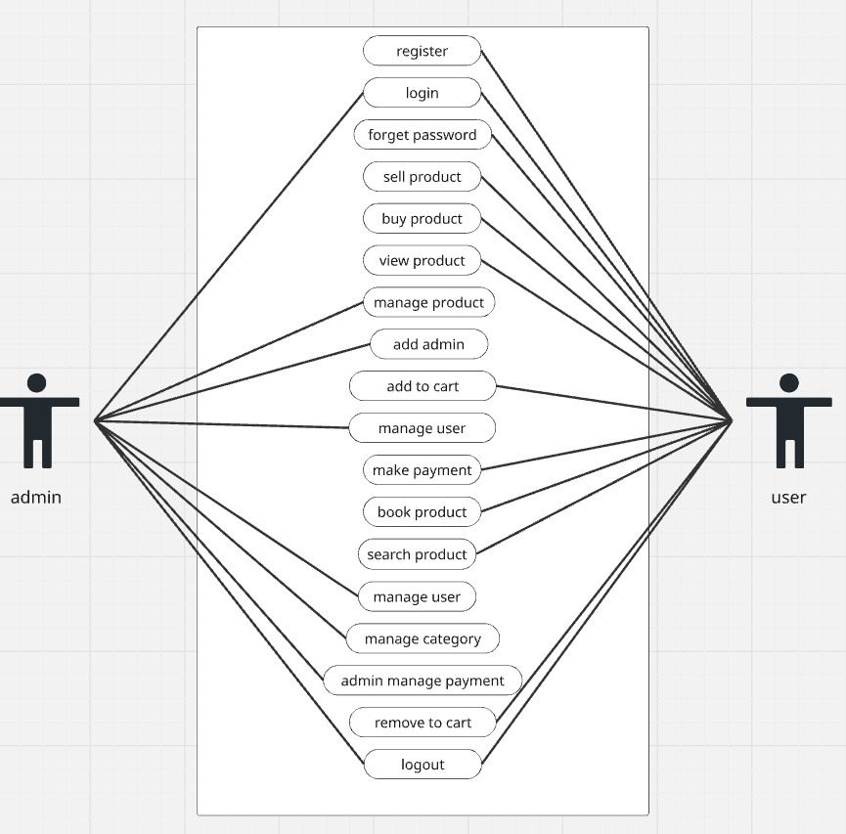

3.2 Activity Diagram

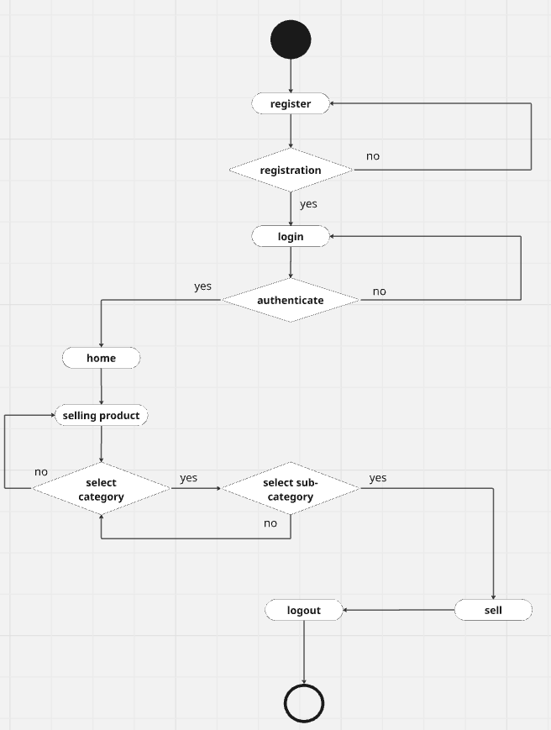

3.3 Activity Diagram

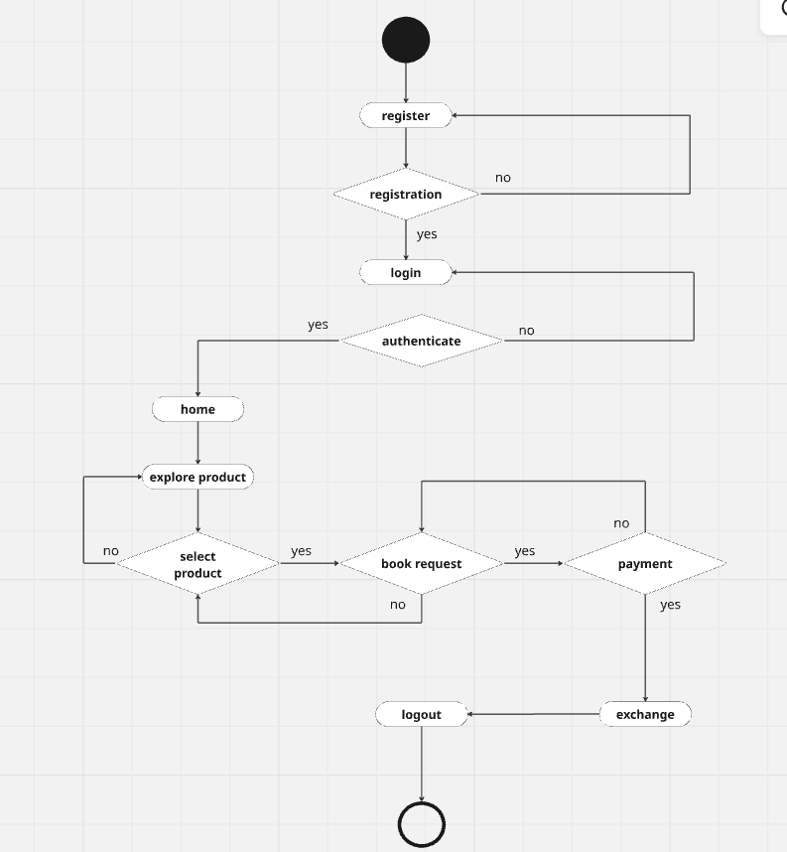

3.4 Sequence Diagram

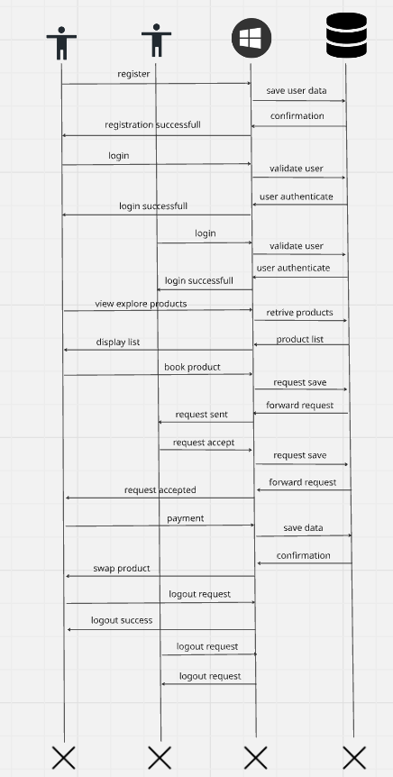
3.5 Class Diagram

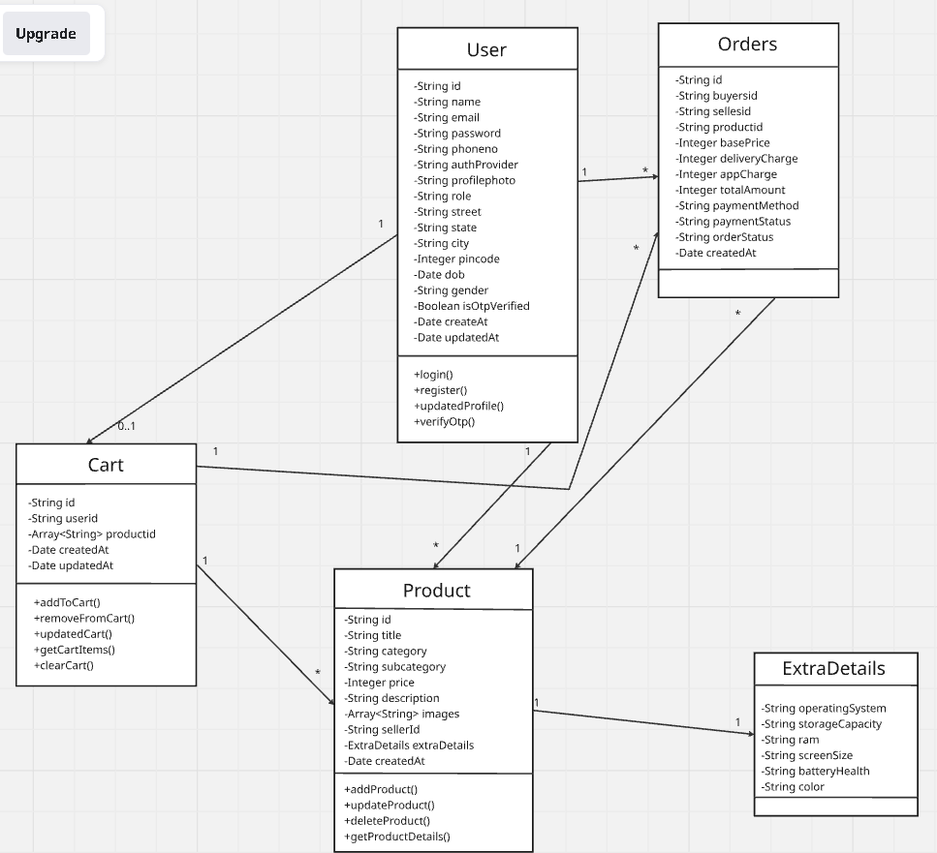

3.6 Data Dictionary

1. User
Fieldname | Datatype | Field size | Constraint | Example
Id | String | 50 | Not null | 67f6c02dc5a0504124894dc6
name | String | 50 | Not null | Kunal Shah
Email | String | 100 | Not null | Shahkunal881@gmail.com
Password | String | 50 | Not null | $2a$10$cdnc5bxyuebb1bqwbvmfdeenchisjthvnrrhlbc.khylsany2x5u2
Phoneno | String | 15 | Not null | 1234567890
AuthProvider | String | 50 | Not null | local
Profilephoto | String | 100 | Not null | 1744224697311.jpg
Role | String | 20 | Not null | User
Street | String | 100 | Not null | Sweetal apartment,shapur
State | String | 100 | Not null | Gujarat
City | String | 100 | Not null | Ahmedabad
Pincode | Integer | 6 | Not null | 380001
Dob | Date | 50 | Not null | 2002-12-04T00:00:00.000+00:00
Gender | String | 10 | Not null | Male
isOtpVerified | Boolean | 50 | Not null | False
createdAt | Date | 50 | Not null | 2025-09-06T20:35:12.366+00:00
updatedAt | Date | 50 | Not null | 2025-09-24T13:04:25.214+00:00

2. Product
Fieldname | Datatype | Field size | Constraint | Example
Id | String | 50 | Not null | 67f6c02dc5a0504124894dc6
title | String | 50 | Not null | Samsung s20
Category | String | 100 | Not null | Electronics & Gadgets
subcategory | String | 50 | Not null | Phones & Tablets
price | Integer | 15 | Not null | 50000
description | String | 255 | Not null | here is the phone of Samsung s20
Images | Array | - | Not null | -
Images.0 | String | 50 | Not null | 1757232374712-136674129.jpg
Images.1 | String | 50 | Not null | 1757232374859-203702071.jpg
SellerId | String | 100 | Not null | 68bc9b000d9e5a5871f9b8db
ExtraDetails | Object | - | Not null | -
extraDetails. Operating System | String | 50 | Not null | xiomi
extraDetails. Storage Capacity | String | 50 | Not null | 128gb
extraDetails. RAM | String | 50 | Not null | 8gb
extraDetails.  Screen Size | String | 50 | Not null | 26 x 13
extraDetails.  Battery Health | String | 50 | Not null | 8hr
extraDetails.Color | String | 50 | Not null | blue
createdAt | Date | 50 | Not null | 2025-09-06T20:35:12.366+00:00

3. cart
Fieldname | Datatype | Field size | Constraint | Example
Id | String | 50 | Not null | 67f6c02dc5a0504124894dc6
Userid | String | 50 | Not null | 68cfb1888fb43556f89287aa
Productid | Array | - | Notnull | -
Productid.0 | String | 50 | Not null | 68bd3cf7e8d87d967395d316
CreatedAt | Date | 50 | Not null | 2025-09-22T18:11:29.374+00:00
UpdatedAt | Date | 50 | Not null | 2025-09-22T18:11:29.374+00:00

4. Order
Fieldname | Datatype | Field size | Constraint | Example
Id | String | 50 | Not null | 68e225ab6bec7b7c95c06bf4
Buyersid | String | 50 | Not null | 68cfb1888fb43556f89287aa
Sellersid | String | 50 | Not null | 68bc9b000d9e5a5871f9b8db
Productid | String | 50 | Not null | 68bd425ce8d87d967395d31e
BasePrice | Integer | 50 | Not null | 2000
deliveryCharge | Integer | 50 | Not null | 400
appCharge | Integer | 50 | Not null | 200
totalAmount | Integer | 50 | Not null | 2600
paymentMethod  "COD" | Enum[“cod”,”online”] | 50 | Not null | COD
paymentStatus  "Pending" | Enum["Pending", "Paid"] | 50 | Not null | Pending
orderStatus  "Placed" | Enum ["Placed", "Shipped", "Delivered", "Cancelled"] | 50 | Not null | Placed
CreatedAt | Date | 50 | Not null | 2025-09-22T18:11:29.374+00:00

4. Development

4.1 Coding Standard

1. Project Structure
- Use clear and descriptive names for folders (e.g., frontend, backend, database, API, models, controllers), representing modules of the system.
- Source code files should have meaningful names reflecting their purpose, e.g., userController.js, productModel.js.
- Organize front-end (Flutter) project into components like screens, widgets, services, utils, and assets for better readability.
- Backend (Node.js + Express) should follow MVC (Model-View-Controller) or service-based architecture for scalability.

2. Code Version Management
- Maintain the repository using Git and GitHub/GitLab.
- Follow branching strategy:
  - main → stable production-ready code
  - develop → ongoing development
  - feature → new features
  - bugfix → issue fixes
- Write detailed commit messages
- Use Pull Requests (PRs) and code reviews before merging.

3. Error Handling
- Validate all user inputs (sign-up, login, product listing, swapping, payments).
- Use proper exception handling for:
  - Authentication/authorization errors
  - Payment gateway failures
  - Data validation (e.g., missing product details, invalid price)
- Show user-friendly error messages
- Log internal errors securely for debugging but never expose stack traces to end-users.

4. UI Design
- The mobile app (Flutter) must be responsive across different devices (phones/tablets).
- Follow a clean and minimal UI/UX with consistent colour themes, icons, and typography.
- Use intuitive navigation with bottom navigation bar or side drawer for easy access to modules.
- Include accessibility support (readable fonts, contrast colours, simple icons).

5. Further Development
- Conduct regular code reviews to maintain consistency and detect issues early.
- Maintain up-to-date documentation (README, API docs, and inline comments).
- Follow coding best practices:
  - Frontend (Flutter/Dart): Use meaningful variable names, reusable widgets, and follow Dart style guidelines.
  - Backend (Node.js/Express): Use async/await for clean async handling, modular routes, and environment variables for secrets.
- Write unit and integration tests for critical features (user authentication, product listing, swap functionality).
- Continuously improve security measures (input sanitization, encrypted communication, JWT authentication).

4.2 Screenshots

1. Login Page

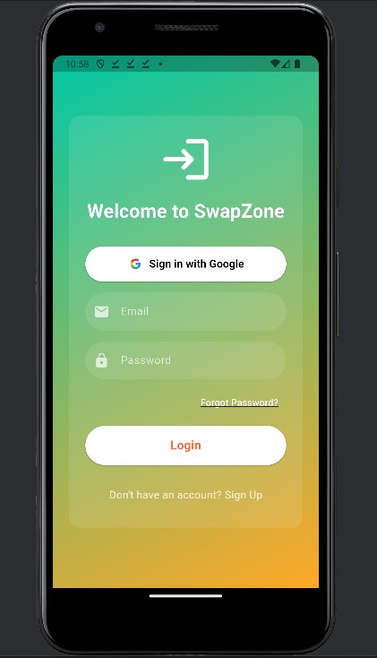

2. Register Page

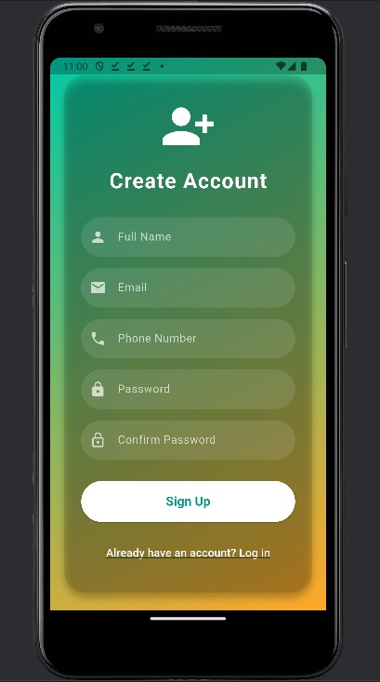

3. Forgot Password Page

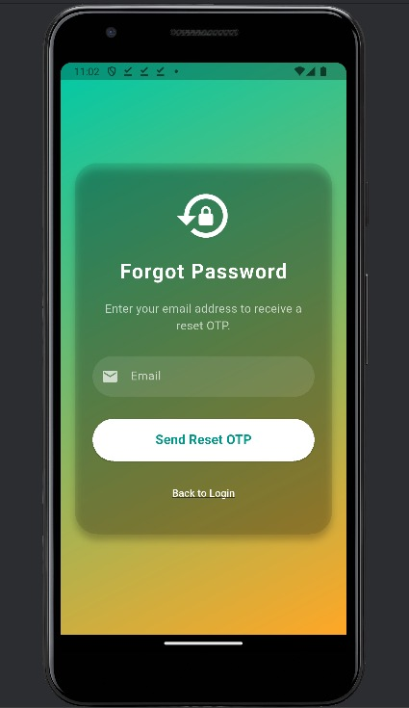

4. OTP Verify Page

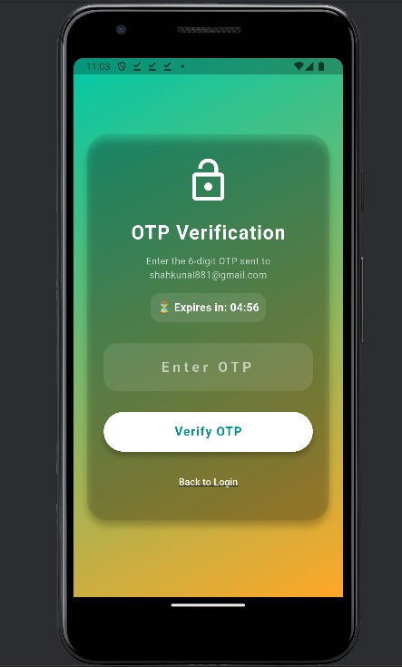

5. Change Password Page

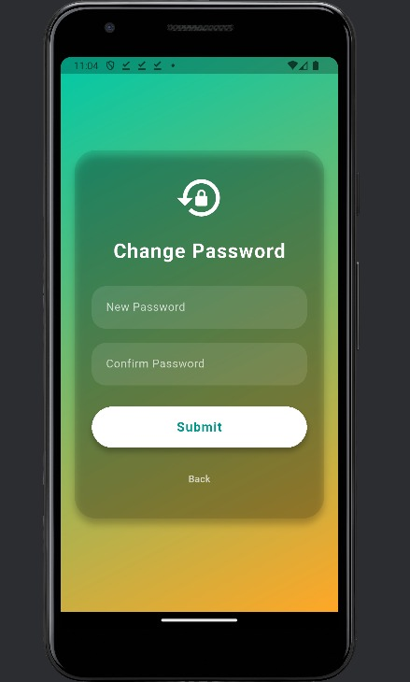

6. Home Page

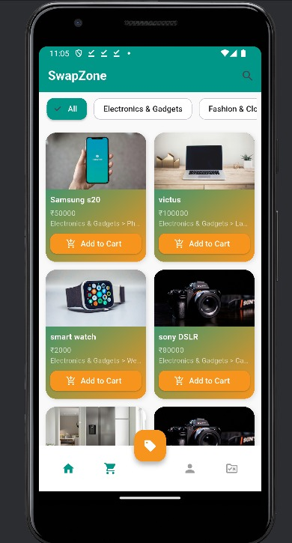

7. Product Page

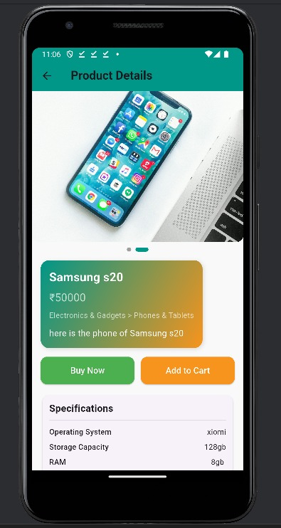

8. Cart Page

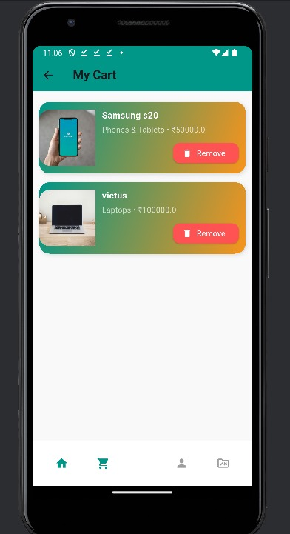

9. Profile Page

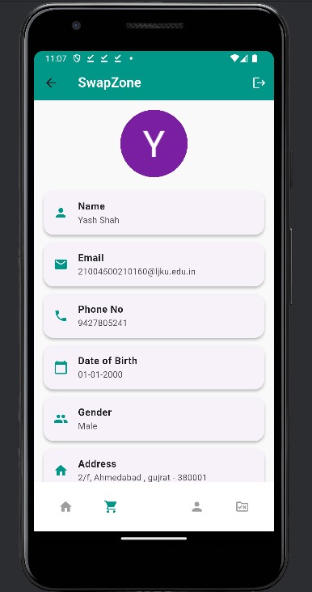

10. Checkout Page

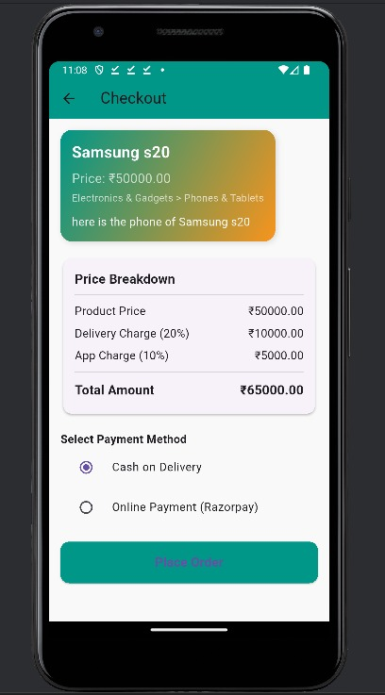

11. Category Page

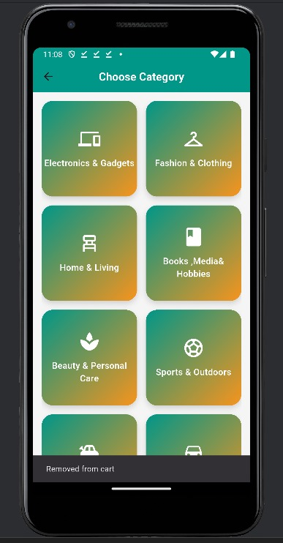

12. Sell Product Page

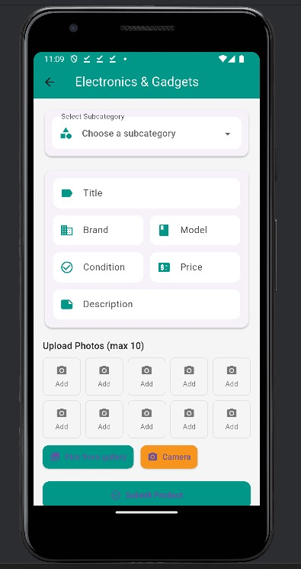

13. Admin Home Page

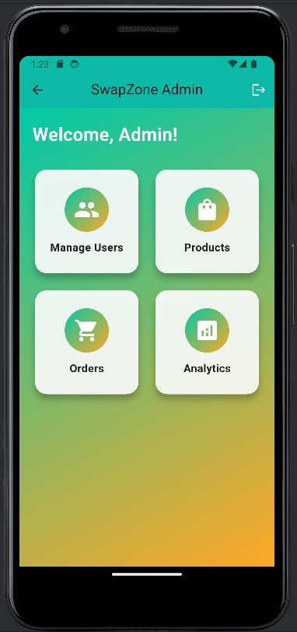

14. Mange User’s Page

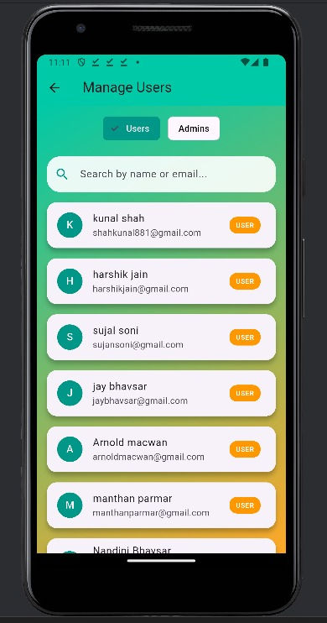

15. Show Admin Page

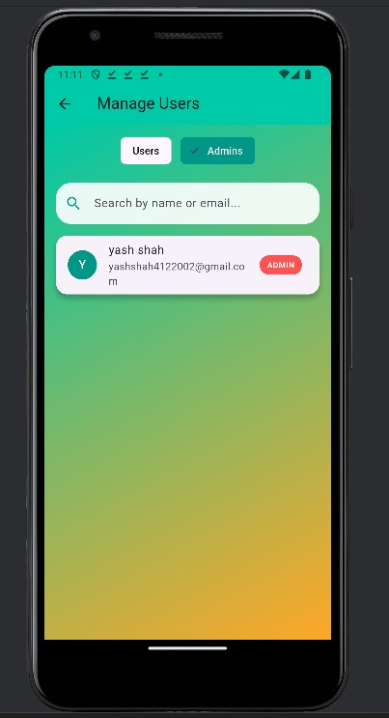

16. Admin Personal Profile page

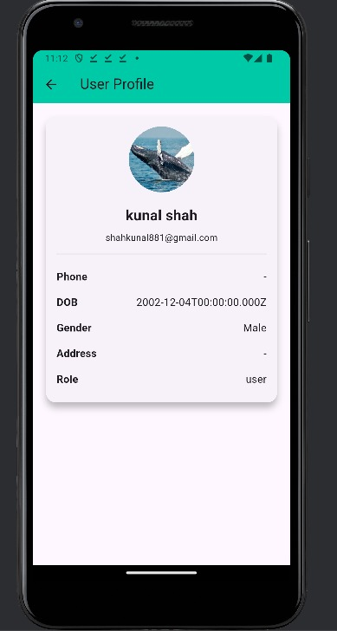

17. My order Page

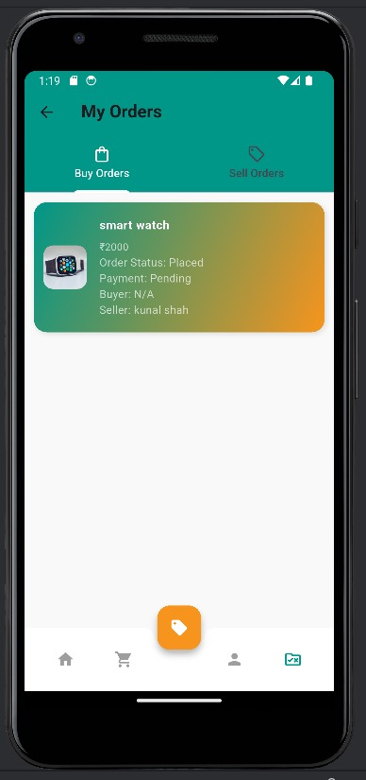

18. Sell Order Page

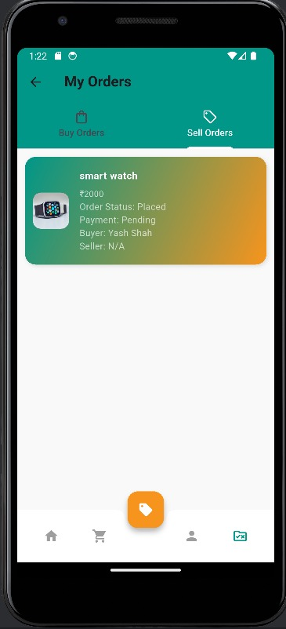

19. Manage Product

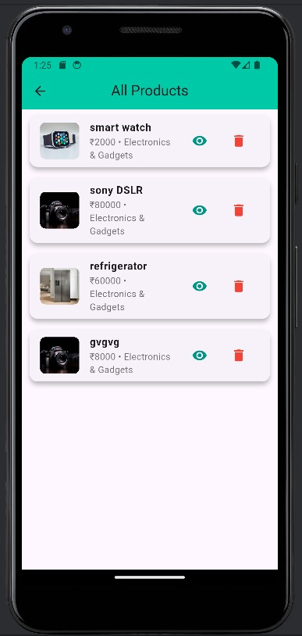

20. Product Details

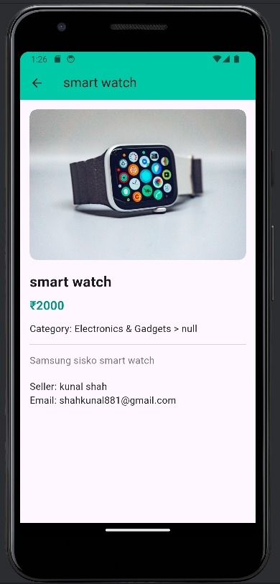

21. Manage Order

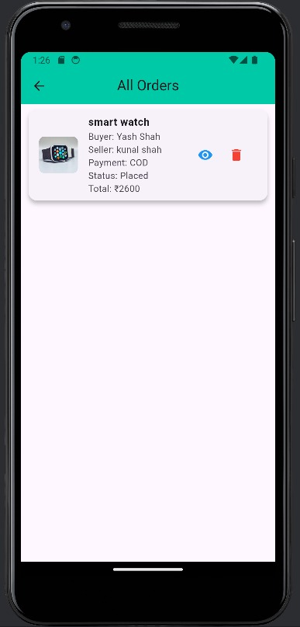

22. Order Details

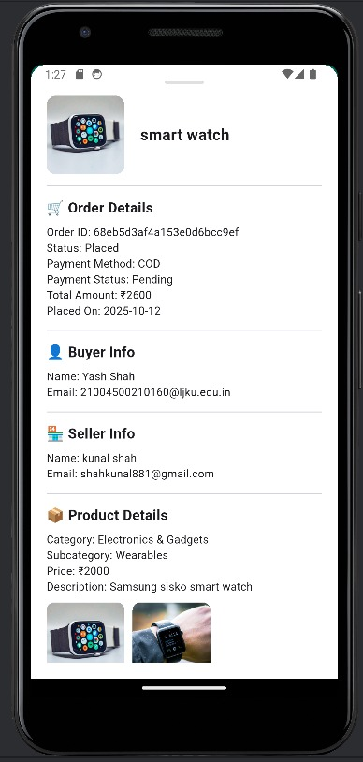

23. Analytics Page

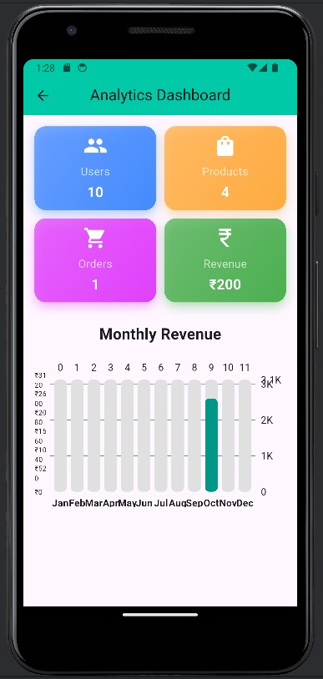

24. Logout Page

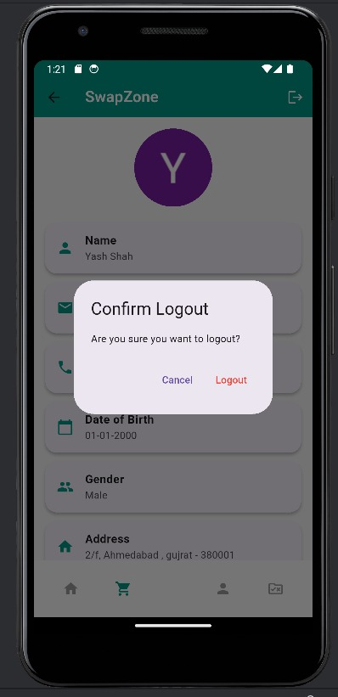

5. Agile Documentation

5.1. Project Charter

Project Name | SwapZone
Guide | Virendra Ingle
Project expected Start date | 15-07-2025
Project expected end date | 15-10-2025
Project Scope | SwapZone will be a cross-platform mobile and web app using Flutter for easy buying, selling, and swapping. It includes an admin dashboard, secure login, and encrypted data storage. Users can browse products with search and filters, manage Wishlist, Cart, and Orders, make payments via Razorpay, and leave reviews to build trust.
Project mission | The main objectives of SwapZone are to provide a user-friendly platform for buying, selling, or swapping products with secure payments. It offers sellers tools for managing products and orders, ensures seamless access via Flutter with a reliable Node.js and MongoDB backend, and maintains a secure environment for trustworthy exchanges.
Project vision | To evolve SwapZone into a modern, reliable, and community-driven marketplace where users can swap, sell, or purchase products effortlessly promoting sustainability, smart trading, and user satisfaction through innovation, technology, and trust.

5.2 Project Roadmap

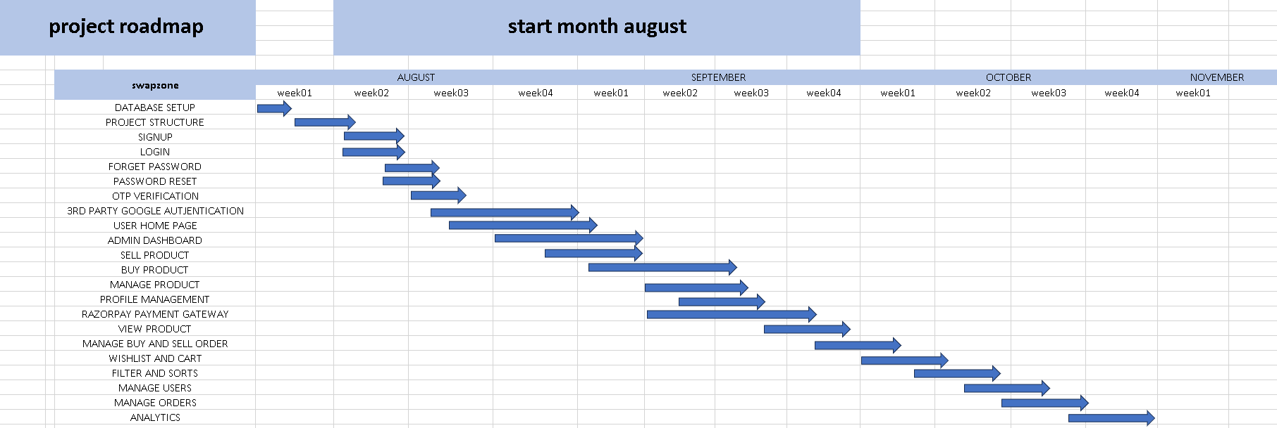

5.3 Sprint Table

Sr No. | Task | Assigned to | Status | Estimated time | Story Points
1 | Database Setup | Yash | Completed | 2 | 5
2 | Project Structure | Nandini | Completed | 4 | 8
3 | Signup | Nandini | Completed | 3 | 7
4 | Login | Nandini | Completed | 3 | 7
5 | Forget Password | Nandini | Completed | 4 | 6
6 | Password Reset | Nandini | Completed | 2 | 6
7 | OTP Verification | Nandini | Completed | 4 | 6
8 | 3rd Party Google Authentication | Yash | Completed | 6 | 9
9 | User Home Page | Yash | Completed | 5 | 7
10 | Admin Dashboard | Yash | Completed | 6 | 8
11 | Sell Product | Raj | Completed | 3 | 7
12 | Buy Product | Yash | Completed | 5 | 8
13 | Manage Product | Raj | Completed | 4 | 7
14 | Profile Management | Raj | Completed | 4 | 6
15 | Razor Pay Payment Gateway | Yash | Completed | 7 | 9
16 | View Product | Raj | Completed | 4 | 7
17 | Manage Busy & Sell Order | Raj | Completed | 5 | 7
18 | Wishlist & Cart | Raj | Completed | 4 | 8
19 | Filter & Sort | Yash | Completed | 2 | 6
20 | Manage Users | Raj | Completed | 4 | 8
21 | Manager Orders | Nandini | Completed | 4 | 8
22 | Analytics | Yash | Completed | 5 | 7

5.4 User Story
Sr. | As a <user> | Want to <task> | So that <goal>
1 | Admin | Login | Admin login to access the system dashboard.
2 | Admin | Logout | Admin logout securely from the system.
3 | Admin | Manage Product | Admin manages the products efficiently.
4 | Admin | Add Admin | Admin can add other admins to manage the system.
5 | Admin | Manage User | Admin can manage or update user accounts.
6 | Admin | Manage Category | Admin can create, edit, or delete product categories.
7 | Admin | Admin Manage Payment | Admin monitors and manages all payment transactions.
8 | User | Register | User creates a new account to access system features.
9 | User | Login | User logs in to access their profile and services.
10 | User | Forget Password | User can reset their password to regain access.
11 | User | Sell Product | User lists products or skills for others to view or buy.
12 | User | Buy Product | User purchases products or exchanges skills.
13 | User | View Product | User views details and descriptions of available products.
14 | User | Add to Cart | User adds items to the cart for future purchase.
15 | User | Make Payment | User completes payment for selected products or services.
16 | User | Book Product | User books a product or service for a specific time or date.
17 | User | Search Product | User searches for specific products or skills quickly.
18 | User | Remove to Cart | User removes unwanted items from the cart.
19 | User | Logout | User logs out safely and ends their session.

5.5 Release Plan
Task | Start Date | End Date | Status | Release date
Database Setup | 02-08-2025 | 02-08-2025 | Released | 03-08-2025
Project Structure | 03-08-2025 | 04-08-2025 | Released | 05-08-2025
Signup | 05-08-2025 | 07-08-2025 | Released | 08-08-2025
Login | 08-08-2025 | 10-08-2025 | Released | 11-08-2025
Forget Password | 11-08-2025 | 12-08-2025 | Released | 13-08-2025
Password Reset | 14-08-2025 | 15-08-2025 | Released | 16-08-2025
OTP Verification | 17-08-2025 | 19-08-2025 | Released | 20-08-2025
3rd Party Google Authentication | 21-08-2025 | 24-08-2025 | Released | 25-08-2025
User Home Page | 26-08-2025 | 29-08-2025 | Released | 30-08-2025
Admin Dashboard | 31-08-2025 | 03-09-2025 | Released | 04-09-2025
Sell Product | 05-09-2025 | 07-09-2025 | Released | 08-09-2025
Buy Product | 09-09-2025 | 11-09-2025 | Released | 12-09-2025
Manage Product | 13-09-2025 | 14-09-2025 | Released | 15-09-2025
Profile Management | 16-09-2025 | 19-09-2025 | Released | 20-09-2025
Razor Pay Payment Gateway | 21-09-2025 | 25-09-2025 | Released | 26-09-2025
View Product | 27-09-2025 | 29-09-2025 | Released | 30-09-2025
Manage Busy & Sell Order | 01-10-2025 | 04-10-2025 | Released | 05-10-2025
Wishlist & Cart | 06-10-2025 | 09-10-2025 | Released | 10-10-2025
Filter & Sorts | 11-10-2025 | 14-10-2025 | Released | 15-10-2025
Manage Users | 16-10-2025 | 19-10-2025 | Released | 20-10-2025
Manager Orders | 21-10-2025 | 24-10-2025 | Released | 25-10-2025
Analytics | 26-10-2025 | 29-10-2025 | Released | 30-10-2025

5.6 Test Plan
Test | Action | Expected Result | Actual Result | Status
1 | Admin Login | Admin logs in and accesses the dashboard successfully. | Admin logged in and redirected to dashboard. | PASS
2 | Admin Logout | Admin logs out securely from the System. | Admin logged out successfully. | PASS
3 | Manage Product | Admin can view, add, edit, or delete products. | Admin managed products successfully. | PASS
4 | Add Admin | Admin can add a new admin with valid credentials. | New admin added successfully. | PASS
5 | Manage User | Admin can View, Update or Remove Users. | User Managed Successfully. | PASS
6 | Manage Category | Admin can Create, edit and delete product Categories. | Categories Managed Successfully. | PASS
7 | Manage Payment | Admin can view and control all payment transactions. | Payments managed successfully. | PASS
8 | User Registration | User creates an account and receives confirmation. | User registered successfully. | PASS
9 | User Login | User logs in and accesses their profile and dashboard. | User logged in successfully. | PASS
10 | Forgot Password | User resets password through email verification. | Password reset verified via email. | PASS
11 | Sell Product | User lists product for others to view or buy. | Product listed successfully. | PASS
12 | Buy Product | User purchases product successfully after payment. | Product purchased successfully. | PASS
13 | View Product | User can view product details and descriptions. | Product details displayed correctly. | PASS
14 | Add to Cart | User adds selected product to cart for purchase. | Product added to cart successfully. | PASS
15 | Make Payment | User completes secure payment for chosen product/service. | Payment completed successfully. | PASS
16 | Book Product | User books a product/service for desired time or date. | Product booked successfully. | PASS
17 | Search Product | User searches and retrieves products easily. | Search results displayed correctly. | PASS
18 | Remove from Cart | User removes unwanted items from the cart. | Product removed from cart successfully. | PASS
19 | User Logout | User logs out and session end securely. | Users logged out successfully. | PASS

5.7 Sprint Burn Chart

6. Proposed Enhancement

- The proposed enhancements for SwapZone aim to make the platform more advanced, secure, and user-centric, transforming it into a feature-rich and scalable trading system. The system proposes to implement the following features:
  - AI-Powered Price Estimator
  - Secure Payment Gateway
  - In-App Delivery Tracking
  - User Review and Rating System
  - Gamification Features
  - Enhanced payment module

7. Conclusion

SwapZone successfully fulfils the vision of creating a dynamic and user-centric marketplace where individuals can buy, sell, or swap products seamlessly. The platform demonstrates how technology can promote sustainable trading by encouraging product reuse and exchange. With its secure backend architecture, intuitive Flutter-based interface, and robust management features, SwapZone establishes a strong foundation for a scalable and reliable e-commerce ecosystem. The project highlights the potential of modern technologies like Node.js, Express.js, and MongoDB in delivering efficient, secure, and accessible digital solutions that enhance user convenience, trust, and engagement.

