

CLASS: B.Tech Gen Sec-C
SUBJECT: Frontend development Lab

PROJECT REPORT

Student Management Dashboard

Submitted by
Arien Khardiya (Reg. no. 2024/17004)

Submitted to
Ms. Shrutika Agrawal

Student Management Dashboard Project Report

This report presents a detailed analysis of the Student Management Dashboard developed using modern web technologies. The project focuses on managing student data efficiently through an interactive and responsive web interface.

Introduction
The Student Management Dashboard is designed to manage and organize student information such as name, roll number, and course. It provides a user-friendly interface that allows users to add, view, and delete student records.
This project helps in understanding how real-world web applications work and demonstrates frontend development skills using Bootstrap and JavaScript.

Website Preview

Login Page: The login page contains a simple form with email and password fields. It validates user input and redirects to the dashboard after login.

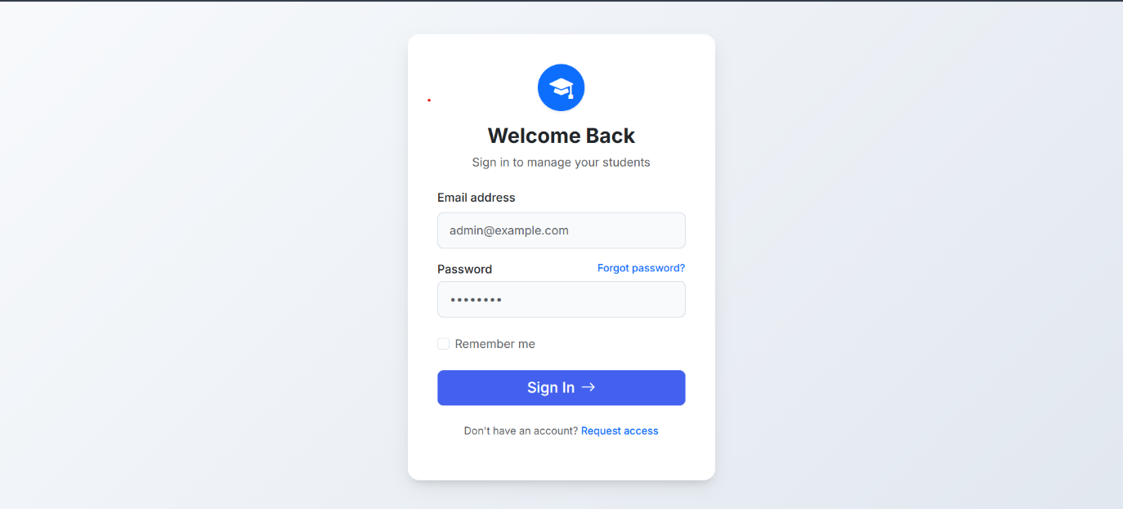
Dashboard Page: The dashboard displays summary cards such as total students, active students, and number of courses. It also includes a navigation bar and clean layout.

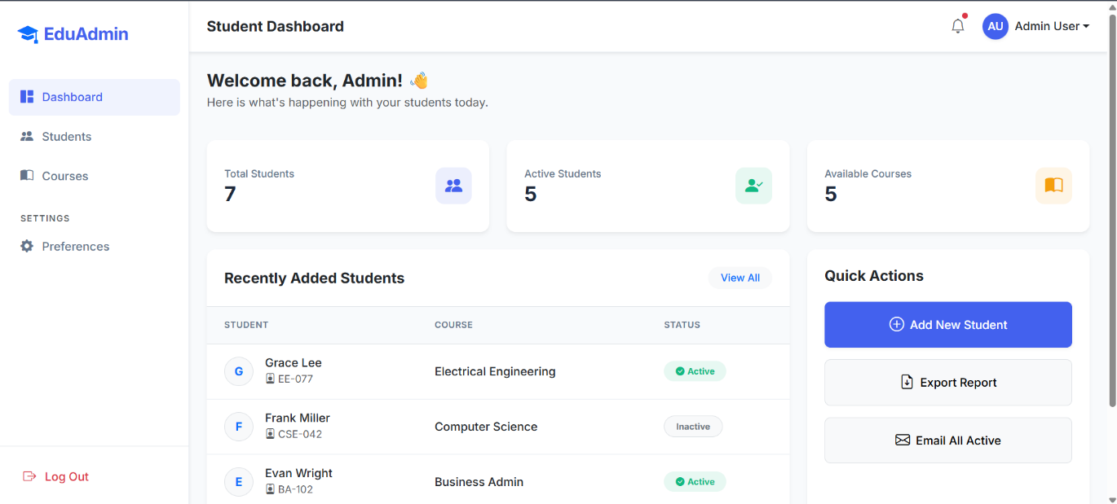

Student Management Page: This page shows student records in a table format. It allows users to:
- Add new students
- Delete students
- View all student details

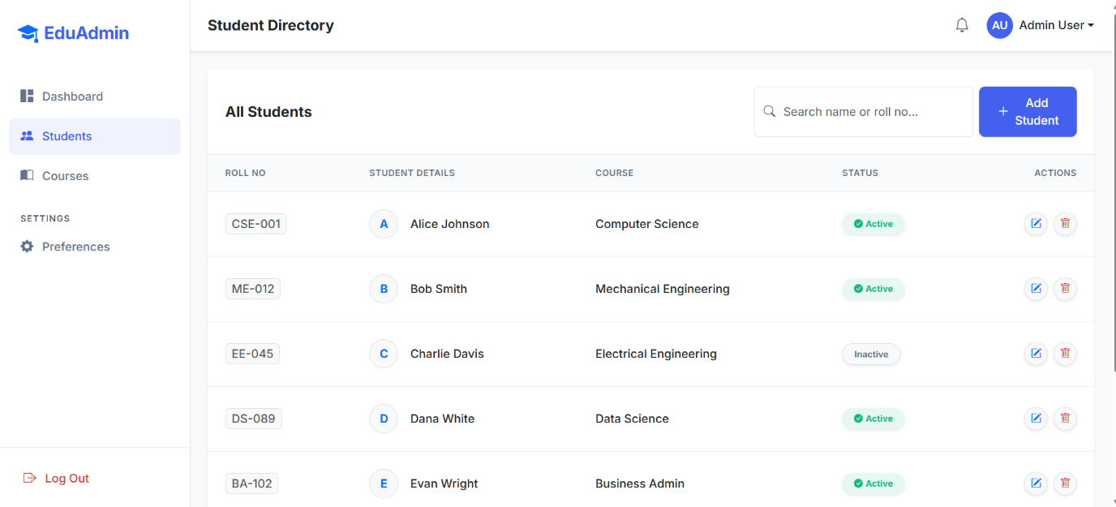

Technologies Used

• HTML: Used to structure the web pages

• CSS: Used for styling and layout design

• Bootstrap 5: Used for responsive design and UI components

• JavaScript: Used for interactivity and dynamic data handling

Features of the Website

• Responsive Design: Works on mobile, tablet, and desktop

• Login System: Simple authentication interface

• Dashboard Overview: Displays key statistics

• Student Management: Add and delete student records

• Interactive UI: Built using Bootstrap components

Code Explanation
The project is divided into multiple files:
- HTML Files:
Define the structure of login, dashboard, and student pages
- CSS File:
Adds styling, colors, spacing, and layout improvements
- JavaScript Files:
Handle functionality such as:
  - Displaying student data
  - Adding new students
  - Deleting students
  - Updating dashboard statistics
The data is stored temporarily using JavaScript arrays.

Challenges Faced
• Designing a responsive layout using Bootstrap
• Managing dynamic data using JavaScript
• Linking multiple pages correctly
• Handling user interactions like add/delete operations

Improvements

In the future, the following improvements can be made:
- Add backend using Node.js or Firebase
- Store data permanently in a database
- Add edit/update student feature
- Improve UI with animations and charts
- Add authentication system with real login

Conclusion

This project helped in understanding the basics of frontend development and how to build interactive web applications. It improved skills in HTML, CSS, Bootstrap, and JavaScript.

The Student Management Dashboard is a practical project that reflects real-world application development and enhances problem-solving skills.

