INMT5526 Individual Assignment
Business Intelligence | Semester 1, 2026 | University of Western Australia

1. Introduction
This report focuses on designing and implementing a database solution to address a business problem related to workforce and accommodation management in FIFO (Fly-In Fly-Out) operations. FIFO systems are commonly used in industries such as mining in Western Australia, where workers are transported to remote locations for specific time periods.
The main objective of this assignment is to apply database concepts learned in the first four topics of the unit, including entity-relationship modelling and SQL, to develop a structured solution. The report outlines the problem, explains the design process, presents the implementation and reflects on the effectiveness of the solution.

2. Background
FIFO operations involve managing multiple components at the same time, including employees, accommodation, shifts and site locations. In many organisations, this process is still handled using spreadsheets or basic systems, which can create several issues such as data duplication, errors and inefficiencies.
A key problem is the lack of a centralised and structured system to manage workforce allocation and accommodation. For example, employees may be assigned to overlapping shifts or rooms may be overbooked due to poor tracking. These issues can affect operational efficiency and increase costs.
Databases provide a more reliable solution because they allow data to be stored in a structured format and accessed efficiently. As discussed in the unit, databases are designed to organise data in a consistent way so that it can be retrieved and analysed to support decision-making (Date, 2003). Compared to spreadsheets, databases are more suitable when dealing with large amounts of data and multiple users.
The proposed solution is to develop a relational database system that stores information about employees, shifts, rooms and site locations. This system would allow managers to easily track which employees are assigned to which shifts and where they are staying.
This problem is worth solving because it improves coordination, reduces errors and supports better decision-making. From a business intelligence perspective, having structured and reliable data is essential for generating insights and making informed decisions (Kimball & Ross, 2013).

3. Design
The database design was developed using entity-relationship modelling, which is used to represent real-world objects as entities and define the relationships between them. An entity refers to something we store data about, such as an employee or a site, while attributes describe the properties of that entity (Chen, 1976).

Entities and Attributes
The following five entities were identified for the system: Employee, Site, Room, Shift and Allocation. Each entity has a surrogate integer primary key (AUTO_INCREMENT) and a set of descriptive attributes. The Allocation entity acts as an associative (junction) table, holding foreign keys that link an Employee to a Room and a Shift for a given deployment period.

Relationships
- A Site can contain multiple Rooms (one-to-many).
- An Employee can have multiple Allocations (one-to-many).
- A Room can be assigned to multiple Allocations over time (one-to-many).
- A Shift can include multiple employees through Allocations (one-to-many).
These relationships reflect how FIFO operations function in reality and allow the system to store data efficiently without redundancy. The full entity-relationship diagram is provided in Appendix A.

Design Justification
The design follows normalisation principles, meaning that data is organised into separate tables to reduce redundancy. Each table represents a single entity and relationships are managed through foreign keys. This approach ensures data consistency and avoids duplication — for example, employee details are stored only once and referenced where needed.
Another important aspect of the design is planning before implementation. As highlighted in the lectures, designing the structure first helps avoid issues when writing SQL queries later (Elmasri & Navathe, 2016).

Use of Unit Concepts
- Entity-relationship modelling (Topic 2)
- Primary and foreign keys (Topic 2)
- Normalisation to reduce redundancy (Topic 3)
- Planning before implementation (Topic 1)

4. Solution
The solution was implemented using SQL, which is used to create, manage and query relational databases. The implementation follows CRUD operations (Create, Read, Update and Delete), which form the basis of database systems (Connolly & Begg, 2015).

Database and Table Creation
CREATE DATABASE fifo_db;
USE fifo_db;
CREATE TABLE Employee (
employee_id INT AUTO_INCREMENT,
name VARCHAR(100) NOT NULL,
role VARCHAR(50),
contact VARCHAR(100),
PRIMARY KEY (employee_id)
);
CREATE TABLE Site (
site_id INT AUTO_INCREMENT,
site_name VARCHAR(100) NOT NULL,
location VARCHAR(100),
PRIMARY KEY (site_id)
);
CREATE TABLE Room (
room_id INT AUTO_INCREMENT,
capacity INT CHECK (capacity > 0),
site_id INT,
PRIMARY KEY (room_id),
FOREIGN KEY (site_id) REFERENCES Site(site_id)
);
CREATE TABLE Shift (
shift_id INT AUTO_INCREMENT,
start_date DATE NOT NULL,
end_date DATE NOT NULL,
PRIMARY KEY (shift_id)
);
CREATE TABLE Allocation (
allocation_id INT AUTO_INCREMENT,
employee_id INT,
room_id INT,
shift_id INT,
PRIMARY KEY (allocation_id),
FOREIGN KEY (employee_id) REFERENCES Employee(employee_id),
FOREIGN KEY (room_id) REFERENCES Room(room_id),
FOREIGN KEY (shift_id) REFERENCES Shift(shift_id)
);

Data Insertion
INSERT INTO Employee (name, role, contact)
VALUES ('Alex Johnson', 'Engineer', '0412 000 001'),
('Sarah Lee', 'Technician', '0412 000 002');
INSERT INTO Site (site_name, location)
VALUES ('Site A', 'Western Australia'),
('Site B', 'Western Australia');
INSERT INTO Room (capacity, site_id)
VALUES (2, 1),
(1, 2);
INSERT INTO Shift (start_date, end_date)
VALUES ('2026-04-01', '2026-04-14'),
('2026-04-15', '2026-04-28');
INSERT INTO Allocation (employee_id, room_id, shift_id)
VALUES (1, 1, 1),
(2, 2, 2);

Queries
Retrieve all employees:
SELECT * FROM Employee;
Join query — employee name, site name and shift start date:
SELECT e.name,
s.site_name,
sh.start_date
FROM Allocation a
JOIN Employee e ON a.employee_id = e.employee_id
JOIN Room r ON a.room_id = r.room_id
JOIN Site s ON r.site_id = s.site_id
JOIN Shift sh ON a.shift_id = sh.shift_id;
Aggregation — total rooms per site:
SELECT site_id,
COUNT(room_id) AS total_rooms
FROM Room
GROUP BY site_id;
Aggregation — total employees per role:
SELECT role,
COUNT(*) AS total_employees
FROM Employee
GROUP BY role;

Explanation
The SQL implementation demonstrates how data can be created, stored and retrieved efficiently. The use of JOIN statements allows multiple tables to be combined in a single query, reflecting the relationships defined during the design phase. Aggregation functions such as COUNT and GROUP BY help generate useful summaries that support business decision-making.
This reflects how databases support business intelligence by transforming raw data into meaningful information (Kimball & Ross, 2013). Each SQL block directly corresponds to a technique covered in the first four topics of the unit.

5. Conclusion
Overall, the database solution successfully addresses the problem of managing FIFO workforce and accommodation. By organising data into structured tables and defining clear relationships, the system improves efficiency and reduces the likelihood of errors.
The solution meets the requirements by ensuring data consistency, enabling efficient queries and supporting decision-making. However, the system is still relatively basic and could be improved by adding features such as automated scheduling or integration with business intelligence tools for deeper reporting.
One challenge during the process was ensuring that relationships between tables were correctly defined, particularly when working with foreign keys. This was resolved by carefully reviewing the ER design before implementation, which reinforced the value of the design-first approach taught in the unit.
If this project were to be completed again, I would focus on expanding the system further and including more advanced queries — for example, window functions or stored procedures — to generate deeper insights and better demonstrate the capabilities of a relational database in a FIFO context.

Appendix A — Design (ER Diagram)
The entity-relationship diagram below illustrates the five entities and the relationships between them as described in Section 3.
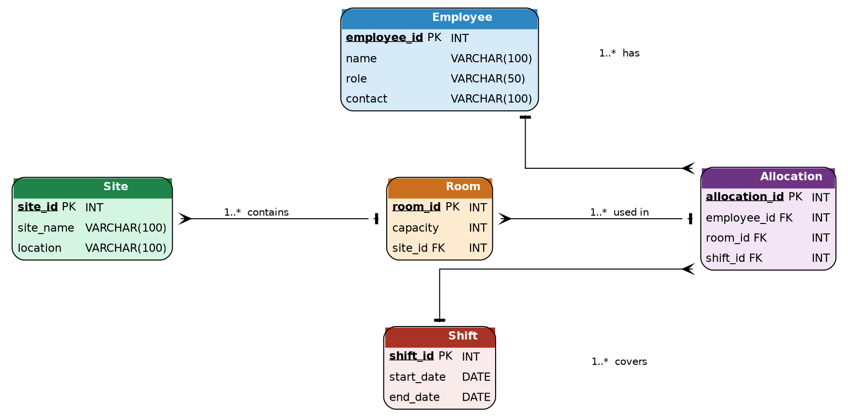
Figure 1. ER Diagram — FIFO Workforce Allocation Database.

Appendix B — Implementation (SQL Statements)
The complete SQL implementation is reproduced below for reference.
-- ── Database setup ──────────────────────────────────────────────────────
CREATE DATABASE fifo_db;
USE fifo_db;
-- ── Table definitions ───────────────────────────────────────────────────
CREATE TABLE Employee (
employee_id INT AUTO_INCREMENT,
name VARCHAR(100) NOT NULL,
role VARCHAR(50),
contact VARCHAR(100),
PRIMARY KEY (employee_id)
);
CREATE TABLE Site (
site_id INT AUTO_INCREMENT,
site_name VARCHAR(100) NOT NULL,
location VARCHAR(100),
PRIMARY KEY (site_id)
);
CREATE TABLE Room (
room_id INT AUTO_INCREMENT,
capacity INT CHECK (capacity > 0),
site_id INT,
PRIMARY KEY (room_id),
FOREIGN KEY (site_id) REFERENCES Site(site_id)
);
CREATE TABLE Shift (
shift_id INT AUTO_INCREMENT,
start_date DATE NOT NULL,
end_date DATE NOT NULL,
PRIMARY KEY (shift_id)
);
CREATE TABLE Allocation (
allocation_id INT AUTO_INCREMENT,
employee_id INT,
room_id INT,
shift_id INT,
PRIMARY KEY (allocation_id),
FOREIGN KEY (employee_id) REFERENCES Employee(employee_id),
FOREIGN KEY (room_id) REFERENCES Room(room_id),
FOREIGN KEY (shift_id) REFERENCES Shift(shift_id)
);
-- ── Sample data ─────────────────────────────────────────────────────────
INSERT INTO Employee (name, role, contact)
VALUES ('Alex Johnson', 'Engineer', '0412 000 001'),
('Sarah Lee', 'Technician', '0412 000 002');
INSERT INTO Site (site_name, location)
VALUES ('Site A', 'Western Australia'),
('Site B', 'Western Australia');
INSERT INTO Room (capacity, site_id)
VALUES (2, 1),
(1, 2);
INSERT INTO Shift (start_date, end_date)
VALUES ('2026-04-01', '2026-04-14'),
('2026-04-15', '2026-04-28');
INSERT INTO Allocation (employee_id, room_id, shift_id)
VALUES (1, 1, 1),
(2, 2, 2);
-- ── Queries ─────────────────────────────────────────────────────────────
-- All employees
SELECT * FROM Employee;
-- Employee allocation summary
SELECT e.name,
s.site_name,
sh.start_date
FROM Allocation a
JOIN Employee e ON a.employee_id = e.employee_id
JOIN Room r ON a.room_id = r.room_id
JOIN Site s ON r.site_id = s.site_id
JOIN Shift sh ON a.shift_id = sh.shift_id;
-- Rooms per site
SELECT site_id,
COUNT(room_id) AS total_rooms
FROM Room
GROUP BY site_id;
-- Employees per role
SELECT role,
COUNT(*) AS total_employees
FROM Employee
GROUP BY role;

References
Chen, P. P. (1976). The entity-relationship model — toward a unified view of data. ACM Transactions on Database Systems, 1(1), 9–36. https://doi.org/10.1145/320434.320440

Connolly, T., & Begg, C. (2015). Database systems: A practical approach to design, implementation and management (6th ed.). Pearson.

Date, C. J. (2003). An introduction to database systems (8th ed.). Addison-Wesley.

Elmasri, R., & Navathe, S. B. (2016). Fundamentals of database systems (7th ed.). Pearson.

Kimball, R., & Ross, M. (2013). The data warehouse toolkit: The definitive guide to dimensional modeling (3rd ed.). Wiley.

[Additional references to be inserted as appropriate.]

